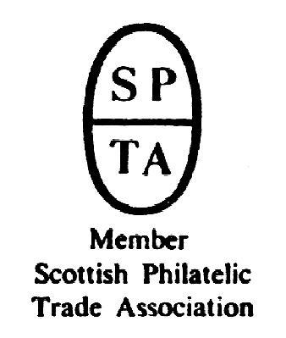

Robert Murray
5 & 6 Inverleith Gardens, Ferry Road,
Edinburgh, EH3 5PU
Tel. 0131 552 1220 :: 0131 478 7021
AUCTION
CATALOGUE
ONE POUND
website www.stamp-shop.com email auction@stamp-shop.com
Stamps and Collectables
Live Online Auction
Monday 19 October 2020
Starting at 7.00pm
Catalogue of Postage Stamps and Collectables to be sold by Online Auction,
via EasyLive Auction.

ONE POUND SALE
(All lots with £1 starting price.)

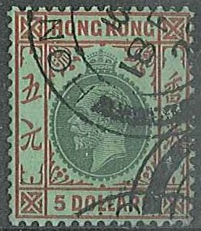
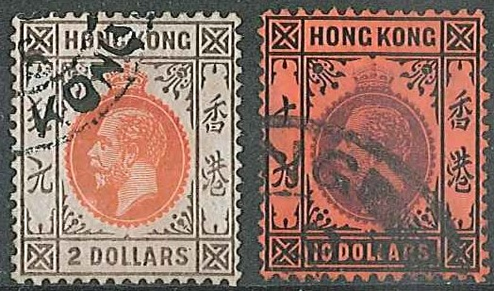
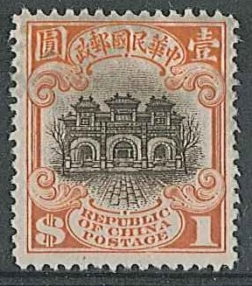
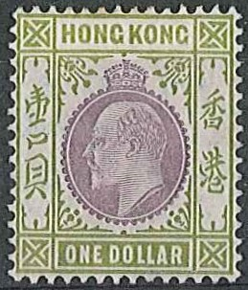

ex 97 ex 144 ex 145

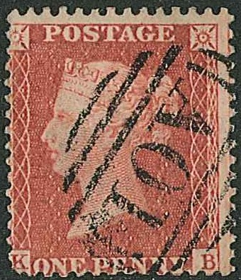
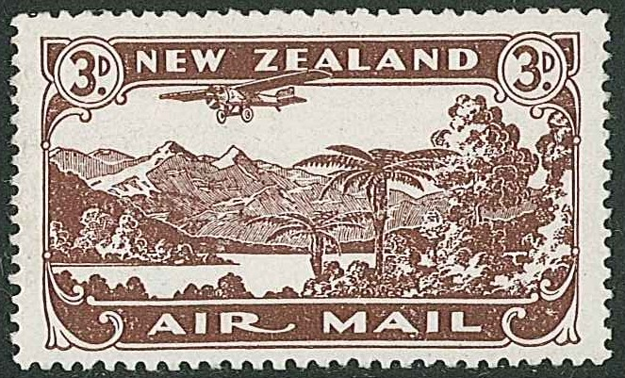
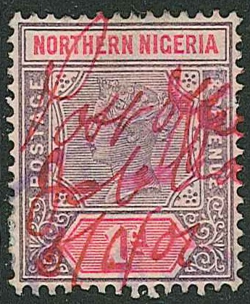

165 (Jamaica) 180 (scarcer perforation) 196
One Pound Sale, 19 October 2020 Page 2 .
We are unable to continue with public auctions for the foreseeable future, so our next auctions will be conducted online.
To test the system, we are holding this “One Pound Auction”, almost entirely of items from our own stock, in which every item has a starting price of just £1. Although we are putting out this simplified printed catalogue, we hope that everybody who can participate online will do so. Any customers who do not have internet access can still make bids to us by post or email and we will handle the bids on their behalf.
If you have received this catalogue by post, but realise now that you can manage without this printed version, please let us know, as we can remove you from our mailing list and save printing and postage.

One difference of course if you look at the auction online is that every lot is illustrated (in larger lots, pictures may well be of just sample parts of the lot). It also means that you can watch the auction as it happens, and bid while the sale is in progress – as long as you first register with EasyLive Auction.

This will be conducted as a “Live Auction”, as that will be the normal style for our main auctions for the foreseeable future. This means that you can follow the auction as it happens, you can see and hear me "calling" the auction, and you can bid right up to the last minute (although the earlier the better).
The whole purpose of this auction is to introduce our customers to this format, and to give us the opportunity to learn how to best use the system. Any mistakes we make will be with our own property, not with that of our clients. It’s a way for you to feel comfortable before we have a “normal” auction.
Instructions and rules for online bidders;
You must register with EasyLive Auction before you make any online bids. Please carefully read the Terms and Conditions.
There is a small fee to participate, and this is for each auction in which you bid. This covers part of the costs of using the online platform. The fee is either £3 paid up-front, or 3% (+ vat) of your purchases. You have to decide which option to go for when you register for each auction, and you shouldn’t then change your mind. Clearly, if your bids are going to be under £100 you should opt for the 3%, or if you confidently expect to spend over £100 then the £3 is the better option. If you are in-between, that’s your gamble !
The £3 fee is paid direct to EasyLive Auction, while the percentage fee would be collected by us with your invoice and then passed on by us to them.
The auction is now live, and can be accessed at www.stamp-shop.com/stamp-auctions or www.auctionontheinter.net or www.easyliveauction.com/auctioneers/robertmurraystampshop/

When the auction is running we will run through lots in numerical order in the traditional fashion, you’ll see the current lot being sold featured on screen. If there are no bids in advance the screen will show an “Asking Bid” price – click the “BID” button to bid that price. From there on it will show the current selling price. If you have bid it will clearly show you if you have been outbid by someone else. Clicking the “BID” button does the same as raising a hand in the auction room, and is legally binding in the same way.
You will be able to switch on audio and video which will allow you to listen to and watch the sale. If you think your connection might be slow, don’t use the video.
You can make “Auto Bids” in advance, at any time from the moment the auction is available online. Auto Bids work in the same way as “postal bids”. If there are no other bids you will get the lot at the starting price, even if your maximum bid is higher. As auctioneer, I do not have access to see advance bids; that is confidential within the system’s servers.
After the auction has completed, every online bidder will be emailed to tell them how their bids fared. If you’ve been successful you’ll get an invoice, and the option to either arrange a collection time with us, or to get a quote for postage/carriage. All payments are made direct to us.

Don’t delay when bidding !
If registering Auto-Bids, in the same way as before, if two people leave the same maximum bid, the earlier one will have precedence.
One Pound Sale, 19 October 2020 Page 3 .

If bidding live online during the auction, always remember that internet connections can have occasional dips and glitches, so don’t hang about; bid as quickly as you can. If you click to bid just a moment before I knock down the lot, but there’s a small delay in the connection, you will miss the lot, and it will not be re-opened.

We maintain an email list which alerts customers each time there is a new auction live online.
EasyLive Auction also send out notifications – sign up for “marketing emails” to get these.
NB some catalogue prices are from older editions, as some of the work for this catalogue was done from home without always having latest catalogues to hand.

CROSS-REFERENCES
PNCs; see 12, 251 Signed Covers; see 13, 278
Cinderellas; 161, 270-271 Austria; see 118-120
Iran; see 265 Netherlands; see 102
Poland; see 122 Russia; see 122

NEXT AUCTION ----- We are working at an auction to follow this as closely as possible. This will be our "proper" auction, the first since February, comprising the properties of several dozen vendors, and with much interesting material.

ESTIMATES are now given as a range, so for example lot 1 has an estimate of "24/35", meaning a lower estimate of £24, and an upper estimate of £35.

A feature of this "One Pound Sale" auction is that there are no reserves - no starting prices - on any lots. So you can bid for any lot at £1 or more, and if nobody else beats you, the lot will be yours !

The Buyer’s Premium of 12% remains unchanged for the present.

How to bid; 1. Online at www.easyliveauction.com/auctioneers/robertmurraystampshop
2. By posting a bid form to us, to arrive by morning of 19th October at latest
3. By emailing to us, to arrive no later than 3pm on 19th October

Abbreviations; a list of abbreviations and symbols used is normally included in the auction catalogue. We suggest that you keep a copy for future reference.
m./u.m. mounted/unmounted mint accum. accumulation
l.m.m. lightly mounted mint colln. collection
g./f.u. good/fine used unu. unused seln. selection
v.f.u. very fine used inc. including pmk. postmark
FDC first day cover PSB prestige stamp booklet cat. catalogue price
lvs. album leaves bkt. booklet p.stat. postal stationery
s.t.c. stated to catalogue (by vendor) m.s. miniature sheet
S.o.W. “Stamps of the World” catalogue PNC philatelic numismatic cover
c. circa (usually approximate quantity) PTSA priced to sell at
c.d.s. circular datestamp

Remember - all lots in this auction have a starting price of just £1 !

One Pound Sale, 19 October 2020 Page 4 Estimate.
There is no viewing for this auction, but anybody who wants further information about any lots should email or write to us.

Collections and Mixed Lots.
1 One of our famous “Munchie Boxes” that was out for sale when we went into lockdown
(priced at £30). A plastic storage tub with junior albums, duplicated stamps in packets, a few
covers and FDCs, loose stamps, etc. (A few other bits have been added since.) .. 24/35
2 World mix in stockbook, mint and used, from a wide variety of countries, generally not the
commoner stamps, and almost all catalogued 50p/£1+ each. (c.1,000) .. 10/20
3 World mix in stockbook, used and mint, from a wide variety of countries, generally not the
commoner stamps, and almost all catalogued £1/£2+ each. (c.450) .. .. 10/20
4 British Commonwealth; 1966 Churchill – two u.m. sheets (of 50 or 60) of the low value
of each of Antigua, Cayman Islands, Gilbert & Ellice, Mauritius, and St. Kitts-Nevis
Anguilla. (540 stamps). .. .. .. .. .. 7/12
5 Overseas (Non-Commonwealth); stockbook of Latin America, USA, and a few others,
mint and used with some dupl. (c.600) .. .. .. .. 4/10
6 --; Africa; mixed countries, mint and used with some dupl. and many pictorials. (c.350+) 4/10
7 --; Asia; mix in stockbook with many pictorials, some dupl. (c.500) .. .. 4/10
8 --; Latin America; mix in stockbook inc. Cuba, many pictorials, some dupl. (c.500+) 4/10
9 --; Middle East; small lot in stockbook, some dupl. (c.150+) .. .. 4/10
10 Thematic; Football; c.140 stamps, probably all-different, in packet. .. 2/3
11 --; Sports; c.73 stamps, probably all-different, in packet. .. .. 1/2
12 Philatelic Numismatic Covers; Isle of Man; 1990 Queen Mother cover with encapsulated
1990 I.o.M. crown. .. .. .. .. .. .. 2/3
13 Covers; Autographed Covers; 1997 Golden Wedding set on illus. FDC, signed by James Whitaker (royalty journalist). .. .. .. .. .. 1/1
➲ Cinderella; see Hong Kong.
14 Literature; Stanley Gibbons King George VI catalogue, 9th edition 2018 (current edition).
Retail price £39.95. .. .. .. .. .. .. 15/20
15 --; “The Story of the First International Rocket Mail USA-Mexico” (Texas 1966); and
“Rocketry - The Story So Far” by Steven Bennett, 1993. .. .. 3/10
16 --; Other Men’s Heroes – Scots honoured on the world’s stamps by Alwyn James, 1982.
Interesting book with biographies of many Scots shown on non-UK stamps. .. 2/5
17 --; The Story of the Penny Black and its Contemporaries by A.G. Rigo de Righi, 1980. 1/2
18 Supplies (Second-Hand); Phila-Combi-Box perforation gauge (raised plastic spots to hold
perforation teeth against). As new. Retail about £20. .. .. .. 3/5
19 --; Hawid cutter (blade) and rule (for cutting mounts) (retail was £5.50 years ago), unused.
NB sharp blade, not suitable for children. .. .. .. .. 1/2
20 --; Royal Mail Miniature Sheets album, very good second-hand, with 20 pages (retail new
with 10 pages is a surprising £15.99). .. .. .. .. 4/6
21 --; SG Instanta perforation gauge, good second-hand. .. .. .. 1/2

Non-Philatelic Items (Collectables)
BANKNOTES
22 Banknotes; Kuwait; 1993 commemorative 1 dinar note unc. in special folder. Krause CS1,
cat.$20. .. .. .. .. .. .. .. 4/10

COINS
23 United Kingdom; 1817 George III small head half crown, below F. .. 7/10
24 --; 1902-10 set of the nine dates of KE7 silver threepences, average, in box. .. 4/7
25 --; 1986 Royal Mint uncirculated year set. .. .. .. .. 4/6
26 --; 1989 £2 Claim of Right, and £2 Bill of Rights, EF. .. .. .. 8/12
27 --; 2016 “four nations” round pound unc. in Change Checker bubble card. .. 2/4
One Pound Sale, 19 October 2020 Page 5 Estimate.

Non-Philatelic Items (continued)
COINS (continued)
28 British Isles; 1983 £1 coins of UK, Jersey, Guernsey, and Isle of Man in presentation box. 5/8
29 Guernsey; 2006 80th Birthday £5 EF, cat.£25. .. .. .. 3/5
30 Isle of Man; 1981 £5 virenium coin proof in presentation card, “PM” mintmark, cat.$14. 3/5
31 --; 1981 £5 virenium coin unc., “PM” mintmark, cat.$12½. .. .. 3/4
32 --; 2000 Decimal Coin Collection of nine unc. coins, £5 to 1p. .. .. 8/12
33 Australia; Victoria; 1861 penny with obverse design coat of arms, and vines/grapes with
“IN VINO VERITAS” on reverse. About F but slight damage. .. .. 8/15
34 New Guinea; 1935 One Shilling VF/EF. Krause 5, cat.$5½/$6½. .. .. 2/4
35 --; another of the same. .. .. .. .. .. 2/4

MEDALS
36 1977 Jubilee Medal (UK issue) in original box. .. .. .. 40/60
37 Women’s Royal Voluntary Service Long Service Medal, in box. .. .. 6/8

POSTCARDS
38 Scotland; four unu. cards of Cambuslang – Dechmont Hill, Main Entrance to Borgie Glen,
Nellie’s Burn and Douglas Drive (rust marks), Brownside Road and Dechmont Hill. 3/6
39 --; fine real photographic card of shopfront of W.P. Laird & Sinclair Ltd., Nurserymen.
Dundee postmark 1925. .. .. .. .. .. 8/15
40 --; undivided back view of Brig o’ Balgownie, Aberdeen, used 1901 Aberdeen to France. 2/5
41 --; Scottish Exhibition Glasgow 1911 “Old Scotch Street & Keep”, exhibition c.d.s. 2/3
42 --; “Childrens Corner, Public Park, Darvel”, unused. .. .. .. 2/3
43 Official MacBrayne's card, unused. .. .. .. .. 2/4
44 England; 1915 card showing “THE RAILWAY DISASTER NEAR CARLISLE./ALL THAT
REMAINED OF THE SLEEPING CAR.” ½d stamp cancelled Longniddry duplex. (late use). 4/6
45 Hong Kong; two unused cards of Race Course. .. .. .. 2/4
46 First World War Silks; “Australian Commonwealth Military Forces” with pocket, fine. 4/6
47 --; “To my Sweetheart”, fine. .. .. .. .. .. 2/4
48 --; flowers with aeroplane at top, and insert card. Touch of toning. .. .. 2/4
49 --; “1917 Souvenir from France”, touch of toning. .. .. .. 2/4
50 --; “Best Xmas Wishes” with insert card, some toning/marks, pin-hole. .. 1/3
51 --; butterfly design “From Your Soldier Boy”, pocket with insert card has Russian flag, fine. 4/6
52 --; “My heart is in Scotland” castle and mountains design with insert card, tone spots. 4/6
53 --; windmill and flowers “I’m thinking of you”, touch of tone spots. .. .. 2/4
54 --; “Forget Me Not” with flowers, marks at foot. .. .. .. 1/3
55 --; “Birthday Greetings” and bird, slightest toning. .. .. .. 2/4

OTHER CATEGORIES
56 Advertising; four blotter cards from 1939, by Arch^{d} H. Hamilton & Co, Possilpark,
Glasgow, each with little artwork at left. (3 diff. + 1 dupl.) .. .. 2/3
57 Autographs; 1981 UK souvenir cover for Slindon Cricket Club, signed by 13 people inc.
Geoff Arnold, John Bailey, Carl Phillips, and Tim Booth Jones. .. .. 10/20
58 --; 1980 India cover (G.S.Ramchand benefit match) signed by 11 people inc. Glen Turner,
1985 Scottish Cricket souvenir cover signed by MCC and SCU presidents, and 1982
S.Africa souvenir cover for Arosa Sri Lanka XI Tour signed by 28 people. .. 15/30
59 Aviation; 1938 pilot’s membership card for Strathtay Aero Club, Perth Municipal Aero-
drome. (not signed by member). .. .. .. .. .. 2/10
60 Collector Cards; 13 Harry Potter cards (11 different + 2 duplicates), lenticular. 2/3
61 Documents; 1554 (yes, 1554, during reign of Mary Queen of Scots) Precept of Sasine on
vellum, Melrose. .. .. .. .. .. .. 20/50

A Buyer’s Premium of 12% (vat-inclusive) will be added to all sale prices.
One Pound Sale, 19 October 2020 Page 6 Estimate.

Non-Philatelic Items (continued)
62 Masonic; enamelled medal for 50 years service/membership, inscribed “LODGE SPIERS
OF ELDERSLIE”. .. .. .. .. .. .. 2/4
63 Matchboxes; seln. of 4 matchboxes and 9 matchbooks. (Some still with matches, which
would be removed if this lot was being posted out.) .. .. .. 2/3
64 Medallions; 1935 Silver Jubilee standard (32mm) silver medallion, unc. in original box. 10/15
65 --; Hudsons Bay Company commemorative medallion (copper/brass ?). .. 2/4
66 --; 1988 medallion for Vesting of Companies House (no.637 of 1,400), in box. .. 1/2
67 --; 1990 Forth Railway Bridge Centenary Meritorious Award medallion in original box, some
deterioration around edge. .. .. .. .. .. 2/3
68 --; 1990 medallion in box for Marcus Humphrey House (Grand Lodge of Scotland Masonic
Home). .. .. .. .. .. .. .. 1/3
69 Publications; 1953 Radio Times Coronation Number (partial), and 1926-27 “album” for La
Revue des Folies Bergère (includes Joséphine Baker). Fair wear. .. .. 3/10

End of Non-Philatelic Section

Stamps Classified by Country
70 Åland Islands; 1998 Year Pack containing 11 stamps, 1 m.s., 1 bkt., face 74.10m. 4/6
71 Algeria; 1943 cover to Red Cross Committee in Geneva, with British censor label, and
“A.x.” in circle on reverse. .. .. .. .. .. 2/5
72 Ascension; 1938-53 1d Green Mountain black & green l.m.m./m.m., SG 39 (cat.£45 for
u.m.). .. .. .. .. .. .. .. 4/7
73 --; 1938-53 1d Green Mountain black & yellow-orange perf.13½ l.m.m., SG 39a (cat.£14
for u.m.). .. .. .. .. .. .. 2/3
74 Australia; 1937-49 perf.13½ x 14 3d Die Ia f.u. (cat.£8½), Die II m. (stained, £65), and thin
paper l.m.m. (£60). .. .. .. .. .. .. 6/10
75 --; 1959-64 defin set (13) l.m.m., SG 316-27 (cat.£32. for u.m.). .. .. 3/4
76 --; 1963-65 4/- Tasman misperforated to right, f.u. .. .. .. 2/5
77 --; Booklets; 1953 3/6 booklet, complete and very fine u.m., SG SB31 cat.£11. .. 3/5
78 --; --; 1957 4/-booklet, complete and very fine u.m., SG SB33 cat.£14. .. 3/6
79 Austria; 1918 (3 June) real photographic postcard (Vienna ?) headed ms “feldpost”, with
c.d.s. “9/4 WIEN 68” (a little unclear). .. .. .. .. 2/5
80 --; 1916-51 m.m. small seln. of mainly medium values. (Cat.382.) (15) .. 15/40
81 --; 1950-53 Birds 3s and 5s f.u, cat.£320. .. .. .. .. 15/35
82 --; 1969 souvenir sheet for Centenary of Vienna State Opera, with three 1922 stamp
overprinted “NEUDRUCK”. .. .. .. .. .. 1/2
83 Belgium; 1849-1938 colln. on a few printed pages, mostly used. Includes a few better e.g.
1914 Red Cross 20c m.m., 1915 Red Cross set used. (c.350) .. .. 30/50
84 Brasil; seven earlier stamps - unused SG (S.o.W.) 55, 57, 61, and used SG 45, 47, 91, 100.
Cat.£155. .. .. .. .. .. .. 5/8
85 British Antarctic Territory; 2012 Diamond Jubilee £3 stamp in min. sheet u.m., cat.£11. 2/3
86 British Levant; 1912 postcard to England franked 1905-12 1d cancelled Constantinople. 2/3
87 British Solomon Islands; 1914-23 10/- fine used and sound, but the green faded. SG 37
cat.£65. .. .. .. .. .. .. .. 5/8
88 Brunei; 1989 W.H.O. set (3), and National Day set (4) u.m., cat.£7.60. .. 1/3
89 Canada; Newfoundland; 1896-98 Dog ½c mint fourblock - 1 good, 1 fair, 2 poor. SG 62,
cat.£65 each = £260. .. .. .. .. .. 15/24
90 Canada; 1897 Jubilee ½c, 2c, 3c, and 5c (2 shades) m.m. with small/medium faults, plus 6c
m.m. with part gum, and 8c unused with no gum. (Cat.£420. for m.m.) .. 15/30
91 --; 1917 Confederation 3c, 1927 Confederation Commem set (5, some poorer), and
Historical set (3), all m.m. Cat.£106. .. .. .. .. 8/15
92 --; a page of postmarks, mainly c.d.s., all on 1949-51 4c on small pieces. (26) 2/3
One Pound Sale, 19 October 2020 Page 7 Estimate.

93 Canada; 1953 defin coil set (3) l.m.m., and same set g./f.u. (3c wrinkle), cat.£9.75. 2/2
94 --; 1997 Ice Hockey booklet of ten stamps u.m. .. .. .. 2/2
95 Cayman Islands; 1970 definitive set (15) l.m.m., SG 273-87 (cat. £10½ for u.m.) 2/2
96 --; 1974-75 defin sideways watermark set (3) u.m. cat.£9. .. .. 2/3
97 China; 1913-33 (1923-33) second Peking printing 4c olive-green, 5c, 7c, 8c, 16c good m.m.,
$1 fair m.m., cat.£178. .. .. .. .. .. 20/50
98 --; cover from Hopei to Edinburgh with six of 1946 surcharge $500. .. 2/10
99 --; People's Republic; 1983 Terracotta Army miniature sheet fine u.m., SG MS3260
cat.£70. .. .. .. .. .. .. .. 15/30
100 Curaçao; 1889 set (5) m.m., SG (S.o.W.) 37-41 cat.£62. .. .. 12/18
101 Dominica; 1963-65 14c “eyes left” type II u.m., SG 171a cat.£2. Also type I l.m.m. 1/1
102 Egypt; 1927 postcard (of the pyramids) addressed to Weymouth, England. Stamps cancelled
by Dutch “POSTAGENT BATAVIA-AMSTERDAM” c.d.s., and redirected, with Upwey c.d.s. 2/5
103 Ethiopia; 1929-36 m.m. seln. comprising SG (S.o.W.) 241, 242, 243, 247, and 313-7, cat.
£24.45 .. .. .. .. .. .. .. 3/4
104 Falkland Islands; 1997 five commercial postcards from Falklands to Scotland, with UK
stamps cancelled FPO 941. .. .. .. .. .. 2/3
105 --; 2013 [?] Penguins Predators and Prey II set (4) u.m., cat.£11.50. .. .. 2/4
106 Faroe Islands; 1975-83 u.m. stock of mainly sheets and part sheets, a large proportion
making up sets – 20 issues represented. Face value DKk.2,798. (= £313) .. 30/50
107 --; 1975 defin set (14) on seven illus unaddressed FDCs. .. .. 2/4
108 France; 1902 Mouchon set (5) mixed m.m. - 10c good m.m., 15c good m.m., 20c m.m. (gum
thins), 25c looks ok m.m. but is thinned and regummed, and 30c good m.m. with diagonal
crease. SG 309-313 cat.£654. (5) .. .. .. .. 40/60
109 --; 1903 Sower (with sun) 10c (2 types), 15c (3 types), 20c, and 25c, mixed m.m. (some
heavy m.m.). Cat. minimum £325. .. .. .. .. 26/40
110 French Colonies etc.; French Somali Coast; 1902 25c black & blue, 50c black& green
both with inverted centres, and 5f black & orange imperforate, all fair m.m. (some toning). 2/5
111 --; New Caledonia; 1886 “N.C.E.” 5c on 1f unused, SG 10 cat.£35. .. .. 2/4
112 Germany; duplicated mainly used in tatty stockbook. Largely West Germany 1960s-90s,
plus a few Third Reich period at the back. (c.750). .. .. .. 8/15
113 --; stockbook with just a few pre-war, then mainly duplicated West and East Germany mint
(these mainly u.m.) and used, a few Bohemia & Moravia. (c.1,500+) .. 8/15
114 --; small bundle of remainder club books, 1920s to modern, m. & u., sets and odds, inc. a
few Third Reich period. PTSA c.£290. (100s) .. .. .. 40/50
115 --; 1937 cover with Winter Relief 6pf and 8pf. .. .. .. 1/3
116 Germany; Hitler Head 6pf postal stationery card unused. .. .. 1/1
117 --; 1939 “Tag der Briefmarke” postal stationery card (3pf Hindenburg) plus 3pf adhesive,
with Stamp Day special cancel. .. .. .. .. .. 2/4
118 --; 1939 Hitler’s Birthday 12+38pf on unaddressed cover (folded well clear of stamp) with
special cancel 20.4.39 “WIEN/Geburtsdags des führers/Deutsch die Ostmark”. .. 2/4
119 --; 1941 plain unaddressed cover with 1941 Hitler’s Culture Fund 12+38pf cancelled Vienna
1.2.41. .. .. .. .. .. .. .. 2/4
120 --; 1943 local registered Vienna cover with two Hitler stamps and 1942 Postal Congress
3+7pf, cancelled Day of the Stamp special cancel (marked). .. .. 2/4
121 --; 1944 field post cover addressed to Ostritz, including original letter. .. 2/4
122 --; 1944 field post cover (lettersheet) from Russia to Vienna. Sender’s address given as
Breslau (= Wrocław, Poland), accompanying note says Dirmasti/Cernovitz. .. 4/6
123 --; 1944 field post lettersheet with Luftfeldpost stamp cancelled Wiederitzch. .. 3/6
124 --; West Germany; 1950-60 mounted mint and used mix on pages inc. several of the high-
catalogue sets, some duplicated. (c.160, 5 covers/cards) .. .. .. 50/80
125 c.1971-94 duplicated mainly used (a few mint) in stockbook. (c.1,000+) .. 8/12
126 --; West Berlin; 1949 UPU set (7) m.m., small fault at corner of 12pf. (Cat.£1,116 for u.m.) 24/40
A Buyer’s Premium of 12% (vat-inclusive) will be added to all sale prices.
One Pound Sale, 19 October 2020 Page 8 Estimate.

127 Germany; East Germany; big fat old stockalbum of used stamps from late-1950s to 1990,
usually duplicated. (Estimated c.1,800+) .. .. .. .. 12/20
128 --; --; 39 covers (some just fronts or large pieces) sent through normal post but obviously
with a collector in mind, so a big variety of stamps, c.1978-90. .. .. 4/8
129 --; --; similar, but just on pieces (100s of different stamps). .. .. 3/5
130 --; East Germany; 1968 “Useful Beetles” set (6) u.m., SG E1132-7 cat.£4.75. .. 1/2
131 --; --; 1968 Orchids set (6) u.m., SG E1141-6 cat.£4.25. .. .. .. 1/2
132 --; --; 1969 Forest Fires set (4) u.m., SG E1183-6 cat.£3.75. .. .. 1/1
133 --; Reunified; 2001 Youth Welfare (children’s characters) charity set (5) fine used comer-
cially on cover. Set catalogued £15. (Also 2006 World Cup m.s. similarly used, with wrinkle
on one, MS3412 cat.£19.) .. .. .. .. .. 2/4
134 Gibraltar; 1946 Victory set (2) v.f.u., cat.£2.75 .. .. .. 1/1
135 --; 1964-77 thirteen u.m. sets, cat.£8.80. .. .. .. .. 2/3
136 --; Uniforms sets for 1969, 1970, 1971, 1972, 1973, 1975, and 1976, all u.m., cat.£23.90. 5/8
137 --; 1975-96 collection of 78 different presentation packs in three binders, containing u.m.
sets (odd m.s. also). Face value of the stamps £63.59. .. .. .. 30/45
138 --; 1982 and 1983 Naval Crests sets u.m. .. .. .. .. 1/3
139 --; 1996 Puppies set (6) u.m., cat.£4.55. .. .. .. .. 1/2
140 --; 1998 RAF set (4) u.m., cat.£3.65. .. .. .. .. 1/2
141 Greece; picture postcard of Corinthian costumes, with 1906 Olympics 10l used on picture
side. .. .. .. .. .. .. .. 2/3
142 Greenland; Thule; 1935-36 set (5) u.m. (couple minor blemishes). .. .. 3/5
143 Hong Kong; page of QV to KG5 inc. Canton and Shanghai cancels. Mixed condition (see
scan). Cat. c.£50+ (21) .. .. .. .. .. 4/6
144 --; 1903 wmk. Crown CA 2c (no gum), 4c, 10c (poor), 12c (crease), 20c, 50c, plus 1904-6
wmk. Multiple Crown CA 5c, 30c, $1 m.mint. Cat.£546. Also two used. .. 50/70
145 --; 1912-21 and 1921-37 used seln. of defins inc. 1912-21 $2 fair u. (cat.£75), $10 g.u.
(£110, crease), 1921-27 $3 u. (£70, badly trimmed), $5 f.u. (£80). (16) .. 24/35
146 --; 1963 Stampex souvenir sheet showing colour separations of Annigoni design. 1/2
147 --; seven modern higher values f.u. .. .. .. .. 1/2
148 --; post-1997 selection of 69 used on three pages. .. .. .. 2/4
149 --; British Post Offices in China; KG5 postal stationery 10c cut-out, used. .. 1/2
150 India; 1862 entire Calcutta to Volterra (Italy) with 1856-64 8a adhesive cancelled Calcutta
duplex, various other markings front and back. .. .. .. 7/20
151 --; 1863 entire Calcutta to Volterra (Italy) with 1856-64 8a adhesive cancelled Calcutta
duplex (stamp also with ms “Stamped”). Red manuscript on front “Per Str Candia” (?) and
“Via Egypt & Trieste”, various other markings front and back. .. .. 7/20
152 --; 1871 cover Calcutta to Cognac (France) with four adhesives (2 x 1865 8p, 1866-78 4a,
1868 8a) cancelled by B1 markings (and company “chop”), other markings front and back. 15/30
153 --; 1878 registered cover to London with three adhesives (pair of 1866-78 4a pair, 1865 2a)
cancelled “B1”. London oval registration datestamp front and back. .. .. 5/15
154 India; nine KE7 used values to 2r, inc. 2a6p with “BUSRAH” c.d.s. (Basra, Iraq), and 6a
with part “RANGOON” cancel. Basis stamps cat.£16.90 (9) .. .. 5/15
155 --; 1935 Silver Jubilee set (7) f.u., cat.£18. .. .. .. .. 2/4
156 --; 1954 Stamp Centenary set u.m., cat.£17. Also similar 1952 for Pakistan. .. 2/4
157 --; page of mainly used, inc. 10 fiscals. .. .. .. .. 1/3
158 Indian States; two old sheets each with 50 different stamps from a good variety of States.
(One sheet has stamps mounted with old hinges, the other with spots of glue.) .. 5/20
159 Indian States; Bussahir; unissued 2a and 4a stamps with large monogram opt, unused. 1/3
160 Iraq; 1948-51 defins seln. of u.m. odds with duplication, inc. ½d pair, 1d fourblock, plus
similar of 1949 Airs inc. 100f (9). (107) .. .. .. .. 24/40
161 --; Revenues; six different revenues (+ 3 duplicates). .. .. .. 3/7
162 Israel; big old stockalbum with duplicated used (smaller numbers of mint) stock up to about
1980s. (estimated c.1,800) .. .. .. .. .. 15/30
One Pound Sale, 19 October 2020 Page 9 Estimate.

163 Italian Colonies; Eritrea; 1893 opt. on Italian 10c mounted mint, some toning at edges.
SG 4 cat.£150. .. .. .. .. .. .. 8/15
164 --; Libya; Parcel Stamps; 1915 2l two used halves (left and right), SG P23, cat.£32. 3/5
165 Jamaica; UK penny red (wmk. Large Crown, perf.14) fine used with “A01” cancel, blunt
corner. SG Z12 cat.£600. .. .. .. .. .. 20/40
166 Japan; 1999-2000 “Twentieth Century” collection of 17 sheetlets (each of ten stamps,
catalogued £1.30 to £2.10 per stamp = c.£270.) .. .. .. 15/30
167 Kenya, Uganda and Tanganyika; 1895-96 (Oct.) opt. short set to 6a, plus 12a and both 1r,
mounted mint. No gum on ½a, some other tone spots etc. SG 49-56, 58-60, cat.£352. (11) 20/35
168 --; 1963 Freedom from Hunger set (4) in u.m. fourblocks with cylinder numbers. Cat.£12. 2/3
169 Labuan; 1902-3 seln. of values to 25c in blocks of four, five, or six, all cancelled-to order
(19 blocks = 102 stamps, cat.30p/50p each). Also North Borneo 1909-23 18c c.t.o. (36,
mainly in multiples, cat.£1 each), and a few others. .. .. .. 15/30
170 Luxembourg; 1952 Olympics set (6) u.m. (1f possibly l.m.m.), cat.£55. (S.o.T.W.) 7/12
171 --; 1956 European Community set (3, faults), 1956 Europa set (3, 2f creased), and 1957
Europa set (3), all used, a few odd short perfs. Cat.£137. (S.o.t.W.) .. .. 10/20
172 Malaya; mainly used mix on page.(46) .. .. .. .. 1/2
173 Malaya; Straits Settlements; 1922 Exhibition wmk. Mult. Crown CA 5c m.m. pair, one
with short “I” variety (SG 243h cat.£75), and 25c m.m. pair, one with “X” virtually missing.
Fair only. .. .. .. .. .. .. 12/20
174 Monaco; 1885 10c brown on yellow fair used (few short perfs, wrinkle), SG 4 cat.£55. 3/5
175 Morocco Agencies; Tangier; 1949 UPU and 1953 Coronation sets u.m., cat.£10. 2/4
176 Netherlands; 1852-63 10c f.u. (4 margins, close at left, minor bend, cat.£23), 1872-91
50c poor u. (£13½), and 1899-1923 short set to 5g mainly g./f.u. (£39). .. 12/20
177 --; 1852-63 5c (2), 10c (3), 1869-76 and 1872-91 odds, mixed used condition, poor to fine.
Cat.£300+ (16) .. .. .. .. .. .. 12/20
178 New Hebrides; English Language; 1908 wmk. Mult. Crown ½d green, 1d red, wmk.
Crown CA 2d, 2½d, 5d, 6d (crease), each in u.m. fourblock. Cat. only £14.40, but would
make a very pretty page. (Can you believe that a mint Colonial King Edward VII 6d stamp
is only catalogued at seventy pence ?) .. .. .. .. 5/12
179 New Zealand; 1909-12 ½d, set (7), plus shades of 4d, 8d (tone spots) mint, mainly fine
l.m.m./m.m., cat.£200. .. .. .. .. .. 24/35
180 --; 1931-35 Air 3d perf.14x15 l.m.m. with a horizontal bend (not quite a crease), SG 548a
cat.£130. .. .. .. .. .. .. 15/30
181 --; 1938-44 KG6 defin set (7, 1d green with some short perfs), 1941 surch set (2), and
1947-52 defin set (10) all fine m.m. SG603-9, 628-9, 680-9 (cat.£61½) .. 6/10
182 --; 1941 9d in smaller size - single wmk. u.m. and fine but for lightest touch of
toning at top corner (SG 630, cat.£95.), and multiple wmk. u.m. (SG 631, £3) .. 8/12
183 --; 1959 Health (Birds) set of two miniature sheets v.f.u., cat.£24. .. .. 4/6
184 --; 1960-66 Flower ½d u.m. sixblock (hinged on margin) one with “broken L” in
“ZEALAND”, and 1967-69 Flower 2½c u.m. sixblock with two varieties – “blue flaw on
flower” and “serif to large 2”. .. .. .. .. .. 4/7
185 --; 1960-66 6d upper-right corner block of 20, 6d lower-left corner block of 15 with imprint,
and 8d marginal six-block (hinged on margin). All u.m., cat.£19.90. .. 3/6
186 --; 1960-66 flower defins used 1d (2), 2d, 3d, 4d (2), 6d, 8d, all Chambon perfs. 2/4
187 --; 1962 Health (Birds) set of two miniature sheets v.f.u., cat.£50. .. .. 6/10
188 --; 1963 Health (Prince Andrew) set of two min. sheets, l.m.m. on margins (cat.£17 for u.m.) 1/3
189 --; 1964-89 seln. of Health m.s. Includes 1964 pair of m.s. in original printed cellophane
sleeve (a form of presentation pack ?), another pair of same (1 grubby), etc. (11). Also four
other m.s., and a few 1960s u.m. stamps/blocks. .. .. .. 20/30
190 --; 1967 Health (Rugby) set of two min. sheets l.m.m. (cat.£12 for u.m.) .. 1/2
191 --; 1968 Health (Sports) set of two min. sheets unmounted mint, cat.£11. .. 2/3
192 --; 1970 Health (Sports) set of two min. sheets unmounted mint, cat.£13. .. 2/4
A Buyer’s Premium of 12% (vat-inclusive) will be added to all sale prices.
One Pound Sale, 19 October 2020 Page 10 Estimate.

193 New Zealand; 1978 Year Pack containing 5 u.m. sets. .. .. .. 2/3
194 --; 2008 ANZAC set (6) u.m., SG 3032-7 cat£12.80 .. .. .. 2/4
195 --; mainly m.m. seln. on card with several postal fiscals, 1913 Auckland 1d heavy u., etc.
Cat.£600+ (15) .. .. .. .. .. .. 40/60
196 Nigeria; Northern Nigeria; 1900 1d single with part of red ink manuscript “Post Office/
Jebba/5/1/02” cancel. .. .. .. .. .. 10/30
197 North Borneo; 1888-92 2c and 3c imperforate pairs, heavily mounted mounted mint, SG
38c (cat.£50), 39b (£35). .. .. .. .. .. 10/20
198 --; 1894 3c m.m. (SG 70 cat.£2.75), and two others. .. .. .. 1/1
199 North Ingermanland; Forgeries; 1920 pictorial set (7) in mint perforated fourblocks, plus
the same set (7) in imperforate sheets of 25. Some faults. .. .. 30/50
200 Papua New Guinea; 10d aerogramme unused. .. .. .. 1/3
201 Saint Vincent; 1991 Pearl Harbor/Congressional Medal of Honor miniature sheet of 15
stamps. SG 1762-76, cat.60p each = £9. .. .. .. .. 1/3
202 Somaliland; 1938 defin set (12) m.m. (slightly toned). (Cat.£150. for u.m.) .. 15/30
203 South Africa; 1999 Migratory Species booklet pane u.m. .. .. 1/1
204 Spain; 1930 Goya postage set (17) and air set (13) m.m. (50c short perfs), SG 553-569, 570-
582, cat.£50. .. .. .. .. .. .. 4/8
205 Sudan; five f.u. stamps - SG 112, 136, 138, 139, and O83, cat.£16.85. .. 2/3
206 Sudan; 1939 airmail cover to England with pair of 1938 airmail 3p on 7½p with indistinct
c.d.s., Khartoum c.d.s. on reverse, worn at edges. .. .. .. 2/3
207 Suriname; 1906 picture postcard (local woman) with 5c stamp cancelled Paramaribo,
beneath which is boxed “SURINAME/VIA/PLYMOUTH”. .. .. 3/10
208 Sweden; 1984 (June) Stockholmia (letters) set of four maximum cards. .. 1/3
209 --; 1986 (January) Stockholmia (stamps) set of four maximum cards. .. 1/3
210 --; 1986 (August) Stockholmia (posts) set of four maximum cards (stamps cat.£23). 2/5
211 --; 1987 Lindgren Children’s Books set of five maximum cards. .. .. 1/3
212 --; 1987 Circus set of three maximum cards. .. .. .. 1/3
213 --; 1988 Midsummer set of four maximum cards. .. .. .. 1/3
214 --; 1988 Christmas set of three maximum cards. .. .. .. 1/3
215 Tonga; 1892 1/- m.m. (disturbed gum, SG 14 cat.£85.), and 1895 7½d on 2½d unused
(backing adherence, SG 31, £60.). .. .. .. .. 15/30
216 --; 1937 Tin Can Mail cover to Australia with 2½d stamps and the usual covering of rubber
stamps back and front. Buckles at right. .. .. .. .. 2/5
217 --; 1963 Coins (circular gold foil) set (13) u.m., cat.£14. .. .. .. 3/5
218 Tristan da Cunha; 1952 4d and 6d f.u. cat.£5, and poorer u. 8d (£8½) .. 1/2
219 Turks and Caicos Islands; 1900-4 ½d to 6d, and 2/-, 3/-, and 1905-8 3d, all overprinted
SPECIMEN, mainly fine though two or three poorer. Cat. approx.£250+ (9) .. 24/40
220 United States of America; 1918 (Dec.18) picture postcard (Nevers Cathedral) with US
Army Post Office duplex, and A.E.F. censor mark. Folded. .. .. 1/3
221 United States of America; 1931 airmail cover Newark to Chicago with cachet “AVIATORS
POST – 743/AMERICAN LEGION/IN MEMORIAM – CAPT. JOHN O. DONALDSON/WORLD
WAR ACE”, signed at left “Leo August”. .. .. .. .. 1/5
222 --; 1976 Bicentennial Paintings set of four miniature sheets on four large illus. unaddressed
FDCs. (Cat.£33 for used.) .. .. .. .. .. 5/10
223 --; 1991-95 the five World War II u.m. blocks, in special folder, cat.£79. .. 6/10
224 Venezuela; small m. & u. selection to c.1933, s.t.c.£220 but this includes forgeries ! 2/5
225 Yugoslavia; 1948 Danube Conference set (4) u.m., cat.£13.50 .. .. 3/5

This Auction will be conducted live online
Every lot will start at the minimum of £1

One Pound Sale, 19 October 2020 Page 11 Estimate.

United Kingdom
226 1840 Penny Black IA used with red MC cancel, looking like it’s been torn in two and stuck
back together with a stamp hinge. (In Sumner Collection folder.) .. .. 5/15
227 1854-57 nice little range of these issues. Not checked in detail by us, but it appears that both
perfs and wmks. are represented. Some faults. (1d x 64, 2d x 10) .. .. 30/50
228 1855-57 no corner letters 4d (sl. faded, short perfs), 6d (2 shades), and 1/- sound used, all
with inverted watermarks. Cat.£1,900. .. .. .. .. 35/60
229 1865-67 large white letters 3d plate 4 unused. No gum, a little off-centre, and a couple of
very small spots, but a very adequate spacefiller of an otherwise difficult stamp. SG 92 cat.
£2,500. .. .. .. .. .. .. .. 20/40
230 Greetings postcard with ½d stamp showing the “no cross on crown” variety. (Minimum cat.
£55.) .. .. .. .. .. .. .. 10/20
231 1924 and 1925 Wembley sets used (1925 1d heavy cancel), cat.£126. .. 8/15
232 1937 piece with KG6 defin 1d plus a diagonal bisect of the same, tied by Liverpool machine
cancel. .. .. .. .. .. .. .. 3/8
233 1959-68 (1963) Bradbury Wilkinson Castles set (4) f.u., SG 595a-598a cat.£11. .. 1/3
234 1967 Christmas 3d complete u.m. sheet of 120 with patchy phosphor bands – the first two
vertical columns with missing phosphor, the others with varying levels of presence. Signs
of adhesion on gum in line with phosphor on one column, some perf splitting. .. 8/15
235 1971 Machin ½p irregular block of three with margin showing pale blue background (poor
cleaning of cylinder), and 7½p marginal pair misperforated, u.m. .. .. 3/6
236 1971-75 Machins u.m. cylinder blocks of 12 (3 x 4) of 2½p 2B, 4½p, 5½p 2B, 5½p 1B, 8p
2B, and 8½p PCP. .. .. .. .. .. .. 2/4
237 1971 Anniversaries 9p u.m. with the yellow shifted about 3mm to lower-right. .. 10/20
238 1972 Christmas 2½p u.m. block of eight, with gold blotch over upper-right pair. Block has
been folded on perfs, a bit rubbed on surface, and crease on lower-right stamp. .. 6/15
239 1978 Historic Buildings miniature sheet u.m. with “broken sea wall” variety. .. 1/1
240 Country Stamps; 1976-78 u.m. cylinder blocks of six for Northern Ireland 7p, 8½p, 9p, 10p
2B, 10½p, and 11p. .. .. .. .. .. .. 2/4
241 --; a similar group, but for Scotland. .. .. .. .. 2/4
242 --; a similar group, but for Wales. .. .. .. .. 2/4
243 --; 1978 7p of N.Ireland, Scotland, and Wales, each in u.m. cylinder block of six. 1/2
244 Booklets; 1929 PUC 3/- booklet with partial contents (3 x 1½d, 3 x 1d, 4 x ½d remain, all
upright wmks.) .. .. .. .. .. .. 7/15
245 Departmentals; Government Parcels; 1883-86 9d sound used with heavy violet cancel,
average colour, SG O63 cat.£1,200. .. .. .. .. 20/40
246 Presentation Packs; 1974 Churchill souvenir book, cat.£1½. .. .. 1/1
247 --; 1994 The British Season book produced by Royal Mail, containing the Summertime set.
Still in shrink-wrap. .. .. .. .. .. .. 2/4
248 First Day Covers; 1964 Forth Road Bridge ordinary set on PO illus FDC with good strike of
North Queensferry special handstamp. Handwritten address, small mark on front. Cat.£50. 2/5
249 --; 1980 Railway strip on official Newton 150 illustrated cover, with Newton-le-Willows
special cancel. Cat.£75. .. .. .. .. .. 5/10
250 Philatelic Covers; 1985-89 seven Robert Burns covers. .. .. .. 2/3
251 Philatelic Numismatic Covers; 2001 cover for 30th Anniv. of Decimalisation, with 1970
10p, 20p, 50p stamps, and seven encapsulated pre-decimal coins half-crown to halfpenny. 2/4
252 Scottish Covers and Postal History; 1841 cover addressed to Honble. Fox Maule, Home
Office, London (Under Secretary of State, Home Department, later Lord Panmure) with
three-strip of Penny Red imperfs cancelled 3 x MC (faults, inc. on stamps). .. 8/15
253 --; 1843 entire entire to Drumin, with Penny Red Imperf cancelled MC. Two datestamps on
front of Craigellachie (missing top) and Ballindalloch (partial), as well as Mortlach circular
mileage mark (late use). .. .. .. .. .. 3/6

A Buyer’s Premium of 12% (vat-inclusive) will be added to all sale prices.
One Pound Sale, 19 October 2020 Page 12 Estimate.
United Kingdom, continued.
254 Scottish Covers and Postal History; 1843 entire (plaid manufacturer’s account) Galashiels
to Edinburgh with penny red imperf (4 margins) cancelled Galashiels MC. .. 4/6
255 --; 1843 entire (wool manufacturer’s account) Galashiels to Edinburgh with penny red imperf
(2½ close margins, filing crease) with Galashiels MC. .. .. .. 5/10
256 --; 1844 rather untidy Penny Red cover with ms instruction at top “Per Steamer and the
Red Sea”, oval INDIA mark, Penny Red imperf with MC probably added when redirected
from Edinburgh to London. Back flap missing but still with little “ETON COLLEGE” seal.
Other faults. .. .. .. .. .. .. 3/10
257 --; 1849 Penny Red cover addressed to The Hon^{ble} Robert Dundas, Melville Castle, Lasswade,
by Edinburgh, with Lasswade and faint Prestonkirk backstamps. .. .. 2/4
258 --; 1849 Penny Red cover addressed to William G. Craig Esq. M.P., Riccarton, Edinburgh
with boxed Corstorphine datestamp on front, poor Forres on reverse. .. 2/4
259 --; 1849 Penny Red cover addressed to The Honourable, Captain Ogilvy, Airlie Castle, By
Kirriemuir, N.B. Fenchurch Street and Dundee backstamps, Kirriemuir datestamp on front
partly on stamp. .. .. .. .. .. .. 2/4
260 --; 1858 Fochabers to Glenlivet with Penny Red Star cancelled Scottish “143”, backstamps
of Fochabers, Elgin, and Ballindalloch. Letter refers to legal action to recover land (at
Elrick ?). .. .. .. .. .. .. 2/4
261 --; 1860 2d blue plate 8 f.u. on entire Edinburgh to Dundee, toning at edges of stamp. 2/4
262 --; 1907 picture postcard (Lighthouse, Islay) with KE7 ½d stamp cancelled “GK &
ARDRISHAIG PACKET/COLUMBA” large c.d.s. .. .. .. 10/20
263 --; 1934 (20 Aug.) cover to Bristol, with 1½d stamp cancelled Glasgow, air mail label at
corner, by first flight Glasgow to Birmingham. Faulty at top. .. .. 6/10
264 U.K. Covers and Postal History; 1865-71 seln. of fronts (mixed postmarks) all addressed to
Napes, Italy, and each franked with a surface-printed 6d adhesive, comprising 1862-64
small corner letters (1), 1865-67 large white letters plate 5 (3), plate 6 (3), 1867-80 large
white letters plate 8 (2), and plate 9 (1). Stamps mainly good/fine though one with trimmed
edge, one with short corner. Stamps cat.£1,680. (10) .. .. .. 70/100
265 --; 1934 ? fron from Iran to England with Teheran registration mark and “A.R.”, UK
“POSTED OUT/OF COURSE” and “3^{D}” marks, and 3d postage due stamp. .. 2/5
266 --; small colln. of triangular cancels on piece or cover, on QV to QE stamps. (200+ items). 6/15
267 Postal Stationery; nineteen unused and used items, mainly airletters. .. 2/3
268 Postal Orders; £1 Postal Order, datestamped Broomvale Newton Mearns 1994, with counter-
foil. .. .. .. .. .. .. .. 1/3
269 --; 50p Postal Order, datestamped Broomvale Newton Mearns 1994, with counterfoil. 1/3
270 U.K. Cinderellas; National Savings Stamp Book, with 9 of the 1960 Princess Anne stamp. 2/5
271 --; BT £2 Telephone Stamp (3) on savings card, and unused TV Licence savings card. 3/5
272 Local Issues; Summer Isles; four u.m. sets (flowers, birds, butterflies, marine mammals). 2/2
273 --; --; 1981-2005 five illus. FDCs. .. .. .. .. 2/2
274 --; Stroma; 1968 Olympics complete sheet imperforate, cancelled (= 5 sets of 5) 2/4
275 Guernsey; 1972 Guernsey Bull 5p on maximum card with first day cancel. .. 1/2
276 Isle of Man; 2016 Matt Sewell’s Birds set (10) u.m. in pres. pack (face £7.80). .. 2/4
277 --; 2016 Aardman (Wallace & Grommit, Morph, etc.) set (8) in pres. pack (face £7.16). 2/4
278 Jersey; 1984 FDC of Christmas set on Jersey Cheshire Home cover, signed by Leonard
Cheshire (one spot on cover). .. .. .. .. .. 5/10

THE END OF THE SALE
© Robert Murray 2020

A Buyer’s Premium of 12% (vat-inclusive) will be added to all sale prices.

BID FORM – Online Stamps and Collectables Auction 19 October 2020
to Robert Murray, Tel. 0131.552 1220 (limited answering)
5 & 6 Inverleith Gardens,
Edinburgh, EH3 5PU Email auction@stamp-shop.com
Please bid on my behalf for the undermentioned lots, up to the limits stated. I understand that lots will be purchased as cheaply as other bids, or reserves, if any, permit. I accept the rules printed on the reverse of this bid form.
Date; .............................. Signed; ..................................................
Lot No Description Maximum Bid Lot No. Description Maximum Bid

NB; a buyer’s premium of 12% will be added to the hammer price of any purchases.
BLOCK CAPITALS, PLEASE ! Please post my purchases and charge to my
credit/debit card;
Name;
❑ MasterCard  Visa  Debit Card
Address;
Card number;
Postcode;
Telephone number; Expiry date; ......... Start date; ......... Security Code; .........
Signed; …………....................Name as on card; .....................
bid form overleaf
FORTHCOMING AUCTIONS; Our next online auction (stamps and collectables) is planned for November 2020.
This auction is conducted according to the “Philatelic Auctioneers Standard Terms and Conditions of Sale” (available if requested), with the exception of Clause 6, where “Scottish” should be substituted for “English”.

This auction is conducted online and is subject to the Terms and Conditions at www.easyliveauction.com/auctioneers/robertmurraystampshop

Any bids lodged with us using this bid form will be handled by Robert Murray Stamp Shop on the bidder’s behalf during the online auction.

A Buyer’s Premium of 12% (inclusive of global v.a.t.) will be added to the sale price of all lots.
Material may be accepted for inclusion in future sales. Please contact in the first instance. Our commission is 12% of the sale price, plus administration fee of £1.70 per lot + £7 per vendor (all plus v.a.t.). Full details on request.

Please bid early. In the case of equal bids, the lot will be sold to the person whose bid was received first.

The annual subscription for our auction catalogues is currently £10 for inland addresses. If you are not already on our mailing list, please send us £10 with a note of your name and address. Regular bidders and buyers may qualify for free renewal. Rates abroad are European countries £15, Overseas £20.
Inclusion on our Email mailing list is free.
Successful postal bidders should note that postage stamps are not an acceptable means of paying your account.
Any invoices remaining unpaid fourteen days from the auction date (or after delivery to a postal buyer) will attract interest at the rate of 2% per month or part thereof.
Robert Murray
Scotland’s Best-Stocked and
Most Popular Stamp Shop.

One Pound Sale, 19 October 2020 Page 15 .
NORMAL BIDDING STEPS
We list here our normal bid steps for your information. Any written bids received which do not fit our normal pattern would usually be taken down to the next normal step. (We keep to these increments as much as possible, but do sometimes change if circumstances make it desirable.)
Up to £20, bids are in £1 steps. From £20 to £30, bids are in £2 steps.
From £30 to £50, bids are in £2 or £3 steps (i.e. £30, £32, £35, £38, £40, £42, £45, £48, £50).
From £50 to £100 in £5 steps. From £100 to £200, bids are in £10 steps.
Then £220, £240, £260, £280, £300, £320, £350, £380, £400, £420, £450, £480, £500, £550, £600, £650, £700, £750, £800, £850, £900, £950, £1,000, £1,100, £1,200, etc., and above this in 5% to 10% steps.
During an auction the auctioneer may, for certain lots (e.g. UK postage material, gold coins), reduce the bidding increments.

Methods of payment accepted;
Cash (Sterling, in shop only) Cheque (from established customers)
Debit Card (no surcharge) Credit Card (no surcharge)
Direct bank transfer to our account (Robert Murray Stamp Shop, sort code 82-45-05, account
80371787) but please quote invoice number, and email or phone to advise us of payment,
plus PayPal by arrangement (additional fee of 4% UK, 5% foreign).

THIS IS HOW YOU CAN BID;
Online. Register at www.easyliveauction.com/auctioneers/robertmurraystampshop, read the Terms and Conditions there, and follow the instructions there.
By post. Please use the Bid Form supplied, and send first class.
E-mail bids should be sent to us at auction@stamp-shop.com at any time from the moment you receive this catalogue until 3.00pm on Monday 19 October. Please do not e-mail bids to us after that time. Please use the format and wording used on the bid form that comes with your auction catalogue, and include your postal address. (We have a back-up email address of stamps@blueyonder.co.uk in case of problems.) We normally confirm receipt of email bids within 24 hours (not on the Sunday before the auction, and usually within one hour on the auction day). If you do not get an email confirmation from us within that time, please try again.

Follow us or connect online – as well as our main website at www.stamp-shop.com we can be found on social media by searching for “Robert Murray Stamp Shop” on Facebook and LinkedIn.
Our Website will still be the first port-of-call for most information, but the Facebook page is a useful place for extra auction pictures, plus news, updates, snippets, and comments.

>>>>>>>>>>>>>>>>>>>>>>>>>>>>>>>>>>>>>>>>>>>>>>>>>>>>>>>>>>>>>>>>>>>>>>>>

What’s the difference between this and other online auctions ?
Is there an advantage to this ?
Yes !
The descriptions have been written by a 45+ years philatelic professional.
If you want to ask a question, you’ll get an answer based on that experience.
If you are local to us in Edinburgh, you can arrange to collect your purchases, saving postage costs. This will be done by appointment (face coverings mandatory, other restrictions).
If you buy a number of lots, you’ll save postage by having them all sent from one auctioneer.

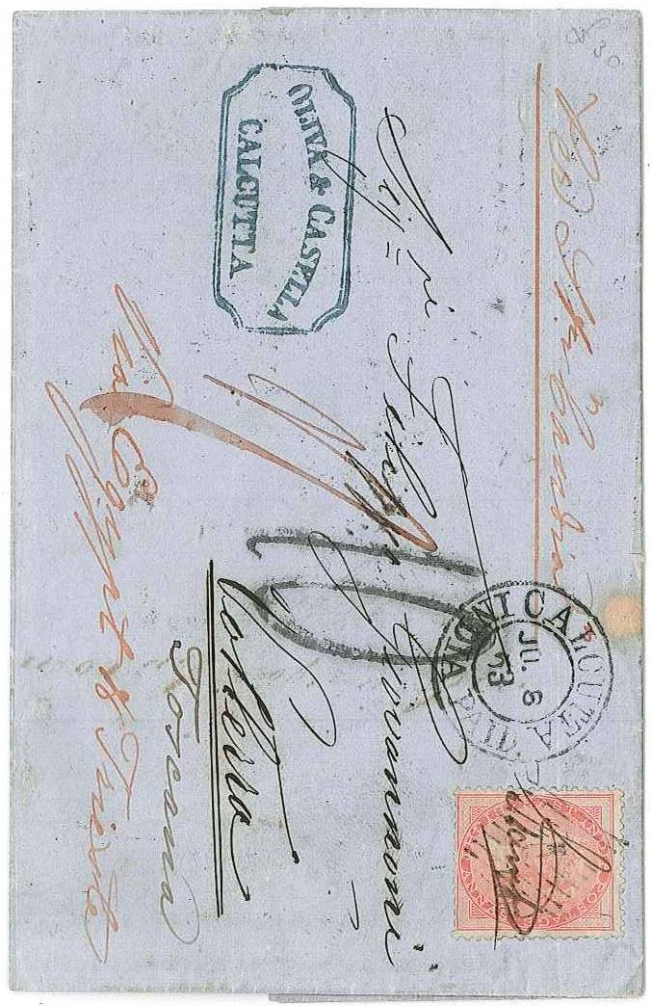
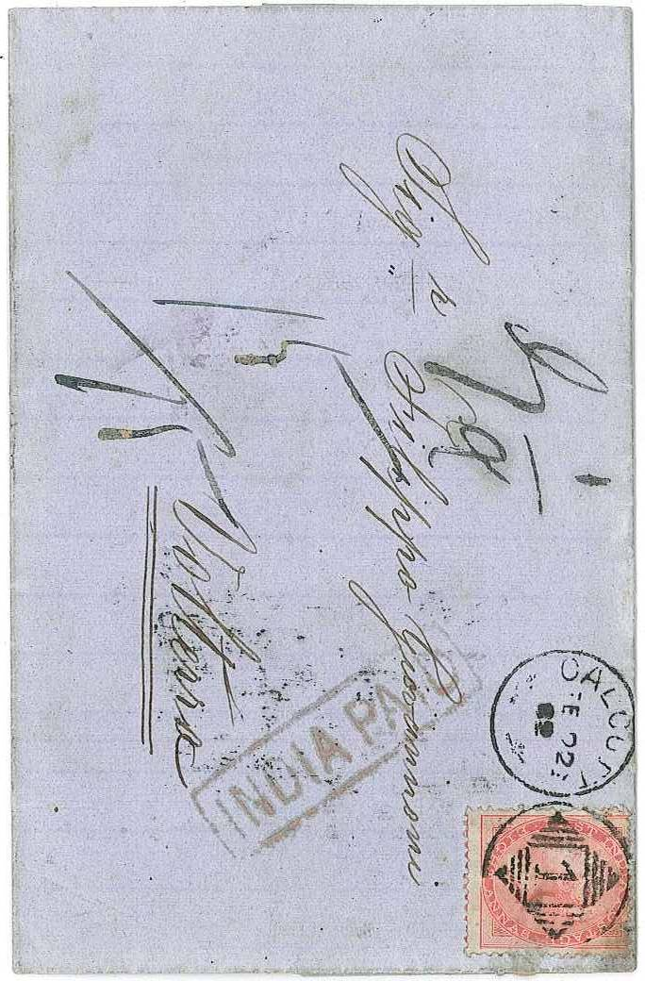
One Pound Sale, 19 October 2020 Page 16 .

150 151
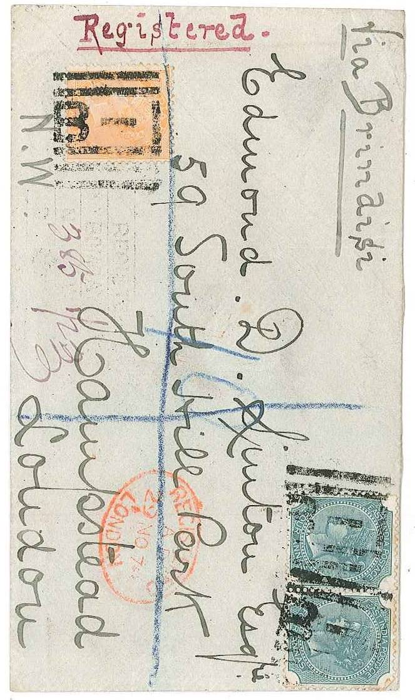
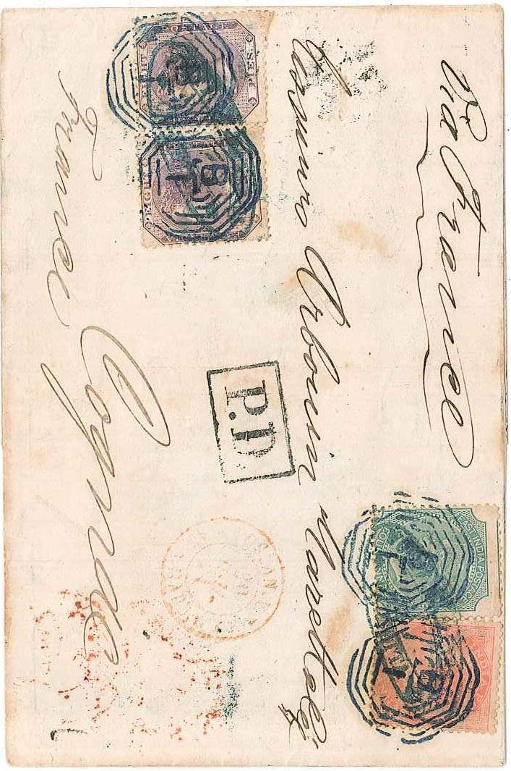

152 153

