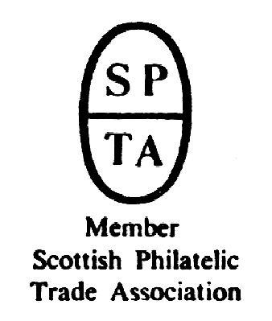

Robert Murray
5 & 6 Inverleith Gardens, Ferry Road,
Edinburgh, EH3 5PU
Tel. 0131 552 1220 :: 0131 478 7021
AUCTION
CATALOGUE
ONE POUND
website www.stamp-shop.com email auction@stamp-shop.com
Stamps and Collectables Auction
Monday 25 November 2019
at 7.00pm
Catalogue of Postage Stamps and Collectables to be sold by Public Auction, within the
STEWART’S-MELVILLE CLUB PAVILION, 523 FERRY ROAD,
EDINBURGH, EH5 2DW.
On view at Pavilion on afternoon and evening of sale, and at Shop for one week prior to sale (see details later in catalogue).

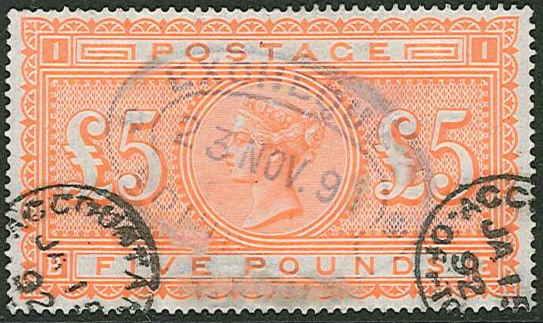

304

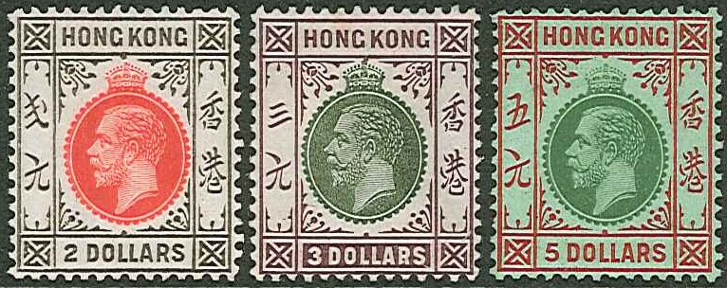

ex 245
Stamps and Collectables Auction, 25 November 2019 Page 2 Estimate.
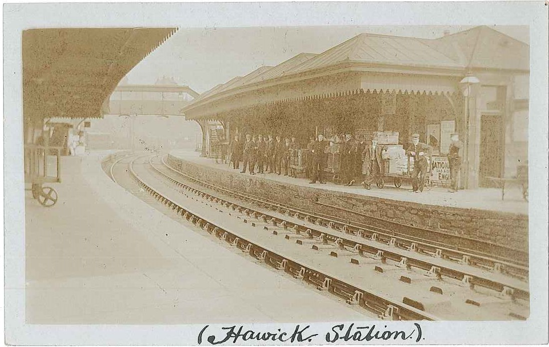

ex 165

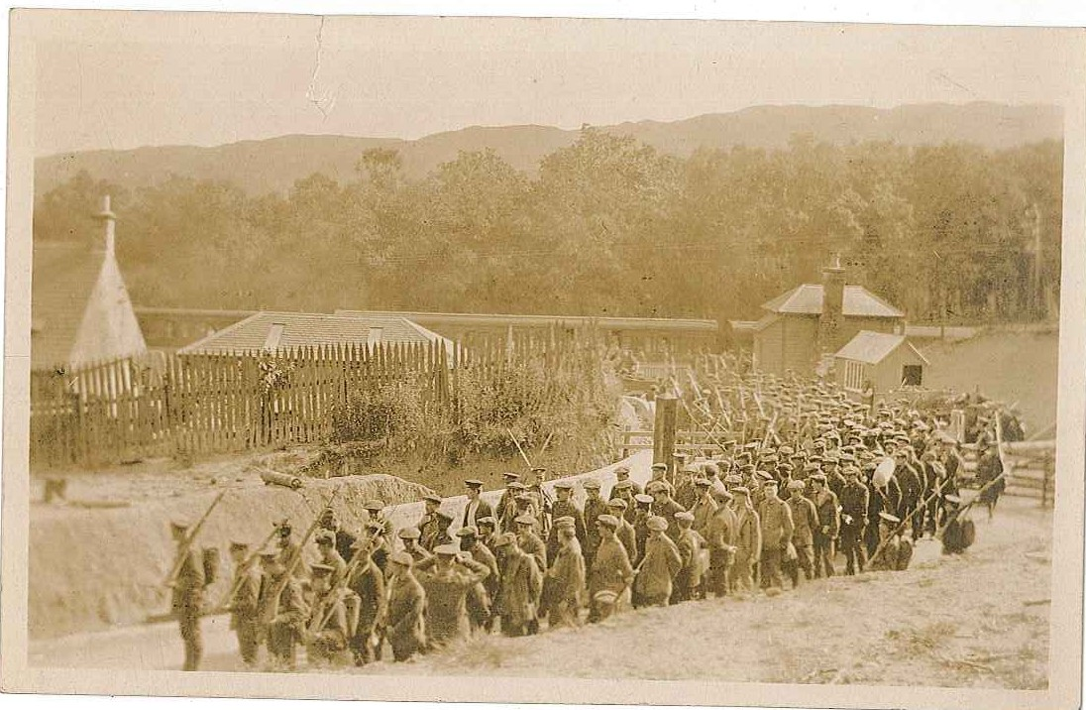

ex 168
(German Prisoners of War arriving at Stobs Station)

Stamps and Collectables Auction, 25 November 2019 Page 3 Estimate.
Viewing times are listed on page 7.
(Viewing starts on Tuesday 19th November)

Collections and Mixed Lots.
1 A large carton and three smaller plastic tubs with world new issues, inc. some FDCs,
collected over many years inc. Falkland Is., Cyprus, Faroes, Finland, Greenland, Belgium,
B.W.I. and many, many others. Also includes some older stamps. Should repay the many
hours needed to get these into order. (1,000s) ☑ .. .. .. £200.
2 Early Mahé printed album (dated 1878) with world stamps up to about 1900. Collection
has been heavily picked, with many of the pages cut up, but would still reward careful
attention. Starts with UK 1840 Penny Black and Twopence Blue and continues with
scattered classics throughout. Condition typically mixed, with many stuck down. Also
includes some postal stationery. (c.1,500) ☑ .. .. .. £150.
3 Four large stockbooks of mint and used from Afghanistan to Monaco, mostly smaller
countries, largely odds, some sets, up to c.2000 with a few later. (1,000s) ☑ .. £120.
4 Large carton with all manner of world stamps – in envelopes, packets, small boxes, etc.
Duplication, medium to heavy in places. (10,000s) ☑ .. .. .. £100.
5 A heavy carton with 12 assorted albums/stockbooks of world stamps inc. a stockbook of
used KG5 Commonwealth. Also a box of world album pages, stockcards, loose on/off-
paper, etc. (1,000s) [1a] .. .. .. .. .. £100.
6 Two large and heavy cartons with 28 assorted albums/stockbooks and loose pages with
themes inc. animals, Scouts, Christmas, sports, and countries South Atlantic, Norfolk Is.,
Belgium, and many others. (1,000s) [1a] .. .. .. .. £100.
7 Box with 30 small Lighthouse stockbooks with duplicated (heavy in places) world, much
QE period Commonwealth odd values used, but not much very modern. (1,000s) ☑ 90.
8 Two heavy cartons with 7 albums of world stamps, a Fanfare album with a poor Penny
Black and various Penny Reds/Plates on pages throughout, 4 boxes of world stamps on/off-
paper, a case and an album of UK FDCs (many in unopened Bureau envelopes), and a box
of NZ FDCs. Also non-philatelic items - a box of cigarette cards, a tin of Kensitas Flowers
silk cig. cards, some coins, and a first edition of Agatha Christie’s The Mouse Trap. (1,000s
stamps, 100s covers). [1a] .. .. .. .. .. 90.
9 A heavy carton with 4 stockbooks, a binder, and loose pages with much modern inc. u.m.
sets, and with £10 and £20 notes in one stockbook. Also a stockbook of Barbados, Singa-
pore 2004 yearbook, 2 binders of mostly used Ireland on printed pages, etc. (1,000s) ☑ 80.
10 Heavy carton with c.26 assorted albums/stockbooks of world stamps. (1,000s) [1a] 80.
11 Album with 61 m.m. sets of Commonwealth 1949 UPU, minor world collection in old
Lincoln album, an album of mainly Commonwealth KG6, and others. (1,000s) ☑ 80.
12 Tub with 19 assorted albums/stockbooks (some small), and a bundle of album pages with
a wide range of world stamps (1,000s). Also three small albums of cig./trade cards. Proceeds
to charity (even the buyers’ premium gets passed on !). ☑ .. .. 80.
13 A four-volume world collection of mostly used odd values, with dupl, and little after 1970s.
Also a UK album of similar period, a junior album, and loose. (1,000s) ☑ .. 80.
14 Box of c.85 remaindered club books. (1,000s) ☑ .. .. .. 80.
15 Box with an Imperial album, a New Imperial (2 vols.), and an Ideal album. Partly picked
over, sparse in places, and some later stamps added in. (Many 100s) ☑ .. 80.
16 Box with world stamps on album leaves, sorted by area, and some on/off-paper in envel-
opes. (1,000s) ☑ .. .. .. .. .. .. 80.
17 Stockbook of world with much Commonwealth inc. Malta, Cyprus, many Falklands, and
mixed postage dues. Early Italy and some mint USA noted in foreign. (c.1,600) ☑ 80.
18 Carton with 13 stockbooks of world stamps, much used odd values with some dupl., with
many Europe and Commonwealth. (1,000s) ☑ .. .. .. 70.

A Buyer’s Premium of 12% (vat-inclusive) will be added to all sale prices.
Stamps and Collectables Auction, 25 November 2019 Page 4 Estimate.

Collections and Mixed Lots, continued.
19 A box with a printed album of used Australia 1913-82, also five stockbooks of duplicated
mostly used from QV onwards from Ceylon, Cyprus, Egypt/NZ, Hong Kong, and KUT.
(1,000s) ☑ .. .. .. .. .. .. 70.
20 A three-volume world collection of m.m. and used, the used being mostly odd values, much
from 1970s/90s, with little earlier. Also a similar album of UK with some decimal mint and
duplicated used, and Australia 1989 year book. (Many 100s) ☑ .. .. 60.
21 A tub of album leaves of stamps and a few covers, much Commonwealth, with a tray of
loose on/off-paper on top. Also a box of 7 assorted albums/stockbooks, and 7 bags of
Canada KG6 defins used on/off-paper. (1,000s) ☑ .. .. .. 60.
22 Large carton with world on/off-paper partly sorted in packets etc. (1,000s). Also a box of
covers and another of mostly modern postcards (100s) [1a] .. .. 60.
23 Large and heavy tub with two stockbooks, eight binders of world stamps and covers inc.
USA u.m. 1977-2001. Also stockbooks of USSR/Russia etc. Disorganized. (1,000s) [1a] 60.
24 Stockbook with much Commonwealth inc. Australia, Bahamas, Hong Kong, with many
stamps cat. in pounds. (c.1,500) ☑ .. .. .. .. 60.
25 Old Gibbons album dated 1871 with world stamps of that period and a bit later, stuck down,
inc. a penny black (2+ margins), and many others cat. in pounds. Mixed condition. (100s) ☑ 50.
26 Box with seven assorted albums/stockbooks with a wide range of world stamps, m.m. and
used. Also 12 uncirculated old approval books, and 3 sets of cigarette cards. (Many 100s) ☑ 50.
27 An old case with four stockbooks of various thematic stamps, six albums/stockbooks of
world inc. duplication. (1,000s) ☑ .. .. .. .. 50.
28 Mixed box containing several general albums of mixed ages, bundles of covers (mainly
FDCs), etc. (100s) ☑ .. .. .. .. .. 50.
29 Box with 8 assorted albums and 7 various stockbooks, with a wide range of stamps inc. a
binder of Danish charity labels. (1,000s) ☑ .. .. .. .. 50.
30 Seven binders with world stamps on stockleaves, much in odd values used. Also a folder
with covers etc. inc. some recent UK FDCs, UK 2002 Commonwealth Games PNC (English
flag £2 only), and UK 2011 Penny Red reproduction pack. ☑ .. .. 50.
31 Carton with three stockbooks of mixed world, much used, three stockbooks of USSR, a
stockbook of UK inc. some decimal mint, loose stamps on/off paper and covers. (1,000s) ☑ 50.
32 Strand album (dated 1931) with m.m. & u. stamps up to c.1945 with better inc. Hong Kong
KG6 m.m. to $1 and others cat. in pounds. Also loose pages from old album. (100s) ☑ 50.
33 A carton with 12 assorted world albums/stockbooks, some better filled than others, etc.
(few 1,000s). Also a box with c.1,200 UK commercial covers, and 5 items of numismatic
literature. [1a] .. .. .. .. .. .. 50.
34 Carton with eight assorted remainder albums of UK, Germany, and Ireland, and album
pages of Commonwealth and Foreign. (1,000s) ☑ .. .. .. 40.
35 Carton with an old Lincoln, an album of USA, 11 assorted smaller albums/stockbooks,
envelopes of display pages inc. Burns, Channel Is. WW2 Occupation, Rotary, etc., and
loose stamps. (1,000s) ☑ .. .. .. .. .. 40.
36 Carton of mostly off-paper, partly sorted by theme or country. (1,000s) ☑ .. 40.
37 An album of mostly used Commonwealth, much KG5/KG6 up to early QE, with a packet
of 1945 Victory. Also an album of foreign mostly used of similar period. (100s) ☑ 40.
38 The shop’s regular charity box – a large and heavy carton with world covers, albums, loose
stamps, etc. (Many 100s stamps, 100s covers) [1a] .. .. .. 40.
39 A similar lot. [1a] .. .. .. .. .. .. 40.
40 A similar lot. [1a] .. .. .. .. .. .. 40.
41 Box with 12 assorted larger unsold Buy or Bid Sale lots in albums etc., inc. much UK etc.
PTSA £128. (100s) ☑ .. .. .. .. .. 30.
42 World stamps in two Devon albums (100s), and a stockalbum of UK c.1968-81 (decimal
mint with about £28 face). ☑ .. .. .. .. .. 30.
43 Box with five junior albums (100s). Also some supplies – various album pages, a shoebox
of mainly Showgard mounts, Showgard cutter, etc. ☑ .. .. .. 30.
Stamps and Collectables Auction, 25 November 2019 Page 5 Estimate.

Collections and Mixed Lots, continued.
44 An album of mostly used Switzerland, two other albums, four unopened packets of Devon
leaves, loose on/off-paper, some booklets, covers, etc. (100s) ☑ .. .. 30.
45 Three shoeboxes of sorted envelopes of off/on-paper – one box of UK, one Commonwealth,
third one foreign. (1,000s) ☑ .. .. .. .. .. 30.
46 Box with eight assorted albums/stockbooks of world stamps (100s), and an album of modern
postcards (mainly transport). ☑ .. .. .. .. .. 30.
47 Box with 3 medium and 6 small boxes/tins with older world (little after 1950), and much
unsorted. Also a stockbook with Penny Reds and some later UK. (1,000s) ☑ .. 30.
48 Remainders on loose old pages, plus mix in stockbook etc. (100s) ☑ .. 20.
49 British Commonwealth; fine old collection in Whitfield King Standard album with printed
spaces to 1911, and some stamps for just a few years thereafter. Mixed condition but on the
whole better than average for this vintage of collection. Good general spread with good
scattering of better items. Some better inc. UK 1840 Penny Black and Twopence Blue g./
f.u., other reasonable late QV/KE7, K.U.T. 1903-4 1r, 5r m.m., Canada 1915 War Tax 20c,
50c m.m., HK 1904-6 50c m.m., India 1866 6a opt. g.u., Natal 1857-61 three embossed
stamps perforated unused (1d, 3d, 1/- - sold “as is”), Rhodesia 1910-13 Double Head 10d,
1/-, 2/6 m.m., Transvaal 1902 2/- to 10/- m.m., and many others similar catalogued at
pounds or tens of pounds each. (c.1,800) ☑ .. .. .. .. £500.
50 --; four Lighthouse albums (one broken) with mint (mostly u.m.), used, booklets, and
covers, with much from QE period, many cat. in pounds, much from Africa and BWI but
many other countries included, inc. many sets and blocks. Also some foreign. (Many
100s) ☑ .. .. .. .. .. .. .. £240.
51 --; an album with m.m. sets from Alderney, Ascension, B.A.T., Falklands and Falkland
Dependencies, from 1970s to c.2005. (Many 100s) ☑ .. .. .. £120.
52 --; heavy carton with 9 albums/binders etc. of mint (mostly u.m.) new issues from the first
issues to 2000 of Christmas Is., Cocos Is., Pitcairn, and Tristan (inc. 1952, 1954, 1960,
1961 defin sets). Also similar from first issues to 1997 from Jersey, Guernsey/Alderney,
Isle of Man. (100s) ☑ .. .. .. .. .. £120.
53 --; an album with m.m. sets from Gibraltar, St.Helena, South Georgia, and Tristan da
Cunha, from late 1960s to c.2005. (Many 100s) ☑ .. .. .. £100.
54 --; four albums with m. & u. from earlies up to c.2000 with sets, part sets, odd values with
many countries represented. (1,000s) ☑ .. .. .. .. £100.
55 --; 28 unsold Buy or Bid lots, inc. UK, s.t.c.£3,000. (100s) .. .. £100.
56 --; SG printed King George VI interleaved album, with m.m. and u. sets, part sets, and odds.
(Many 100s) ☑ .. .. .. .. .. .. 90.
57 --; three albums and loose pages from QV to 1970s (with a few later), much is odd values,
some used part sets, some m.m. sets, and inc. UK Penny Black u. (1+ margin). Toning on
some pages which affects some stamps. (1,000s) ☑ .. .. .. 80.
58 --; stockbook of mint (the modern mainly u.m.) and some used inc. B.A.T., Malta, and
much Gibraltar. Many sets. (c.1,000) ☑ .. .. .. .. 70.
59 --; three stockbooks of mostly used, much KG6, some earlier. Also a broken stockbook of
QE. (Many 100s) ☑ .. .. .. .. .. .. 60.
60 --; a King George VI album, in poor condition, with extra pages added in. Also two binders
of printed pages of a KG6 colln. (Many 100s) ☑ .. .. .. 50.
61 --; four albums (with slipcases) with used stamps and FDCs from 1953 to c.1967 with a
few earlier, much Africa and West Indies. (100s) ☑ .. .. .. 50.
62 --; Devon album with m.m. (and a few used) commem sets and defin part sets, from a wide
range of countries, much from 1970s/80s. (Many 100s) ☑ .. .. 50.
63 --; box with nine assorted albums/stockbooks inc. UK (with decimal mint face £28), various
South Africa, etc. (Many 100s) ☑ .. .. .. .. 50.
64 --; shoebox with off-paper assortment inc. UK, seems better than average mix with KG6
and earlier. (1,000s) ☑ .. .. .. .. .. 40.
A Buyer’s Premium of 12% (vat-inclusive) will be added to all sale prices.
Stamps and Collectables Auction, 25 November 2019 Page 6 Estimate.

Collections and Mixed Lots, continued.
65 British Commonwealth; two New Age albums of 1953-67 with m.m./u. sets, part sets, and
odds. (Many 100s) ☑ .. .. .. .. .. 40.
66 --; an album of m.m. commem sets from New Zealand 1968-2004, also range of m.m.
omnibus sets from many countries from 1970s-90s. (Many 100s) ☑ .. .. 30.
67 --; Africa; stocksheets of QV to KG6 Bechuanaland (3), Nyasaland (40), and South West
Africa (75, inc. 1923-26 £1 split pair m.m., 1927 2/6 and 10/- split pairs). Some faults. 40.
68 --; Americas; ten stockbooks and stockleaves of m. & u. from West Indies (Anguilla to St.
Vincent) with sets, part sets, and odds, up to c.2000. Also stockbook of Canada. (1,000s) ☑ 70.
69 --; Pacific; mainly m.m. range on two stockleaves of New Guinea (54), Norfolk Is. (14),
and Papua (76). S.t.c.£970. .. .. .. .. .. £100.
70 --; South Atlantic; slim stockbook of u.m. sets and m.s. from Falklands, B.A.T. and South
Georgia, mainly 1980s-2000s. S.t.c. £450. (100s) ☑ .. .. .. 50.
71 --; Omnibus; 1935 Jubilee seln. of 13 different sets, all f.u. except for two m.m., all non-
standard design. S.t.c.£274. (44) .. .. .. .. .. 50.
72 --; --; 1935 Jubilee m.m. sets for Bechuanaland, Cyprus, Leeward, Papua (inc. 3d Accent
Flaw), St.Helena, and Seychelles. Also Bechuanaland set used on cover. .. 50.
73 Europe; stockleaf with selected older mostly used seln. of Germany (4, inc. West Ger-
many 1951 NBA set of 2), Italy (18), Netherlands (1 mint), Sweden (1), and Switzerland
(31, inc. 1939 Zurich Exhib. set). S.t.c.£1,000. .. .. .. 80.
74 --; two stockbooks of m. & u. from Italy and Vatican up to c.2000 with dupl. (Many
100s) ☑ .. .. .. .. .. .. .. 40.
75 --; shoebox of m. & u. on stockcards and in packets. Also a few Overseas. (1,000s) ☑ 30.
76 --; stockbook of u.m. & u. Switzerland (mostly 1970s/80s), Norway year books for 1994
and 1995, and Åland book commemorating 10 years of stamps. ☑ .. .. 15.
77 --; Western Europe; four albums with mint and used from early to c.2000 with sets, part
sets, and odds – two albums of Belgium, one of Germany, and fourth of various countries
excluding Scandinavia. (1,000s) ☑ .. .. .. .. 90.
78 Foreign; fine old collection in Whitfield King Standard album with printed spaces to 1911,
and some stamps for a few years thereafter. Reasonable general spread with some better
to be found in mixed areas. Should repay attention. (Many 100s) ☑ .. .. £300.
79 --; six albums from earlies to 1970s (with a few later), much in odd values and used part
sets, some m.m. sets. Wide range of countries covered. Toning on some pages which does
affect some stamps. (1,000s) ☑ .. .. .. .. .. 90.
80 Middle East; stockbook of u.m. sets and odds from a wide range of countries inc. much
Yemen. (Many 100s) ☑ .. .. .. .. .. 50.
81 --; stockbook of used Iraq 1959-2000 and Jordan 1922-97 with better inc. Jordan 1922 ⁵/₁₀p
on 5m SG 24, and others cat. in pounds or tens. Also 8 Jordan covers. (100s) ☑ 60.
82 --; Arabia; used colln. in stockbook with better inc. Bahrain 2002 definitive miniature
sheet, Qatar 1973 defin. 10r, UAE 1983 Arab Literacy set, various defin. sets, etc. Dupl.
in places. (Many 100s) ☑ .. .. .. .. .. 60.
83 Scandinavia; two albums of m. & u. from earlies to c.2000 with sets and odds – one
album is Denmark, Iceland and Sweden, other is Finland and Norway. (1,000s) ☑ 70.
84 Miniature Sheets; two stockalbums of m.s. of the whole world, mixed ages though
mainly modern, mainly mint (mostly u.m.) but fair number also used/c.t.o. (c.250 on stock-
leaves, plus further bundle in pocket) ☑ .. .. .. .. 60.
85 Thematic; Art; four binders and a broken stockbook of stamps/m.s./covers of art and artists.
(100s) ☑ .. .. .. .. .. .. 40.
86 --; Football; 2002 World Cup Westminster colln. in two binders with sheets, covers, etc. ☑ 20.
87 --; Rotary; a box of stamps, covers, ephemera, literature, etc., mostly on the Rotary theme.
(Few 100s) ☑ .. .. .. .. .. .. 40.
88 --; Science; two stockalbums with mixed range of inventors, space, medicine, Nobel Prize, science, and aviation. Includes China PRC 1974 Country Doctors set (4) u.m. (100s) ☑ 30.
Stamps and Collectables Auction, 25 November 2019 Page 7 Estimate.

Collections and Mixed Lots, continued.
89 Thematic; Shipping; two binders, a stockbook, display pages, and loose stamps and covers.
(100s) Also a few others. ☑ .. .. .. .. .. 50.
90 --; Słania; rather disorganised collection in folder of stamps engraved by Czesław Słania,
with stamps, covers, booklets, etc. (c.175 items) ☑ .. .. .. 30.
91 --; World Wildlife Fund; seven albums of WWF 1986-97 u.m. sets of stamps, sets of maxi-
cards, and FDCs, plus pages of text. (100s) [1a] .. .. .. 80.
➲ Cinderella; see Denmark, Hong Kong, U.K.
92 Covers; three flat boxes of world covers – FDC/philatelic/commercial, with duplication,
with many Commonwealth FDCs noted. Also album of 1976 US Revolution FDCs. ☑ 60.
93 --; three boxes of world covers – philatelic and commercial. (100s) ☑ .. 40.
94 --; bundle of covers (some are fronts only), nothing later than c.1950, much from foreign
addresses to Edinburgh. (c.80) ☑ .. .. .. .. 30.
95 --; four binders of world commercial covers in polypockets, often with philatelic frankings.
Also a binder of USA space-related covers/cards/photos etc. (100s) [1a] .. 20.
96 --; box of RAF and Army Museum covers (c.300), and a box of world covers, commercial
and philatelic (few 100s). Toning in places. ☑ .. .. .. 20.
97 Literature; SG Commonwealth catalogue 2018, GB Concise 2015, and four earlier
Commonwealth country catalogues. ☑ .. .. .. .. 20.
98 --; L.Balian Catalogue Stamps of Egypt, with Egypt used in Palestine and Sudan, 1998.
Binding partly shaken. ☑ .. .. .. .. .. 10.
99 --; The Postal History of Oman 1856-1985 and 1986-1990 (2 volumes), and Bahrain 1997
book to accompany Arabian Horses stamp issue (inc. set of stamps and 3 FDCs). ☑ 20.
100 --; The Postal Agencies in Eastern Arabia and The Gulf by Neil Donaldson (1975), and SG
France & Colonies sectional catalogue (2010). ☑ .. .. .. 10.
101 Supplies (Second-Hand); box with large quantity of stamp mounts, mostly Prinz or Prinz-
gard in strips or cut-to-size, black or clear backgrounds. Also two guillotines. ☑ 60.
102 --; two boxes of assorted albums/binders etc. (c.26). Also a tub of Hagner pages, empty club
books, and various other supplies, also some literature (c.20). [1a] .. .. 40.
103 --; tub containing five Martin Mills Trinity 22 albums, an Avon album, 2 binders, loose
leaves, a large stockbook, etc. [1a] .. .. .. .. 30.
104 --; heavy carton with nine Lindner albums in slipcases for Guernsey/Alderney (6 – one
broken), Isle of Man (2), and one for miniature sheets, etc. [1a] .. .. 30.
105 --; tub with 9 assorted albums/binders, 4 stockbooks (3 of which are small), etc. [1a] 10.

VIEWING ARRANGEMENTS
Viewing at our Shop; The shop will be open at the following times for viewing.
Tuesday 19th November 12 noon-4pm Wednesday 20th November 2pm-8pm
Thursday 21st November 10am-6pm Saturday 23rd November 12 noon-6pm
Viewing by appointment available at some other times (e.g. the Friday)
Viewing at the Auction Venue; Monday 25th November;
Larger lots (marked “☑” in the description); on view at auction venue from 3pm: Smaller lots, on view by 4.00pm. Viewing will end at about 6.50pm.
Lots marked “[1a]” are not taken to the auction venue (see information box on page 21).

AUCTION PROGRAMME

 No firm dates are yet fixed, but we are aiming to have our first auction of 2020 in early February 

Remember the Buy or Bid Sale, which runs from 5pm until 5 minutes after the main auction finishes - you can buy items outright at the “buy” price, or place a bid at or above the “upset” price.

A Buyer’s Premium of 12% (vat-inclusive) will be added to all sale prices.
Stamps and Collectables Auction, 25 November 2019 Page 8 Estimate.

Non-Philatelic Items (Collectables)
BANKNOTES
106 Scotland; 1932-72 selection of notes of Bank of Scotland (8 x £1, 1 x £5), Clydesdale
Bank (7 x £1), Commercial Bank of Scotland (7 x £1), and National Bank of Scotland (4 x
£1) in mainly F to EF grades. Also Bank of England 10/- (12, plus 2 badly damaged), and
£1 (6). .. .. .. .. .. .. .. £100.
107 --; British Linen Bank; 1964-70 nine notes comprising 1968 £1 (2), 1969 £1, 1970 £1 (2),
1964 £5, 1968 £5 (3), VF to EF. .. .. .. .. 60.
108 --; Clydesdale and North of Scotland Bank; 1950 (1 Nov.) £1 note - sequential runs of 7
and 4 in generally EF condition. BNS CL24a, cat.£70 each for EF. .. .. £100.
109 --; National Commercial Bank of Scotland; 1959 £1 (5), 1966 £1 (2), 1968 £1 (2), and
1959 £5. Mixed grades F to EF. .. .. .. .. .. 70.
110 --; North of Scotland Bank; 1928 £1 about F, and 1949 £1 (6 sequential mainly EF, and
2 sequential VF). .. .. .. .. .. .. £100.
111 --; Royal Bank of Scotland; 1952-73 selection of £1 (12) and £5 (7) notes, F to EF. 60.
112 --; Union Bank of Scotland; 1947 (31 Mar.) £5 note in about VF grade (not too much
wear, has been folded into eighths, small tear into upper margin, quite fresh and crisp).
PMS UB64e, cat.£280 for VF. .. .. .. .. .. 80.

BOOKS
113 Schiller Gallerie Nach Original Cartons by von Wilhelm von Kaulbach and Goethe
Gallerie Nach Original Cartons by von Wilhelm von Kaulbach, Both have gold and red
decorated hardcovers, Bruckmann, Munich, c.1890 ☑ .. .. .. 20.
114 Pictures from Nature by Richard and Cherry Kearton, Cassell, London. 1905. .. 20.
115 The Rambler, by Samuel Johnson, a periodical paper published in 1750, 1751, 1752, Jones
and Company, London, 1825. ☑ .. .. .. .. 40.
116 The Household Narrative of Current Events for 1850/1/2/3/4/5 conducted by Charles
Dickens, 6 volumes, Office, London, 1850 -1855. ☑ .. .. .. 80.
117 The Highlands and Western Isles of Scotland in 4 vols by John MacCulloch, Longman
Hurst Rees Orme Brown and Green, London, 1824. ☑ .. .. .. £150.
118 The Scots Magazine, 1812 (modern binding). ☑ .. .. 20.
119 Dictionnaire de la Langue Verte by Alfred Delvau, C Marponet et E Flammarion, Paris,
1883. ☑ .. .. .. .. .. .. 20.
120 The Pillars of the Earth by Ken Follett, limited signed edition 26 of 1000 (in slipcase),
Macmillan, London, 2008. ☑ .. .. .. .. .. 60.

COINS
➲ Estimates are based on a gold market price of £1,150./oz, and silver of £13.25/oz.
121 Mainly UK mixture in shoebox and tin inc. UK 2009-12 Olympic Countdown £5 coins
(8 in 4 different designs), 24 other £5 crowns, 2008 unc. year set, mixed others, and a
few banknotes. (Dozens) .. .. .. .. .. £150.
122 Mixture inc. Jordan 1977 boxed set of two silver proof coins (2½d and 3d), a loose mix of
UK silver threepences (c.58), three other silver coins, UK 1953 “plastic set”, plus mixed
general others. Also a few world banknotes, and world stamps in album and loose. ☑ 70.
123 Box with four UK £5 crowns, fifteen other commem coins of mixed countries (crown size,
of which six may be silver), and 20 Cook Is. 2007-08 Golden Wedding coloured coins. ☑ 70.
124 Plastic tub with various containers of mixed world coins. All sorts, in no particular sense of
order. (Approx. 15kg gross weight) ☑ .. .. .. .. 60.
125 Mix of items inc. Australia 2001 Centenary of Federation proof set, 1994 D-Day 3-coin
silver proof set (3 countries), 3 UK £5 crowns, UK 2005 1oz Britannia, etc. ☑ .. 50.
126 Small mix inc. UK 1814 3/- VG, modern Ascension 1oz silver medallion, etc. (14) ☑ 40.
127 Small box of mainly UK coins inc. 1889 crown (worn), 2 x 1993 £5 crown, etc. ☑ 30.
Alternative bids, and overall spending limits, are acceptable. Advice available if required !
Stamps and Collectables Auction, 25 November 2019 Page 9 Estimate.

Non-Philatelic Items, continued.
COINS
128 Shoebox-sized box with a fairly modern mix, mainly left-over holiday money, and much of
it out-of-date (100s). Also a few cheap banknotes. ☑ .. .. .. 20.
129 Silver; selection of boxed items inc. Fiji 2007 Birds coloured set of four x 1oz (some slight
bloom), six crown-size silver proofs of Alderney, Australia, and Guernsey, and 2 smaller
silver proofs. ☑ .. .. .. .. .. .. £100.
130 United Kingdom; 1853 penny, 1859 halfpenny, and 1853 farthing, each EF with some
lustre (the farthing with a few spots on obverse). .. .. .. 70.
131 --; 1953 proof set (10 coins) in original box of issue, excellent condition. Cat.£125. ☑ 50.
132 --; small selection inc. 1937 Coron. crown and another 5s3d in pre-47 silver, about three
dozen other cheaper coins, and 1969 official Prince of Wales Investiture medallions (57mm
bronze gilt in box, and 32mm bronze loose). ☑ .. .. .. 20.
133 --; 1989 three of the “Claim of Right” £2 coin, EF. ☑ .. .. .. 20.
134 --; 2009 Royal Mint Brilliant Uncirculated Coin Collection (11 coins inc. 50p Kew). £100.
135 --; Silver; 1996-2008 seln. of silver proof crowns comprising 1996 70th Birthday, 1998
Prince of Wales, 1999-2000 Millennium (both in one case, 2000 being gold-enhanced),
2002 Q.Mother, Golden Jub., 2005 Trafalgar (one in box for two), 2008 Queen Elizabeth
(standard and piedfort), 2008 Prince of Wales (standard and piedfort). ☑ .. £170.
136 --; --; 1996-2008 selection of individually boxed silver proof coins comprising £2 (6 stan-
dard, 6 piedfort, 1 piedfort with hologram), £1 (5 standard, 1 frosted, 2 piedfort), plus
1990 5p (2 coins), 1997 50p (2 coins), and 1998 50p (2 piedfort). ☑ .. £150.
137 --; Silver Sets; a mix of items comprising 1992 Silver Proof Collection (2 x 10p, 50p EU
Council, £1), 2003 Silver Proof Piedfort 3-Coin Collection (some bloom on 50p), 2004
Silver Pattern Set, 2004-07 Silver Proof Piedfort £1 Coin Collection, and 2008 Royal
Shield of Arms Silver Proof Collection. ☑ .. .. .. .. £120.
138 --; --; 1997 proof silver Britannia set (4 coins). Cat.£150. ☑ .. .. 40.
139 --; --; 1998 proof silver Britannia set (4 coins). Cat.£185. ☑ .. .. 50.
140 --; --; 2006 silver proof Piedfort Collection (6 coins, the £5 enhanced with gold) (a little
rust on staple of booklet). Cat.£350. ☑ .. .. .. .. £100.
141 --; --; 2006 The Queen’s 80th Birthday Collection – A Celebration in Silver Royal Mint
set of 13 coins (£5 to 1p, plus set of four Maundy), in original box. Cat.£325. ☑ £150.
142 --; --; 2006 Britannia Golden Silhouette Collection of five different designs of 1oz coins,
all dated 2006. Cat. £350. ☑ .. .. .. .. .. £100.
143 --; --; 2007 proof silver Britannia set (4 coins). Cat.£145. Box marked but coins OK. ☑ 30.
144 --; --; 2007 Piedfort Collection (5 coins). Cat.£300. ☑ .. .. .. 80.
145 --; --; 2008 proof silver Britannia set (4 coins). Cat.£150. Slight surface bloom on coins. ☑ 30.
146 --; --; 2008 Family Silver Collection (5 coins). Cat.£200. ☑ .. .. 60.
147 --; --; 2008 proof set of 14 different silver £1 coins, all with reverse highlighting in gold.
Scarce set, cat.£500. Due to storage there is some wear and scratching to the outside of the
box, and a bit of rust at the hinges. ☑ .. .. .. .. £120.
148 --; --; 2008 Royal Shield of Arms – Silver Proof Collection (7 coins) in original box (which
has scratches on outside and some rust at hinges). Cat.£160. ☑ .. .. 40.
149 --; --; 2009 Family Silver Proof Collection comprising six silver proof coins inc. Kew 50p.
Cat.£225. ☑ .. .. .. .. .. .. £100.
150 --; Proof Sets; boxed proof sets for 1996, 1998 (2), 2000, 2001, 2006, 2007, and 2008.
Base metal, mixed standard/de-luxe. ☑ .. .. .. .. 90.
151 East Caribbean States; 2002-03 set of twelve British Military Leaders $2 coins piedfort
proofs (gold-plated cupro-nickel). ☑ .. .. .. .. 30.

Our Facebook page often has a few illustrations and further descriptions and comments, extra to what is in the catalogue. Just search for “Robert Murray Stamp Shop” . . . feel free to “like” us !

A Buyer’s Premium of 12% (vat-inclusive) will be added to all sale prices.
Stamps and Collectables Auction, 25 November 2019 Page 10 Estimate.

Non-Philatelic Items, continued.
MEDALS
152 Unusual group comprising standard WW1 pair named to Lieut. I. McHardy (with no
number or regiment), 1935 Jubilee Medal, 1937 Coronation Medal, and 1953 Coronation
Medal. Also from the same source a mounted group of miniatures comprising these five
plus WW2 War Medal and Defence Medal, suggesting there should be two more medals
in the main group. The miniature Victory ribbon has an oak leaf but has the medal broken
off loose. Also a few badges inc. KOSB Assoc., and Special Constable Berwickshire.
Further information about the recipient is available. ☑ .. .. .. £100.
153 WW1 standard pair named to 33027 Pte. R.M. Dickson, K.O. Sco. Bord. (1 ribbon missing,
other poor). ☑ .. .. .. .. .. .. 20.
154 WW2 group of six comprising 1939-45, Atlantic, Africa, and Burma Stars, War Medal, and
Royal Naval Volunteer Reserve Long Service and Good Conduct Medal (KG5 head) named
to E.S.D.2. J.McLeod P.O., R.N.V.R. ☑ .. .. .. .. 50.

POSTCARDS
155 Two old wooden filing drawers filled with very mixed cards, mainly c.1910s-30s. Wide
variety of mainly topographical from many countries. While much is common, there are
sparks of interest here and there. (c.1,500) ☑ .. .. .. 80.
156 Small box of mainly 1900s-20s cards of Scotland and England, plus other countries, some
subjects etc. Reasonable mix from original source. (c.250) Also a few old greetings cards. ☑ 50.
157 Mainly modern mix in 7 large folders and 5 smaller albums. UK and world plus some
subjects, inc. many royalty (these inc. some older). (Estimated c.1,000+ ?) [1a] .. 50.
➲ Scotland; Hawick; the following fifteen lots are all from one very strong collection, which
must be one of the best ever formed of the area. The majority are earlier cards (i.e. c.1900-
1920s), but later are often included. Not everything is postcard back although only a few
are not postcard size. A few bits of ephemera are included.
158 --; --; mixed views in album with houses, Saint Margaret's Home, schools, fire (2),
Patriotic Memorial (several), churches, post office (2), etc. (107) ☑ .. £100.
159 --; --; album of events, parades, Hawick Ba', flood, groups (school classes, Sunday School,
bands), local sports, some personal photos, etc. (97) ☑ .. .. .. £200.
160 --; --; album of Common Riding Cornets, complete from 1904 to 2004 but for 1915-18
and 1940-45 (war years), 1948, 1949, 1979, 2001. Generally plain back from 1950s
onwards, some of these signed. A few duplicates also, and a couple of Lasses. (99) ☑ 40.
161 --; --; album of Stobs Castle, Mosspaul, Teviothead, Branxholm, Newcastleton, Hermitage
Castle, Slitrig, etc. Mainly older postcards, a few photos, a few modern. (96) ☑ 70.
162 --; --; album of varied subjects inc. delivery carts, troops (inc. returned P.o.W.s), Stonefield
Mills, street processions, Hawick “Excursionists” on board West Coast paddle steamer,
flood, shop fronts, postmen, etc. (80) ☑ .. .. .. .. £150.
163 --; --; album of mixed views inc. multi-views, views from surrounding hills, etc. Early to
modern. (106) ☑ .. .. .. .. .. .. 30.
164 --; --; album of general views, many from surrounding hills, a few better. (105) ☑ 60.
165 --; --; album with railway station, railways, motor vehicles, numerous of Teviot (river) and
then most of Wilton Lodge Park (plus house and waterfall). (87) ☑ .. .. 60.
166 --; --; two albums of only Stobs Camp, some general, but inc. some dated, or R.P., or
named units. (112) ☑ .. .. .. .. .. £100.
167 --; --; album of houses in Hawick area, inc. Cavers, Denholm Dean, Ormiston, Spittal
Tower, Wells (inc. two RP of stonemasons' sheds), Midgard, and some others e.g.
Ruberslaw, Bedrule RP, couple of churches, etc. (73) ☑ .. .. 50.
168 --; --; mix in album with several railway photos (Riccarton), a few houses, Common Riding
(inc. dated, and RP), troops at Stobs Station (1915 RP), German PoWs arriving at Stobs
Station (torn), Stobs Camp, numerous Hornshole, etc. (92).☑ .. .. £100.
169 --; complete album of Common Riding, with crowns, street scenes, Cornets, ceremonies,
Cornet's Chase, and inc. dated cards and many RP. (69) ☑ .. .. £120.
Stamps and Collectables Auction, 25 November 2019 Page 11 Estimate.

Non-Philatelic Items, continued.
POSTCARDS, continued
170 Scotland; Hawick; album with mainly views of the High Street, 1514 Memorial Statue,
and Wilton Dean. (114) ☑ .. .. .. .. .. 50.
171 --; --; album of mixed views in the town, with Drumlanrig Square, Albert Bridge, Moat,
Buccleuch Street, etc. (112) ☑ .. .. .. .. .. £100.
172 --; --; large folder with colln. of mainly town views, with many of High Street, 1514
Memorial, a number of railway photographs (but inc. RP postcard of Reedsmouth (North-
umberland) with station prominent), golf course (2), two RP cards of 1917 Mothers Day,
etc. (117 pc, 69 photos) ☑ .. .. .. .. .. 50.
➲ --; --; see also Ephemera, Scottish Postal History.
173 Japan; attractive bundle, probably c.1910s-30s, with mixed views, some artistic, series
showing wedding ceremony, Japanese traditional life, Kobe Golf Club (10), etc., all
unused. (c.280) ☑ .. .. .. .. .. .. 70.
174 Royalty; large folder of mixed cards, roughly 1900s-1950s, majority quite standard portraits
and groups but inc. some better e.g. visits etc. (c.140) ☑ .. .. 50.

TOKENS
The following section presents a fine selection of this specialist and very interesting field of
collecting. Most UK tokens were produced during distinct periods in the 17th, 18th, and 19th
Centuries, and mainly in England, Wales, and Ireland. Many thousands of different designs
were produced.
References (and catalogue prices) here are from The Token Book - 17th 18th and 19th Century
Tokens and their Values (Withers, 2010).
175 Scotland; five copper tokens; Gatehouse Thos. Scott ½d VF/EF (Withers 1, £30/£60),
Perth 1797 ½d (yarn & flax) VF (5-9, £20), Perth ½d “Tay Bridge” F/VF (2-3, £70 for EF),
Dundee 1797 ¼d Horse & Cart VF (40-42, £25), and Dundee ¼d Scales F (39, £20). ☑ 60.
176 --; Edinburgh; six copper tokens; 1797 Anderson Leslie ½d VF (Withers 6-8, cat.£24),
1795-96 Campbell's ½d VF (13-17, £50), 1791 Hutchison ½d F+ (31-40, £9), Mitchell
Tobacconist ¼d EF (105, £50), and two 1823 Caverhill & Co (farthing ?) tokens EF. ☑ 70.
177 --; Leith; 1796 John White, Kirkgate, copper halfpenny token (ship and fort), about EF.
(58-59, £50 for EF). ☑ .. .. .. .. .. 20.
178 British Isles; all-different selection of England (8, plus 2 dupl.), Scotland (6), Ireland (3),
and unlocated (1). Generally G./F. ☑ .. .. .. .. 40.
179 England and Wales; four silver tokens - Charing Cross 6d, Neath 6d, Fazeley 6d, and
Stockport 1/-, F to EF. ☑ .. .. .. .. .. 50.
180 --; interesting selection of 19 different copper tokens, mainly English halfpennies. Includes
Appledore windmill, Chichester Queen Elizabeth, John Howard, Thames & Severn Canal,
Sir John Jervis, Chesham 1795, South Wales ¼d, and 1847 Brazier & Tin Plate. Mainly
F/VF/EF. ☑ .. .. .. .. .. .. 90.
181 England; c.late-1700s copper halfpenny showing mailcoach, worded “MAIL COACH
HALFPENNY/TO TRADE EXPEDITION & TO PROPERTY PROTECTION”, and on reverse
“TO J.PALMER ESQ. THIS IS INSCRIBED AS A TOKEN OF GRATITUDE FOR BENEFITS
RECED FROM THE ESTABLISHMENT OF MAIL COACHES”, EF. .. .. 20.
182 Hampshire; 1811 silver sixpence - HAMPSHIRE/SILVER TOKEN around arms, with
reverse VALUE SIXPENCE/TO FACILITATE TRADE around design of ship. About EF
(slabbed by PCGS, graded by them as MS63). Withers 7, 9, or 10, cat.£100. ☑ .. 40.
183 Middlesex; seven different copper ½d tokens, generally in VF/EF quality, comprising
Richardson Goodluck Ltd., London & Middlesex, Bakers, Sise Lane, W.Stinton,
J. Lackington, and First Equestrian Performance. ☑ .. .. .. 50.
184 Northumberland; three Newcastle-upon-Tyne silver tokens dated 1811 - Robertson
sixpence (Withers 14, VF but bent, cat.£75 for EF), and two of Robertson shilling, each
F/VF (Withers 10-13, cat.£70 for EF). ☑ .. .. .. .. 40.
A Buyer’s Premium of 12% (vat-inclusive) will be added to all sale prices.
Stamps and Collectables Auction, 25 November 2019 Page 12 Estimate.

Non-Philatelic Items, continued.
TOKENS, continued.
185 Somerset; two Bristol Commercial Token Bank Co. 1811 silver tokens - sixpence VF/EF
but slight buckle and marks, and shilling EF. (Withers 55 and 23-29, cat.£35 for VF and
£65 for EF). ☑ .. .. .. .. .. .. 40.
186 --; three copper tokens, comprising Bath 1794 ½d Botanic Garden EF (Withers 26, £40),
Bath 1794 ¼d Lambe & Son VF (111, £12), and 1795 ½d Bristol leopard and bale VF
(99-101, £14). ☑ .. .. .. .. .. .. 30.
187 Yorkshire; 1811 Sheffield silver sixpence of Younge & Deakin, EF (Withers 73, £55), and
1811 silver shilling of Cattle & Barber VF (Withers 76-86, £50 for EF). .. 40.
188 Ireland; 1800 Enniscorthy copper ½d (castle by sea) F/VF (1-4, £80 for EF), and Dublin
1794 Dublin ½d (woman with scales, monogram on reverse) about VF (slabbed by NGC,
graded by them as “VF 35 BN”. ☑ .. .. .. .. 30.

OTHER CATEGORIES
189 Ephemera; large heavy carton with 12 various folders of ephemera, most of which is
Hawick and area – invoices/receipts, letterheads, compliments slips, documents, progr-
mmes, leaflets, etc., etc. Mainly 20th Century, some older. [1a] .. .. 50.
190 Photographs; small album with 23 photos stuck in, possibly Singapore (at least one is of
Macao). Several show streets decorated, parts of parade, union jacks – one has tram marked
“1919 PEACE GR”. ☑ .. .. .. .. .. 20.

End of Non-Philatelic Section

Stamps Classified by Country
191 Åland Islands; 1984-92 u.m. collection in Safe hingeless album, another binder with
1984-2004 u.m., yearpacks for 2000-02, year books for 1994/5 to 2004/5 (6), loose FDCs,
etc. (Many 100s) ☑ .. .. .. .. .. .. 70.
192 --; printed pages in a binder with u.m. and used 1984-99, a document wallet with maximum
cards, FDCs, stamps written-up on pages 1986-2006, and year packs 1996-98 and 2011.
(100s) ☑ .. .. .. .. .. .. 40.
193 Antigua; 1863-1968 mint and used collection on pages, from engraved 1d (7) and 6d (4)
mixed used, later QV inc. 1884-87 1/-, then a comprehensive range inc. 1903-7 6d, 1/-, 2/6
m.m., 2/- f.u., 1908-17 1/- g.u., 2/- m.m., 1913 5/- l.m.m., 1921-29 complete set (7 + 18)
missing wmk. MCA £1 and wmk. Script 2/6 (which is used), 1938-51 set (12) l.m.m.,
1953-62 set (15) l.m.m. (but the 8c to 24c used), etc. (c.190) .. .. £100.
194 --; 1932 Tercentenary set (10) m.m. (the 2/6 l.m.m., 5/- very l.m.m., ½d and 2d a little
poorer). SG 81-90, cat.£225. .. .. .. .. .. 60.
195 Australia; three binders with printed pages with used plus a few mint. Also two year books,
AAT 1966-2002 mostly used on pages, and Christmas Is. 1958-98 mostly u.m. loose in
polypockets (in a binder with printed pages). (1,000s) ☑ .. .. 60.
196 --; 2000 Olympics – 2 binders of Australian gold medallists u.m. sheets of ten, each with 16
sheets. Also a folder of 96 duplicated similar sheets of 10, and other Olympic related sheets,
packs, covers. Face value c.A$594 (= c.£315) ☑ .. .. .. 80.
197 Austria; c.1947-58 stockleaf of used commems, often two of each. S.t.c.£600. (146) 30.
198 Barbados; 1852-1967 m. & u. collection on pages with quite an impressive range of
engraved Britannias (66, mainly used), then 1882-86 set (9) u. (the 5/- fine but toned at
edges), 1892-1903 set (11) mixed u., 1897-98 Jubilee white paper set mixed m./u., 1906
Nelson set (7) mixed m./u., 1912-16 set (11) mixed m./u. (inc. 2/- f.u., 3/- f.u. on piece),
1916-19 set (11) mixed m./u., 1920-21 Victory set (12) m.m. (the 1d u.), and quite compre-
hensive from 1930s onwards. (c.385) .. .. .. .. £200.
199 --; 1918-20 3/- overprinted SPECIMEN fine with gum, centred to right (one short perf).
SG 200s. .. .. .. .. .. .. 20.
Stamps and Collectables Auction, 25 November 2019 Page 13 Estimate.

200 Belgium; 1861-1962 colln. of mint (mostly u.m.) and used in stockbook, inc. 10 imperfs,
1883 25c, 50c u. (SG 65-66), 1915 Red Cross set m.m. SG 157-9, 1922 5f, 10f (slight gum
crease) m.m. (SG 372-3), and others cat. in £tens. S.t.c. £3,200. (c.1,100, 5 m.s.) ☑ £160.
201 Brasil; 1988-93 u.m. range on stockleaves, mainly in blocks. S.t.c.£450+ (100s) 20.
202 Canada; Newfoundland; 1911-16 Coronation set (11 + 8c shade), and mixed values from
1928-29 and 1929-31 sets, all m.m. S.t.c.£500+ (25) .. .. .. 70.
203 Canada; 1859-2014 used collection in three albums with numerous better in earlier years
e.g. 1897-98 set (8), 1908 Quebec set (missing 15c), various KG5 perfs/coils, 1928-29
set (11), 1930-31 set (16), etc. (Many 100s) Also 2013 Unitrade Specialised catalogue. ☑ £150.
204 --; 1870-1976 m. & u. collection in printed album, inc. 1897 Jubilee 10c m.m. (thin
etc.), 15c unu. (no gum, centred right), some later high values, etc. (100s) ☑ .. 60.
205 --; year books for 1980, 1989-90, 1993, 2003-9, 2011. (11 books) ☑ .. 60.
206 --; printed pages in a binder for 1995-99 mostly used, a few u.m. 1999 m.s., loose u.m.
stamps from 2010-12, booklets, FDCs, etc. (100s) ☑ .. .. .. 30.
207 Ceylon; 1857-1949 m. & u. on two stockleaves with several better values, many medium
values. Poor to fine. S.t.c.£1,330. (c.190) .. .. .. .. 60.
208 China; two stockbooks and a binder with u.m. P.R.C. new issues 1978-2009 inc. m.s., with
m. & u. earlier. Also five special packs, loose album pages, loose stamps, 2006 SG cata-
logue, etc. Includes some Japan and other countries. (1,000s) ☑ .. .. £120.
209 --; People’s Republic; 1967-68 commercially used selection of twelve different comp-
rising SG nos. 2344, 2348, 2349, 2351, 2354, 2358, 2370, 2376, 2383, 2385, and 2389-90.
Cat.£725. Most are decent sound used, but one or two minor faults. (The best stamp,
Huichang, is fine but a touch grubby on the face.) .. .. .. £100.
210 --; --; four binders of FDCs and a few other covers, much from 1980s, a few later into
1990. (100s) ☑ .. .. .. .. .. .. £100.
211 --; --; printed album pages – two binders of 1981-89 m.m. & u., 1997-2001 u.m. & u. in
polypockets (100s). Also 2006 SG catalogue. ☑ .. .. .. 40.
212 --; --; 1979 Fourth National Games miniature sheet u.m., cat.£130. .. .. 30.
213 Cook Islands; 1893-1929 mainly m.m. range on two stockleaves including numerous
better values, and inc. some Aitutaki, and Penrhyn. S.t.c.£1,387. (151) .. £100.
214 Denmark; printed pages in two binders 1858-2004 mostly used. Also some albums and
stockleaves of used. (Many 100s) ☑ .. .. .. .. 30.
215 --; Cinderella; small selection of “frimærkepenge” emergency currency from WW2 – each
a 1 öre stamp in cellophane packet with small advertising card, used as small change. (13
different – designs or colours). .. .. .. .. .. 40.
216 Dominica; 1874-1967 mint and used collection on pages with much that is useful. Some
better inc. 1874 set (3) g.u., 1877-79 set (6) g.u., 1882-83 surcharges set f.u. (3 - two of
these in pairs), 1886-90 1/- g.u., 1908-20 set (10) m.m., 1921-22 set (10) m.m., 1938-47 set
(15) m.m., and later defin and commem sets mainly l.m.m. (c.175) .. .. £200.
217 --; 1903-07 wmk. Crown CC set (10) m.m. (the 1/- just a little poorer - the 5/- mounted
on margin only and with very light creases). SG 27-36 cat.£225. .. .. 60.
218 --; 1923-33 set (21) mounted mint - the £1 value having a SPECIMEN overprint, mainly
fine. SG 71-90, 91s. (Cat.£375 for normal set) .. .. .. 80.
219 Egypt; 1867-1989 mint collection in stockbook with various earlies, then 1926 King’s
Birthday 50p l.m.m., 1929 Birthday set (4, plus shade of 5m, but probably not the scarce
shade), 1933 Aviation set (5) m.m. (tone spot on 5m), plus many others cat in pounds (or
tens). Also some Gaza. (100s, 6 covers) ☑ .. .. .. .. 70.
220 --; 1867-2004 used colln. in a stockbook with better inc. 1867 5pi SG 16 (Balian type III),
1879 5pa wmk. inverted SG 44w, and others cat. in tens of pounds. (Many 100s) Also four
2004 FDCs. ☑ .. .. .. .. .. .. 80.
221 --; 1953-2010 u.m. collection in stockbook with many better stamps e.g. 1959 defin set,
1962 officials set, 1969 defin values to £E1, 1976 Post Day set, 2004 Telegraph, 2009 FIFA
sheet, etc. (100s) ☑ .. .. .. .. .. .. 80.
A Buyer’s Premium of 12% (vat-inclusive) will be added to all sale prices.
Stamps and Collectables Auction, 25 November 2019 Page 14 Estimate.
222 Falkland Islands; 1912-20 wmk. Mult. Crown CA 2d maroon, line perforation 14, fine
m.m., centred to left and a bit low. SG 62b cat.£425. Also 2d deep reddish purple, comb
perf. for comparison (62c, £8.50). .. .. .. .. 80.
223 --; 1929-37 Whale & Penguin short set to 10/- m.m. (small faults on 2d, 4d, and medium
thin on 2/6) SG 116-125 (cat.£486 as odd values). Also 1935 Jubilee set (4) m.m. (cat.£48),
and 3 used odds. .. .. .. .. .. .. 50.
224 --; 1981-94 (with a few earlier/later) u.m. stamps and m.s. Also a stockbook of B.A.T. u.m.
1981-94 and stockleaves of S.Georgia 1986-99. ☑ .. .. .. 60.
225 Faroe Islands; printed pages in a binder with m. & u. 1975-2005, a stockbook of stamps
and FDCs which also includes other countries, a binder of yearpacks 2000 and 2002-15.
(100s stamps, 15 packs) ☑ .. .. .. .. .. 70.
226 --; box of covers inc. FDCs 1975-2001 (fairly complete to 1994), Denmark stamps inc. 25
on last day covers, etc. (c.450 covers) ☑ .. .. .. .. 40.
227 --; stockbook and stockleaves etc., 1975 onwards, with u.m. stamps (c.400) inc. some sheets,
used stamps (c.500), booklets SB2, SB12, presentation packs, 12 sheets of Christmas seals,
etc. .. .. .. .. .. .. .. 20.
228 Fiji; 1877-1953 mainly m.m. (most of used in QV) range on two stockleaves, with QV to
5/-, KE7 to 5/-, KG5 to 5/- (2), KG6 to £1. S.t.c.£1,505. (154) .. .. £100.
229 Finland; 1866-1962 mint and used on stockleaves inc. many better, with ten used from the
1875 etc. issue (s.t.c.£505), three mint fro 1889 (£224), and others cat. pounds, North
Ingermanland (12), Finnish Occ. of E.Karelia (10), etc. (c.875). Also some cards of Russian
period stamps (c.48) etc. ☑ .. .. .. .. .. £150.
230 France; mainly 1950s-60s range on two stockleaves, mainly pictorials and postage dues
etc. and often two of each. S.t.c.£850. (c.300) .. .. .. 40.
231 France and Colonies; four stockbooks of m. & u. from 1850-2015. Also a stockbook of
French Colonies/Area and some world. (1,000s) ☑ .. .. .. 60.
232 Germany; 1949-2006 printed pages in four binders, with mostly used stamps, best filled in
middle period. (1,000s) ☑ .. .. .. .. .. 40.
233 Gibraltar; shoebox of FDCs, pres. packs, and mint stamps from 1980s, as received. ☑ 20.
234 Greenland; 1938-93 collection of u.m. and used on stockleaves (c.220), and covers 1970-93
with a few earlier (c.119), some modern souvenir items, etc. ☑ .. .. 40.
235 --; 1977-84 and 1987-88 yearpacks. (10) .. .. .. .. 15.
236 France; 1920-2003 commems more used than m.m., and a range of defins from a bit earlier
again with much used, all in two Devon albums. (Many 100s) ☑ .. .. 50.
237 Germany; two boxes of Germany of all periods/areas inc. German Occupations, in stock-
book, on album pages, loose in packets etc. inc. better Third Reich (inc. various m.s. e.g.
1937 Brown Ribbon SG MS637a u.m. with interleaf a light tone spots on reverse), and SG
Germany 2011 catalogue. Also a few stamps of other countries. (1,000s) ☑ .. 90.
238 --; 1923 Inflation period in mint upper corner fourblocks, mounted in margin (stamps u.m.),
light duplication. S.t.c.£900. (44 blocks); also West Germany 1962-2000 collection of mint
(u.m. from 1975) and used in five various albums. Also albums of Germany 1876-1945
m. & u., W.Berlin 1949-79 used, and East Germany 1950-78 used. (1,000s) Charity lot.☑ 80.
239 --; West Germany; 1949-69 collection of mint (mostly u.m.) and used on stockleaves inc.
many better in 1949-55 period, and from 1957 fairly complete u.m. and used. Also includes
tête-bêche, gutter pairs, coil stamps, etc. S.t.c.£2,750. (c.900, 31 u.m. fourblocks). Also
FDCs 1959-68 (c.85). ☑ .. .. .. .. .. £130.
240 --; West Berlin; 1948-90 collection of mint (much u.m.) and used in Borek hingeless
album with u.m. 1956-76 fairly complete, stockleaves with 1977-90 u.m. (fairly complete
from 1982), stockleaves with 1948-90 used, FDCs, postcards etc. inc. many better stamps
cat. £tens. (c.630, 6 m.s. for mint, c.560, 1 m.s. in used). ☑ .. .. £120.
241 --; --; 1949-90 m. & u. on stockleaves with many sets and inc. 1949 Goethe 20pf, 30pf
used, Berlin Relief Fund set m.m., 1950 Philharmonic set m.m., Lortzing u., various
Freedom Bells u., and various other better from this period. From 1965 onwards mostly
one mint and one used set. (100s) .. .. .. .. 80.
Stamps and Collectables Auction, 25 November 2019 Page 15 Estimate.
242 Germany; East Germany; 1949-90 m. & u. in seven stockbooks and on stockleaves, with
many sets, formed as two separate collections, with duplication, inc. many better earlies
with 1950 Academy m.m. and others cat. in tens of pounds. (1,000s) [1a] .. 40.
243 Hong Kong; 1863-1962 on pages with a few QV/KE7, 1912-21 odd values to 50c (2) m.m.,
then mainly odds until 1954-62 $1 to $10 heavy m.m., 1962-73 set (15) heavy m.m., etc.
(c.110) .. .. .. .. .. .. .. 60.
244 --; 1912-21 wmk. MCA $10 fine m.m. with some hinge remains, couple of partly short
perfs at foot. SG 116 cat.£600. .. .. .. .. .. £100.
245 --; 1921-37 wmk. Script 20c to $5 fine mounted mint, SG 125-132, cat.£963. Small tone
spot on reverse of $3. (8) .. .. .. .. .. £180.
246 --; a printed album of used 1983-99, and FDCs 1988-2001. (100s stamps, c.20 FDCs) ☑ 20.
247 --; Revenues; 1972 selection of 13 different Contract Note values with (6) or without (7)
surcharges, all in used fourblocks. S.t.c.£420 (Barefoot). .. .. 50.
248 Iceland; binder of yearpacks 2001-15. (15) ☑ .. .. .. 90.
249 --; 1876-1994 mint (mostly u.m.) and u. seln. on stockleaves, inc. better from 1882 used.
Many catalogued in pounds (or tens) (c.500, 8 m.s.). Also c.37 covers. ☑ .. 50.
250 India; 1854-1951 m. & u. on stockleaves, plus a few Burma. High catalogue in earlies but
these most varied in condition. S.t.c.£2,090. (c.450) .. .. .. 50.
251 Iran; 1889-2003 m.m./u.m. colln. in stockbook inc. 1990 Ferdowski set of 16 m.s. and
some fourblocks. (100s) ☑ .. .. .. .. .. 50.
252 --; duplicated in stockbook from earlies to 1980s. (Many 100s) ☑ .. .. 20.
253 Ireland; heavy carton that requires sorting inc. a printed hingeless album of mint (much
u.m.) from 1922-97, an album of used 1922-2000, an album of FDCs 1980s-90s, five doc-
ument wallets of mint stamps, booklets, PSBs, FDCs, and Year Packs. Also 11 envelopes
of displays of stamps of Ireland which inc. some Northern Ireland etc. (1,000s) Estimate
may be conservative ? ☑ .. .. .. .. .. £200.
254 --; printed pages in a binder of mostly used 1980-2000, two binders of assorted m. & u.,
commem year packs 2005-7, new issues as delivered (often not opened) from 2011-14 at
least. (Many 100s) ☑ .. .. .. .. .. £100.
255 --; 1922-23 Thom three-line overprint (wide date) on Seahorses 10/- very fine used,
centred slightly to right, couple of slightly short perfs at top. SG 66 cat.£350. .. 60
256 --; box of FDCs, mint stamps, etc., much from 1970s/80s, but inc. some later. ☑ 40.
257 Israel; box with stamps, some with tabs, others in plate blocks, others in sheets, plus
postal stationery, covers, etc. (Many 100s) ☑ .. .. .. 50.
258 Italian Colonies; seln. of m. & u. on stockleaves inc. numerous better, with Italian East
Africa 1941 Axis 1l SG 62 u.m. (cat.£120), Libya 1912 SG 5 m.m. (£300), Rhodes inc.
parcel post and postage dues s.t.c.£270. Total s.t.c.£1,900. (c.355) .. .. £150.
259 Italy; mostly used colln. on stockleaves, with parcel post, postage dues, express, and other
“back-of-the-book” issues. The parcel post are mostly two singles inc. 1914 set (missing
left half of 12l). (c.290) .. .. .. .. .. 40.
260 Jamaica; 1870-1953 m. & u. on stockleaf, with QV to 2/-, KG5 to 5/-, KG6 to 10/-. S.t.c.
£700. (150+) .. .. .. .. .. .. 50.
261 Japan; printed album pages in two binders, one 1876-1975 mostly used odd values/part sets,
other 1994-2001 mostly used, some loose in polypockets. Also an album, stockbook, and
loose pages mainly used. Includes a few from other countries. (Many 100s) ☑ .. 50.
262 Kuwait; 1963-73 colln. of FDCs, mainly plain addressed covers. (c.74) ☑ .. 10.
263 Lebanon; 1924-2005 used colln. in a stockbook with better inc. 1930 Silk Congress set and
others cat in pounds/tens. (100s) Also 4 covers. S.t.c.£1,000+ ☑ .. .. 80.
264 Leeward Islands; 1890-1953 mainly m.m. seln. on stockleaf, with 1890 5/- fiscally used
(and small thin, and counted at postally used £325 in total), 1907-11 2/6 m.m., 1921-32 10/-
m.m., 1938-51 set (19) mainly u.m., etc., S.t.c.£1,160. (113) .. .. £150.
265 Lesotho; 1983 Rock Paintings m.s. in imperf. progressive proof of 6 sheets. Also 1984 Mail
Coaches 30c value progressive proofs in 8 horiz. pairs. .. .. .. 15.
A Buyer’s Premium of 12% (vat-inclusive) will be added to all sale prices.
Stamps and Collectables Auction, 25 November 2019 Page 16 Estimate.
266 Montserrat; 1884-1953 mainly m.m. range on two stockleaves with several useful items
e.g. 1903 short set to 2/6, 1904-8 5/-, 1908-14 5/-, 1922-29 2/6 to 5/-, 1932 Tercentenary
set (10), 1951 set (13, the top value u.m.), etc. S.t.c.£1,150. (115) .. .. £150.
267 Nepal; 1917-30 4a in sheet of 64 with one stamp cut out at corner. Sold “as is”. 20.
268 Netherlands; printed album pages in three binders, 1921-2005 mostly used part sets/odds
with just a few mint. Also another binder of used, and a 2003 catalogue which has stamps
between some pages. (Many 100s) ☑ .. .. .. .. 50.
269 New Zealand; 1901-36 mainly used seln. on two pages. S.t.c.£530. (64) .. 30.
270 --; printed album pages in two binders – 1882-1982 used in one, other 1991-2004 m.m. & u.
mostly in sets. Also some loose pages etc. (Many 100s) ☑ .. .. 40.
271 --; 1981-92 year packs, then year books for 1984, and 1989-97. (12) ☑ .. 60.
272 North Borneo; 1886-1953 m. & u. range on stockleaves inc. a useful selection of better
stamps/higher values. (150) .. .. .. .. .. 40.
273 Norway; printed pages in two binders 1914-2001 with a mostly used collection. Also a
binder of yearpacks 2005-12. (100s stamps, 8 packs) ☑ .. .. .. 60.
274 Nyasaland; 1903-33 m. & u. seln. on page inc. 1903-4 2/6 g.u., 4/- m.m. (face slightly
rubbed), 1913-21 2/6 f.u., £1 unused (no gum), 1921-33 2/-, 4/-, 5/- m.m. Total s.t.c.£550.
(27) .. .. .. .. .. .. .. 70.
275 Pitcairn Islands; 1940-67 small mint colln. inc. 1940-51 set (10) heavy m.m. (the 2/6 u.),
1949 S.Wedding set (2) u.m., etc. (84) .. .. .. .. 20.
276 Portugal; 1963-81 Europa stamps complete run inc. 1977 and 1978 miniature sheets.
S.t.c. £641. (50, 2 m.s.) .. .. .. .. .. 30.
277 --; 1960-83 u.m. range on stockleaf, mainly in sets, s.t.c.£430. (62, 3 m.s.) .. 20.
278 Saar; 1920-59 colln. of mint (u.m. from 1947) and used (a couple fiscal ?) on stockleaves
inc. 1953 Air 5f brown, SG 158, and other better. (c.280, 2 FDCs). .. .. 40.
279 Saint Kitts-Nevis; 1903-67 small mint colln. inc. 1903 set (10) m.m. (1/- poor), 1921-29
odd values to 2/-, 5/- m.m., 1923 Tercentenary odds to 2/6 m.m., 1938-50 set (12) m.m.,
etc. (c.150) .. .. .. .. .. .. 70.
280 Saint Lucia; 1864-1936 used seln. on stockleaf with many useful stamps. S.t.c.£630. (56) 60.
281 Saint Vincent; 1861-1965 m. & u. colln. on pages, with QV engraved (14), 1921-32 5/-
f.u., various other medium values. (98) Also a few loose. .. .. 20.
282 Samoa; 1886-1953 mainly m.m. on two stockleaves with a good general coverage, a few
with some toning. S.t.c.£675. (114, 1 cover) .. .. .. .. 50.
283 Sarawak; 1875-1953 m. & u. on two stockleaves with parts of various sets, and 1947 set
(15) u.m., 1950 set (15) l.m.m., etc. Also some Brunei and Labuan. S.t.c.£495. (c.125) 50.
284 South Africa; printed pages in a binder – 1926-97 mostly used, a few u.m. m.s., etc. Also a
stockbook of m. & u. inc. m.s. with much from 2000-14 period. (Many 100s) ☑ 50.
285 Sudan; 1936-54 m. & u. colln. on printed leaves inc. 1950 Air set m.m., 1951 set mixed
m./u., 1936-46 Officials set m.m. (15m is f.u.), 1948 Officials set m.m., 1950 Airs set u.,
1948 p.dues m.m., etc. S.t.c. c.£800. (c.145) .. .. .. .. 50.
286 Sweden; printed pages in two binders with 1920-2004 used stamps. Also loose printed
pages of 1891-1918 and stockleaves of assorted used. (Many 100s) ☑ .. 30.
287 Switzerland; substantial accumulation, mainly used, in a KA-BE album and six stock-
books/stockalbums, inc. a colln. of used fourblocks 1960-87, a colln. of used 1955-81, etc.
Duplication medium to heavy in places. (1,000s) ☑ .. .. .. 60.
288 --; 1850-54 small used (1 unu.) seln. with 1850 Rayon I 10r, 1851 Rayon I 5r, 1852 Rayon
III 15r, and eight imperf Seated Helvetia. Also two locals. S.t.c.£1,600., condition mainly
fair/good, though some with faults. (13) .. .. .. .. 50.
289 Syria; 1919-2000 collection of used in stockbook inc. 1921 25p on 5f SG 77 (cat.£180),
1922 air set SG 89-92 (£225), 1958 Damascus Fair m.s. SG 661a (£200), and others cat.
tens of pounds. (100s) ☑ .. .. .. .. .. £120.
290 Turkey; box of commercial covers addressed to BBC Istanbul, mainly c.d.s. cancels from
all over Turkey, dated around 1985 (c.900), and 1950-64 loose FDCs with light duplication
(c.250). ☑ .. .. .. .. .. .. 40.
Stamps and Collectables Auction, 25 November 2019 Page 17 Estimate.
291 Union of Soviet Socialist Republics; 1958-75 colln. in two Schaubek albums, fairly
complete either mint (much m.m.) or used. S.t.c.£1,400+ (1,000s) ☑ .. 50.
292 United States of America; 1857-1975 m. & u. collection in album, with better early used
but condition very mixed inc. 1857 1c, 1861 1c, 2c, 10c, 12c, 1870 6c, 12c, 15c, 30c, 1890
set (11), 1893 Columbian 1c-10c, 50c, 1898 Mississippi values to 10c, 1901 Pan-American
odds to 10c, 1904 Louisiana odds to 10c, etc. (Many 100s) ☑ .. .. 70.
293 --; American Heirloom Collection Vol.III, with m. & u. commems 2000-11 quite sparse, two
binders of various m. & u. inc. blocks, and three year packs. (Many 100s) ☑ .. 30.
294 --; 1861-1990s used colln. in Devon album. (Many 100s) ☑ .. .. 20.
295 --; mixed lot inc. year packs, stamps, booklets, postal stationery, etc. Face value stated by
vendor $105+. ☑ .. .. .. .. .. .. 20.
296 Vietnam; 1951-84 m. & u. selection on stockleaves and loose with Independent State,
South, North, and Combined State inc. better e.g. 1951 30p SG 73 u.m. Light dupl. (c.240) 20.

United Kingdom

297 1840 seln. of six used Penny Blacks – five are on individual pieces with red MC cancels,
but each of these stamps has a filing crease, and one is a single off-paper with creases,
mainly three to four margins. .. .. .. .. .. £200.
298 1840 Penny Blacks (3), all with four margins; DK with close to good margins, red MC, tiny
scrape at left; HF with one close margin, others good, black MC; JK with small to wide
margins, black MC, a bit discoloured. Also 18 used penny red plates inc. some higher plate
numbers, and set of 1983 Gardens Benham small “silk” FDCs. .. .. £120.
299 1840 Penny Black LE fine used on large piece (15 Aug. 1840). Stamp is plate 1B and has
three good margins plus a half margin at top. Tied by red MC, partial Worcester datestamp
to side. .. .. .. .. .. .. .. 50.
300 1840 Penny Black RG plate 7 good used with four margins (closer at top and at lower-right).
Fairly heavy black MC, with possibly another cancel showing also. A bit toned, and paper
remains on reverse. .. .. .. .. .. .. 40.
301 1840 Penny Black MB plate 8 attractive used with four neat margins and red MC, but
something has happened to lower-right corner (paper adherence ?). .. .. 40.
➲ 1840 Mulready; see Postal Stationery.
302 1854-79 range on stockleaves of Penny Red Stars (182) and Plates (160) in mixed used
condition. .. .. .. .. .. .. 30.
303 1867-80 2/- pale blue attractive used with a particularly neat cancel – part of an Edinburgh
circular cancel at corner. Stamp is centred low to left, one short perf at top, and some
wrinkles, but still stands out. SG 120 cat.£275. .. .. .. 40.
304 1867-83 £5 Orange on white paper, used fiscally but still quite attractive. Oval rubber
Exchequer datestamp at centre, small fiscal c.d.s. at each lower corner. Quite well centred,
good perfs but for three or four a little short at upper-left. SG 137 cat.£3,500. .. £300.
305 1883-84 Lilac & Green set (10) average used, and five average used sets (of 14) of 1887-
1900 “Jubilee” issue. .. .. .. .. .. 50.
306 1883-84 9d dull green fine used in close to its original colour, with Beaufort Road,
Edinburgh c.d.s. Paper remains on reverse (these usually get their colour washed when
soaked) and very small imperfections. SG 195 cat.£480. .. .. 40.
307 1887-92 “Jubilee” 5d Die I g./f.u. with 1887 c.d.s., quite reasonable colour. SG 207 cat.
£120. .. .. .. .. .. .. .. 30.
308 1887-92 £1 green sound used with decent perfs, centred high. Two c.d.s. cancels plus a few
other marks. SG 212 cat.£800. .. .. .. .. .. £100.
309 1902-13 (1902) KE7 £1 sound used with parts of three London hooded c.d.s. cancels,
centred high, a few short perfs, mark on reverse. SG 266 cat.£825. .. .. 50.
Phoning for results ? Note that our shop does not open until noon on a Tuesday, and
we do not normally answer the phone on the day after the auction until after that time.
A Buyer’s Premium of 12% (vat-inclusive) will be added to all sale prices.
Stamps and Collectables Auction, 25 November 2019 Page 18 Estimate.
United Kingdom, continued.
310 1913-19 Seahorses set (4) used. The 2/6 and 5/- are average, and 10/- (probably Waterlow)
is f.u. centred to right, light oval cancels, some shorter perfs at foot. The £1 is good sound
used, centred to left, reasonable perfs, circular rubber datestamp (and part of another). £1
is SG 403, cat.£1,400. .. .. .. .. .. £300.
311 1929 PUC £1 fine mounted mint with toned gum. Lower-right corner marginal, centred
slightly to upper-left, good perfs. Shows small paper fold variety at corner of margin. SG
438 cat.£750. .. .. .. .. .. .. £240.
312 1957 Parliamentary Conference – a specialised collection in album comprising stamps
(84, mint and used, inc. blocks and varieties), first day covers (16, excellent range on illus-
trated or plain covers inc. different time codes, and better items as listed shortly), other
covers (5), and airletters m./u. (10). The FDCs inc. four illus. with special handstamp
(2 handwritten, 1 typed, 1 handwritten with fourblock); other covers inc. two illus. covers
dated 25 Sep. with House of Commons and House of Lords c.d.s. cancels (rubber stamp
addresses). ☑ .. .. .. .. .. .. £100.
313 1960-86 seln. of u.m. varieties – missing phosphors, inverted watermarks, small colour
shifts, missing embossing, minor varieties, etc. Includes 1969 Gandhi “tooth flaw”
1971 Literary set with missing phos., 1972 Churches 3p missing embossing, etc. (51) £100.
314 1970 Rural Architecture 5d u.m. pair, one with the lemon omitted on left chimney. SG
815a, cat.£160. .. .. .. .. .. .. 40.
315 1972 Christmas 3p u.m. with the bright green omitted, centred slightly to lower-left. SG
914b, cat.£250. .. .. .. .. .. .. 60.
316 2012 Olympic Winners set of 29 sheetlets of six u.m. and on Olympic Park FDCs, Para-
lympics set of 34 sheetlets of two u.m. and on Olympic Park FDCs, plus two of Welcome
m.s., and R.Mail book Team GB Gold Medal Winners Stamp Collection (no stamps). Face
value c.£177. ☑ .. .. .. .. .. .. £110.
317 2012 Olympic Winners set of 29 sheetlets of 6, also 19 vertical pairs taken from similar
sheets, and Memories m.s., u.m. in special album. Face value c.£152. ☑ .. 80.
318 2012 Olympic Winners complete set of 29 sheetlets of six. Face value £121.80. 70.
319 Postage Dues; 1936-69 seln. on two pages with 1936-37 set (8), 1937-38 set (8), and
1951-52 set (5) m.m., and 1959-63 (13), 1968-69 (5), 1968-69 (2) u.m. Mainly fine. £100.
320 Booklets; wide range of decimal booklets with duplication, in two Lighthouse albums
(one broken ) and loose. Face value c.£2,760 of which c.£2,165 is at various NVI rates.
(c.830 booklets). ☑ ▲ .. .. .. .. .. £1,500.
321 --; 1968-70 complete sets of illustrated booklets for 4/6 Ships (14), 5/- Homes/Philympia
(13), 6/- Birds (18), and 10/- Explorers (8). .. .. .. .. 30.
322 --; Prestige Stamp Booklets; 1980-2017 (Great War) complete run in two Royal Mail
folders and loose. Also two of Stamps for Cooks and one Royal Mail Guide to Space
(with Universe and Microcosmos PSBs). Face value c.£864. (c.75) ☑ ▲ .. £480.
323 --; --; 1980-2004 duplicated colln. with up to four of each. Face value c.£855. (77 book-
lets). ☑ ▲ .. .. .. .. .. .. £480.
324 --; --; 1980-2017 (Great War) incomplete run with three duplicates. Also includes some
partial booklets not counted in face value or numbers. Face c.£668. (c.64) ☑ ▲ .. £380.
325 --; --; 1990-2014 (Buck. Palace) run of PSBs with a few earlier, face value c.£615. (55
booklets). ☑ ▲ .. .. .. .. .. .. £340.
326 --; 1984-2004 six different PSBs, face £83. ▲ .. .. .. 44.
327 Presentation Packs; 1964 Forth Road Bridge pack, fine but missing cellophane wrapper.
Looks fine and clean but has some bends/wear at top, and a serious rub on one of the bridge
photos of the card. Also 1998 Diana Welsh pack. .. .. .. 50.
328 --; presentation book for 15th UPU Congress, Vienna 1964 containing 15 pages of stamps,
another page has been roughly torn out, and a few odd items removed. Generally clean. 15.

Any lots marked “[1a]” will not be taken to the auction venue, and have to be collected from our shop (see notes on page 26).
Stamps and Collectables Auction, 25 November 2019 Page 19 Estimate.
United Kingdom, continued.
329 Presentation Pack Collections;. 1974-2009 colln. in seven albums, fairly complete from
1985 onwards (c.315 packs). Also a box with 2010-17 (c.120) and earlier with much
1980s-90s (c.120), and a selection of various special packs (18). Also two 1964 Shake-
speare. Decimal face expected to be in the region of £1,400. ☑ ▲ .. .. £750.
330 --; 1981-91 commem packs in two albums, excluding Greetings. Face value c.£96. (c.90) ☑ 50.
331 Year Books; yearbooks for 2012 and 2013, plus year pack for 2011 but cover damaged.
Face value c.£280. (3 items) ☑ ▲ .. .. .. .. £160.
332 --; 2010 yearbook, face value c.£90. ▲ .. .. .. .. 50.
333 --; 2011 yearbook, face value c.£98. ▲ .. .. .. .. 60.
334 --; 2012 yearbook, face value c.£90. ▲ .. .. .. .. 60.
335 --; 2013 yearbook, face value c.£93. ▲ .. .. .. .. 60.
336 --; 2014 yearbook, face value c.£84. ▲ .. .. .. .. 60.
337 --; 2015 yearbook, face value c.£115. ▲ .. .. .. .. 70.
338 --; 2016 yearbook, face value c.£118. ▲ .. .. .. .. 80.
339 Year Books Collections; 1984-2009 complete run, face value c.£729. (26) ☑ ▲ £400.
340 --; 1984-98 complete run, face value c.£170. (15) ☑ ▲ .. .. .. 90.
341 Smilers Sheets; 2006-10 selection in a folder. Face value c.£509. (36 sheets) ☑ ▲ £280.
342 U.K. Cinderellas; post-WW1 Scottish National War Memorial sheets of 12 poster labels –
“sheet 2” The Navy, “sheet 3” RAF and other Troops, and “sheet 4” The Women’s Ser-
vices (this sheet sticking). .. .. .. .. .. 20.
343 UK Postage Material; 1999-2000 m.m. in album, 2001-11 u.m. in stockbook, and loose
inc. 2000 Smilers sheets LS2-3 but folded. Face value c.£980. ☑ ▲ .. £550.
344 --; selection of booklets in a shoebox, some incomplete. Face value c.£600, of which
c.£500 is at NVI rates. (c.220) ☑ ▲ .. .. .. .. £320.
345 --; two stockbooks (one broken) of mainly sets, plus loose PSBs. Face c.£520. Also few
pre-decimal. ☑ ▲ .. .. .. .. .. .. £280.
346 --; 1971-87 and a few later on album pages, presentation packs (dupl. up to 48 of each),
miniature sheets (up to 48 of each). Face c.£225. Also some used on the pages. ☑ ▲ £130.
347 --; 1st class booklets, 2003 Fruit & Veg, etc. Face value c.£200. ☑ ▲ .. £110.
348 --; various presentation packs, stockcards, etc. Face value c.£70. ▲ .. .. 40.
349 First Day Covers; 2012 Olympic Winners complete set of 29 sheetlets of six on FDCs
with Olympic Park cancels. Also Royal Mail Team GB Gold Medal Winners Stamp
Collection book (no stamps). ☑ .. .. .. .. .. 30.
➲ --; see also 1957 Parliamentary (lot 312).
350 First Day Cover Collections; 1979-2010 in six albums and some loose pages – standard
bureau covers. Also two boxes of covers which seem to include the years 2011-17 and
duplicated earlier back to mid-1960s. Includes some other special event covers. (c.440 in
albums, c.1,800 loose) Finally another five binders with 1963-77 which also includes mint
stamps and world covers. ☑ .. .. .. .. .. £300.
351 --; 1989-2013 in five albums and loose, standard bureau covers (c.315). Also includes some
earlier FDCs, and some world covers and stamps. ☑ .. .. .. £100.
352 --; 1980-99 collection of Benham small silk covers in 18 albums, probably nearly all
making up sets. (c.900 covers) [1a] .. .. .. .. £100.
353 --; 1967-2015 (March) in five R.Mail album and three other albums, much handwritten to
1989 with FDI cancels, then 1990 onwards standard Bureau covers often with alternative
cancel. (c.625) ☑ .. .. .. .. .. .. £120.
354 --; 1991-2002 in two Royal Mail albums, three Benham albums, and loose (c.170 R.Mail
covers, c.185 mixed small/larger Benham). Also other world covers, stamps, etc. inc. UK
with mint decimal face c.£23. ☑ .. .. .. .. 80.
355 --; 2005-15 standard Royal Mail covers many with alternative cancels, all in three binders
(c.100). Also a binder of earlier 1976-86 (c.75) ☑ .. .. .. 70.
Please post bids First Class – don’t miss a bid to save a few pennies !
A Buyer’s Premium of 12% (vat-inclusive) will be added to all sale prices.
Stamps and Collectables Auction, 25 November 2019 Page 20 Estimate.
United Kingdom, continued.
356 First Day Cover Collections; 1971-2004 in five assorted albums and loose, mostly hand-
written to 1986, then typed, mostly Edinburgh FDI to 1982, then Bureau cancels. Covers in
2002-4 have special cancels. (c.410) ☑ .. .. .. .. 50.
357 --; 1968-2004 in 8 assorted albums, much being standard bureau covers (c.560). Also
includes some decimal mint. Charity lot. [1a] .. .. .. 30.
358 Philatelic Numismatic Covers; 1996-2017 colln. of Royal Mail/Royal Mint covers in
album and loose. (Face value of coins c.£225). ☑ .. .. .. £300.
359 --; 1993-2002 album of Royal Mail/Royal Mint and Benham covers. The UK coins with
face value c.£69, plus £5 note. (37 UK, 1 Jersey, 1 Australia). ☑ .. .. £100.
360 --; 1994-2007 mostly Royal Mail/Royal Mint, with UK coin face value £29+ (13) Also a
Spanish PNC. ☑ .. .. .. .. .. .. 30.
361 --; 2002 Commonwealth Games Royal Mail cover with four different £2 coins. .. 90.
362 --; 2002 Commonwealth Games Royal Mail cover with four different £2 coins, two very
slightly dented corners to cover. .. .. .. .. .. 80.
363 --; 2009 Kew Gardens Royal Mail cover with 50p Kew coin. .. .. £120.
364 Philatelic Covers; Navy; a binder of Navy Day covers 1988-92 (many autographed), and
some photos/postcards (c.110), also a binder of Benham Great British Warships covers
2006-11 (c.40) ☑ .. .. .. .. .. .. 50.
365 --; Royalty; two binders of mostly Benham covers 2005-7 much on royalty but inc. three on
Pope John Paul II and a few stamps. (c.120 covers). ☑ .. .. .. 30.
366 Scottish Covers and Postal History; 1916 postcard with fine strike of the rare
ACREKNOWE CAMP/HAWICK c.d.s. (PO open only 8 Aug. to 26 Sep. 1916) (the sender
served with the Royal Scots and died in France on 11 April 1917). Also 1911 postcard with
fine strike of scarce rubber c.d.s. LANGHAUGHWALLS/HAWICK, and 1906 postcard with
fine violet HAWICK rubber c.d.s. .. .. .. .. 40.
367 UK Covers and Postal History; 1808-78 mainly Scottish selection (7 stampless, 3 with
penny red). Also 1890 Penny Post Jubilee items inc. ½d card with South Kensington
special cancel and cachet of “1790 Post Office”. .. .. .. 20.
368 Postal Stationery; 1840 Mulready 1d envelope Forme A174, and 2d envelope Forme a197,
both unused (reasonable condition though some wear and grubby marks). Cat.£350 and
£450. .. .. .. .. .. .. .. 70.
369 --; 1840 Mulready 1d envelope Forme A178 used in 1841 (1 April) to Aberdeen, with
Stonehaven and Aberdeen backstamps. Various faults (worst of which have been caused by
string/band round a bundle. .. .. .. .. .. 30.
370 Airletters; flat box of unused airletters (dozens), plus a few other countries also. ☑ 20.
371 Islands; three boxes of Jersey, Guernsey, Alderney, and Isle of Man u.m. stamps, pres.
packs, booklets, PSBs, etc. up to c.2000 with some later noted. High face value but in
disorder. (1,000s) [1a] .. .. .. .. .. £600.
372 --; four Lighthouse albums and loose pages with u.m. commems, mostly fourblocks, defins
and m.s. as singles, and booklets, for Jersey 1969-78, Guernsey/Alderney 1969-96, I.o.M.
1973-85, but not always complete. Also two printed albums with single u.m. stamps to
1976, and Guernsey 2016 Year of the Monkey “press sheet” in a tube. Total face value
expected to be in the region of £1,600. ☑ .. .. .. .. £400.
373 --; heavy carton with Jersey, Guernsey, Alderney, and Isle of Man FDCs often with two
of each, much pre-2000 but some up to 2013 noted. (possibly c.2,000 to 3,000 ?) [1a] £100.
374 --; heavy carton from Guernsey, Jersey, and Isle of Man inc. two Lindner albums of
I.o.M. u.m./u. 1973-2003 (face value u.m. c.£300), albums of m./u. Jersey and Guernsey,
album of Guernsey FDCs, 3 albums of IoM FDCs, folders of IoM FDCs, PSBs, etc.
(Many 100s) [1a] .. .. .. .. .. .. £100.
375 --; album of m.m. sets from Jersey and Guernsey 1969-2004 with commems and some
defins. Also seven PSBs. Total face expected to be about £360. ☑ .. .. 60.
You can phone for results from Noon on the day after the auction.
Stamps and Collectables Auction, 25 November 2019 Page 21 Estimate.
United Kingdom, continued.
376 Islands; bootbox of mint, used, FDCs, packs, booklets, etc. of Guernsey, Isle of Man, and
Jersey, plus some country issues, and two “Air Service” labels. Includes Guernsey 1941-44
SG 1-5 l.m.m. and Jersey 1941-44 SG 1-8 l.m.m. ☑ .. .. .. 50.
377 --; yearbooks for Jersey 1986 (2), 1987, 1990-94, 1995 (2), 1996-98, and for Isle of Man
1986, 1987 (2), 1988 (2), 1989 (2). ☑ .. .. .. .. 50.
378 --; Jersey and Guernsey 1969-89, Isle of Man 1973-89, u.m. defins and commems in two
stockbooks and an album. Seems fairly complete. (100s) ☑ .. .. 40.
379 --; an album of Jersey 1977-83 mint/blocks/FDCs, plus 3 albums and a stockbook of
Guernsey 1975-82mint (inc. blocks), p.packs, FDCs, etc. (100s) Charity lot. ☑ .. 20.
380 Isle of Man; 1973-93 u.m. colln. in Lindner hingeless album (face value c.£150); binder
with similar Lindner pages with a used colln. 1973-84; binder with FDCs 1974-77 (c.40);
shoebox with later FDCs to 1995 (c.90) some accompanied by mint stamps. Some toning
from storage. ☑ .. .. .. .. .. .. 40.
381 Jersey; 1941-94 u.m. colln. in stockbook, also some pres. packs and a PSB. Face value
c.£160. ☑ .. .. .. .. .. .. 40.
382 United Kingdom Collections and Mixed Lots; large collection in two heavy cartons,
comprising 1971-2010 in eight Lighthouse binders (with slipcases) and loose pages of
unmounted mint and a few used, covers, etc. The general pattern for the u.m. commems
is {a} a gutter pair, plus {b} a cylinder block of six, plus one or two miniature sheets.
Definitives and country issues are mainly in u.m. cylinder blocks of six. Also later issues
(2011-17, but not in good order) which had the same Bureau order as earlier, plus some
earlier where the block size was too large to fit on a page. Total face value expected to
be in the range of £12,000 to £15,000. [1a] ▲ .. .. .. £7,000.
383 --; 1978-2014 (July) collection of u.m. gutter pairs of commem stamps in four stockbooks,
which also has many (but not all) single examples of miniature sheets with same designs
as stamps, and some others. Face value expected to be in the region of £2,200. ☑ ▲ £1,200.
384 --; 1968-2010 (with a few earlier), m.m. collection of commems, m.s., definitives, country
issues in two albums and loose, fairly complete (missing the m.s. which had the same
stamps as normal issue, and a few others). Face value c.£940. ☑ ▲ .. .. £460.
385 --; 1946-2012 in heavy carton where main value is in decimal mint in stockbook, sleeves,
pres. packs, etc. Also contains 3 binders and stockbook of used, mostly QE and some
other countries (Denmark etc.). Decimal mint face is expected to be in the region of £700.
(1,000s) ☑ .. .. .. .. .. .. £380.
386 --; 1971-2000 (with a few later) m.m./u.m. commems in three albums, where the pattern
is often a mint set with a fourblock of the lowest value. Also two albums of defins and
country issues. Finally stockleaves and loose inc. later in a box. Face value is expected to
be in the region of £700. (1,000s) ☑ ▲ .. .. .. .. £380.
387 --; 1971-99 colln. of u.m. commems and defin high values in two printed albums. Also
defins/country issues in another album. Face value c.£433. (100s) ☑ ▲ .. £240.
388 --; 1841-1970 m. & u. colln. in a printed album inc. KE7 set to 1/- m.m. (15), KG5 1912
set (15) m.m., 1924 set (12) m.m., both Wembley sets m.m., 1934 set (11) u.m., KG6
mainly u.m. inc. 1948 S.Wedding £1, 1951 high vals., and QE of lesser value. (100s) ☑ £150.
389 --; 1841-1976 m. & u. colln. in printed album with various used QV-KG5, KG6 inc. 1948
S.Wedding £1 u.m., QE with much 1960s-76 u.m. Also a Lighthouse album with 1924-70
m. & u. colln. inc. many QE u.m. commem blocks. (Many 100s) ☑ .. .. 80.
390 --; 1840-1970 colln. of m. & u. in two albums and on stockleaves, inc. two Penny Blacks
(one no margins, other three margins but torn), 1883-84 “Lilac & Green” set (10) average
used, 1924 KG5 defins to 5d in m.m. fourblocks, and a range of later mint (many blocks)
and used. (100s) ☑ .. .. .. .. .. .. 80.
391 --; a Windsor album with pages to 1977 containing some mint, loose pages 1840-1987
containing a Penny Black (u., no margins) and m.m. commems 1971-87 etc. Decimal face
value c.£100. ☑ .. .. .. .. .. .. 80.
A Buyer’s Premium of 12% (vat-inclusive) will be added to all sale prices.
Stamps and Collectables Auction, 25 November 2019 Page 22 Estimate.
United Kingdom, continued.
392 United Kingdom Collections and Mixed Lots; 1841-1993 m. & u. colln. of defins and
country issues in two stockbooks. Pre-decimal inc. 1900 Jubilee 1/- green & carmine
m.m., 1951 high values m.m. Decimal has runs of u.m. and used (decimal mint face
c.£115). (100s) ☑ .. .. .. .. .. .. 70.
393 --; box with 4 assorted albums, 11 various stockbooks, loose in packets, etc. (1,000s) ☑ 50.
394 --; 1935-70 stockbook and stockleaves of u.m. singles and blocks of various sizes of u.m.
commems. Also some defins, and Morocco Agencies 1948 Olympics blocks. (1,000s) ☑ 50.
395 --; 1840-1969 colln. of used in a Windsor album inc. penny black (2+ margins), penny red
plates (c.75), other QV/KE7, 1924-25 Wembleys, 1948 S.Wedding £1, etc. Also a stock-
book of duplicated inc. later. (100s) ☑ .. .. .. .. 50.
396 --; 1841-1980 colln. of m. & u. on stockleaves inc. various Penny Reds (c.75), and dupli-
cated other QV-QE. Also various UK overprints for Morocco Agencies etc. (100s) ☑ 50.
397 --; 1971-2004 (a few later) colln. of used commems in three albums, which also includes
some defins and country issues. Further used in 3 stockbooks (2 broken) and on loose
pages. (1,000s) ☑ .. .. .. .. .. .. 30.

THE END OF THE SALE
© Robert Murray 2019

A Buyer’s Premium of 12% (vat-inclusive) will be added to all sale prices.

NORMAL BIDDING STEPS
We list here our normal bid steps for your information. This may be of help to bidders who are unable to
attend the sale, as any written bids received which do not fit our normal pattern would usually be taken
down to the next normal step. (We keep to these increments as much as possible, but do sometimes
change if circumstances make it desirable.)
Up to £20, bids are in £1 steps. From £20 to £30, bids are in £2 steps.
From £30 to £50, bids are in £2 or £3 steps (i.e. £30, £32, £35, £38, £40, £42, £45, £48, £50).
From £50 to £100 in £5 steps. From £100 to £200, bids are in £10 steps.
Then £220, £240, £260, £280, £300, £320, £350, £380, £400, £420, £450, £480, £500, £550, £600, £650, £700, £750, £800, £850, £900, £950, £1,000, £1,100, £1,200, etc., and above this in 5% to 10% steps.

Methods of payment accepted at auction;
Cash (Sterling, Euro notes) Cheque (from established customers)
Debit Card (no surcharge) Credit Card (no surcharge)
Methods of payment accepted after auction; all the above plus
Direct bank transfer to our account (Robert Murray Stamp Shop, sort code 82-45-05, account
80371787) but please quote invoice number, and email or phone to advise us of payment,
plus PayPal by arrangement (additional fee of 4% UK, 5% foreign).

€uro Currency; We are happy to accept Euro cash payments in our shop. We normally allow the market rate rounded down to the next whole penny. For example, at the time of writing, the market rate is 0.8564, so we are allowing 85p per Euro (which is probably better than your bank will give you). You can also pay for lots in this auction by Euro banknotes (postal customers please confirm before sending). We also accept payments in our shop in Euros, and we buy some old “legacy” currencies, as well as other coins and notes.

The Auction Venue is 650 metres West of our Shop, on Ferry Road. It has its own car park.
The bar (upstairs) is open 6-10pm and also serves a variety of food, teas and coffees. Please note that we do not allow drinks in the auction room during viewing, but you are welcome to bring drinks down from the bar once the auction has started.

Email bids are acknowledged within 24 hours (1 hour on auction day). If no reply from us, please resend.

Stamps and Collectables Auction, 25 November 2019 Page 23 Estimate.
Abbreviations; a list of abbreviations and symbols used is normally included in the auction catalogue. We suggest that you keep a copy for future reference.
m./u.m. mounted/unmounted mint accum. accumulation
l.m.m. lightly mounted mint colln. collection
g./f.u. good/fine used unu. unused seln. selection
v.f.u. very fine used inc. including pmk. postmark
FDC first day cover PSB prestige stamp booklet cat. catalogue price
lvs. album leaves bkt. booklet p.stat. postal stationery
s.t.c. stated to catalogue (by vendor) m.s. miniature sheet
S.o.W. “Stamps of the World” catalogue PNC philatelic numismatic cover
c. circa (usually approximate quantity) PTSA priced to sell at
c.d.s. circular datestamp [1a] lot not being taken to auction
▲ Smaller bid steps accepted ☑ earlier viewing of lot on auction day

THIS IS HOW YOU CAN BID;
In Person. This is a public auction, and bids are made in person at the auction in the traditional manners.
By post. Please use the Bid Form supplied, and send first class.
Telephone bids will be accepted at any time before the sale (but the earlier the better). These bids should be confirmed in writing (post or email), even if the written confirmation will not reach us until after the auction. Numbers are 0131 552 1220, or 0131 478 7021 up to about 2pm on sale day, after which use the mobile number.
A mobile number (07974 962649) can be called on the afternoon and evening of sale only. Please speak to someone – no texts, no recorded messages. If no answer, just try again (we can be busy !).
E-mail bids should be sent to us at auction@stamp-shop.com at any time from the moment you receive this catalogue until 2.45pm on Monday 25 November. Please do not e-mail bids to us after that time. Please use the format and wording used on the bid form that comes with your auction catalogue, and include your postal address. (We have a back-up email address of stamps@blueyonder.co.uk in case of problems.) We normally confirm receipt of email bids within 24 hours (not on the Sunday before the auction, and usually within one hour on the auction day). If you do not get an email confirmation from us within that time, please try again, or phone.
CREDIT CARDS
We are happy to accept MasterCard and Visa credit card payments, as well as payments by Debit Card. This facility can be used by room purchasers (who pay their accounts at the auction), by other local customers (who pay their bill in our shop), and by postal buyers.
In order to deal with postal clients, our bid forms have been designed to make space for credit or debit card instructions.
If you want your purchases charged in this way, please complete the appropriate section.
Do not complete these details unless you want to pay by card, and to have the lots posted.

IMPORTANT; Viewing Arrangements for “Not-To-Auction” Lots.
This relates to all lots in this auction which have the “[1a]” symbol in their description, signifying that they will not be taken to the auction venue. It will be arranged so that these lots can be viewed at our shop premises on auction day, and that purchases can be collected that same evening.
{a} In addition to the normal viewing arrangements noted above, any lots marked “[1a]” can be viewed at our smaller shop at 1A Inverleith Gardens, on Monday 25th November from 3pm to 6.45pm. Should there be pressure on available space, viewing will be at the discretion of our staff.
{b} After purchasing and paying for any “[1a]” lots at the auction venue, customers can take their receipted invoice to our shop and pick up these lots, from 8pm until ten minutes after the last customer has been cleared through accounts.
{c} Customers can still opt to collect their lots from us later in the week during shop opening hours.
{d} There is no parking directly outside 1A, so customers will have to park a little further along Inverleith Gardens. While we can lend you a trolley, there will be no available staff to carry boxes.
Stamps and Collectables Auction, 25 November 2019 Page 24 Estimate.
Bids can be in person, handed in at our shop, or made by post, phone, or email.

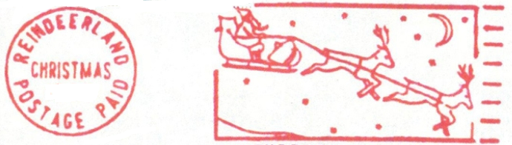
Shop Hours over Christmas 2019 and New Year 2020
Our shop will be open as normal to :: When it arrives……
Tuesday 24th December 2019,
then we’ll be closed from
Wednesday 25th December to
Friday 3rd January, and then back
to normal hours from Saturday 4th January 2020
:: a good Christmas and New Year to you !

List of Prices Realised Stamp and Collectables Auction 7 October 2019
1 2200. 2 70. 3 120. 4 400. 5 120. 6 95. 7 55. 8 55. 9 110. 10 120.
11 40. 12 40. 13 100. 14 40. 15 50. 16 130. 17 130. 18 35. 19 35. 20 65.
21 160. 22 130. 23 35. 24 100. 25 70. 26 80. 27 No Lot 28 28. 29 28. 30 80.
31 70. 32 50. 33 28. 34 30. 35 95. 36 40. 37 38. 38 22. 39 20. 40 20.
41 50. 42 20. 43 16. 44 18. 45 40. 46 32. 47 1100. 48 200. 49 400. 50 110.
51 180. 52 70. 53 160 54 120. 55 100. 56 48. 57 35. 58 No Lot 59 22. 60 40.
61 75. 62 95. 63 55. 64 700. 65 - 66 - 67 - 68 - 69 14. 70 1600.
71 19. 72 13. 73 28. 74 30. 75 48. 76 35. 77 45. 78 38. 79 13. 80 80.
81 50. 82 100. 83 100. 84 45. 85 65. 86 30. 87 22. 88 - 89 20. 90 -
91 40. 92 50. 93 40 94 35. 95 60. 96 40. 97 42. 98 20. 99 22. 100 22.
101 - 102 55. 103 30. 104 13. 105 13. 106 140. 107 110. 108 55. 109 - 110 60.
111 200. 112 100. 113 130. 114 65. 115 65. 116 45. 117 300. 118 300. 119 280. 120 140.
121 130. 122 35. 123 35. 124 - 125 350. 126 450. 127 190. 128 32. 129 200. 130 35.
131 110. 132 800. 133 20. 134 48. 135 30. 136 35. 137 22. 138 45. 139 60. 140 22.
141 - 142 80. 143 95. 144 20. 145 48. 146 180. 147 150. 148 55. 149 26. 150 48.
151 - 152 70. 153 80. 154 38. 155 30. 156 - 157 45. 158 190. 159 280. 160 420.
161 900. 162 - 163 10. 164 - 165 20. 166 20. 167 80. 168 70. 169 65. 170 38.
171 400. 172 60. 173 16. 174 - 175 90. 176 32. 177 - 178 70. 179 - 180 20.
181 20. 182 40. 183 65. 184 28. 185 - 186 - 187 35. 188 40. 189 40. 190 50.
191 13. 192 19. 193 14. 194 - 195 140. 196 650. 197 140. 198 - 199 100. 200 150.
201 20. 202 32. 203 - 204 14. 205 - 206 28. 207 50. 208 30. 209 32. 210 60.
211 200. 212 700. 213 20. 214 - 215 - 216 - 217 40. 218 13. 219 40. 220 55.
221 45. 222 28. 223 - 224 48. 225 55. 226 26. 227 17. 228 30. 229 100. 230 -
231 42. 232 13. 233 30. 234 55. 235 13. 236 30. 237 20. 238 14. 239 11. 240 14.
241 45. 242 13. 243 - 244 40. 245 22. 246 70. 247 28. 248 28. 249 20. 250 50.
251 - 252 50. 253 200. 254 - 255 10. 256 280. 257 -- 258 20. 259 85. 260 85.
261 70. 262 110. 263 65. 264 28. 265 130. 266 85. 267 80. 268 95. 269 60. 270 28.
271 110. 272 55. 273 32. 274 100. 275 90. 276 160. 277 65. 278 28. 279 210. 280 140.
281 90. 282 390. 283 150. 284 90. 285 70. 286 70. 287 92. 288 220. 289 26. 290 35.
291 35. 292 42. 293 42. 294 32. 295 75. 296 60. 297 35. 298 32. 299 38. 300 50.
301 38. 302 40. 303 35. 304 42. 305 60. 306 60. 307 42. 308 32. 309 28. 310 42.
311 16. 312 35. 313 20. 314 60. 315 32. 316 90. 317 40. 318 95. 319 70. 320 -
321 42. 322 120. 323 35. 324 110. 325 3. 326 130. 327 13. 328 200. 329 130. 330 1050.
331 700. 332 470. 333 220. 334 300. 335 170. 336 190. 337 180. 338 120. 339 100. 340 75.
341 65. 342 45. 343 30. 344 95. 345 20. 346 50. e.& o. e.


A History of Scotland in Fifteen Songs
with Bob Murray
Saturday 30th November 2019, 7.45pm (doors 7.15pm)
The Canons’ Gait (Cellar Bar), 232 Canongate, Edinburgh EH8 8DQ
Having first performed this new one-man show at this year’s Fringe, Bob Murray will present it again (and updated !) on Saint Andrew’s Night.
From Romans to Referendums, it does what is says in the title.
Tickets just £5 each from our shop, at this auction, or online from www.ticketsource.co.uk/murray (NB two flights of steps to venue, bar in venue.)

BID FORM – Stamps and Collectables Auction 25 November 2019
to Robert Murray, Tel. 0131.552 1220 :: 0131.478 7021
5 & 6 Inverleith Gardens,
Edinburgh, EH3 5PU Email auction@stamp-shop.com
Please bid on my behalf for the undermentioned lots, up to the limits stated. I understand that lots will be purchased as cheaply as other bids, or reserves, if any, permit. I accept the rules printed on the reverse of this bid form.
Date; .............................. Signed; ..................................................
Lot No Description Maximum Bid Lot No. Description Maximum Bid

NB; a buyer’s premium of 12% will be added to the hammer price of any purchases.
BLOCK CAPITALS, PLEASE ! Please post my purchases and charge to my
credit/debit card;
Name;
❑ MasterCard  Visa  Debit Card
Address;
Card number;
Postcode;
Telephone number; Expiry date; ......... Start date; ......... Security Code; .........
Signed; …………....................Name as on card; .....................
bid form overleaf
FORTHCOMING AUCTIONS; Our next auction is planned for early February 2010.
This auction is conducted according to the “Philatelic Auctioneers Standard Terms and Conditions of Sale” (available if requested), with the exception of Clause 6, where “Scottish” should be substituted for “English”.
A Buyer’s Premium of 12% (inclusive of global v.a.t.) will be added to the sale price of all lots.
Telephone bids are accepted, but must later be confirmed in writing. Alternatives and limits are accepted.
Material can be accepted at any time for inclusion in future sales. Our commission is 12% of the sale price, plus administration fee of £1.70 per lot + £7 per vendor (all plus v.a.t.). Full details on request.
We DO NOT charge buyers a handling charge per lot, nor is there VAT added to any sale prices.
Please bid early. In the case of equal bids, the lot will be sold to the person whose bid was received first (unless free bidding in the room equals the top book-bid, although the Auctioneer will try to regulate the bidding in such a way as to avoid this).
Apart from viewing the lots in person, you can get a better description of any lot, by telephoning or writing. (Photocopies are available, at a minimal plus postage, or request scans by email.)
Remember the Buy or Bid Sale - bring items along on the night. We will try to sell them for you, at a charge of 10% + 50p (optional insurance 1% extra). Have a look at what’s on offer before and during the main auction. You can buy items outright or place a bid. (Larger lots delivered to our shop are charged £1 per lot entry fee.)
The annual subscription for our auction catalogues is currently £10 for inland addresses. If you are not already on our mailing list, please send us £10 with a note of your name and address. Regular bidders and buyers may qualify for free renewal. Rates abroad are European countries £15, Overseas £20.
Successful postal bidders should note that postage stamps are not an acceptable means of paying your account.
Prices realised for this sale will be published with our next catalogue. If you are not normally on our mailing list, the List of Prices Realised can be had by simply sending us a stamped addressed envelope. Alternatively, you can be put on our auction mailing list (see above).
The telephone number at the Stewart’s-Melville Pavilion is 0131.551 2331 (mobile 07974 962649).
Open Bids (“Buy Bids”) are not normally accepted. If such bids are made, they will be taken to mean a bid of ten times the printed estimate.
Any invoices remaining unpaid fourteen days from the auction date (or after delivery to a postal buyer) will attract interest at the rate of 2% per month or part thereof.
Robert Murray
Scotland’s Best-Stocked and
Most Popular Stamp Shop.

Stamps and Collectables Auction, 25 November 2019 Page 27 .

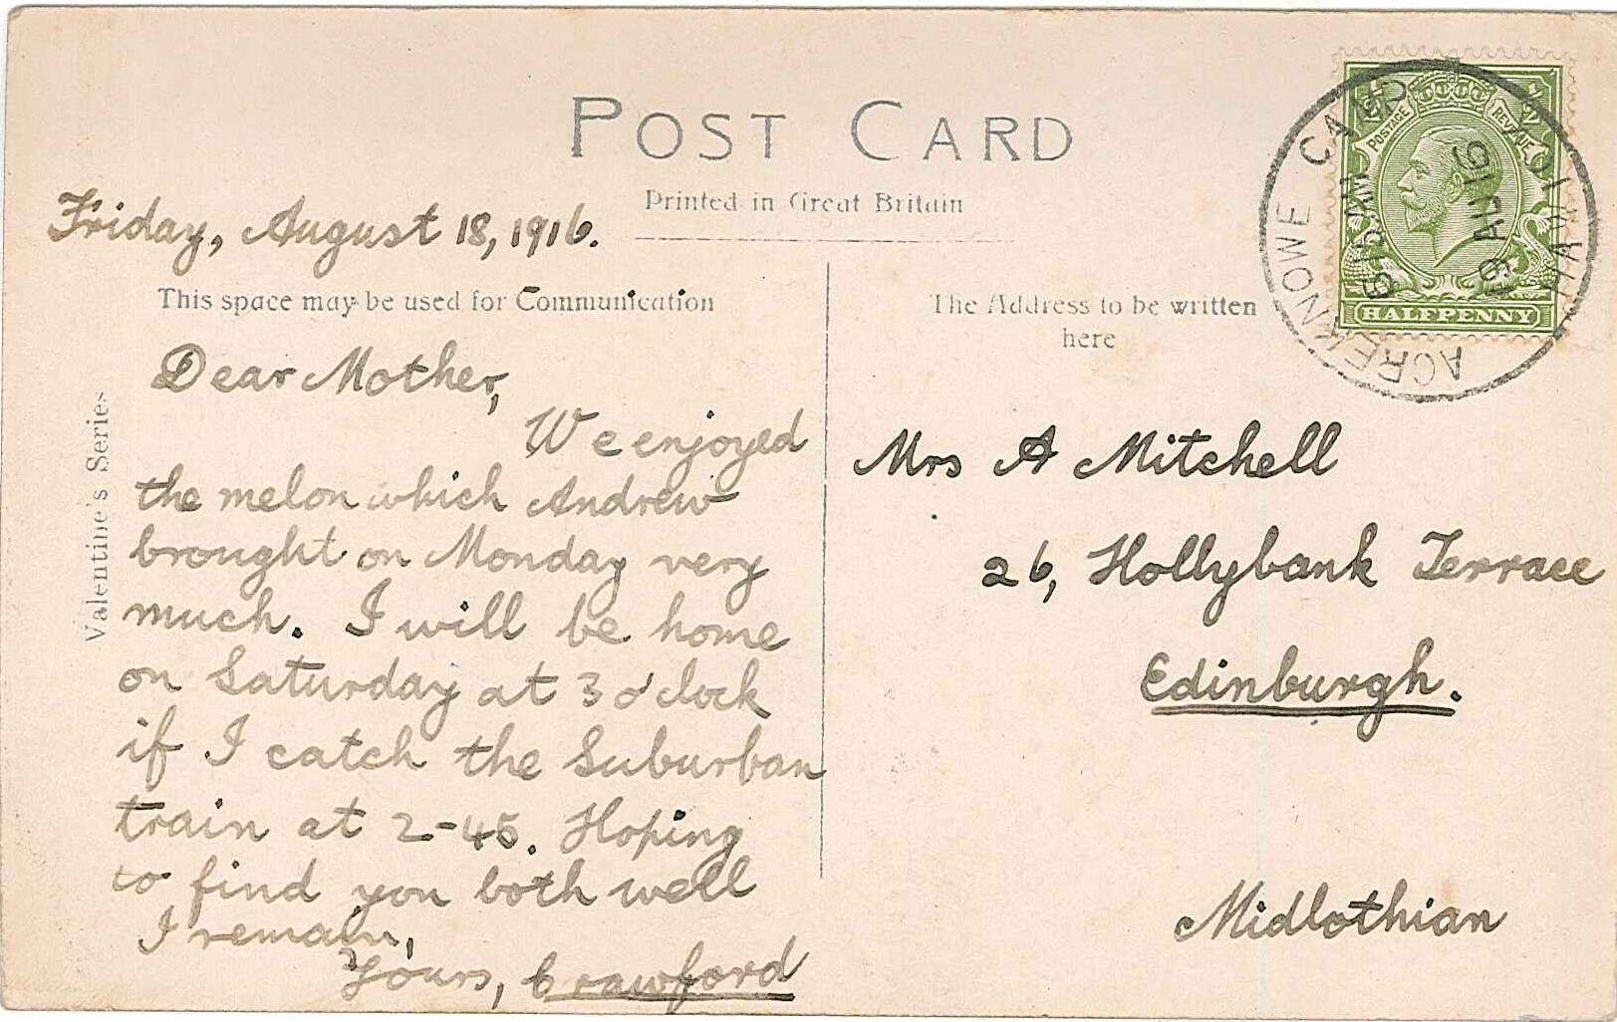

ex 366

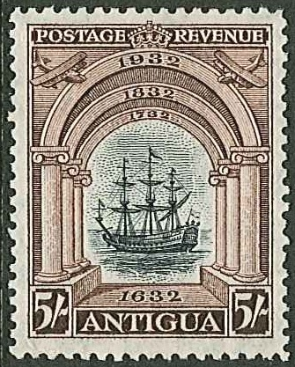

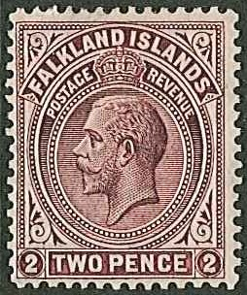

ex 194 222
(scarce perforation/shade variety)
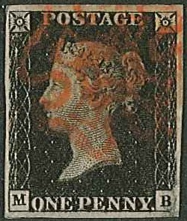
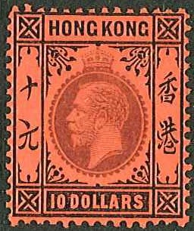
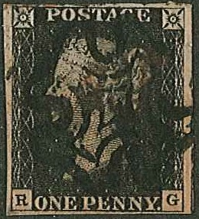

244 300 301

Stamps and Collectables Auction, 25 November 2019 Page 28 .
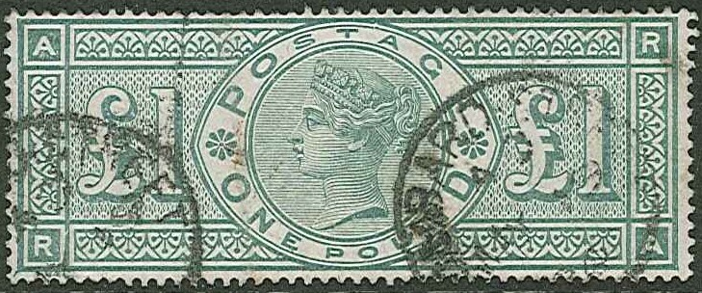
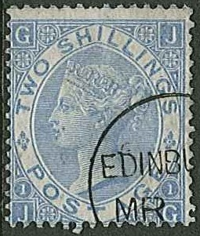
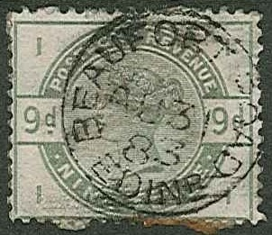

303 306 308
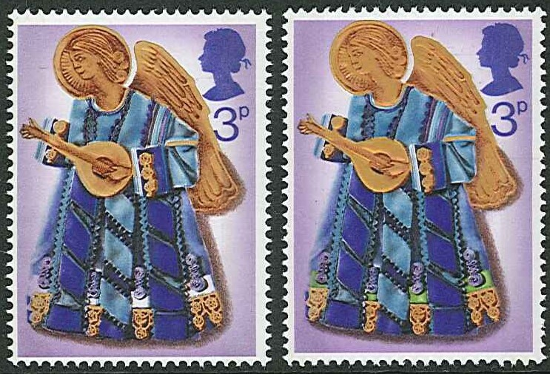

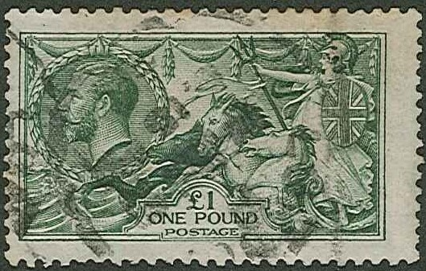

ex 310

315
(left stamp = bright green omitted)

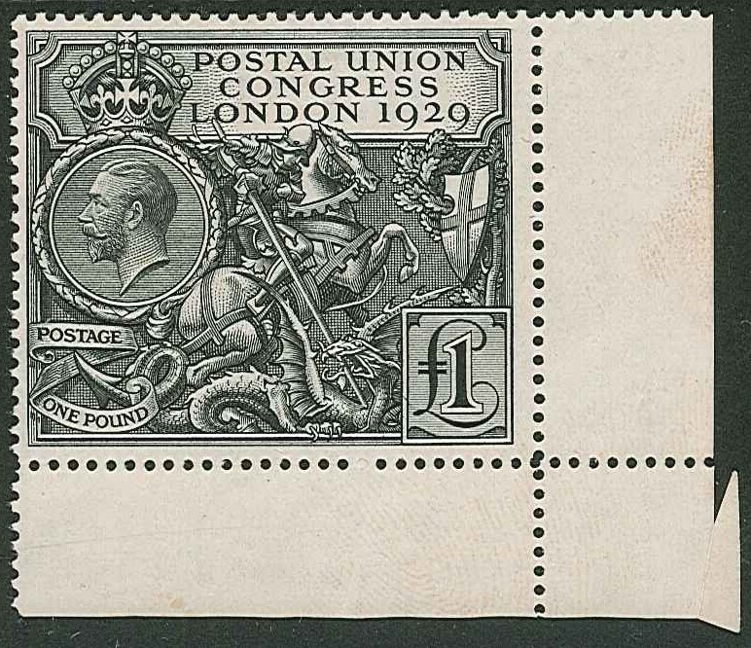

311

