

Robert Murray
5 & 6 Inverleith Gardens, Ferry Road,
Edinburgh, EH3 5PU
Tel. 0131 552 1220 :: 0131 478 7021
website www.stamp-shop.com email auction@stamp-shop.com
Stamps and Collectables Auction
AUCTION
CATALOGUE
ONE POUND
Monday 25 March 2019
at 7.00pm
Catalogue of Postage Stamps and Collectables to be sold by Public Auction, within the
STEWART’S-MELVILLE CLUB PAVILION, 523 FERRY ROAD, EDINBURGH, EH5 2DW.
On view at Pavilion on afternoon and evening of sale, and at Shop for one week prior to sale (see details later in catalogue).
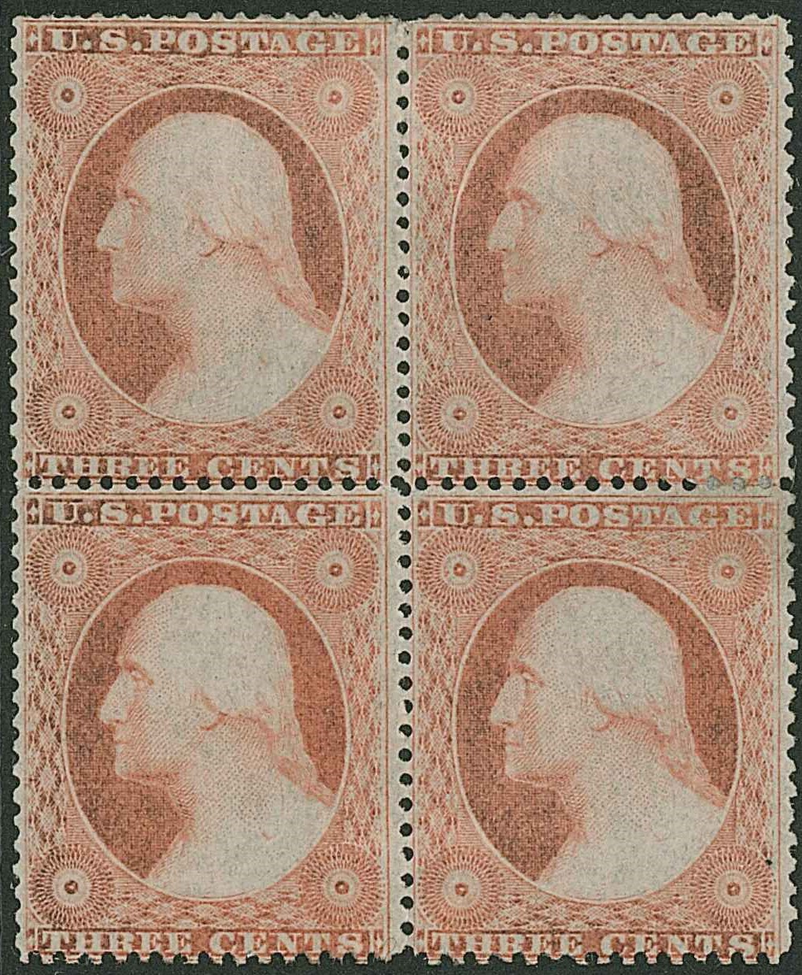

Lot 244
Stamps and Collectables Auction, 25 March 2019 Page 2 Estimate.
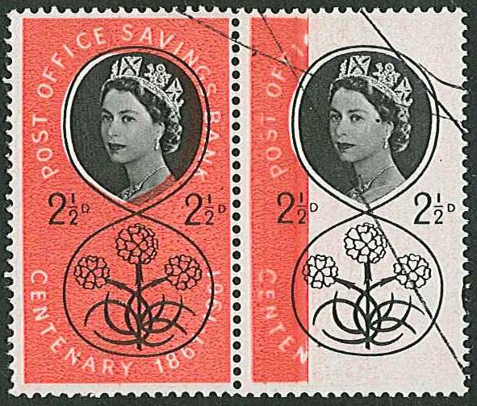
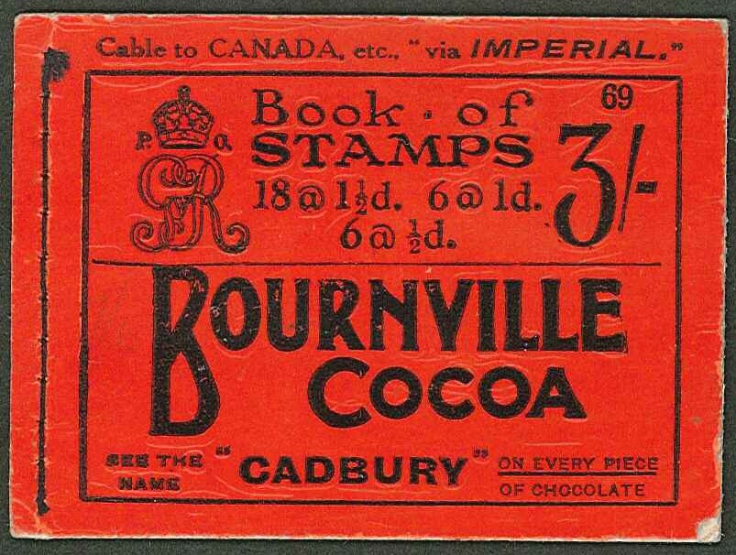
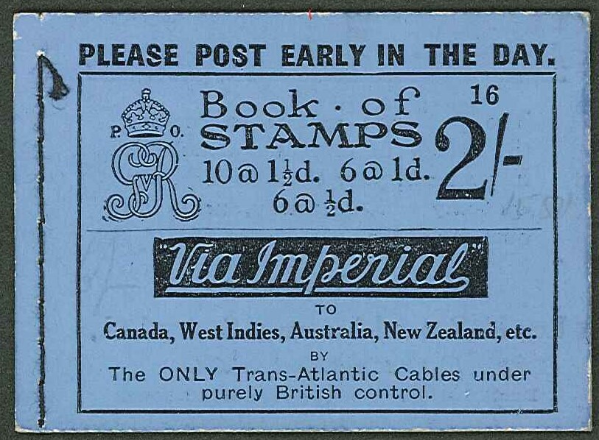
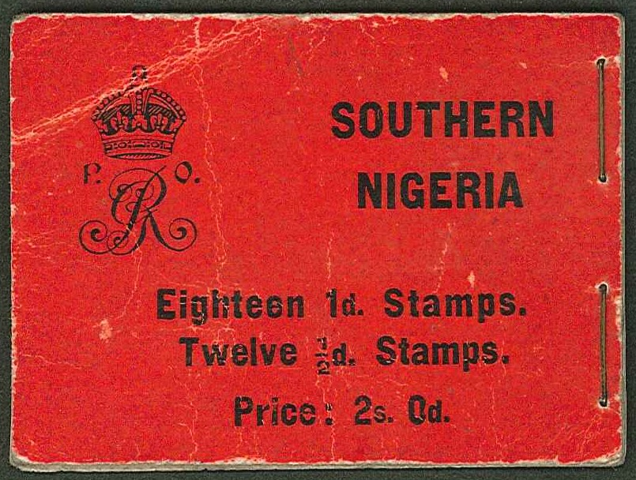
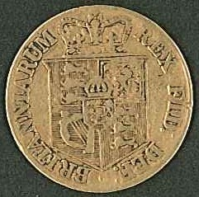
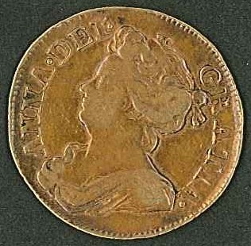
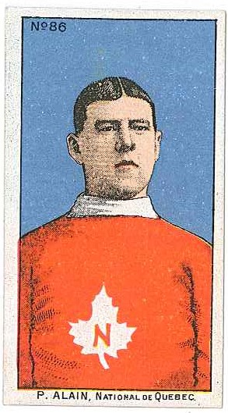
105
104
ex 92
224
329 330
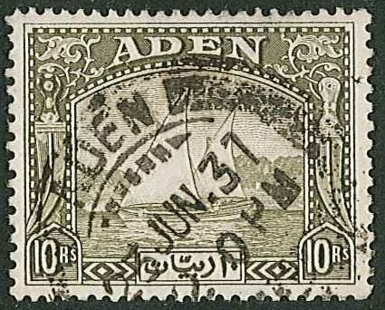

ex 120
327
Stamps and Collectables Auction, 25 March 2019 Page 3 Estimate.
Viewing times are listed on page 21.
(Viewing starts on Tuesday 19th March)

Collections and Mixed Lots.
1 Two cartons with 24 assorted albums/stockbooks (one broken) with world stamps, loose
partly sorted, covers, etc. While much is fairly common, better are in Australia, Canada,
Israel, Italy, NZ, and USA. (1,000s) [1a] .. .. .. .. £120.
2 Old Centurion album with used and m.m. from earlies up to c.1950s, mainly odd values.
Includes UK Penny Black (3 margins, red MC), Italian States (16 inc. some genuine),
China inc. Hankow 1893 2c u., etc. (Many 100s) ☑ .. .. .. £100.
3 Large and heavy plastic tub with 21 assorted albums/binders of world stamps, loose, and
covers in shoeboxes, plus more covers in three albums, etc. (1,000s, 100s covers) [1a] £100.
4 Three albums – a worn Centurion album of general world stamps to about 1940s, from
which the Commonwealth A-R has been transferred into two Swing-o-Ring albums. Also
a few loose. (Many 100s) ☑ .. .. .. .. .. £100.
5 Old club exchange book with nice selection of early European (and a few Overseas). Inc-
ludes Greece Paris prints Large Heads, France and Colonies, German States, etc., and the
condition generally fair to fine. (152) .. .. .. .. £100.
6 Heavy carton with wide-ranging general world collection in five stockalbums. Mainly
odds but with very occasional mint sets etc. (1,000s) [1a] .. .. £100.
7 Album of m. & u. mostly Commonwealth inc. Falkland 1933 Centenary ½d to 6d m.m.,
Japanese Occupation of Brunei, various Malaya, 1946 Indonesian Republic, etc. (100s) ☑ 80.
8 Big accumulation in two cartons with all sorts of generally fairly modern stamps and covers.
Includes a few UK p.packs and some decimal postage, some numbers in British Africa
(though little value), etc. (1,000s) [1a] .. .. .. .. 80.
9 Box with two Ideal albums (vol.1 up to 1914/15 parts I & II, vol.2 1915-30 parts I & II,
rather sparse). Also three other albums/stockbooks, two cover albums of UK FDCs and
pres.packs, two 1981 Royal Wedding albums, two of The British Postage Stamp by
Robson Lowe, etc. (Many 100s) ☑ .. .. .. .. 70.
10 Album with world collection arranged by year of issue 1887-1972, notable for some better
airmail issues inc. Germany 1922 Zeppelin 2m u., Newfoundland 1931 $1 Routes m.m.
(small crease), USSR 1932 Air Express 1r u., France 1936 100th Flight 10f m.m., etc.
(100s) ☑ .. .. .. .. .. .. 70.
11 Old album (published by Moens, 1878) with a typically untidy and unpredictable collection
of very varied quality. Contains many stamps of interest, as well as many standard common
items, and numerous forgeries. Most stamps stuck down. Album has loose pages. (100s) 50.
12 Small box of world stamps on stockcards, much Commonwealth, some unsold Buy or Bid
Lots, plus a few covers and postcards. (100s) ☑ .. .. .. 50.
13 Box with 3 small stockbooks of m. & u. (inc. one of Jamaica, and various 1937-48 omnibus
inc. dupl. Victories), world on album pages, stockcards, packets, etc. (1,000s) ☑ 50.
14 A carton of on- and off-paper, album leaves, covers, small albums and stockbooks, etc.
(1,000s) ☑ .. .. .. .. .. .. 50.
15 Small box with three junior world albums, an old club book of Commonwealth (with a few
useful earlier), etc. (100s) ☑ .. .. .. .. .. 50.
16 Carton with New Zealand album, Canada album, world in 4 assorted albums/stockbooks,
world sorted into envelopes, various covers, some literature, etc. (Many 100s) ☑ 50.

Phoning for results ? Note that our shop does not open until noon on a Tuesday, and
we do not normally answer the phone on the day after the auction until after that time.

Alternative bids, and overall spending limits, are acceptable. Advice available if required !

A Buyer’s Premium of 10% (vat-inclusive) will be added to all sale prices.
Stamps and Collectables Auction, 25 March 2019 Page 4 Estimate.

Collections and Mixed Lots, continued.
17 The shop’s charity box, filled with all manner of odds and ends handed in to us. Extensive
this time, in two cartons and two medium boxes. Contains various albums (mainly junior),
loose in envelopes/packets, some covers, etc. (Many 1,000s) [Please note that the entire
proceeds – including the buyer’s premium – are sent on to charity. The buyer of the lot has
the option to nominate a charity.] [1a] .. .. .. .. 50.
18 Three boxes and a crate of mixed albums, stockbooks, loose, etc. Some of the albums are
sparse, others better filled. Also a box of commercial covers, and a box of modern post-
cards. (1,000s) [1a] .. .. .. .. .. .. 50.
19 Box with world mint and covers (inc. Hong Kong 1982 defin set u.m. and FDC), used, much
unsorted, five junior albums, NZ packs, UK FDCs 1960-95, etc. (1,000s, 100s covers) ☑ 40.
20 Box with unsorted world in two shoeboxes, more partly sorted in envelopes, Buy or Bid
Commonwealth lots, etc. (1,000s) ☑ .. .. .. .. 40.
21 Box of albums, album pages, covers, loose stamps, display pages on Easdale Island, etc.
Requires sorting. (1,000s) ☑ .. .. .. .. .. 40.
22 A box of covers, loose stamps, album pages, etc. Requires sorting. (1,000s) ☑ .. 40.
23 A box of eight assorted albums of stamps and covers, and some loose. (Many 100s) ☑ 40.
24 Medium carton with albums, covers, loose stamps, etc. (1,000s) ☑ .. .. 40.
25 Box of loose stamps, covers, etc. (100s) ☑ .. .. .. .. 40.
26 Box with covers, loose stamps etc. inc. bundle of duplicated 1960 World Refugee Year
folders. (100s) ☑ .. .. .. .. .. .. 40.
27 Ideal album (7th edition, quite worn) with mint and used collection (dated 1918, plus others
added up to c.1940), mostly odd values with a few part sets. (100s) ☑ .. 40.
28 Worn Ideal album with general collection generally to about 1930s (some later) inc. a UK
Penny Black (2 margins, cut-into), plus some others. (100s) ☑ .. .. 40.
29 Tub and box with 5 junior albums, thick bundle of album pages (some sparse), bundle of
1950s magazines, 3 cover albums of UK FDCs 1965-88 (handwritten), etc. (100s) ☑ 40.
30 Tub with world on/off-paper, partly sorted, in five small boxes, 17 small tins, bags, etc.,
Noting some Commonwealth u.m. KG6/early-QE new issues. (1,000s) ☑ .. 40.
31 Box with Hinton Empire Postage Stamp Album (quite sparse), and two Lincolns, partly
Picked over. (100s) ☑ .. .. .. .. .. 40.
32 Box with varied contents inc. album of world covers (very mixed, mainly of some interest),
album with small colln. of Bolivia, small bundle of world covers (inc. a few Afghan FDCs),
and a couple of other items. ☑ .. .. .. .. .. 40.
33 Carton with covers (FDC and commercial), album pages, four albums/stockbooks, stamps
on stockcards, album of UK PHQs, two albums of UK FDCs (1982-83, 1991-92 with bureau,
alternative, and special cancels), old album of postcards (European views), etc. (100s, 100s
covers) ☑ .. .. .. .. .. .. 40.
34 Odd mix comprising a small collection of Ceylon up to 1960s (some reasonable QV-KG5
but some tone spots), Israel m.m. on pages (inc. Halbanon sheet heavily mounted), and a few
UK (inc. a few different KE7 with special postmark for 1912 Stamp Exhibition). (100s) ☑ 40.
35 Medium carton of album leaves, covers, loose on/off-paper, junior albums, etc. (1,000s) ☑ 40.
36 Slim stockbook with odd world mix. Some very common, but some medium-value older
Commonwealth, France, etc. (100s) ☑ .. .. .. .. 30.
37 Box of covers, world on/off-paper, etc. (Many 100s) ☑ .. .. .. 30.
38 A box of six junior albums, world on-paper, etc. (1,000s) ☑ .. .. 30.
39 Mixture in carton with four various albums, UK 1986-88 year books, album pages, and
others. (Many 100s) [1a] .. .. .. .. .. 30.

The Auction Venue is 650 metres West of our Shop, on Ferry Road. It has its own car park.
The bar (upstairs) is open 6-10pm and also serves a variety of food, teas and coffees. Please note that we do not allow drinks at the viewing tables, but you are welcome to bring drinks down from the bar once the auction has started.
Stamps and Collectables Auction, 25 March 2019 Page 5 Estimate.

Collections and Mixed Lots, continued.
40 Heavy box with two albums of standard UK, stockbook of world, 2008 Stamps of the World
(as new), etc. (100s) [1a] .. .. .. .. .. 30.
41 Stockbook of world (mainly used QE Commonwealth), and various world on stockleaves
and stockcards inc. some moderate France 1950s mint. (100s) ☑ .. .. 30.
42 Box with a world album of mostly used foreign, shoebox of off-paper in packets, bundle-
ware, postcards, etc. (1,000s) ☑ .. .. .. .. .. 24.
43 Box of 20 unsold Buy or Bid lots, inc. a few covers/postmarks, UK, Channel Is., etc. Total
upset price c.£100. ☑ .. .. .. .. .. 20.
44 Folder of Commonwealth and foreign mix (100s) and a folder of mainly Scottish commem
covers. ☑ .. .. .. .. .. .. 20.
45 Small mix comprising a stockbook of Commonwealth (c.1,000, cheaper mix), 7 items of
Scottish postal history, and an illuminated magnifier. ☑ .. .. .. 20.
46 A few packets of world stamps by theme, plus other African by country. (c.1,400) 15.
47 British Commonwealth; a heavy carton with much Australia 1913-2007 m. & u. in three
stockalbums inc. min. sheets and booklets, Bicentennial Collection (5 folders), 2 albums of
Australia FDCs, etc. Also a binder of UK, another of Rhodesias/S.Africa, and some empty
stockleaves. (1,000s) ☑ .. .. .. .. .. £100.
48 --; three-volume collection from QV to about 1985 of m. & u. with sets, part sets, and odd
values. Also an album of m. & u. omnibus issues of 1937, 1945, 1949, 1953. (Many 100s) ☑ 90.
49 --; two albums of u. & m.m. inc. Cape triangular 1d, 4d u., KG6/early-QE sets and part sets
m.m. inc. Nyasaland 1945 set, NZ 1953 defins. Earlier more used inc. NZ early airmails.
(100s) ☑ .. .. .. .. .. .. 60.
50 --; album leaves/stockleaves of m. & u. with much QE (some earlier), mainly Fiji, Gibraltar,
Leeward, Falklands Dependencies, and Nigeria. (100s) .. .. .. 50.
51 --; album of KG6/early-QE with just a few later, with odd values/part sets/sets m.m. and
used. A few foreign (USA etc.). (Many 100s) ☑ .. .. .. 50.
52 --; collection in four albums with nothing very modern inc. some British Occ. of Italian
Colonies m.m. values to 10/-. Also a junior world album. (100s) ☑ .. .. 40.
53 --; box with album of Canada FDCs 1990-93, booklets, stamps, airletters, 2000 yearbook,
an album of Norfolk Is. FDCs etc., album of Australia FDCs, album of various countries
PHQs and two small albums of stamps. (Few 100s) ☑ .. .. .. 40.
54 --; u.m. seln. of KG5 pictorials of St. Lucia (38), Bermuda (26), St. Helena (34), and Bahamas
(4) inc. a few pairs and blocks. S.t.c.£200. .. .. .. .. 40.
55 --; small m. & u. range of Ceylon (19, s.t.c.£19), Fiji (9, £18), Gibraltar (1938-51 perf.13½ 1/-
and 2/- m.m., £305), and Gold Coast/Ghana (26, £88, inc. 1948 S.Wedding set m.m.). 40.
56 --; Africa; two well-filled albums of mint and used from QV to QE with many better stamps
included (often catalogued tens of pounds each) in the QV to KG6 period in many of the
countries. Includes Atlantic Islands. Many mint are stuck at hinges. Stronger countries
include Ascension, Bechuanaland, Gambia, Gold Coast, K.U.T., Morocco Agencies,
Nigerias, Nyasaland, Rhodesias, St. Helena, Somaliland, S.W.Africa, Tanganyika, Tristan
da Cunha.
[Several lots in this auction, from the same source, have a problem with many of the mint
stamps having been heavily mounted, a proportion of which are stuck to the page around
the stamp hinge. In order to prevent damage we will not allow viewers to “experiment”
with these. The standard is about the same in all these collections.] ☑ .. £700.

Follow us or connect online – as well as our main website at www.stamp-shop.com we can be found
on the social media by searching for “Robert Murray Stamp Shop” on LinkedIn and Facebook.
Our Website will still be the first port-of-call for most information, but the Facebook and

A Buyer’s Premium of 10% (vat-inclusive) will be added to all sale prices.
Stamps and Collectables Auction, 25 March 2019 Page 6 Estimate.

Collections and Mixed Lots, continued.
57 British Commonwealth; Americas; three well-filled albums of mint and used QV to QE with
many better stamps catalogued at tens of pounds each in the QV-KG6 period in many countries.
Has many West Indies and also includes Falkland Islands inc. some better there. Many of the
mint stamps are stuck at the hinge. (1,000s) [See note at lot 56] ☑ .. .. £650.
58 --; Asia; two well-filled albums of mint and used from QV to QE with many better catal-
ogued at tens of pounds each in QV-KG6, noting early Ceylon, India and States. Many mint
are stuck at the hinge. (1,000s) [See note at lot 56] ☑ .. .. .. £500.
59 --; Australasia; a well-filled album of m. & u. from New Zealand, Papua New Guinea, and
Pacific Islands from QV to QE with many better cat. In tens of pounds each in QV-KG6
Period. Many mint are stuck at hinge. (100s) [See note at lot 56] ☑ .. .. £140.
60 --; Europe; a well-filled album of m. & u. from Cyprus, Gibraltar, Ireland, Malta, Jersey,
Guernsey, I.o.M., etc. from QV to QE with many better (cat. tens of pounds each) in QV-
KG6. Many stuck at hinges. Also an album of mint Guernsey. (100s) [See note at lot
56] ☑ .. .. .. .. .. .. .. £150.
61 --; West Indies; seln. on stockcards of Cayman Is. m. (31, s.t.c.£64), Jamaica m. (17, s.t.c.
£136, inc. 1938-52 10/-, £1, 1948 S.Wedding £1), Montserrat m. (13, s.t.c.£129, inc.
1938-48 ten values perf.14), mainly fine m.m./l.m.m./u.m. .. .. 40.
62 --; --; small used seln. of St. Kitts-Nevis 1903-18 (13, s.t.c.£165), Jamaica 1889-1962 m.
& u. seln. (85), and Jamaica 1964-71 u.m. on pages (160). .. .. 20.
63 --; Omnibus; 1937 Coronation complete (202) in singles plus fourblocks on pages. Some
blocks are in photocorners (and probably all u.m.), others are hinged on upper pair. Singles
are m.m. .. .. .. .. .. .. £180.
64 --; --; 1949 UPU u.m. colln. in stockbook, not quite complete. Generally very fine but some
are just below par – minimal offsets, bends (not creases), etc. (275) ☑ .. 50.
65 --; --; 1953 Coronation almost complete u.m. in stockbook in either fourblocks or strips of
four, the Crown Colonies designs with marginal imprints. (103 different) ☑ .. £100.
66 --; --; two albums of royal events, a stockbook of dupl. 1981 stamps and m.s., 1981 book-
lets, and a NZ Q.Mother 100 souvenir book. (1,000s) [1a] .. .. 20.
67 Europe; heavy carton with 11 well-filled albums of m. & u., much middle to modern period
used, with a wide range of countries represented. Many of the mint are stuck at the hinge.
(1,000s) [See note at lot 56] ☑ .. .. .. .. .. £200.
68 Foreign; box with envelope of Swiss stamps m. & u., FDCs, booklets, year packs, shoebox
of Scandinavia stamps, covers, yearpacks, etc., album of USA, album leaves of Belgium,
etc. (100s) ☑ .. .. .. .. .. .. 50.
69 Overseas; a heavy carton with nine well-filled albums of mint and used, much middle to
modern period used, with USA (1 volume), Middle East (2), Asia (2), Africa (2), and
Americas (2). Many mint are stuck at their hinges. (1,000s) ☑ .. .. £180.
70 Scandinavia; two stockleaves with a modern seln. of u.m. or c.t.o. Norway, Sweden,
Denmark, and a few others. S.t.c.£490. .. .. .. .. 30.
71 Thematic; heavy carton of modern souvenir collections with History of Space Exploration
(2 vols.), Route to Victory coin cover collection, Railway Heritage (2 vols.), 24 Hours of
D-Day, Victory - End of WW2, mixed album inc. 1946 Victory omnibus complete u.m.
(164). (Many 100s) [1a] .. .. .. .. .. £100.
72 --; box with seven albums – one is railway covers (c.69), four with aviation covers and
postcards (c.210), one of Royal Navy covers (c.150, many signed), and one of WW1
commemoration with stamps, m.s., and covers (c.80 items). ☑ .. .. 60.
73 --; Art; Titian; three binders of u.m. stamps, min. sheets, etc. on printed pages. (100s) ☑ 40.
74 --; Aviation; m. & u. collection in a stockbook. (c.1,500) ☑ .. .. 30.

Alternative bids, and overall spending limits, are acceptable. Advice available if required !

Stamps and Collectables Auction, 25 March 2019 Page 7 Estimate.

Collections and Mixed Lots, continued.
75 Thematic; David Livingstone; thick bundle of display pages with stamps, labels, covers,
postcards, and illustrations. Some more unusual items. This collection was put together by
the 1930s-70s owner of Ulva Cottage, Livingstone’s home in Hamilton. (100s) ☑ 40.
76 --; Football; World Cup Masterfile colln. of stamps and covers for 1986 in six albums. Also
two albums of FDCs of earlier World Cups. (100s) ☑ .. .. .. 30.
➲ Forgeries; see China, Heligoland.
77 Covers; Aviation; six covers comprising – {1} USSR 1931 Zeppelin Polarfahrt cover with
N.Pole Flight 35k and 2r imperf with BRISE-GLACE MALYGUIN cancels (slight toning), {2}
Germany 1937 Hindenburg Deutschlandfahrt card with 8 stamps, {3} Argentina 1930
Condor flight cover, {4} USA 1936 Hindenburg cover, {5} Poland 1936 Gordon-Bennet
cover with International Balloon Competition special cancels, and {6} France 1946
Neptune balloon cover. .. .. .. .. .. 40.
78 --; Philatelic Numismatic Covers; two albums of 2002 Golden Jubilee covers (Mercury)
with UK coins face £12 (20). Also UK £5 coins 2000-07 (4), RBS 2000 commem. £20
Queen Mother note, 1970 proof set, etc. ☑ .. .. .. .. 80.
➲ --; --; see also UK (Philatelic Numismatic Covers).
79 Literature; SG Commonwealth & Empire 1840-1970 catalogue, 2017 ed^{n}., good 2nd-hand. ☑ 30.
80 --; SG Commonwealth & Empire 1840-1970 catalogue, 2016 edition, good 2nd-hand. ☑ 20.
81 Supplies (Second-Hand); single size cover albums, as new. (9) ☑ .. .. 24.
82 --; heavy carton with various supplies – glassine bags, albums, FDC pockets, etc. Also 7
packs (each of 25) eBay bubble bags for posting (3 different sizes). [1a] .. 30.

Non-Philatelic Items (Collectables)
BANKNOTES
83 Small bundle of UK and world, mainly quite modern and circulated (some better) inc. UK
face value £30 (mainly Scottish), Canada total $50, etc. (74) .. .. 60.
84 Scotland; Caledonian Bank; 1904 (4 Jan.) £1 note in very poor condition (much wear, and
various faults, the worst of which is unsightly sticky tape stuck down the centre of the note
on both front and back). PMS CA15b (cat. From £1,500 for fine). .. .. £100.
85 Portugal; 1979 (1982) 500e – seven examples (of which six sequential) in condition from
VF to EF/unc. .. .. .. .. .. .. 40.
CIGARETTE AND TRADE CARDS
86 Various collections of cigarette cards in albums. Some interesting and older noticed. (Many
100s) ☑ .. .. .. .. .. .. .. 90.
87 Large mixed quantity of cigarette and trade cards in two plastic storage tubs. Mostly common
but some more unusual or scarcer noted here and there. (1,000s) [1a] .. 50.
88 Two old slip-in albums with sets and odds inc. Wills 1911 Celebrated Ships set (50, cat.£60),
1908 Cricketers (53 cards, possibly set, £225+), 1912 Historic Events set (50, £60), 1911
Signalling Series (49 of 50), some useful odds, etc. (c.370) ☑ .. .. 50.
89 Cigarette cards loose, in tin, and old albums. General mix. (Many 100s) ☑ .. 40.
90 Two albums of mixed mainly sets. Some pre-war, some modern, some repros. (19 sets plus
various odds) ☑ .. .. .. .. .. .. 40.
91 Brooke Bond; a wholesale quantity of cards, apparently in reasonable order, many bundled
in sets, and some as sorted odds. High level of duplication. Over 3 metres of cards, which
we estimate to be probably about 10,000 cards. [1a] .. .. .. 75.

A Buyer’s Premium of 10% (vat-inclusive) will be added to all sale prices.
Stamps and Collectables Auction, 25 March 2019 Page 8 Estimate.
Non-Philatelic Items, continued.
CIGARETTE AND TRADE CARDS, continued.
92 Imperial Tobacco Co. of Canada; 1912 Hockey Players selection of 18 different. Mainly
very fine, though a few faults. Cat.£450. Also 9 different Lacrosse Series in poor to very
fine condition. .. .. .. .. .. .. 60.
93 Liebig; collection of mixed Liebig cards, probably mainly in sets. (c.1,500) ☑ .. 40.
94 Wix; Kensitas 1934 silk Flowers (medium size) set (60) in original folders in a contempor-
ary slot-in album (cat.£270, a little toning on folders), part set (40) in modern album, and
1934 silk National Flags set (50) in contemporary stuck-in album (£70). ☑ .. 50.
95 Sport; a few pages of mainly golf, plus some other sports (some of these the golf cards from
sets of mixed subjects). Fair to fine. (76) .. .. .. .. 20.

COINS
➲ Estimates are based on a gold market price of £990/oz, and silver of £11.50/oz.
96 Large quantity of UK and world coins, mostly mid-20th Century onwards but with some older,
some silver, and some redeemable currencies. A few stamps also. (100s) [1a] .. 80.
97 Sweetie tub with world and UK mix, mostly 20th Century but some older noted with a scattering
of silver. ☑ .. .. .. .. .. .. 30.
98 United Kingdom; 1750 farthing in attractive VF/EF grade. ☑ .. .. 50.
99 --; George III crown (worn), 1887 crown, 1935 Jubilee crowns (3), plus 1889 double florin
EF, and 1825 halfcrown about fine. ☑ .. .. .. .. 50.
100 --; 1977-2006 seln. of 14 Royal Mint uncirculated coins/sets, inc. £5 crowns (6), and two of
1989 £2 Claim of Right/Bill of Rights folder. ☑ .. .. .. 60.
101 --; 1977-97 seln. of proof sets (std. or de-luxe) with slight duplication. (12) ☑ .. 40.
102 --; selection of Royal Mint silver proofs in original boxes (18 items) comprising £5 (3), £2
(6 of 1986 Games, one of 1989 2 x £2 Bill and Claim), £1 (4), 25p (2), 2 x 10p (1), and 5p
(1). Also 1986 Wedding medallion. ☑ .. .. .. .. £120.
➲ See also Mixed Lots (Covers; Philatelic Numismatic Covers).
103 Gold Coins; six mainly damaged gold coins – Bengal Presidency AH 1202/19 mohur
(normally AGW .3958 oz but holed), and five Egypt 1861-76 Sultan Abdul Aziz 5 qirsh
(3 holed, 2 EF – each normally AGW .012oz). ☑ ▲ .. .. .. £450
104 --; United Kingdom; 1714 Queen Anne guinea, fair/fine. ☑ ▲ .. .. £270.
105 --; --; 1817 George III half-sovereign, fair. ☑ ▲ .. .. .. £120.
106 --; --; 1989 proof sovereign, 400th Anniversary issue in original box. ☑ ▲ .. £400.
107 --; --; 1981 proof sovereign in original box. ☑ ▲ .. .. .. £200.
108 --; Spain; 1747 ½ escudo JB, generally fine but has been mounted as a button (then
removed). AGW .0498oz. ☑ ▲ .. .. .. .. .. 50.
109 --; Philatelic Numismatic Covers; UK 1981 sovereign unc. encapsulated in 1998 Diana
FDC. ▲ .. .. .. .. .. .. £210.
110 --; --; UK 1982 sovereign unc. encapsulated in commemorative cover for 16th Anniversary
of Princess Diana’s 21st Birthday. ▲ .. .. .. .. £210.
111 --; --; UK 2003 sovereign unc. encapsulated in commemorative cover. ▲ .. £210.
112 --; --; Guernsey 1999 £25 gold coin for Queen Mother’s 99th Birthday, encapsulated in
Guernsey FDC. Coin’s AGW 0.2492oz. ▲ .. .. .. .. £210.

MEDALLIONS
113 2015 Waterloo Bicentenary folder containing six medallions; {a} small gold medallion
showing Wellington/statue (7g, 14 carat = 0.1312 AGW), and {b} five larger bronze
medallions each showing a contemporary monarch. ☑ .. .. .. £120.
Stamps and Collectables Auction, 25 March 2019 Page 9 Estimate.
Non-Philatelic Items, continued.
POSTCARDS
114 Modern; four boxes of postcards mid-20th Century onwards. (Estimated c.6,000) [1a] 20.

OTHER CATEGORIES
115 Documents; 1789-1884 eight documents (lease, assignment, conveyance, mortgage, etc.)
relating to properties in Beeston and Hartlepool. ☑ .. .. .. 15.
116 Precious Metal Stamp Replicas; The Victorian Stamp Ingot Collection (6), Castle Stamp
Ingot Collection (2), and KG5 1d stamp repro. All in sterling silver, gross silver weight
128g. ☑ .. .. .. .. .. .. .. 40.
117 Collectables Mixed Lots; bag and box of mixed postcards and cigarette cards (many 100s),
and two boxes of baseball cards (1,000s) ☑ .. .. .. .. 50.
118 --; a few mixed buttons, badges, etc. inc. UK 1893 crown (fair), WW1 British War Medal
(damaged), etc. ☑ .. .. .. .. .. .. 30.
119 --; the shop’s charity box – coins, some cigarette cards, a few banknotes, empty coin boxes,
etc. [1a] .. .. .. .. .. .. .. 20.
End of Non-Philatelic Section

Stamps Classified by Country
120 Aden; 1937 Dhow set good/fine used, a few short perfs on 1r and 2r, tiny corner thin on
5r. SG 1-12, cat.£800. .. .. .. .. .. £150.
121 Andorra; Spanish; 1972 Europa 8p u.m. fourblock, SG 67, cat.£225 each = £900. 60.
122 --; --; 2002 Europa (Circus) 50c complete sheet of 50 u.m., SG303 cat.£22 each = £1,100. 50.
123 Ascension; 1922-53 selection of mostly m.m. on stockleaves inc. 1922 opt. short set to 3d
m.m. (plus ½d used), 1935 Jubilee set (4) u.m., 1938-53 defin set (16 + 16 extras), 1948
S.Wedding set (2) m.m., etc. Cat. c.£800. (62) .. .. .. 90.
124 --; 1924-33 set (12, plus 1d shade) fine l.m.m./m.m., one perf short at right of 3/-. SG 10-20
cat.£460. (13) .. .. .. .. .. .. 90.
125 --; 1938-70 m. & u. range on two stockleaves inc. 1938-53 values to 2/6 f.u., 1956 set (13)
u.m., 1963 Birds set (14) m.m., etc. (c.100) .. .. .. .. 50.
126 Australian States; Victoria; 1884-96 3/-, 4/-, 5/-, and 1884-92 2/6 unused (some part gum,
a few perf faults). SG 260c, 268, 269, 292b, cat.£580. .. .. .. 50.
127 Australia; 1913-86 colln. of m. & u. in a printed hingeless album, with 1913 ‘Roos to 2/-
u., 1914 KG5 Heads to 1/4 m. or u., and later stamps in both these issues, many catalogued
tens of pounds each. Also includes 1932 Sydney Bridge 5/- f.u., good run of KG6/QE inc.
1963 Navigators £2 f.u., 1971 Christmas block of 25 u.m., etc. (100s) ☑ .. £180.
128 --; a well-filled album of m. & u. from 1913 to recent, as well as States issues, with many
catalogued at pounds each. Also inc. AAT, Cocos, BAT, etc. Many mint stuck at hinges.
[See note at lot 56] (100s) ☑ .. .. .. .. .. 90.
129 --; 1937-49 Robes thin paper set (3) each in fine used corner marginal block with Common-
wealth imprint, plus similar 5/- block with Ash imprint. The £1 block with some trimmed
perfs at top. Also thick paper single 5/- f.u. and 10/- m.m. .. .. 60.
130 --; 1981-2008 complete run of year books in heavy carton, inc. 2008 Olympics. Face value
c.A$1,325 (= c.£710). (39 books) [1a] .. .. .. .. £180.
131 Austria; 1867-1999 m. & u. colln. in album. Also 1850-1994 m. & u. in stockbook, and on
loose pages with slight dupl. (Many 100s) ☑ .. .. .. 40.
132 --; 1950-53 Air (Birds) set (7) l.m.m./m.m. (cat.£535 for u.m.), and a few others. (21) 40.

Scottish Philatelic Congress – 12/13 April – Dewars Centre, Perth. See further notes later in catalogue.

A Buyer’s Premium of 10% (vat-inclusive) will be added to all sale prices.
Stamps and Collectables Auction, 25 March 2019 Page 10 Estimate.
133 Bahamas; 1863-84 selection of m. & u. on stockleaf inc. 1863 values to 6d used with shades.
S.t.c.£1,000 (as cheapest shades). (30) .. .. .. .. 60.
134 Bechuanaland; 1888-1953 seln. of m. & u. on stockleaf with various overprints, mixed later
issues. S.t.c. c.£280 (76) .. .. .. .. .. 40.
135 --; 1885-1965 m. & u. mix on stockleaf with slight dupl. and a number of better values (e.g.
1888 5/- heavy m.m. (tone spot). S.t.c.£350. (76) .. .. .. 30.
136 Belgium; shoebox of commercial covers and cards, mainly 1940s-80s. (c.700) ☑ 10.
137 Burma; fragile bundle of telegraph forms used about 1900s, a couple of later envelopes. ☑ 10.
138 Canada; Newfoundland; 1937 Additional Coronation 3c Die I (perf.14, diagonal crease
affects six stamps) and Die II (perf.13½), each in u.m. corner block of 25. SG 258, 258ec,
cat.£1,325. .. .. .. .. .. .. 75.
139 --; Nova Scotia; 1860-63 yellowish paper 12½c black - four u.m. fourblocks. SG 17, cat.
£38 each = £608. .. .. .. .. .. .. 60.
140 Canada; 1892 cover to Denmark with ten of 1882-97 ½c (five-strips, three-strip, pair) with
Toronto c.d.s. cancels, other marks, faulty at right. .. .. 20.
141 --; 1928-29 10c and 50c heavy m.m., and 1937-38 20c, 50c, $1 m.m., cat.£298½. 30.
142 --; 1975-99 box of mint stamps, first day covers etc., much in envelopes as delivered. From
a correspondent in Canada, so completeness not certain. (100s) ☑ .. .. 80.
143 --; a big mixed box with albums and stockbook, various loose, inc. an album of booklets,
a shoebox of sorted used duplicates, etc. ☑ .. .. .. .. 70.
144 China; well-filled stockbook with duplicated ranges of used and unused of mixed periods
(but little very modern). Includes c.200+ Junks, hundreds of Sun Yat-sen, etc. (c.3,000+) ☑ 40.
145 --; 1885-88 5c perf.12 m.m. (SG 15 cat.£225, but tiny thin and mark on face), plus 14
forgeries of 1878-94 issues “used”. .. .. .. .. 30.
146 --; People’s Republic; 1986-2013 box of twelve various special packs/books inc. 1986 and
1988 year packs and later well-illustrated books/packs inc. some silk packs with various
stamps, covers, etc. One duplicate. Minor knocks. ☑ .. .. .. 40.
147 Denmark; 1854-2000 used collection on pages. Sketchy in earlier issues, but a good
range of commercially used later. (100s) ☑ .. .. .. .. 30.
148 --; 1912 5k GPO wmk. Crowns fine used, centred to right (SG 134 cat.£180), and 1915 5k
GPO wmk. Crosses good used (centred slightly left, couple short perfs.) (SG 185 cat.£180). 40.
149 --; 1942-81, 1984-2013 colln. of first day covers in five albums (2 single, 3 double-size).
Typically hand-written addresses to 1981, then unaddressed 1984 onwards. (c.370) ☑ £100.
150 Dominica; 1883-c.1990 m. & u. seln. on various pages inc. 1951 set (15) .m., various later
sets/part sets. (c.400) .. .. .. .. .. 40.
151 Falkland Islands; 1929-37 Whale & Penguin short set to 5/- (missing 4d but with both
shades of 1/-) m.m., cat.£273. .. .. .. .. .. 50.
152 Falkland Islands and Dependencies; 1891-1953 mainly m.m. range on five stockleaves
with numerous medium values, 1952 set (14) m.m., most of F.I.D. 1944 opts. set (31 of 32),
1948-49 Thin Map set (9) m.m., etc. Also 1878 1/-poor u. Cat.£1,000+ (140) .. £100.
153 --; two-volume printed album with Falkland pages starting at 1878 but only a few stamps
up to 1952, then better range of u.m. stamps to 1982, the Dependencies mostly u.m. inc.
1944 (4 sets), later sets inc. some S.Georgia and B.A.T. (100s) ☑ .. .. 50.
154 Falkland Islands Dependencies; 1946 Thick Map set (8) in u.m. fourblocks, the upper-
left stamp in each block with the “gap in 80th parallel” variety (1d has pulled perf on this
stamp). SG G1/1a-G8/8a, cat.£77½. .. .. .. .. 20.
155 Finland; 1875-2000 used collection on pages from a medium range of earlies inc. 1875-84
8p g.u., 32p g.u., some of the medium-priced 1930s charity issues (inc. 1932 Red Cross set
g./f.u.), and a decent range of modern commercially used. (100s) ☑ .. .. 80.

Phoning for results ? Note that our shop does not open until noon on a Tuesday, and
we do not normally answer the phone on the day after the auction until after that time.
Stamps and Collectables Auction, 25 March 2019 Page 11 Estimate.
156 France; 1893-1927 stockleaf of u.m. and m.m. mostly defins (largely Sowers) and postage
Dues. S.t.c.£500+ (66) .. .. .. .. .. 60.
157 --; 1930-71 u.m. range on stockleaf, usually with duplication, of mainly Air, Red
Cross, and postage due issues, usually in sets. S.t.c.£530. (c.190) .. .. 40.
158 --; 1936-60 m.m./l.m.m. range on stockleaf, nearly all-different, with sets and higher-catal-
ogued items. S.t.c.£620. (81) .. .. .. .. .. 40.
159 --; 1950-2002 (and a few earlier) colln. of m. (mostly u.m.) and u. in 3 albums and 1 stock-
book, often both m. & u., with the mint often in pairs from 1972-84. Includes National
Relief Fund and Heroes of Resistance sets and odds. Also four stockbooks of odds, two
albums of FDCs etc., some literature, 1983 Vol Humain PNC, and a few foreign. ☑ £100.
160 --; 1960-90 mint collection in four Yvert et Tellier hingeless printed albums. Nearly all
u.m. (few l.m.m. in early 1960s) and mostly complete in standard issues to about 1987
with less later. Contains some precancels etc. S.t.c.£2,700. (100s) ☑ .. £160.
161 Gambia; 1886-1953 m. & u. selection on stockleaf with various medium values, 1938-46
set (16) m.m., etc. S.t.c.£390. (80) .. .. .. .. 40.
162 Germany; three albums and a stockbook of m. & u. from 1872 up to c.2000 inc. Third
Reich m.m. & u., West Germany (decent used colln. to c.1995 inc. some better earlies, and
mint up to 1990 in stockbook). Some others at back of stockbook. (1,000s) ☑ .. 50.
163 --; flat box with three stockbooks of m. & u. of many periods inc. Third Reich, album pages
of W.Germany defins m. & u. pairs (inc. se-tenants), sales pages of Berlin, W.German
1990s booklets (these s.t.c.£200), etc. (100s) ☑ .. .. .. 40.
164 --; 1920-23 used selection on stockleaf. Looks ordinary but inc. 1920-21 Germania set (13),
1921 (May-Dec) set (19), 1922-23 Air low values (5, probably c.t.o.), etc. S.t.c.£350. (76) 30.
165 --; six approval books of Bavaria, Germany, E. & W. Germany. (100s) ☑ .. 24.
166 --; Allied Occupation; 1945-49 m. & u. colln. on pages of the Soviet Zone inc. 1949 Goethe
min. sheet m.m. Also 1946-48 general issues. (c.110, 1 m.s.) .. .. 50.
167 --; Soviet Zone and East Germany; 1948-53 range of m.m. on stockleaf inc. 1950 Leipzig,
Academy of Science sets. S.t.c.£1,140 (for u.m.) (52) .. .. .. 80.
168 --; East Germany; 1949-70 colln. in Schaubek album with many better earlies inc. 1950
Academy set u.m., 1950 Philatelic Exhib., Leipzig, DEBRIA m.s. u.m., 1951 China set used
with extra 50pf on piece, 1951Youth set m.m., 1953 Marx min.sheets perf & imperf u.m.
(one perf sheet has crease at upper left), 1958 National Memorial m.s. used, with mostly
u.m. in 1960s. Also 1971-90 u.m. colln. in two Lighthouse albums. In addition W.Germany
1968-77 mostly u.m. in Lindner album. (100s) ☑ .. .. .. £120.
169 Gibraltar; selection of sixteen UK QV stamps all with “A26” cancels, generally sound to
fine. .. .. .. .. .. .. .. 40.
170 --; 1886-1950 m. & u. on stockleaves, the main value in a range of 1938-51 defins to 5/-
(mainly m.m. with good variety of perfs etc.). (c.130) .. .. .. 30.
171 Gold Coast; 1884-1953 m. & u. seln. on stockleaf with QV to 1/-, KE7 to 1/-, KG5 to 5/-,
1935 Jubilee set (4) m.m., 1938-43 set (13) m.m., 1948 set (12) u.m., etc. S.t.c.£750. (c.115) 80.
172 Greece; 1927-35 set (missing 4d) m.m. (25d with crease), 1950 Battle of Crete, UPU, and
1951 St. Paul set (4) m.m. Cat.£849. .. .. .. .. 70.
173 Heligoland; 1867-75 m.m. selection, some faults and heavy mounts. Probably reprints. (14) 15.
174 --; reprint of 1875-90 3pf in u.m. strip/sheet of ten with margins. .. .. 15.
175 Indian States; Jaipur; 1932-46 “POSTAGE” ¾a and 1a each in u.m. upper-left corner
marginal block of ten (small fault on reverse of one of 1a). SG 59-60, cat.£320. 60.

The Auction Venue is 650 metres West of our Shop, on Ferry Road. It has its own car park.
The bar (upstairs) is open 6-10pm and also serves a variety of food, teas and coffees. Please note that we do not allow drinks at the viewing tables, but you are welcome to bring drinks down from the bar once the auction has started.
A Buyer’s Premium of 10% (vat-inclusive) will be added to all sale prices.
Stamps and Collectables Auction, 25 March 2019 Page 12 Estimate.
176 Ireland; 1976-2000 colln. of FDCs in five An Post cover albums – handwritten or label
addresses 1976-77, then from 1978 standard unaddressed covers (c.320). Also an album of
unused and used maximum cards 1985-99 (c.150). ☑ .. .. .. 70.
177 Israel; 1948-79 colln. in album of used, with some m.m., covers, and used postage dues.
Also Palestine 1918-42 m.m. & u. (100s) ☑ .. .. .. .. 30.
178 --; 1949-80 colln. of mainly m.m. in an album, the earlier without tabs. Also includes a few
covers, booklets, postcards, etc. (c.1,370) ☑ .. .. .. .. 40.
179 Italian Colonies and Post Offices Abroad; Eritrea; 1910-29 perf.13½ 5c block of nine,
and 10c block of ten, all u.m., some weak perfs. SG 34-35, cat.£92. .. .. 15.
180 --; --; 1916-34 largely used seln. mainly of Parcel Post and Postage Due stamps. S.t.c.£223.
(13, 6 pairs) .. .. .. .. .. .. 20.
181 --; General Issues; 1932 Dante Air 50c to 10l, each in f.u. vertical strip of five (7l70 strip
split), cancels not guaranteed. SG 30-35 cat.£550. .. .. .. 40.
182 --; Somalia; 1950 Parcel Post 3c in block of 40 (= 20 pairs) u.m. with margins. SG P256,
cat.£11½ per pair = £230. .. .. .. .. .. 15.
183 Jamaica; 1860-1905 stockleaf of mostly used, sorted by watermark and inc. several better
values, the condition mainly good/fine but a few poorer. S.t.c.£660. (49) .. 50.
184 --; 1938-52 defin set (missing 1951 ½d, 1d, 1952 3d) l.m.m./m.m. (Cat. c.£136 for u.m.) 20.
185 Kenya, Uganda, and Tanganyika; 1890-1953 attractive m. & u. seln. on stockleaf with
British East Africa, East Africa and Uganda with 1904-7 1r, 2r m.m. (both top marginal with
serial nos.), 1907-08 set (9) m.m., Kenya and Uganda, and KUT with 1938-54 set (20)
mixed m./u., etc. S.t.c.£760. (c.140) .. .. .. .. 90.
186 Luxembourg; 1932 Ermesinde (4 sets of 5 m.m.), 1951 United Europe set (6) m.m., and a
few others. Cat.£600. .. .. .. .. .. 35.
187 Malaya; bundle of airmail covers etc. late-1940s/early-1950s, much Singapore to UK, often
with letter still inside (c.90). Also a packet of used Malaya of same period (100s) ☑ 20.
188 Malta; 1885-1968 m. & u. on mixed pages inc. 1938-43 defin set (21 - one set u.m., one set
m.m.), 1948-53 opt. set (21) u.m., 1956-58 set (17) u.m., etc. (c.290) .. £100.
189 --; 1938-43 defin 1½d slate-black with the “broken cross” variety m.m. (one short perf at
left). SG 220ba (cat.£80 for u.m.). Also 2d slate-black with variety at king's hair l.m.m. 20.
190 Mauritius; 1858-1938 stockleaf of mainly defins m.m. with many medium values. Mainly
good/fine. S.t.c.£400. (64) .. .. .. .. .. 50.
191 Monaco; 1951 overprinted Red Cross sheet of four fourblocks, imperforate, mounted mint
(hinged at top, with couple of very small thins where hinges removed). SG MS459 cat.£550. 50.
192 Morocco Agencies; 1898-1905 m.m. collection on a few pages, with 1898 (local opt.) 10c
to 1p, 1898 (London) set (8), 1903 set (missing 5c), 1905 set (7). (27) .. 90.
193 --; Spanish Currency; 1937-52 25c u.m. quarter sheet (6 x 10), SG 168 cat.£120. 20.
194 Netherlands; 1852-1980 mainly used colln. in home-made printed album (well made and
bound). Includes numerous charity sets. (100s) ☑ .. .. .. 70.
195 --; 1923-46 m.m. and used colln. on pages with better values throughout inc. charity issues,
interrupted perfs, etc. Has a little duplication and some spots of toning (though most are fine),
S.t.c.£1,750. (c.600+) .. .. .. .. .. 80.
196 --; 1942 Netherlands Legion set of two miniature sheets mounted mint. Couple of marginal
creases, and 7½c sheet ever so slightly toned at left. SG MS569a-b cat.£340. .. 30.
197 --; 1973-2000 (a few earlier) dealer’s stock of mainly u.m. sets on cards, all in flight case.
(100s) ☑ .. .. .. .. .. .. 40.
198 --; 1981-85 range of sets in u.m. fourblocks on two stockleaves. S.t.c.£280. (87 blocks) 24.
199 --; 1982-2001 collection of presentation packs with u.m. sets. (c.110) ☑ .. 40.
200 --; four different albums and some loose pages, with m. & u. from 1946-98. (100s) ☑ 35.

Remember the Buy or Bid Sale, which runs from 5pm until 5 minutes after the main auction finishes - you can buy items outright at the “buy” price, or place a bid at or above the “upset” price.
Stamps and Collectables Auction, 25 March 2019 Page 13 Estimate.
201 Netherlands Antilles; 1950-82 m.m./u.m. collection in Davo printed album. Many com-
plete sets. (c.300, 9 m.s., 4 panes) ☑ .. .. .. .. 30.
202 New Zealand; 1920-92 used colln. in Davo album (pages from 1855), reasonable spread
from 1935 onwards. (100s) ☑ .. .. .. .. .. 30.
203 -- 1931-35 Air 3d perf. 14 x 15 l.m.m., centred slightly to left. SG 548a, cat.£130. 30.
204 --; 1855-2002 used colln. in two-volume SG printed albums. Also some officials, Life
Insurance, etc. Most held by photocorners. (100s) ☑ .. .. .. 30.
205 Nigeria; useful mix on stockleaf, more mint than used, of Lagos (25, with QV and KE7
both to 1/- m.), Oil Rivers (3), Niger Coast (11), N.Nigeria (38, inc. QV to 1/- m., KE7 odds
to 2/6 m., badly damaged 10/- u., , KG5 2/6 heavy u.), and S.Nigeria (42, with KE7 to 1/-
m., KG5 to 2/6 m.). S.t.c.£1,150. .. .. .. .. £100.
206 --; 1914-53 m. & u. seln. on stockleaf inc. KG5 values to 2/6, KG6 dupl. m. & u. to 5/-,
etc. S.t.c.£486. (c.90) .. .. .. .. .. 40.
207 Norway; 1855-2000 used collection on pages. Starts with 1855 4sk f.u. with four good
margins, then moderate other early inc. Posthorns, 1878 Oscar set (3), through to a fair
range of modern commercially used. (100s) ☑ .. .. .. 70.
208 Nyasaland; 1891-1953 m. & u. seln. on stockleaves inc. BCA opt values to 8d, KE7 to 6d,
KG5 to 2/-, 1935 Jubilee set m.m., KG6 values to 5/- m.m., etc. S.t.c.£471. (93) 50.
209 Poland; 1918-2006 collection of mint and used stamps in three Schaubek printed albums,
with many better sets in earlier period (some mixed m./u.). Includes 1925 45g (SG 251)
m.m., 1925 Air set u.m., and German Occupation issues m. & u. From 1944 onwards many
better inc. 1944 Heroes set m.m., 1z used, 1945 Revolt 5z m.m., 1945 Liberation opt. set
(10) m.m., and others cat. in pounds in post-WW2 period, continuing fairly complete with
2000 onwards more sparse. Also includes Upper Silesia, East Silesia, Danzig Polish PO.
Finally officials and postage dues on loose pages. (1,000s) ☑ .. .. £300.
210 --; 1919-2005 m. & u. colln. on printed pages in 7 binders of polypockets, all in a large
heavy carton. Includes various WW2 Exiled Government, but majority is post-war. Some
pages out of order (pages may not be complete). (1,000s) [1a] .. .. 70.
211 --; 1928-2005 m. & u. collection of miniature sheets in Schaubek album with better e.g.
1928 Warsaw Ex. m.m. (tone spot), 1938 Warsaw Ex. used, 1948 Culture u.m., and so on.
(c.125) ☑ .. .. .. .. .. .. £200.
212 --; Exiled Government in London; pages with 1941 and 1943 sets m.m., 1944 Monte
Cassino set m.m. & u. Also two postcards (of Cambridge) sent registered to PO Box, each
with four stamps of 1943 set and various postal markings, and others. .. 50.
213 Rhodesias; 1892-1978 m. & u. range on stockleaves, with Rhodesia 1892-1913 inc.
1892-93 10/- with sheet wmk. m.m., S.Rhodesia 1924-53, N.Rhodesia 1925-53 inc. 1938
values to 10/- m.m., and Rhodesia 1965-78 with sets/part sets. S.t.c. (2014 cat.) £1,350.
(c.420) .. .. .. .. .. .. .. £120.
214 Romania; 1906-2005 m. & u. collection on printed pages in three large binders (some
pages out of order – may be incomplete). Also a Lighthouse album of U.N. and a binder of
various. (Many 100s) ☑ .. .. .. .. .. 40.
215 Saint Helena; 1864-1953 seln. of mostly m.m. on stockleaves inc. surcharged QV 1d
imperf (no gum), five perforated QV surcharges, KE7 values to 8d m.m./u., KG5 to 1/-
m.m., 1935 Jubilee set m.m., etc. Also Tristan da Cunha 1952 to 1/- u.m. S.t.c. (2014) £623.
(c.80) .. .. .. .. .. .. .. 70.
216 San Marino; 1948 Air surcharge 200l u.m. (SG 373 cat.£80), 1949 Garibaldi air set (5)
u.m. (£26), 1950 air Views short set to 250l plus recess 500l m.m. (£630), and 1952 Colum-
bus set (missing air 200l) l.m.m. (£240). .. .. .. .. 80.

Material accepted for future sales – please make an appointment if you would like to discuss your lots.

A Buyer’s Premium of 10% (vat-inclusive) will be added to all sale prices.
Stamps and Collectables Auction, 25 March 2019 Page 14 Estimate.
217 Sierra Leone; 1876-1949 mint (and some used) seln. on stockleaves with QV to 1/- m.m.,
KE7 to 2/- m.m., KG5 to 5/- m.m., KG6 values to £1 m.m. or u. S.t.c.£795. (c.140) 80.
218 Somaliland; 1903-49 mint selection on stockleaf with various defin part sets m.m. etc.
S.t.c.£285. (84) .. .. .. .. .. .. 30.
219 South Africa; Cape of Good Hope; 1855-64 set of four Triangulars good/fine used with
two to three margins, in presentation box. ☑ .. .. .. 70.
220 --; --; 1863-1902 seln. of m. or u. on stockcard inc. Triangular 4d f.u. and 6d average u., and
later values to 1/- (49). Also a few Natal 1861-1908 with QV inc. opts/surcharges, KE7 to
2/6. (47) .. .. .. .. .. .. .. 60.
221 --; Orange Free State; 1868-1905 seln. of m. & u. on stockleaf with part sets, overprints,
surcharges, and KE7 to 1/-. S.t.c.£404. (58) .. .. .. .. 40.
222 --; Transvaal; 1878-1905 seln. of m. & u. on stockleaf with values from Second Republic
m. & u. to 10/-, etc. S.t.c.£600 but this may include reprints. (c.95) .. .. 30.
223 South Africa; 1910-49 m. & u. selection on stockleaves inc. some S.W.A. (c.220) 15.
224 Southern Nigeria; 1912 2/- booklet with complete contents, stapled at right. The stamp
panes are very fine, with just some print offset on the gum of the last pane. Cover is
moderate, showing a bit of rubbing, and a crease at upper-left corner of front cover. Scarce
in any condition, this one, while imperfect, is above most. SG SB5, cat.£2,000. £400.
225 Southern Rhodesia; 1931-37 set (15) fine mint (all u.m. except 5/- which is l.m.m.). SG
15-27 cat.£160. .. .. .. .. .. .. 50.
226 --; 1924-64 two stockleaves of m. & u. odds inc. some better values. S.t.c.£300 (a couple of
KG5 5/- fiscally used counted at £5 each). (83) .. .. .. 20.
227 --; 1937 definitives - five sets of 13, all appear good/fine used. Cat.£115. .. 20.
228 Spain; 1946-84 colln. in two stockbooks, mint and used inc. many sets, some decent
medium values (especially earlier), some dupl. (1,000+). Also Spain 1851-c.1948 dupl.
accum. on pages, mainly used (c.460) ☑ .. .. .. .. 40.
229 Sudan; 1897-1951 m. & u. seln. on stockleaves inc. 1951 set (17) m.m., other sets and part
sets. S.t.c.£562. (130) .. .. .. .. .. 60.
230 Swaziland; 1933-53 m. (and a few u.) on stockleaf with defin part sets and commem sets.
S.t.c.£130. (52) .. .. .. .. .. .. 15.
231 Sweden; 1858-2000 used collection on pages, starting with a range of early issues inc.
1858-72 5ø, 12ø, 24ø, 30ø, various Ring Type, thereafter less value but a good general
colln. of mainly commercially used. (100s) ☑ .. .. .. 50.
232 --; 1949-77 u.m. lot on stockleaves with some duplication. Often in sets and inc. various
booklets or panes. (100s) .. .. .. .. .. 50.
233 --; a generally similar lot but with more in defins, less in panes. S.t.c.£780. .. 30.
234 Switzerland; 1862-1978 colln. in album of used, with some m.m., Pro Juventute 1913-90
used, National Fête and Pro Patria used, postage dues used, and International Organisations
m.m. & u. Also an album of dupl. used, and a binder of FDCs 1988-89 with some later.
(100s, c.65 covers). ☑ .. .. .. .. .. 40.
235 --; five approval books of m. & u. inc. some better sets. Vendor states remainder PTSA
€1,000+. (100s) ☑ .. .. .. .. .. .. 40.
236 --; Pro Juventute; 1949-67 dupl. m. & u. sets and odds on two stockleaves. S.t.c. £930.
(c.470, 2 m.s.) .. .. .. .. .. .. 50.
237 --; International Organisations; United Nations; 1950 overprint set (20) l.m.m./m.m. (SG
LU1-20, cat.£700 for u.m.), and seven others. .. .. .. 60.
238 Tibet; 1933-60 ½t orange imperf sheet of 12 fine unused, appears genuine. Also 1911 3p
surcharge m.m., and four others. .. .. .. .. 60.

Our Facebook page often has a few illustrations and further descriptions and comments, extra to what is in the catalogue. Just search for “Robert Murray Stamp Shop” . . . feel free to “like” us !

Stamps and Collectables Auction, 25 March 2019 Page 15 Estimate.
239 Tristan da Cunha; 1952-82 mint collection in stockalbum inc. 1952 defin set m.m., 1954
defins (2 l.m.m. sets), 1960 set l.m.m. (high values u.m.), 1961 set l.m.m., 1965 set u.m.,
and most commems and later defins. Some dupl. (100s) ☑ .. .. 70.
240 Turks and Caicos Islands; 1938-67 mint seln. on stockleaf inc. 1950 set (13) l.m.m. (4d
poorer), 1957-60 set (15) m.m., etc. S.t.c.£180. (45) .. .. .. 30.
241 Tuva; 1926 set (10), 1927 surcharges set (4), 1927 set (14, two or three with faults), and
1932 surcharges set (6), all m.m. Cat.£239. Also two used. .. .. 50.
242 U.S.S.R./Russian Area; small box of similar illustrated covers with a variety of stamps,
some Soviet Union overprinted, others local productions etc., much from Ukraine 1992/93,
and some with Soviet period stamps. (c.150) ☑ .. .. .. 20.
243 United Nations; New York; six printed albums (in German) of Flag Series stamps on
UNICEF FDCs. (100s) ☑ .. .. .. .. .. 20.
244 United States of America; 1857-61 3c brown-rose type I (with upper and lower frame lines)
in fine and very attractive fourblock. Nice condition for such an item, with fine and complete
gum, outer perforations generally good though less regular at top, perforations within block
strengthened at centre right and a bit weaker at centre top and centre foot. A little adhesion at
foot also. [Scan of reverse available on request.]
SG27, cat.£10,000 as singles. Scott 25, cat. $16,000 as block
This lot carries a reserve price of £1,500. .. .. .. .. £1,700.
245 --; 1922-32 2c carmine from rotary press, perf.10, design measuring 19¾ x 22¼mm, in four-
block with full but disturbed gum. SG 599, cat.£1,100 as singles, Scott 595 s.t.c.$1,900. £150.
246 Vatican City; 1949-52 m.m. seln. on pages inc. 1952 Stamp Centenary m.s. S.t.c.£620. (18,
1 m.s.) .. .. .. .. .. .. .. 35.
247 Zambia; 1964-94 collection of mostly used on stockleaves in a binder, and collection of
FDCs 1964-89 in cover album. (100s stamps, c.80 FDCs) ☑ .. .. 30.

United Kingdom
1840 Penny Blacks
248 Selection of 24 used Penny Blacks, mainly good/fine, and generally with three or four margins
(some with less), a few faults here and there. From a dealer's stock, with total retail price of
£1,660. .. .. .. .. .. .. .. £750.
249 Selection of ten used Penny Blacks from a dealer's stock, identified as being one each from
plates 1A, 1B, 2, 3, 4, 5, 6, 7, 8, and 9. Mainly 3 or 4 margins, some small faults. Priced retail
at total £620. .. .. .. .. .. .. £300.
250 Selection of ten used Penny Blacks from a dealer's stock, identified as being one each from
plates 1A, 1B, 2, 3, 4, 5, 6, 7, 8, and 9. Mainly 2 or 3 margins. Priced retail at total £455. £200.
251 Five used Penny Blacks, all four-margins but with small faults. Stated to be plates 1B, 3, 4, 5,
and 9. .. .. .. .. .. .. .. £150.
252 Five used Penny Blacks from five different plates (stated to be 1B, 4, 5, 6, and 9), each with
four margins but with minor faults (thins, creases). .. .. .. £150.
253 Four used Penny Blacks from four different plates (stated 1B, 4, 5, and 6), each with four
margins but small faults. .. .. .. .. .. £100.
254 Selection of nine used Penny Blacks from a dealer's stock, identified as plates 1B, 3, 4, 5, 6,
7, 8, 9, and 10. Generally good/fine with about 3 or 3½ margins. Priced retail at £635. £260.
255 Five medium/poorer used Penny Blacks, from 1 to 4 margins but some faults. .. 80.
256 Plate 1A BE with four good margins, quite light red MC. Some remains on reverse. 80.

Email bids are acknowledged within 24 hours (1 hour on auction day). If no reply from us, please resend.

A Buyer’s Premium of 10% (vat-inclusive) will be added to all sale prices.
Stamps and Collectables Auction, 25 March 2019 Page 16 Estimate.
United Kingdom, continued.
1840 Penny Blacks, continued.
257 Plate 1A QB with four small to good margins, red MC, clearly worn plate. Couple of minor
thins. .. .. .. .. .. .. .. 40.
258 Plate 1B BD with four margins (mainly medium, but virtually touching at upper-right), red
MC. .. .. .. .. .. .. .. 50.
259 Plate 1B GH with four margins (wide at top and right, medium to good at left and foot) with
smudged red MC on small piece. .. .. .. .. 50.
260 Plate 1B JC with four margins (small to good), distinct red MC, tiny surface chip at top (and
large shallow thin ?). .. .. .. .. .. 40.
261 Plate 1B JE with four margins (medium to good), unclear red MC. .. .. 70.
262 Plate 1B NH with four margins (close at left, others good), clear red MC. Has had crease
ironed out, giving the stamp surface a flat appearance. .. .. .. 40.
263 Plate 2 DB with four margins (medium to good at left and foot, others close to medium),
tied to piece by black MC. .. .. .. .. .. 50.
264 Plate 2 EF with four margins (close at upper-left, others medium), red MC, very small thin. 50.
265 Plate 2 FB with four margins (fair at right, large at top and left, lower margins closer and
uneven), red MC. .. .. .. .. .. .. 60.
266 Plate 2 JK fine used with neat red MC, almost 4 margins (small fault at upper-right corner). 40.
267 Plate 2 KA with four quite even margins, red MC. .. .. .. 60.
268 Plate 2 PA with four margins (very large at right, wafer-thin at right, others good), red MC.
Shows distinctive doubled “P”. Suspected slight thin may just be impregnated gum. 50.
269 Plate 3 OJ with four margins (good, virtually even but for little chip at top-right), faint red
MC. Small stain near centre. .. .. .. .. .. 70.
270 Plate 4 BC with four margins (mainly medium to good, narrower at foot on both sides), red
MC. .. .. .. .. .. .. .. 50.
271 Plate 4 OK with four medium to good margins, red MC. Fairly large thins but an attractive
stamp. .. .. .. .. .. .. .. 40.
272 Plate 4 QF with four margins (medium, even), dark red MC. .. .. 60.
273 Plate 4 QL with four margins (medium to good), black MC, tiny corner crease. .. 60.
274 Plate 4 RF with almost four margins (narrow to touching at top, medium at left, others good/
wide) tied by black MC to piece with boxed “5” to left. (“Dundee” pencilled on reverse.) 40.
275 Plate 4 TD with four medium to good margins, very blurred red MC. .. 60.
276 Plate 5 HK with 3 good to wide margins, a couple of faults, but an excellent strong red MC. 30.
277 Plate 5 KJ with four margins (quite even, medium to good), red MC quite smudged. 60.
278 Plate 5 MA with four margins (medium to good), blurred red MC. .. .. 60.
279 Plate 5 TF with four margins (medium to good, quite even), red MC. .. 70.
280 Plate 6 FD with four margins (generally medium, very wide at left, closer just at lower-right),
quite faint red MC. .. .. .. .. .. .. 70.
281 Plate 6 FJ with four decent margins, vertical crease near top, red MC. .. 40.
282 Plate 7 BK with four margins (narrow to good), red MC. .. .. 50.
283 Plate 7 HG with four margins (generally quite generous and even, but comes close at top of
left side), red MC. .. .. .. .. .. .. 70.
284 Plate 7 LC with four margins (medium at foot, others a little wider), red MC. .. 70.
285 Plate 8 EJ with four margins with four very regular margins, black MC. Couple of tone
spots visible from back. .. .. .. .. .. 60.
286 Plate 8 OD with four medium to good margins, indistinct black MC. Slight discolouration at
lower right. .. .. .. .. .. .. 50.
287 Plate 8 PE with four margins (very narrow at foot, others good and even), red MC. 60.

Our Facebook page often has a few illustrations and further descriptions and comments, extra to what is in the catalogue. Just search for “Robert Murray Stamp Shop” . . . feel free to “like” us !
Stamps and Collectables Auction, 25 March 2019 Page 17 Estimate.
United Kingdom, continued.
1840 Penny Blacks, continued.
288 Plate 9 NF (although “O” flaw not apparent) with four margins (close to medium at right
and foot, large at top and left), central black MC, flattened crease at right. .. 40.
289 Plate 10 HF with four margins (two very tight, two small to medium) with black MC on
piece (only just tied). .. .. .. .. .. 50.
290 Unplated (possibly 5 or 6) OA with four margins (mixed, from wide to almost touching),
flattened crease. .. .. .. .. .. .. 30.
291 1840 Penny Black FD and 1841 Penny Red imperf. FD matched pair. The black is 3½
margin, black MC, thinned on reverse. The red is four margins but creased. .. 30.
292 1840 Penny Black LI fine used on large piece. Stamp has 3½ margins, black MC, partial
Towcester c.d.s. on the piece. .. .. .. .. .. 30.
293 1840 Penny Black NI g./f.u. with 3½ margins, red MC. .. .. .. 26.
➲ See also Scottish Postal History, UK Postal History.

1840 Twopenny Blues
294 Selection of six used Twopenny Blues, with 2 to 3½ margins, some with faults to varying
degrees, all with black MC cancels. .. .. .. .. £180.
295 Twopence Blue IB fine used with four margins (good at sides, medium at top and foot),
slightly smudged red MC. .. .. .. .. .. 70.
296 Twopence Blue HB g./f.u. with four margins (narrow to medium), smudged black MC. 60.
297 Twopence Blue JC fine used with just four margins (close to medium), black MC, tiny thin
at top. .. .. .. .. .. .. .. 50.
298 Twopence Blue LD f.u. with only just four margins (good at top and left, others close or
almost touching), black MC. .. .. .. .. .. 50.
299 Twopence Blue JL fine used with 3½ margins (mainly medium to large, but cut-into at
upper-right), neat black MC. .. .. .. .. .. 50.

Later Line-Engraved Issues
300 1841 Penny Red imperforates used selection on several stockleaves with MC cancels (34),
1844 cancels (253), number in MC cancels (5), blue numeral cancels (8), and one uncan-
celled on piece. Range of qualities across the board from fairly poor to fine. .. £100.
301 1841 Penny Red imperf seln. of 46 all with black MC cancels, mainly 3-4 margins. 50.
302 1841 Penny Red imperf. on blued paper, with inverted watermark, fine used with 3½
margins. SG 8Wi cat.£400. .. .. .. .. .. 30.
303 1841 Twopence Blue imperforate used selection on several stockleaves comprising those
with MC cancels (49) and with numeral cancels (c.140), in varied condition but inc. many
fair/good/fine. .. .. .. .. .. .. £100.
304 1854-61 priced stock on stockleaves of Penny Red Stars (120 of 1854-57 issues, and c.240
of 1856-61 issues) and Twopence Blue Stars (26). Mainly sound/good/fine. Total PTSA
c.£900. .. .. .. .. .. .. .. £120.
305 1870-79 Halfpenny plates priced dealer's stock between 8 and 18 of each plate (except 9).
Also 1870-74 1½d plates 1 (5) and 3 (5). Mainly sound/good/fine used. PTSA c.£1,000.
(110) .. .. .. .. .. .. .. 80.
306 1870-79 Halfpenny plate 9 fair used - couple of short perfs, small area marked, decent
cancel. Cat.£850. .. .. .. .. .. .. 60.
307 1864-79 collection of 150 different Penny Red plate numbers (i.e. missing 77 and 225) in
stockbook, all used and Mainly good, though some with faults. ☑ .. .. 80.

Our Facebook page often has a few illustrations and further descriptions and comments, extra to what is in the catalogue. Just search for “Robert Murray Stamp Shop” . . . feel free to “like” us !
A Buyer’s Premium of 10% (vat-inclusive) will be added to all sale prices.
Stamps and Collectables Auction, 25 March 2019 Page 18 Estimate.
United Kingdom, continued.
Later Line-Engraved Issues, continued.
308 1864-79 Penny Red plates dealer's stock arranged on stockleaves, with between 3 and 7 of
each plate from 71 to 73 and 80 to 224 (excluding 77) (only 1 of plate 82). Mainly sound/
good/fine used. (c.250) Also plate 89 misperforated, and plate 158 m.m. .. 50.
309 1864-79 Penny Red plate 225 good used. Sound, with moderate numeral cancel, good perfs
but tone spots on a number of perf. teeth. Cat.£800. .. .. .. 80.
310 1858-76 priced dealer's stock of used Twopence Blue plates 7 (9), 8 (12), 9 (11), 12 (4), 13
(11), 14 (9), and 15 (11), mainly good/fine. PTSA c.£400+ .. .. 50.

311 1847-54 Embossed 1/- fine used with particularly good margins - a decent margin at foot
and very wide on other three sides. Reasonable London “14” cancel. SG 54 cat.£1,000. £120.
312 1847-54 Embossed 6d cut-square but cut-into at foot, sound used, plus two of 1/- poor/
average used cut-square. Also further poorer used examples of 6d (5). .. 70.
313 1855-57 No Corner Letters used seln. comprising 4d (14), 6d (16), and 1/- (3), poor to good
quality. .. .. .. .. .. .. .. 40.
314 1862-64 Small White Corner Letters used selection comprising 3d (1), 4d (9), 6d (7), 9d (3),
and 1/- (3), in poor to good grades. .. .. .. .. 40.
315 1865-67 Large White Corner Letters used selection comprising 3d (1), 4d (41), 6d (5), 1/-
(3), and 1867-80 3d (18), 6d (18), 9d (4), 10 (1), 1/- (7), 2/- (2), plus 1872-73 6d brown
(6), 6d grey (2). Mixed quality poor to good. .. .. .. £100.
316 1873-80 Large Coloured Corner Letters used selection comprising 2½d mauve (55), 2½d
blue (16), 3d (32), 4d green (2), 6d (7), 8d (3), 1/- (15), plus 1880-83 2½d (26), 3d (4), 3d
surch. (3), 4d (10), 6d (5), 6d surch. (3), and 1/- (3). Poor to good grades. .. £100.
317 1880-1900 used stock on stockleaves, often with a few of each value, generally about
average/good sound condition, and with many better values. Includes for example 1880-81
2d (5), 5d (6), 1881 1d lilac with 14 dots (28), 1883-84 4d (5), 5d (5), 6d (5), 9d (1), 1/-
(4), 1887-1900 (6 sets of 14), etc. (100s) .. .. .. .. 80.
318 1883-84 white paper 2/6 and 10/- mint. The 2/6 fine and fresh right marginal and unhinged,
though small bit of adherance on gum and a slightly short perf, plus heavy mount on margin.
The 10/- looks fine but has had its upper margin turned down behind, where it is stuck to
the stamp's gum. SG 178, 183, cat.£600 and £2,250. .. .. .. £170.
319 1883-84 2/6 (5), 5/- (3), and 10/- (1), fair/average used, some smallish faults. .. 50.
320 1887-92 £1 green very fine mint, lower-right corner marginal. Fresh and well centred. The
stamp has not been hinged, but has a small area of paper adhesion on the gum at left, and a
slip of gummed paper stuck to the gum of the margin at foot. Tiny colour smudge at centre
foot. A very attractive example. SG 212 cat.£4,000. .. .. .. £1,000.
321 1887-92 £1 green good sound used with a couple of oval cancels. Decent appearance, has
been reperforated at top (not too obvious). SG 212 cat.£800. .. .. £100.
322 1887-92 £1 green used. Reasonable appearance with two oval cancels (and small parts of
two others), partly reperforated, diagonal crease to left. SG 212 cat.£800. .. 70.
323 1902-13 2/6 (5), 5/- (5), and 10/- (1) fair/average/good used, the best being the 10/- which
is quite decent g./f.u. with c.d.s. (small ink mark on reverse). .. .. 90.
324 1902-13 £1 dull blue-green fine used with light oval cancels. Centred high, the reverse has
some original paper adherance, and a couple of light creases. SG 266 cat.£825. £100.
325 1902-10 KE7 £1 dull blue-green good sound used with two c.d.s. cancels, a bit smudged
to right. SG 266 cat.£825. .. .. .. .. .. £100.
326 1913-34 used stock of Seahorses comprising 1913-19 2/6 (39), 5/- (18), 10/- (5), 1934 2/6
(12), 5/- (9), and 10/- (6). Generally average/sound used. PTSA c.£1,300. .. £150.

Alternative bids, and overall spending limits, are acceptable. Advice available if required !

Stamps and Collectables Auction, 25 March 2019 Page 19 Estimate.
United Kingdom, continued.
327 1961 POSB 2½d horizontal pair u.m., the right-hand stamp with the red missing from the
two-thirds at right. Colour registration is also slightly out, and some pen-lines across both.
Very visual. .. .. .. .. .. .. 70.
328 Miniature Sheets; 2004-17 u.m. colln. in album, face value c.£420. (c.105) ☑ ▲ £250.
329 Booklets; 1924 2/- booklet complete and very fine, with Imperial advert on front cover.
The stamp panes are very fine - the first (with labels) having good perforations just slightly
trimmed at foot, second 1½d pane trimmed at foot, 1d pane with good perfs (slightly
trimmed at top), and ½d pane with short corner at foot. All watermarks upright. Cover is
fine and fresh with slightest edge rubbing and the stitching loose at very top. SG BB12
(edition 16) cat.£900. .. .. .. .. .. £240.
330 --; 1924 3/- complete and fine, with Bourneville advert on front cover. Stamp panes fine
with average perfs and all watermarks inverted except ½d. Cover is fine and fresh with
slight edge rubbing (more-so at lower-right corner). SG BB24 (edition 69) cat.£550. £120.
331 --; small album of late pre-decimal and early decimal booklets, light duplication, decimal
face value c.£25. Also a few Channel Is./I.o.M. (c.90) ☑ .. .. 30.
332 Smilers Sheets; 2001 Christmas sheet (10 x 1st) with Consignia imprint, u.m. but with
scuff at upper-right. SG LS3a cat.£625. .. .. .. .. 15.
333 Presentation Pack Collections; 1992-2018 (June) collection in seven Royal Mail albums
with commems, defins, and country issues. Face value c.£1,700. (c.410 packs) ☑ £1,000.
334 --; 1997-2002 in two albums. Face value c.£190. (c.78) ☑ ▲ .. .. £110.
335 --; 1975-2005 bundle of packs, face c.£77. ☑ ▲ .. .. .. 45.
336 --; Year Books; 1985, 1990, 1992-2000, plus three extra 1993 and one extra 1995. (15
books). Face value c.£200. ☑ .. .. .. .. .. £120.
337 --; --; 200-02 and a few other items. Face value c.£130. ☑ .. .. 75.
338 UK Postage Material; booklets, presentation packs, etc. Vendor states face value to be
c.£330. Also 14 airletters. ☑ ▲ .. .. .. .. .. £190.
339 --; folder with 200 1st Class u.m. in blocks, booklets, etc. Face value £134. ☑ ▲ 80.
340 First Day Cover Collections; 2010-2018 (July) standard PO covers in 2 Royal Mail
albums and another binder. Also includes some earlier FDCs and other world covers.
(c.155 FDCs of 2010-18 period). ☑ .. .. .. .. £300.
341 --; 1999-2007 collection of commem FDCs in five Royal Mail cover albums where the
general pattern is at least two of each (with alternative cancel and another appropriate
cancel) up to 2006 Ice Age, then single FDCs only with appropriate cancels. Also another
album with 1986 Doomsday 17p (81 covers with 81 different FDI cancels), 1984 Channel
Tunnel gift pack, and 2000 Stamp Show Smilers sheets with two different Earls Court
cancels. ☑ .. .. .. .. .. .. £100.
342 --; 1952-2001 in large heavy carton in seven various albums with slipcases. Mostly standard
Bureau covers from 1979 onwards, with both std./alternative cancels from 1986. Also an
album of defin/PSB pane FDCs, and another of country issues. (c.580) [1a] .. 60.
343 --; 1948-2003 in 2 double-size and 12 single-size albums, and loose. Consists of defins,
commems, country, PSB panes, etc., mostly standard Bureau covers from 1979 onwards,
mixed before, light duplication. (c.660) ☑ .. .. .. .. 60.
344 --; 2012 Olympic Winners sheetlets of six (29), Paralympic Winners sheetlets of two (34),
and min.sheets (3), all in special binder. All PO covers, mainly Olympic Park cancels. ☑ 60.
345 --; 1960-2004 colln. in five assorted albums, a tray, and loose – mixture of cover types,
cancels (Bureau, FDI, other specials), some covers just with single stamps. (c.340) ☑ 40.

Remember the Buy or Bid Sale, which runs from 5pm until 5 minutes after the main auction finishes - you can buy items outright at the “buy” price, or place a bid at or above the “upset” price.

A Buyer’s Premium of 10% (vat-inclusive) will be added to all sale prices.
Stamps and Collectables Auction, 25 March 2019 Page 20 Estimate.
United Kingdom, continued.
346 Philatelic Covers; 1973-2008 seln. of covers with a Dundee (2), Pittenweem (3), or Basil
Spence (1) theme, each signed by the designer. .. .. .. 10.
347 Philatelic Numismatic Covers; 2002 Commonwealth Games Royal Mail cover with the
four different £2 coins. .. .. .. .. .. 90.
348 --; 2009 Kew Gardens Royal Mail cover with Kew 50p coin. .. .. £120.
349 --; 2003-10 bundle of Benham FDCs all with autographs and non-UK coins/medallions
etc. (26) ☑ .. .. .. .. .. .. 50.
350 --; 2005-10 a similar lot. (25) ☑ .. .. .. .. .. 50.
351 PHQ Postcards; 1973-2000 in six albums, mostly used with typed or handwritten addresses,
and a loose quantity which seem to be mostly unused. Includes better with 1973 Royal
Wedding unused and used (handwritten) and 1974 Tree used (unaddressed). (100s) ☑ 30.
352 Scotland Covers and Postal History; 1840 (21 Oct.) entire Ayr to Edinburgh with Penny
Black HE (3½ margins, unplated) tied by smudged red MC. Some ageing on cover. 60.
353 U.K. Covers and Postal History; 1765-1856 album of pre-stamp and unstamped covers
showing quite a variety of markings and areas. Includes 1832 with Taunton Penny Post with
“No.6” to side, 1808 with v.fine Portsoy circular mileage mark, some to or from foreign
addresses. (38) ☑ .. .. .. .. .. .. 70.
354 --; 1841 (26 Feb.) part cover to London with Penny Black plate 4 (2½ margins) tied by red
MC, Some faults. .. .. .. .. .. .. 30.
355 --; 1845-54 six covers (3 to Edinburgh, 3 to Kendal) each with two of 1841 Twopence Blue
imperfs (2 with pairs, 4 with two singles). .. .. .. .. 50.
356 --; 1844-88 album of mixed covers inc. many with Penny Reds (mixed postmarks), and inc.
attractive 1874 cover with 2d blue affixed to 1d pink envelope (company imprint on flap).
Also inc. Victoria (Australia) to UK cover with 6d adhesive (creased) and Spain 1858 cover.
(50) ☑ .. .. .. .. .. .. .. 90.
357 --; 1860 cover Newport Salop to Cologne with 1855-57 6d, and two 1872 covers to Germany
each with 1867-80 3d. .. .. .. .. .. 30.
358 --; 1879 cover Liverpool to India franked with 1873-90 8d orange (affixed sideways). A little
grubby and part of back flap torn off. .. .. .. .. 30.
359 Islands; stockbook of u.m. sets from Guernsey, Jersey, and I.o.M. 1970s-90s inc. miniature
sheets. (100s) ☑ .. .. .. .. .. .. 50.
360 Jersey; 1969-2012 u.m. collection of stamps and miniature sheets in four Lindner hingeless
albums. Seems complete. Decimal face value c.£880. (100s) ☑ .. .. £220.
361 --; 1971-2006 accumulation of presentation packs and FDCs, mostly still in original Bureau
envelopes as delivered. Completeness cannot be guaranteed but our impression is that it may
well be complete or close to it. Face value may be in region of £500. ☑ .. £150.
362 United Kingdom Collections and Mixed Lots; 1840-2012 in a well-filled album with
mint and used mix inc. three Penny Blacks (one is 4-margin but creased, others 2+
margins), other line-engraved inc. 1841 2d g.u. with four large margins, 1870-74 1½d plate
1 fair m.m. (small tone spots), then surface-printed mainly average u. but inc. 1880-83 3d
on 3d unused (no gum), a few useful departmentals, moderate KE7-KG6, and larger
numbers of modern mainly used. Many mint are stuck at the hinge. (100s) ☑ .. £220.
363 --; 1971-2002 m.m. and used collection of commems in three volumes, more complete
m.m. in 1994-2002 period. Face value c.£225. ☑ ▲ .. .. .. £110.
364 --; 1840-1966 colln. in album, from Penny Black (4-margin, red MC), mixed QV-KG6
inc. a few m.m. singles/blocks (some controls), plus a few FDCs inc. 1935 Jubilee set
(poor), a few reasonable early-1960s, etc. (100s) ☑ .. .. .. 90.

Customers can bring items along to the auction venue on the day to enter them in the Buy or Bid Sale. The best time for this is between 3pm and 5pm. We charge 25p per lot entry fee, and 10% of sales.

Stamps and Collectables Auction, 25 March 2019 Page 21 Estimate.
United Kingdom, continued.
365 --; 1997-2014 used commemoratives, mainly priced in sets, in a dealer’s display stand.
More complete in earlier period. (100s) [1a] .. .. .. .. 40.
366 --; box with cover album of UK defin FDCs, packet of airletters (c.100 mainly unu.), another
packet of NPM cards etc., envelope of QE pre-decimal mint blocks, and a quantity of covers/
PHQs. (100s) ☑ .. .. .. .. .. .. 30.

THE END OF THE SALE
© Robert Murray 2019

PARCELS BY CARRIER – CONFIRMATION OF POLICY
We normally send out lots to successful bidders using the appropriate Royal Mail service, and we only charge the actual cost of postage. (Occasionally there will be a small charge if there is extra insurance.)
Sometimes parcel services can be had for lower prices and if a customer wants to use a different carrier this is what they should do;
{1} Tell us this is their preference. We’ll then pack the parcels and inform the dimensions and weights.
{2} The customer should make the arrangements for the parcels to be picked up from us.
{3} Once the delivery has been booked we should be told which company is collecting and when they can be expected.
Please note that
{A} we charge a modest packing fee of £5 for the first parcel and £2 per parcel thereafter,
and {B} that we will not come in to our shop early or stay on late to meet with your carriers’ collection times. Pick-ups should therefore be arranged for our business hours times.

SCOTTISH PHILATELIC CONGRESS in PERTH

“Congress” is coming along very soon !
The 90th Congress is to be held at the Dewars Centre, Perth on Friday 12th and Saturday 13th April 2019.
If you’ve never been, you’ll find dozens of stamp and postcard dealers from around the UK, plus an interesting stamp exhibition, information tables, and more.
The Host Society this year is the Largs & District Stamp Club, and they will provide some of the exhibition.
Robert Murray Stamp Shop will have a stand there, with some of our stock available to view and buy. If there’s anything in particular you’d like us to bring along please phone or email in advance.
It may be possible for us to bring lots from this auction for successful bidders to collect. The exception is that we’ll only be able to bring larger lots on the Saturday.

VIEWING ARRANGEMENTS
Viewing at our Shop; The shop will be open at the following times for viewing.
Tuesday 19th March 12 noon-4pm Wednesday 20th March 2pm-8pm
Thursday 21st March 10am-6pm Saturday 23rd March 12 noon-6pm
Viewing by appointment available at some other times (e.g. the Friday)
Viewing at the Auction Venue; Monday 25th March;
Larger lots (marked “☑” in the description); on view at auction venue from 3pm: Smaller lots, on view by 4.00pm. Viewing will end at about 6.50pm.
Lots marked “[1a]” are not taken to the auction venue (see information box below).

Stamps and Collectables Auction, 25 March 2019 Page 22 Estimate.

AUCTION PROGRAMME

 3 June 2019 
This date, though fairly firm, is still provisional. The publication of the auction catalogue is confirmation of the date.

IMPORTANT; Viewing Arrangements for “Not-To-Auction” Lots.
This relates to all lots in this auction which have the “[1a]” symbol in their description, signifying that they will not be taken to the auction venue. It will be arranged so that these lots can be viewed at our shop premises on auction day, and that purchases can be collected that same evening.
{a} In addition to the normal viewing arrangements noted above, any lots marked “[1a]” can be viewed at our smaller shop at 1A Inverleith Gardens, on Monday 25th March from 3pm to 6.45pm. Should there be pressure on available space, viewing will be at the discretion of our staff.
{b} After purchasing and paying for any “[1a]” lots at the auction venue, customers can take their receipted invoice to our shop and pick up these lots, from 8pm until ten minutes after the last customer has been cleared through accounts.
{c} Customers can still opt to collect their lots from us later in the week during shop opening hours.
{d} There is no parking directly outside 1A, so customers will have to park a little further along Inverleith Gardens. While we can lend you a trolley, there will be no available staff to carry boxes.

NORMAL BIDDING STEPS
We list here our normal bid steps for your information. This may be of help to bidders who are unable to
attend the sale, as any written bids received which do not fit our normal pattern would usually be taken
down to the next normal step. (We keep to these increments as much as possible, but do sometimes
change if circumstances make it desirable.)
Up to £20, bids are in £1 steps. From £20 to £30, bids are in £2 steps.
From £30 to £50, bids are in £2 or £3 steps (i.e. £30, £32, £35, £38, £40, £42, £45, £48, £50).
From £50 to £100 in £5 steps. From £100 to £200, bids are in £10 steps.
Then £220, £240, £260, £280, £300, £320, £350, £380, £400, £420, £450, £480, £500, £550, £600, £650, £700, £750, £800, £850, £900, £950, £1,000, £1,100, £1,200, etc., and above this in 5% to 10% steps.

Methods of payment accepted at auction;
Cash (Sterling, Euro notes) Cheque (from established customers)
Debit Card (no surcharge) Credit Card (no surcharge)
Methods of payment accepted after auction; all the above plus
Direct bank transfer to our account (Robert Murray Stamp Shop, sort code 82-45-05, account
80371787) but please quote invoice number, and email or phone to advise us of payment,
plus PayPal by arrangement (additional fee of 4% UK, 5% foreign).

Stamps and Collectables Auction, 25 March 2019 Page 23 Estimate.

Abbreviations; a list of abbreviations and symbols used is normally included in the auction catalogue. We suggest that you keep a copy for future reference.
m./u.m. mounted/unmounted mint accum. accumulation
l.m.m. lightly mounted mint colln. collection
g./f.u. good/fine used unu. unused seln. selection
v.f.u. very fine used inc. including pmk. postmark
FDC first day cover PSB prestige stamp booklet cat. catalogue price
lvs. album leaves bkt. booklet p.stat. postal stationery
s.t.c. stated to catalogue (by vendor) m.s. miniature sheet
S.o.W. “Stamps of the World” catalogue PNC philatelic numismatic cover
c. circa (usually approximate quantity) PTSA priced to sell at
c.d.s. circular datestamp [1a] lot not being taken to auction
▲ Smaller bid steps accepted ☑ earlier viewing of lot on auction day

THIS IS HOW YOU CAN BID;
In Person. This is a public auction, and bids are made in person at the auction in the traditional manners.
By post. Please use the Bid Form supplied, and send first class.
Telephone bids will be accepted at any time before the sale (but the earlier the better). These bids should be confirmed in writing (post or email), even if the written confirmation will not reach us until after the auction. Numbers are 0131 552 1220, or 0131 478 7021 up to about 2pm on sale day, after which use the mobile number.
A mobile number (07974 962649) can be called on the afternoon and evening of sale only. Please speak to someone – no texts, no recorded messages. If no answer, just try again (we can be busy !).
E-mail bids should be sent to us at auction@stamp-shop.com at any time from the moment you receive this catalogue until 2.45pm on Monday 25 March. Please do not e-mail bids to us after that time. Please use the format and wording used on the bid form that comes with your auction catalogue, and include your postal address. (We have a back-up email address of stamps@blueyonder.co.uk in case of problems.) We normally confirm receipt of email bids within 24 hours (not on the Sunday before the auction, and usually within one hour on the auction day). If you do not get an email confirmation from us within that time, please try again, or phone.

€uro Currency; We are happy to accept Euro cash payments in our shop. We normally allow the market rate rounded down to the next whole penny. For example, at the time of writing, the market rate is 0.8551, so we are allowing 85p per Euro (which is probably better than your bank will give you). You can also pay for lots in this auction by Euro banknotes (postal customers please confirm before sending). We also accept payments in our shop in Euros, and we buy some old “legacy” currencies, as well as other coins and notes.

CREDIT CARDS
We are happy to accept MasterCard and Visa credit card payments, as well as payments by Debit Card. This facility can be used by room purchasers (who pay their accounts at the auction), by other local customers (who pay their bill in our shop), and by postal buyers.
In order to deal with postal clients, our bid forms have been designed to make space for credit or debit card instructions.
If you want your purchases charged in this way, please complete the appropriate section.
Do not complete these details unless you want to pay by card, and to have the lots posted.

Stamps and Collectables Auction, 25 March 2019 Page 24 Estimate.
List of Prices Realised Stamps and Collectables Auction 11 February 2019
1 400. 2 130. 3 300. 4 350. 5 90. 6 170. 7 150. 8 200. 9 260. 10 260.
11 200. 12 150. 13 65. 14 65. 15 40. 16 40. 17 55. 18 90. 19 35. 20 120.
21 220. 22 160. 23 80. 24 50. 25 45. 26 28. 27 60. 28 30. 29 90. 30 150.
31 38. 32 75. 33 60. 34 65. 35 35. 36 50. 37 110. 38 42. 39 50. 40 48.
41 20. 42 20. 43 60. 44 48. 45 26. 46 50. 47 20. 48 35. 49 1500. 50 500.
51 500. 52 350. 53 130. 54 240. 55 300. 56 240. 57 140. 58 120. 59 80. 60 80.
61 50. 62 40. 63 42. 64 140. 65 40. 66 160. 67 85. 68 35. 69 35. 70 65.
71 35. 72 180. 73 160. 74 65. 75 48. 76 80. 77 55. 78 35. 79 38. 80 150.
81 48. 82 65. 83 95. 84 170. 85 - 86 - 87 70. 88 28. 89 55. 90 40.
91 60. 92 40. 93 26. 94 65. 95 80. 96 70. 97 70. 98 150. 99 38. 100 20.
101 70. 102 38. 103 80. 104 90. 105 48. 106 70. 107 90. 108 40. 109 45. 110 -
111 22. 112 13. 113 12. 114 26. 115 65. 116 38. 117 28. 118 600. 119 24. 120 260.
121 130. 122 55. 123 85. 124 65. 125 300. 126 150. 127 150. 128 90. 129 80. 130 80.
131 95. 132 55. 133 26. 134 190. 135 60. 136 300. 137 300. 138 240. 139 160. 140 100.
141 70. 142 55. 143 35. 144 30. 145 30. 146 35. 147 13. 148 65. 149 24. 150 3300.
151 68. 152 100. 153 - 154 35. 155 60. 156 32. 157 32. 158 55. 159 400. 160 -
161 48. 162 35. 163 50. 164 90 .165 35. 166 45. 167 170. 168 38. 169 130. 170 65.
171 26. 172 55. 173 50. 174 70. 175 14. 176 220. 177 260. 178 45. 179 240. 180 200.
181 100. 182 40. 183 170. 184 16. 185 48. 186 38. 187 1300. 188 220. 189 1100. 190 150.
191 550. 192 65. 193 42. 194 320. 195 - 196 65. 197 40. 198 20. 199 13. 200 150.
201 140. 202 400. 203 28. 204 12. 205 75. 206 160. 207 200. 208 22. 209 80. 210 65.
211 60. 212 - 213 14. 214 65. 215 85. 216 140. 217 13. 218 420. 219 160. 220 90.
221 35. 222 130. 223 300. 224 85. 225 10. 226 65. 227 55. 228 28. 229 - 230 300.
231 70 232 80. 233 160. 234 40. 235 13. 236 60. 237 170. 238 42. 239 35. 240 130.
241 60. 242 80. 243 22. 244 24. 245 35. 246 16. 247 - 248 30. 249 35. 250 35.
251 16. 252 20. 253 42 .254 - 255 - 256 22. 257 - 258 700. 259 180. 260 45.
261 17. 262 160. 263 140. 264 13. 265 65. 266 35. 267 20. 268 110. 269 32. 270 70.
271 40. 272 35. 273 65. 274 45. 275 15. 276 48. 277 160. 278 35. 279 20. 280 28.
281 450. 282 65. 283 140. 284 160. 285 80. 286 90. 287 70 288 - 289 260. 290 70.
291 42. 292 55. 293 40. 294 60. 295 30. 296 30. 297 80. 298 42. 299 120. 300 -
301 35. 302 320. 303 180. 304 150. 305 32. 306 120. 307 350. 308 75. 309 - 310 280.
311 28. 312 38. 313 20. 314 42. 315 90. 316 42. 317 140. 318 14. 319 - 320 35.
321 80. 322 - 323 70. 324 35. 325 150. 326 30. 327 60. 328 35. 329 28. 330 110.
331 140. 332 65. 333 35. 334 12. 335 - 336 55. 337 40. 338 140. 339 160. 340 50.
341 800. 342 110. 343 600. 344 480. 345 240. 346 50. 347 55. 348 150. 349 60. 350 100.
351 140. 352 100. 353 110 354 360. 355 100. 356 1300. 357 490. 358 35. 359 - 360 20.
361 16. 362 260. 363 230. 364 250. 365 860. 366 145. 367 85. 368 500. 369 320. 370 220.
371 260. 372 330. 373 300. 374 240. 375 105. 376 100. 377 90. 378 60. 379 480. 380 35.
381 16. 382 16. 383 900. 384 110. 385 150. 386 28. 387 90. 388 110. 389 15. 390 65.
391 40. 392 45. 393 - 394 70. 395 30. 396 35. 397 18. 398 780. 399 620. 400 750.
401 280. 402 280. 403 280. 404 260. 405 380. 406 220. 407 160. 408 140. 409 190. 410 260.
411 140. 412 100. 413 120. 414 220. 415 95. 416 95. 417 80. 418 85. 419 110. 420 110.
421 78. 422 40. 423 35. 424 75. 425 - 426 42. 427 35. 428 22. 429 50. 430 17.
e. & o.e.

BID FORM – Stamps and Collectables Auction 25 March 2019
to Robert Murray, Tel. 0131.552 1220 :: 0131.478 7021
5 & 6 Inverleith Gardens,
Edinburgh, EH3 5PU Email auction@stamp-shop.com
Please bid on my behalf for the undermentioned lots, up to the limits stated. I understand that lots will be purchased as cheaply as other bids, or reserves, if any, permit. I accept the rules printed on the reverse of this bid form.
Date; .............................. Signed; ..................................................
Lot No Description Maximum Bid Lot No. Description Maximum Bid

NB; a buyer’s premium of 10% will be added to the hammer price of any purchases.
BLOCK CAPITALS, PLEASE ! Please post my purchases and charge to my
credit/debit card;
Name;
❑ MasterCard  Visa  Debit Card
Address;
Card number;
Postcode;
Telephone number; Expiry date; ......... Start date; ......... Security Code; .........
Signed; …………....................Name as on card; .....................
bid form overleaf
FORTHCOMING AUCTIONS; Our next auction is planned for 3 June 2019.
This auction is conducted according to the “Philatelic Auctioneers Standard Terms and Conditions of Sale” (available if requested), with the exception of Clause 6, where “Scottish” should be substituted for “English”.
A Buyer’s Premium of 10% (inclusive of global v.a.t.) will be added to the sale price of all lots.
Telephone bids are accepted, but must later be confirmed in writing. Alternatives and limits are accepted.
Material can be accepted at any time for inclusion in future sales. Our commission is 12% of the sale price, plus administration fee of £1.50 per lot + £6.50 per vendor (all plus v.a.t.). Full details on request.
We DO NOT charge buyers a handling charge per lot, nor is there VAT added to any sale prices.
Please bid early. In the case of equal bids, the lot will be sold to the person whose bid was received first (unless free bidding in the room equals the top book-bid, although the Auctioneer will try to regulate the bidding in such a way as to avoid this).
Apart from viewing the lots in person, you can get a better description of any lot, by telephoning or writing. (Photocopies are available, at a minimal plus postage, or request scans by email.)
Remember the Buy or Bid Sale - bring items along on the night. We will try to sell them for you, at a charge of 10% + 25p (optional insurance 1% extra). Have a look at what’s on offer before and during the main auction. You can buy items outright or place a bid. (Larger lots delivered to our shop are charged £1 per lot entry fee.)
The annual subscription for our auction catalogues is currently £7 for inland addresses. If you are not already on our mailing list, please send us £9 with a note of your name and address. Regular bidders and buyers may qualify for free renewal. Rates abroad are European countries £12, Overseas £15.
Successful postal bidders should note that postage stamps are not an acceptable means of paying your account.
Prices realised for this sale will be published with our next catalogue. If you are not normally on our mailing list, the List of Prices Realised can be had by simply sending us a stamped addressed envelope. Alternatively, you can be put on our auction mailing list (see above).
The telephone number at the Stewart’s-Melville Pavilion is 0131.551 2331 (mobile 07974 962649).
Open Bids (“Buy Bids”) are not normally accepted. If such bids are made, they will be taken to mean a bid of ten times the printed estimate.
Any invoices remaining unpaid fourteen days from the auction date (or after delivery to a postal buyer) will attract interest at the rate of 2% per month or part thereof.
Robert Murray
Scotland’s Best-Stocked and
Most Popular Stamp Shop.
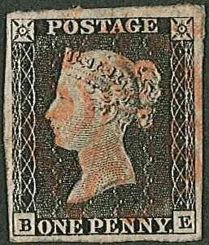
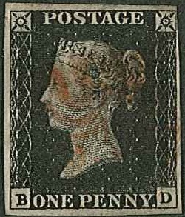
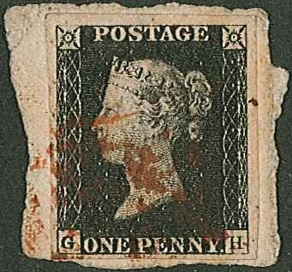
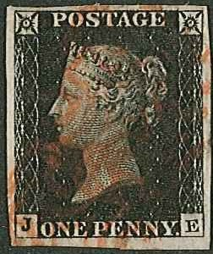
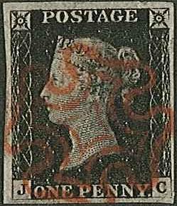
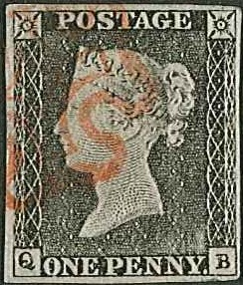
Stamps and Collectables Auction, 25 March 2019 Page 27 .

256 257 258 259 260 261
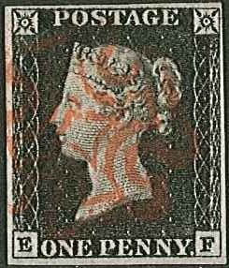
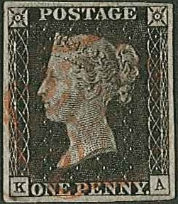
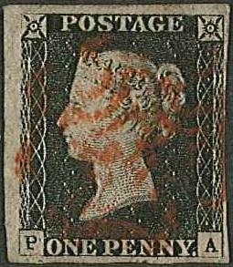
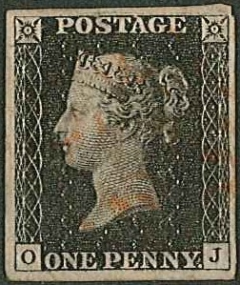
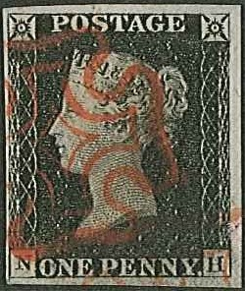
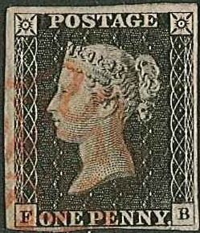

262 264 265 267 268 269

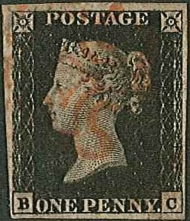
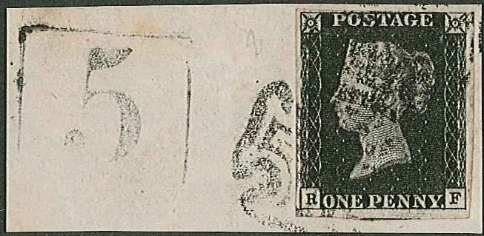
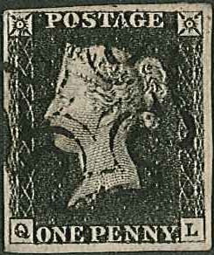
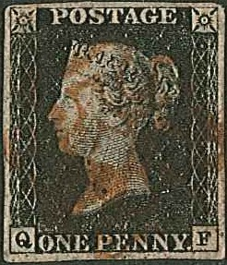
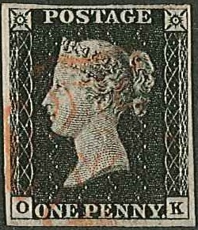
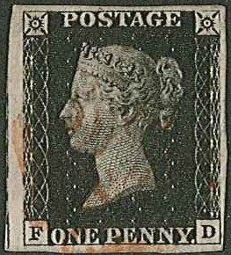
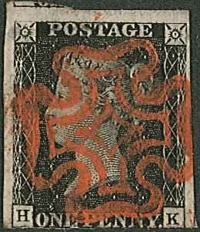
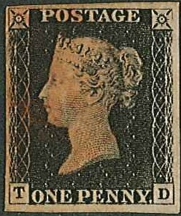

270 271 272 273 274

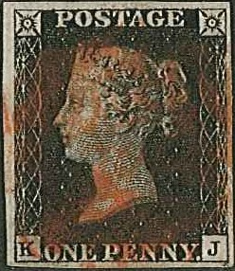
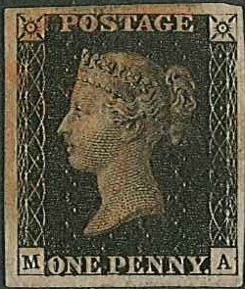
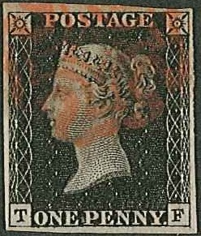

275 276 277 278 279 280

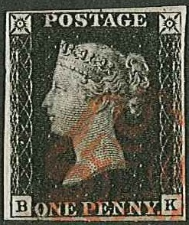
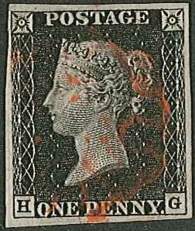
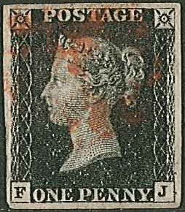
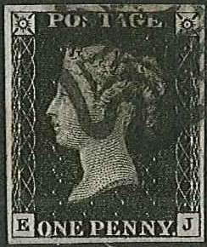
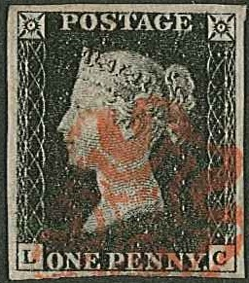
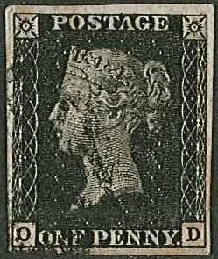

281 282 283 284 285 286

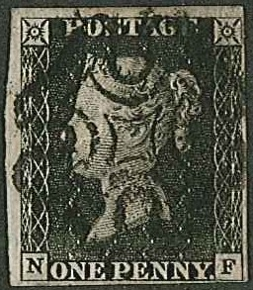
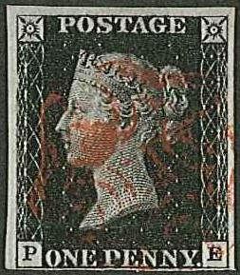
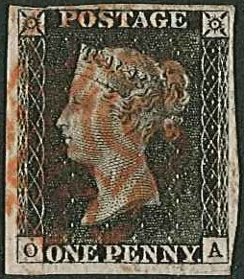
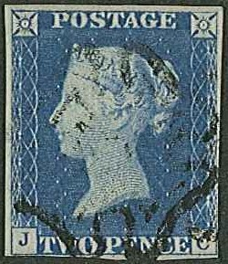
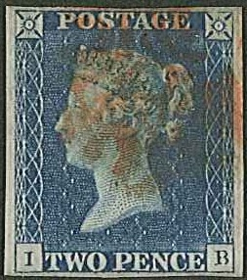
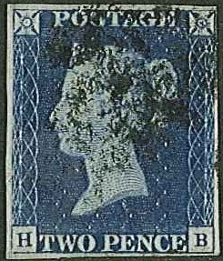

287 288 290 295 296 297

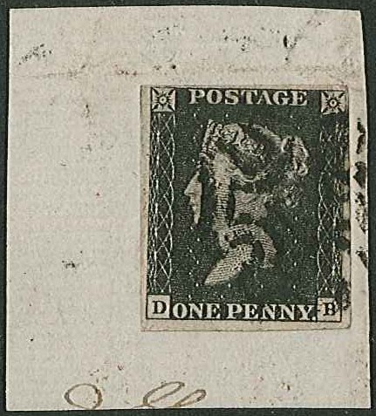
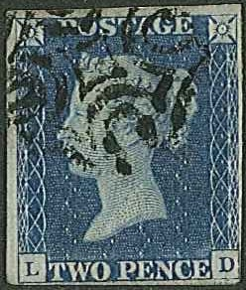
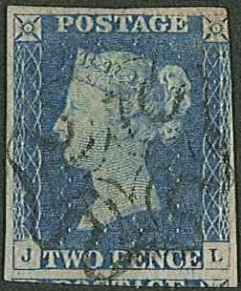
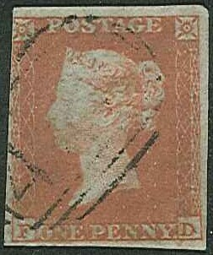
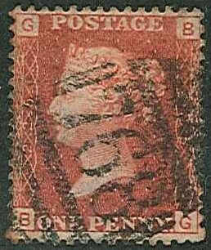
Stamps and Collectables Auction, 25 March 2019 Page 28 .

298 299 302 309
263

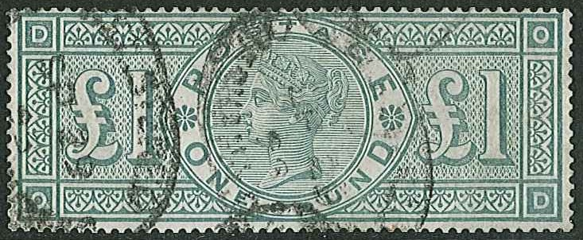
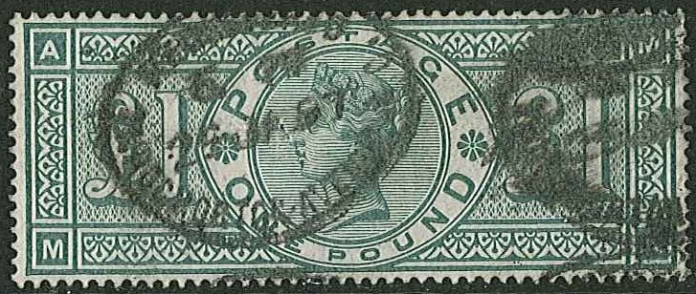

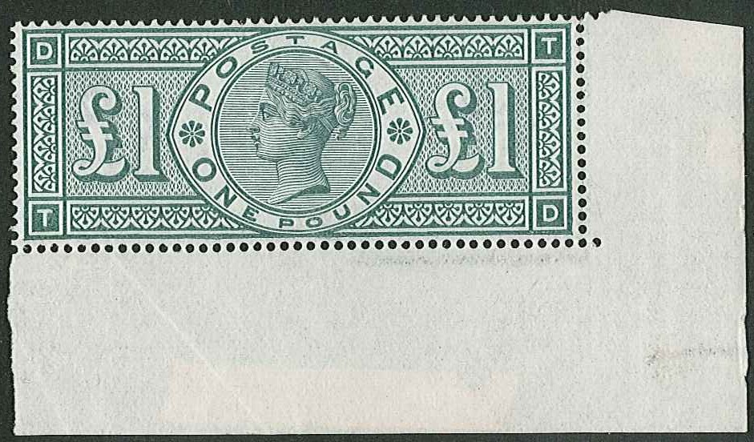
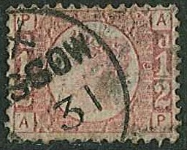
321 322

306
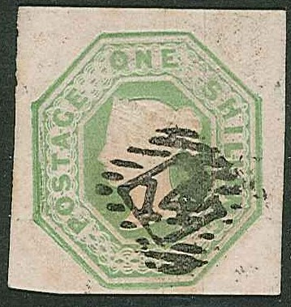

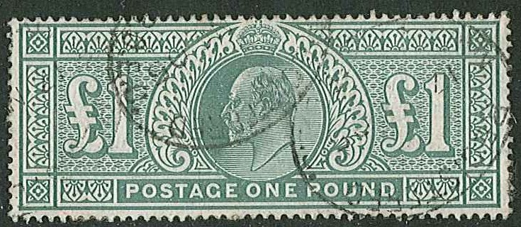
311
320
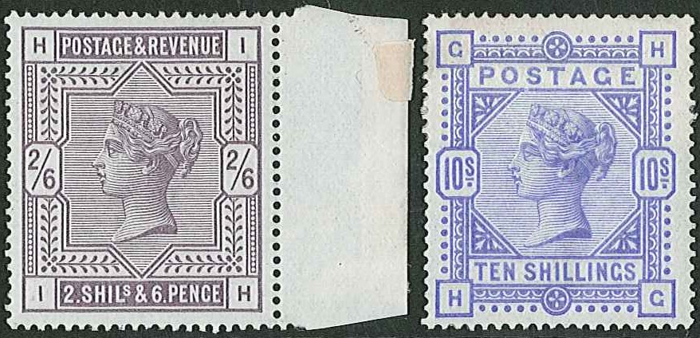

324
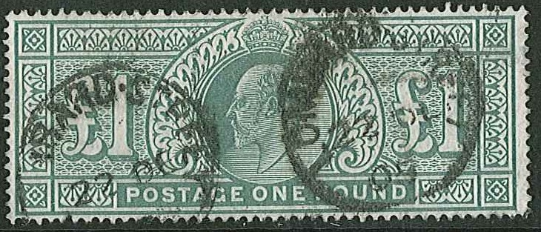

318

325

