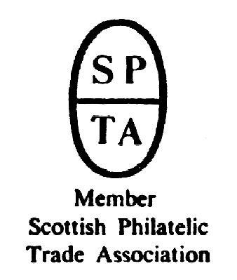

Robert Murray
5 & 6 Inverleith Gardens, Ferry Road,
Edinburgh, EH3 5PU
Tel. 0131 552 1220 :: 0131 478 7021
website www.stamp-shop.com email auction@stamp-shop.com
Stamps and Collectables Auction
AUCTION
CATALOGUE
ONE POUND
Monday 26 March 2018
at 7.00pm
Catalogue of Postage Stamps and Collectables to be sold by Public Auction, within the
STEWART’S-MELVILLE CLUB PAVILION, 523 FERRY ROAD, EDINBURGH, EH5 2DW.
On view at Pavilion on afternoon and evening of sale, and at Shop for one week prior to sale (see details later in catalogue).

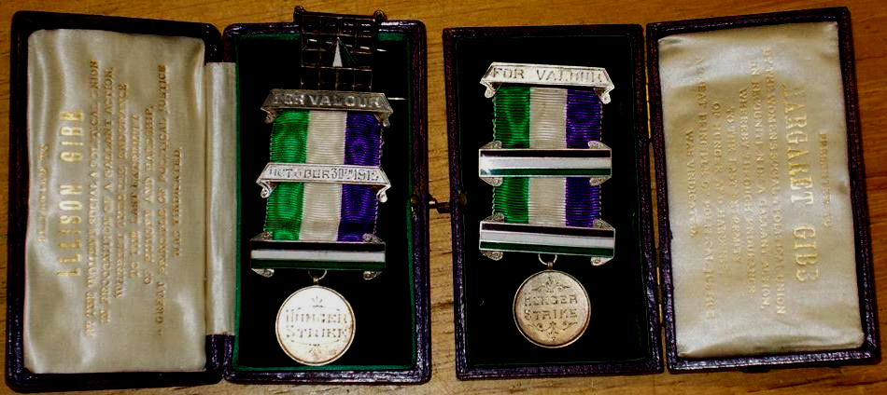

Lot 141.
Pair of Suffragette Medals, and “Holloway Brooch”, awarded to activist sisters Margaret and Ellison Gibb from Glasgow.

Stamps and Collectables Auction, 26 March 2018 Page 2 Estimate.
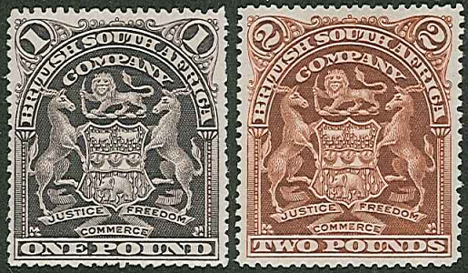
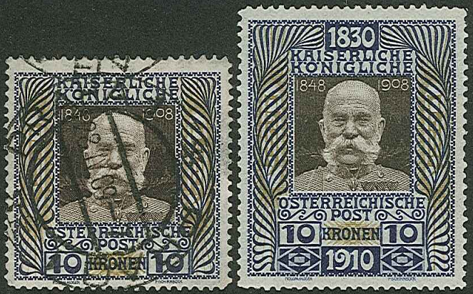
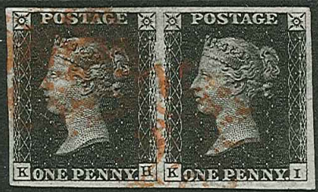
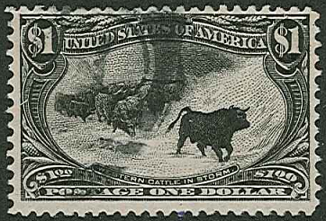
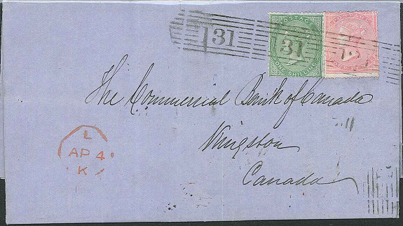
ex 171 ex 244 (NB not a short perf at foot)
247
ex 232
276 Edinburgh to Canada
Stamps and Collectables Auction, 26 March 2018 Page 3 Estimate.
Viewing times and shop hours are listed on page 7.
(Viewing starts on Tuesday 20th March.)

Collections and Mixed Lots.
1 A world collection in 31 green Gibbons medium springback albums, in two heavy boxes,
which seems to have started as a 3-volume collection A-G, H-P, Q-Z, and as each volume
was filled another was added in the same alphabetical split. Much in more common stamps,
and some duplication. Some m.m. stuck at hinges. Also 4 other binders. (10,000s) ☑ £170.
2 A similar colln. in 31 red Gibbons medium springback albums. (10,000s) ☑ .. £160.
3 Senf Illustrated Postage Stamp Album of c.1890 with mainly used odds up to about 1940
with a few later. Reasonably well filled with most in UK, Commonwealth, and Europe, inc.
two Penny Blacks (one 3-margin, other 1+), five Cape Triangulars, mixed condition, and
many others cat. in pounds. (Many 100s) ☑ .. .. .. .. £120.
4 Collection in three volumes mainly 1920s to late-1950s with much Commonwealth inc.
KG6 short sets m.m., UK 1951 high values m.m., 1952 Tudor set m.m. Also four junior
albums, a quantity of loose, empty album, literature, etc. Some toning. (100s) ☑ £120.
5 Four old albums (one without batters) with quite untidy world ranges, sometimes picked,
but still including much of interest inc. a few classics, and little after about 1930s. Messy
but interesting. (Many 100s) ☑ .. .. .. .. .. £100.
6 Three old Lincoln albums with integrated catalogues – 9th edition, 10th edition, and undated
(possibly 10th), with a variety of world stamps inc. Penny Black (3 margins). The 9th edn.
is picked over, the two others are largely original with stamps to about 1930 and a few later.
Also a 5th Series Oblong edition, picked over. (100s) ☑ .. .. .. £100.
7 A heavy carton of 21 assorted albums and stockbooks of world stamps inc. a Disney album,
and some loose (1,000s). Also some covers inc. UK FDCs 2001-3 (20) and £5 PNC. ☑ £100.
8 An old case with The Empire Postage Stamp Album (started 1917 and continued 1956 inc.
one-margin Penny Black, page of Penny Reds, and many odd values with little after 1960).
Also three other albums, loose, modern covers, literature, etc. (Many 100s) ☑ .. 90.
9 Second World War ammunition metal box (P60 MPB I 1943) containing stamps inc. a
Commonwealth album (1953-64 m.m. defin short sets to 1/-, and commem sets, but inc.
Aden to both colours of 20/-), 1953 Coron. in contemporary album m.m., 3 junior albums,
loose on/off-paper, etc. (Many 100s) ☑ .. .. .. .. 90.
10 Stockbook with much Commonwealth inc. Antigua 1938 set (12) u.m., Bermuda various
QV/KE7 m.m., Nyasaland 1945 set u.m. (thin on perf of £1), many modern u.m. inc. much
Canada with blocks, sheets and booklets. Also some foreign u.m. – Spain, USA etc. (Many
100s) ☑ .. .. .. .. .. .. .. 75.
11 Box with 13 junior type albums, with little added after 1960s, some slightly picked, but inc.
in one a Penny Black (2 margins, red MC), and other UK QV, and in another N.Rhodesia
KG5 10/- used, etc. (1,000s) ☑ .. .. .. .. .. 70.
12 Two flat cartons containing 148 “Gold Block” tobacco tins (many with fairly modern “Cav-
endish or Negrohead” labels) or similar with world stamps sorted by country. Some tins
only have a few stamps, but the larger countries are well filled. (1,000s) ☑ .. 70.
13 Old Lincoln album with remainder collection though still with much of interest remaining.
Little after about 1900. Very mixed condition, but still worth checking through. (100s) ☑ 60.
14 New issues from Switzerland 1970s/80s m. & u., other Europe and USA mint new issues.
Also UK presentation packs in 2 albums and other mint (face value c.£63), and loose world
on/off-paper. (Many 100s) ☑ .. .. .. .. .. 60.
15 Old album – 1862 Justin Lallier, Strand c.1930, Hamilton Adams & Co of c.1890, two
other albums, loose on-/off-paper (inc, 1953 Coron. colonies u.m.), covers, polypockets of
UK u.m. curled blocks of KG5/KE8/KG6, etc. (100s) ☑ .. .. 60.
PLEASE USED FIRST CLASS POST – DON’T MISS A BID FOR NINEPENCE !
A Buyer’s Premium of 10% (vat-inclusive) will be added to all sale prices.
Stamps and Collectables Auction, 26 March 2018 Page 4 Estimate.
Collections and Mixed Lots, continued.
16 Storage box with large Statesman album of world (many 100s), album of Germany Third
Reich, another of German WW2 Occupations, another two mixed folders and stockbook,
plus loose pages. (1,000s) .. .. .. .. .. 60.
17 Ideal Postage Stamp albums – vol.I to 1914, vol.II 1915-30, and vol.III from 1930, mostly
odd values, mainly used, fairly sparse with most in Commonwealth and Europe. Stamps in
mixed condition, albums reasonable. (100s) ☑ .. .. .. 60.
18 Two boxes with 27 assorted albums/stockbooks of world stamps, much used, inc. a poor
Penny Black, and a Philatector. Also another box of world, part sorted into tubs, and some
covers. (1,000s)  .. .. .. .. .. .. 60.
19 Mixed carton with a few junior-style world albums, bundle of UK FDCs, kiloware, and a
bag of Australia with many modern u.m. sets. (1,000s) ☑ .. .. 60.
20 A large and heavy carton with albums, album leaves, loose on/off-paper, covers, etc. While
much is fairly (or very) common, there are some better here and there. (1,000s) ☑ 50.
21 A similar large and heavy carton. ☑ .. .. .. .. 50.
22 A similar large and heavy carton. ☑ .. .. .. .. 50.
23 Another similar large and heavy carton. ☑ .. .. .. .. 50.
24 A heavy case with similar contents. ☑ .. .. .. .. 50.
25 A carton of similar material – slightly less volume. Fewer albums, more loose/covers. ☑ 40.
26 Box of world off-paper, wide range of countries and periods, with just a few on-paper. Net
weight c.3.2kg. (Many 1,000s) ☑ .. .. .. .. 50.
27 Old album to 1940s with poor Penny Black, very sparse 1915 Schaubek album, five junior
albums, loose stamps and covers, album of mainly modern Rhodesia/Zimbabwe FDCs (and
some commercial). ☑ .. .. .. .. .. 50.
28 Large Ka-Be stockalbum with wide range of stamps of many countries (many Europe), with
strength in early to middle periods. Includes many medium values, sets/part sets. (100s) ☑ 50.
29 Two-carton lot with 32 assorted albums/stockbooks of mixed world and covers, album
pages, loose, etc. (1,000s) ☑ .. .. .. .. .. 50.
30 Two cartons with world collection in five Senator albums. Also 19 assorted albums, album
pages, and loose in tubs and bags with much UK on-paper. (1,000s)  .. 50.
31 Box with 20 assorted albums/stockbooks etc. of world stamps. (1,000s) ☑ .. 50.
32 Carton with seven assorted world albums/stockbooks, UK FDCs in 2 albums and loose, UK
commercial covers in bag, tin of packets of mounts, etc. (Many 100s) ☑ .. 40.
33 Box with printed album of mint St.Lucia, album pages of m. & u. Jamaica, stockbook of
m. & u. Bermuda, 4 assorted albums, stockbooks, stockleaves, etc. (Many 100s) ☑ 40.
34 Box with Germany in album and stockbook, world covers in album and loose, album pages,
sheets of stamps in folder, remainder club books, etc. (Many 100s) ☑ .. 40.
35 A heavy carton with world mix inc. albums, stockbooks, album pages, loose stamps, packets,
covers, etc. (1,000s)  .. .. .. .. .. 40.
36 A similar lot.  .. .. .. .. .. .. 40.
37 A similar lot but in a tub.  .. .. .. .. .. 40.
38 Two stockbooks of mint world, and a stockbook of mint Germany. (100s) ☑ .. 40.
39 Box with album pages of stamps and covers, a Churchill collection, a binder and stockbook
of world, loose with much France on-paper, etc. (1,000s) ☑ .. .. 40.
40 Carton with a shoebox of loose and packeted on/off-paper, 30 small tins of world, album
and stockleaves of world, a stockbook of Sunday School labels, UK FDCs, world loose,
etc. (1,000s) ☑ .. .. .. .. .. .. 40.
41 A carton with a box of album leaves and packets, another box of off-paper, another box of
Sunday School labels in singles and blocks, stockbook of Belgium, Denmark, and UK,
stockbook of world, loose world, etc. (1,000s) ☑ .. .. .. 40.
42 Box with 12 assorted albums/stockbooks of world stamps, with a wide range of countries.
(1,000s) ☑ .. .. .. .. .. .. 40.
Stamps and Collectables Auction, 26 March 2018 Page 5 Estimate.
Collections and Mixed Lots, continued.
43 Box with 11 assorted albums/stockbooks of world stamps, inc. one of dupl. used Canada.
(1,000s) ☑ .. .. .. .. .. .. 35.
44 Apparently cheaper world mix in stuffed suitcase – albums and packets etc. (1,000s) ☑ 30.
45 Plastic tub with two-volume world collection, three stockbooks, covers in album and loose,
plastic bags of world off-paper. Also coins and banknotes in four small boxes. (1,000s) ☑ 30.
46 Box of loose world mainly off-paper, wide range of countries and periods, with just a few
on-paper. Net weight c.1.65kg. (1,000s) ☑ .. .. .. .. 30.
47 Carton with world colln. in 7 binders, also 4 other binders and a ledger book. (1,000s) ☑ 30.
48 Shirt box with varied mixture – packets, cards, club books, album pages – inc. Greece on
pages. (100s) ☑ .. .. .. .. .. .. 24.
49 A binder of Flowers stamps (some toning).folder of China 1964 Peonies set (15) used, plus
stockbook, binder, and loose of mostly UK and Commonwealth etc. (Few 100s) ☑ 24.
50 Three small boxes, one of mostly UK on-paper (c.1.8kg), another with world on-paper
(c.280g), and third with world off-paper (c.230g). (1,000s)  .. .. 24.
51 Box with three junior albums, packets and tin with much UK 1960s mint and FDCs, 1960s
commems in sheets (4), UK 1998 year pack (face value c.£17), literature, etc. (100s). ☑ 24.
52 Carton with world in 5 assorted binders, loose in packets, covers, etc. (Many 100s)  24.
53 Boot box with s’book of mint USA, two albums, album pages, some covers, etc. (100s) ☑ 20.
54 Two cover albums (much RAF and other UK). Also a stockbook, stockcards, and loose of
assorted world. (Many 100s) ☑ .. .. .. .. .. 20.
55 Box of old stamp catalogues etc., and a carton of matchbox labels and matchbook covers
mainly in albums.  .. .. .. .. .. 20.
56 Some pages of cheap Switzerland, six Swiss printer’s folders, plus minor items of Austria,
Australia, UK, and Hawaii forgery. .. .. .. .. 20.
57 Two older junior albums and some loose in packets. Little after 1950. (c.1,300) ☑ 15.
58 Shoebox of world on/off-paper. c.500g. (Many 100s) ☑ .. .. .. 5.
➲ A large car full of material arrived just as we finalised this catalogue, and the mixed stamp
lots appear here with brief descriptions (lots 59 to 71). The bulk is cheaper material, but
interesting things spotted here and there.
59 Three medium boxes inc. many covers, plus junior albums, etc.  .. .. 30.
60 Carton of albums.  .. .. .. .. .. 50.
61 Plastic tub of albums and a few pages. Commonwealth has many early QE.  .. 60.
62 Two medium boxes. Many albums and pages. Some useful.  .. .. 60.
63 Two boxes of mainly albums.  .. .. .. .. 50.
64 Box of mixed albums, and small box of UK FDCs.  .. .. .. 30.
65 Two boxes of albums and loose.  .. .. .. .. 30.
66 Box of albums etc., and box of mainly covers.  .. .. .. 40.
67 World Cup and other thematic, plus loose mix.  .. .. .. 40.
68 Basket of kiloware, box of albums and loose.  .. .. .. 30.
69 Three medium boxes of cheap and medium mix, inc. covers.  .. .. 30.
70 Box of albums inc. stockbook of Canada mint (stated face value $300).  .. 80.
71 Two boxes of mainly albums and pages.  .. .. .. .. 40.
Our Facebook page often has a few illustrations and further descriptions and comments, extra to what is in the catalogue. Just search for “Robert Murray Stamp Shop” . . . feel free to “like” us !
Remember the Buy or Bid Sale, which runs from 5pm until 5 minutes after the main auction finishes -
- you can buy items outright at the “buy” price, or place a bid at or above the “upset” price.
Material accepted for future sales – please make an appointment if you would like to discuss your lots.
A Buyer’s Premium of 10% (vat-inclusive) will be added to all sale prices.
Stamps and Collectables Auction, 26 March 2018 Page 6 Estimate.
Collections and Mixed Lots, continued.
72 British Commonwealth; two albums with m.m. of KG6 to mid-1960s with a few later inc.
many defin short sets to 1/- or 2/6 (or equivalent), but also some complete e.g. Singapore
1955 (15). A few tone spots, and some slightly stuck at hinge (which might lift). (100s) ☑ £100.
73 --; seln. of m.m. QV-KG5 better values - Lagos QV 2d, 3d, KE7 6d, Mauritius 1902 2r50
Postage & Revenue opt., KG5 10r, N.Nigeria KG5 10/-, Tanganyika 1916 NF opt. 1/-, Fiji
1878 Four Pence surch. (“as is”), and Montserrat 1903-8 1/-. S.t.c.£725. (9) .. £100.
74 --; unmounted mint seln. of nine different stamps of Bahrain, Burma, Fiji, and Hong Kong,
duplicated inc. some blocks. Some toning. S.t.c.£700+ (57) .. .. 75.
75 --; a stockbook of used inc. UK with light to medium duplication, a stockbook of mint inc.
UK, an album of mint Malta, Gilbert/Kiribati, and album of Nevis mint, and PNG m. & u.
(1,000s) ☑ .. .. .. .. .. .. 60.
76 --; stockleaves of u.m. Guyana, Nauru, New Hebrides, New Zealand, Norfolk Island, Papua
New Guinea, Penrhyn, etc. Mainly 1970s/80s sets, s.t.c.£540. (100s) .. 50.
77 --; stockleaves of Niue, Christmas Is., Norfolk Is., Cocos, Pitcairn, BIOT, etc. Mainly 1970s-
2000s u.m. sets, s.t.c.£400. (100s) .. .. .. .. 50.
78 --; SG One-Country albums for Australia, Canada, and New Zealand with mostly used to
1980, the NZ more mixed m./u. Also some pages of South Africa. (100s) ☑ .. 40.
79 --; stockleaves of u.m. Lesotho, Malaŵi, Malta, Mauritius, and Montserrat. Mainly 1970s-
80s sets. S.t.c.£425. (100s) .. .. .. .. .. 40.
80 --; stockleaves of u.m. Cook Is., Cyprus, Dominica, Fiji, Gambia, Ghana, Gibraltar, and
Gilbert & Ellice. Mainly 1960s sets, s.t.c.£460. (100s) .. .. .. 35.
81 --; stockleaves of Br. Virgin Is., Brunei, Canada, Cayman, Ceylon, Christmas Is., and Cook
Is. Mainly u.m. sets, s.t.c.£440. (100s) .. .. .. .. 35.
82 --; album of mostly used, much KG6 to QE (1960s). Also album of 1953 Coronation m.m.,
two later omnibus albums, a tin of on-/off-paper much 1950s/60s Malaya and area. Also
some covers inc. Malaya and a few foreign. (Many 100s) ☑ .. .. 30.
83 --; seln. in binder from Kenya to Lesotho mainly 1960s onwards used with much Kenya to
2009. Also a few stockcards of various countries, mainly earlier. (c.600) ☑ .. 20.
84 Europe; stockbooks of Romania/USSR, Netherlands, Switzerland (2), Czechoslovakia/
Czech Rep., and Germany. Also some loose. (1,000s) ☑ .. .. 60.
85 --; Eastern Europe; ten assorted albums/stockbooks of Poland, DDR, Bulgaria, Yugoslavia,
Hungary, Romania, and Czechoslovakia. Dusty. (1,000s) ☑ .. .. 50.
86 --; Western Europe; box with France (4 albums/stockbooks), Germany (3 stockbooks),
Sweden (1 album), Belgium (1 stockbook of mint), and Vatican (2 albums of stamps, covers
and cards). (1,000s) ☑ .. .. .. .. .. £100.
87 --; --; France 1853-1979 used colln. in Davo printed album, and an album of Germany
1872-1944. (100s) ☑ .. .. .. .. .. 20.
88 Foreign; a stockbook of Europe used, a stockbook of Latin America and Asia used, a stock-
book of Spain and Colonies m. & u. (1,000s) ☑ .. .. .. 40.
89 --; large stockbook of mostly used Switzerland to Zaire, well filled and with little duplication.
(1,000s) ☑ .. .. .. .. .. .. 30.
90 Scandinavia; binder with Faroes and Iceland FDCs, booklets, etc., Norway year books 1988-
91, stockbook of Sweden m. & u. inc. booklets, binder of Åland FDCs and a binder of
various countries maxi-cards etc. (Many 100s) ☑ .. .. .. 40.
91 Thematic; D-Day; 60th Anniversary colln. by Westminster in two volumes (24 covers, 1
PNC, 48 stamps, 12 m.s.). Also UK customised sheet of 10 x 1st. ☑ .. 20.
92 Covers; selection of world covers mostly 1930-55, much UK and Commonwealth, with
commercial mail and FDCs etc. (c.280) ☑ .. .. .. .. 60.
93 --; heavy carton with covers (much FDCs 1970s/80s) from UK (2 albums and loose), Jersey
(album), Guernsey (album), USA (album, loose in envelopes), W.Germany (album and
loose), etc. Also WWF covers in large album. (100s)  .. .. .. 30.
Stamps and Collectables Auction, 26 March 2018 Page 7 Estimate.
Collections and Mixed Lots, continued.
94 Covers; box with binder of AAT FDCs (c.48), binder of mixed covers (c.20), album of
Benham UK covers (c.47), album of Malaysian FDCs (c.37), postcard album of maxi-cards
etc. (c.80), etc. ☑ .. .. .. .. .. .. 30.
95 --; five assorted binders with various modern covers (Century of Flight, royalty, U.N.) (c.180).
Also 2 binders of postcards of aircraft, ships, and Australia (c.110), and a magnifier. ☑ 20.
96 --; box of world covers – commercial and FDCs. Also some postcards. (100s) ☑ 20.
97 --; Railways; album of UK philatelic covers, much 1990s Benham. (c.90) ☑ .. 50.
➲ Perfins; see UK (Perfins).
➲ Cinderellas; see Denmark, Malaya, Palestine.
98 Literature; The Plating of the Penny 1840-1864 (Brown/Fisher, GBPS, 1979-84), plus
Penny Red Stars, Die II Alphabet III, Part I – AA to JL (G.C.Tonna, 1980), The Plating of
Alphabet III, Plates 22-68, AA-DL (Wiggins, Tonna, 1973), and Ormond Plating Cards. ☑ 30.
99 --; several books on UK stamps inc. The Postage Stamps of Great Britain (4 volumes,
1950-62), A Study of the Cracked Units of the De La Rue One Penny Stamp 1902-1910
(Doupé, 1962), John Dickinson and his Silk-Thread Paper (Dagnall, 1975, missing sample),
etc. (11) ☑ .. .. .. .. .. .. 24.
100 --; mixed box of books or pamphlets on UK or Scotland postal history subjects. Some
standard works, some more unusual. (22) ☑ .. .. .. .. 35.
101 --; three various philatelic titles; Errors in Postage Stamp Design (Irvine & Seshold, 1979),
The De La Rue Keyplates (Lowe, 1979), and The Die Proofs of Waterlow & Sons, Part I,
GB & Empire to 1960 (Fraser & Lowe, 1985). ☑ .. .. .. 15.
102 --; five Scottish Postmark Group books; Dotted Circle Postmarks of Scotland, Mileage
Marks of Scotland, Post Offices in Scotland (Joe Henderson’s own copy, quite worn), and
two of Penny Posts of Edinburgh and District. ☑ .. .. .. 20.
103 --; two boxes of mixed catalogues etc. inc. world coins, world banknotes, Netherlands cat.,
Basler Taube, etc. (11)  .. .. .. .. .. 15.
A Buyer’s Premium of 10% (vat-inclusive) will be added to all sale prices.
VIEWING ARRANGEMENTS
Viewing at our Shop; The shop will be open at the following times for viewing.
Tuesday 20th March 12 noon-4pm Wednesday 21st March 2pm-8pm
Thursday 22nd March 10am-6pm, Saturday 24th March 12 noon-6pm.
Viewing by appointment available at some other times (e.g. the Friday).
Viewing at the Auction Venue; Monday 26th March;
Larger lots (marked “☑” in the description); on view at auction venue from 3pm: Smaller lots; on view by 4.00pm. Viewing will end at about 6.50pm. Lots marked “” are not taken to the auction venue (see information box below).

IMPORTANT; Viewing Arrangements for “Not-To-Auction” Lots this Sale
Our experiment with viewing arrangements in February worked fine, so we are repeating them this time.
This relates to all lots in this auction which have the “” symbol in their description, signifying that they will not be taken to the auction venue. We are making arrangements so that these lots can be viewed at our shop premises on auction day, and that purchases can be collected that same evening.
{a} In addition to the normal viewing arrangements noted above, any lots marked “” can be viewed at our smaller shop at 1A Inverleith Gardens, on Monday 26th March from 3pm to 6.45pm. Should there be pressure on available space, viewing will be at the discretion of our staff.
{b} After purchasing and paying for any “” lots at the auction venue, customers can take their receipted invoice to our shop and pick up these lots, from 8pm until ten minutes after the last customer has been cleared through accounts.
{c} Customers can still opt to collect their lots from us later in the week during shop opening hours.
{d} There is no parking directly outside 1A, so customers will have to park a little further along Inverleith Gardens. While we can lend you a trolley, there will be no available staff to carry boxes.
Stamps and Collectables Auction, 26 March 2018 Page 8 Estimate.
Non-Philatelic Items (Collectables)
BANKNOTES
104 Mixed world bundle of recent decades. Some simply left-over holiday money, some in
better condition. Wide mix of countries. (c.95) .. .. .. 50.
105 Scotland; 1949-72 seln. of 26 £1 notes (plus one £5) of mixed banks, issues, and grades
(F. to Unc.) some light duplication. Also seven Bank of England. .. .. £100.
106 United Kingdom; Treasury; three notes – {a} 1914 10/- TR1a, about fine, {b} 1914 £1
TR10e, fine, and 1923 Fisher £1 TR18b, VG. .. .. .. £100.
107 England; Newcastle upon Tyne Joint Stock Banking Company £5 note dated 1838, over-
printed “CANCELLED” twice, numerous creases and grubby. .. .. 20.
108 Uruguay; Bank Issues; five notes; {1} Banco Comercial de Paysandu 1866 20 centésimos,
Krause S141 VG, {2} El Banco Montevideano 1866 1 peso, Krause S353 VG/F, and three
of El Banco Italiano {3} 1867 20 centésimos, Krause S201 VF, {4} 1867 50 centésimos,
Krause S202 about VG but trimmed at top, and {5} 1867 1 peso, Krause S203 F/VF.
A fine group on notes seldom seen. .. .. .. .. £200.
CIGARETTE AND TRADE CARDS
109 Large stock of sets (bundled and wrapped but not checked by us) in five shoeboxes. Mix
of pre-war cigarette cards and modern tea cards etc. Probably c.300+ sets, catalogued at
thousands. ☑ .. .. .. .. .. .. £150.
110 Small suitcase with large numbers of cigarette cards, mainly in cigarette packets. The
majority are of the commoner issues, but better seen inc. some pre-1920s, and some
notably scarce. A mix of sets and odds. (1,000s) ☑ .. .. .. £100.
111 Dozens of sets of cigarette cards in plastic pages, plus c.150+ Brooke Bond sets in
packets. ☑ .. .. .. .. .. .. £100.
112 Large accumulation of cigarette and trade cards in carton. Some sorted, some loose – some
probably have been sorted but have been disturbed. (1,000s) ☑ .. .. 75.
113 Box with thousands of cards bundled by issue. ☑ .. .. .. 50.
114 Shoebox filled with bundles of cigarette cards (c.400), modern trade cards (c.1,000, inc.
many Star Wars, sport, Judge Dredd etc.), and sticker cards (c.875, inc. SPL, Star Wars,
Beano, etc.). Also some others. ☑ .. .. .. .. 50.
115 Accumulation of cigarette cards sorted into packets, mainly part sets. The majority more
standard issues, but some less common also included. (Many 100s) ☑ .. 40.
116 Brooke Bond; a wholesale quantity of cards, apparently in reasonable order, many bundled
in sets, and some as sorted odds. High level of duplication. Over 3 metres of cards, which
we estimate to be probably about 10,000 cards. ☑ .. .. .. 75.
117 D.C. Thomson; 1956 The World’s Best Cricketers duplicated bundle of 72 cards (all num-
bered between 1 and 18 – some same nos./different subject) cat.£3.35 = £241.20, and 1957
County Cricketers dupl. bundle of 58 cards (all numbered between 1 and 16) cat.£2½ each
= £145. .. .. .. .. .. .. .. 50.
118 --; 1957 Football Stars set (48 + 2 dupl.) cat.£120 + £4.80, 1958 World Cup Footballers
dupl. bundle of 34 cards (all numbered between 1 and 16) cat.£3.15 each = £107. Also
Barratt 1957-61 Famous Footballers (10 odds, cat £4.75 ea.). .. .. 40.
119 --; 1961 Cup-Tie Stars of All Nations set (16, cat.£68), Star Teams of 1961 set
(22, £90), and Famous Teams in Football History set (12, £70) plus four of 2nd series (£21).
All very fine in three original wallets. .. .. .. .. 40.
120 Wills (Australia); 1913 Animals (cut-outs, “Specialities”) set (missing no.23) in generally
VF condition. Cat.£50. (59 of 60) ☑ .. .. .. .. 15.
121 --; 1913 Animals (cut-outs, “Specialities”) quantity of duplicated odds (145), with only a
few numbers missing, generally F/VF condition. Cat. 85p each = £123. ☑ .. 15.
Email bids are acknowledged within 24 hours (1 hour on auction day). If no reply from us, please resend.
Stamps and Collectables Auction, 26 March 2018 Page 9 Estimate.
Non-Philatelic Items, continued.
COINS
➲ Estimates are based on a gold market price of £930/oz, and silver of £12./oz.
122 Mix in shoebox with main value in UK pre-1947 silver coins, also a couple of modern
silver, UK commem £5 (3), a few banknotes, etc. ☑ .. .. .. £350.
123 Mix in small box of mainly UK pre-1947 silver coins (face value c.£7)– generally lower
grades, but a high proportion being pre-1920. A few others also. ☑ .. .. £200.
124 Fairly small mix of coins, UK and foreign of various ages (back to Roman, nothing modern),
inc. several of interest. (c.90) ☑ .. .. .. .. .. 75.
125 Bulk lot with hundreds and hundreds of mixed world coins loose or in little bank bags, tins,
jars, etc. (c.13kg net weight) ☑ .. .. .. .. .. 60.
126 Box of mixed UK and foreign inc. S.Africa crowns 1948 (2), 1949, 1952 amongst very
mixed others. (100s) ☑ .. .. .. .. .. 50.
127 Shortbread tin filled with little bank bags of UK and world coins. Mainly commoner, c.8kg
weight. ☑ .. .. .. .. .. .. 35.
128 Small mix of mainly commoner UK but inc. 1826 shilling, etc. ☑ .. .. 30.
129 Scotland; Alexander III silver penny, probably class 3 (SA31D), F+. ☑ .. 40.
130 England; 1693 William & Mary shilling, about F-. ☑ .. .. .. 40.
131 United Kingdom; mix in Whitman folders with main value in the silver coins (face value
£3-3s-9d in pre-47, 3s-6d in pre-20) ☑ .. .. .. .. 75.
132 --; wooden and cardboard boxes of mainly duplicated UK coins, much decimal or late pre-
decimal, often in tubes or rolls. Mixed others e.g. older pennies, etc. Gross 20kg+ ☑ 60.
133 --; Gold; 1822 George IV sovereign, obverse F+, reverse F-. ☑ ▲ .. .. £220.
134 --; Silver; selection/accumulation of halfcrowns comprising QV (11), KE7 (38), KG5 pre-
1920 (33), 1925 (19), and 1930 (10). Average mixed condition. ☑ .. .. £500.
135 --; --; seln./accum. of florins comprising QV (13), KE7 (6), KG5 pre-1920 (23), 1921 (2),
1930 (16), 1932 (6). Average mixed condition. ☑ .. .. .. £260.
136 --; --; seln./accum. of shillings comprising QV (14), KE7 (17), KG5 pre-1920 (12), 1920
(1). Also 145 mixed sixpences QV to KG6. Average mixed condition. ☑ .. £200.
137 --; --; mix of pre-1947 silver coins, total face value £16.4s.6d. ☑ .. .. £300.
138 --; Maundy; 1893 set (4) EF though discoloured. ☑ .. .. .. 40.
139 United States of America; presentation box containing 14 different recent $1 (Presidents)
coins, each as a tube of 12 plus a single, plus 12 different Quarters (America the Beautiful)
each as tube of 12 plus single. Total face $221. ☑ .. .. .. £120.
140 --; three Indian Head cents – 1870 (VG), 1875 (VF), and another 1875 (VG/F). ☑ 30.
SCOTTISH PHILATELIC CONGRESS will be held as usual at the Dewar’s Centre, Glover Street, Perth, on Friday 20th April (10am-5pm) and Saturday 21st April (10am-4pm). There will be over forty stamp, postcard, and postal history dealers attending, plus exhibitions, junior workshop, etc.
Host Society this year is the Scottish Philatelic Society (it’s their 125th Anniversary), and being a member, Robert Murray will be providing one of the displays in the exhibition.
We’ll have a stand at Congress as usual, and look forward to meeting customers there. There will be a selection of stock available for sale, we can bring orders for customers, and we are always happy to have a chat.
This will be Robert Murray’s 45th consecutive year as a standholder at Scottish Congress.

Phoning for results ? Note that our shop does not open until noon on a Tuesday, and
we do not normally answer the phone on the day after the auction until after that time.
A Buyer’s Premium of 10% (vat-inclusive) will be added to all sale prices.
Stamps and Collectables Auction, 26 March 2018 Page 10 Estimate.
Non-Philatelic Items, continued.
MEDALS
141 Suffragette Medals; important pair of medals awarded to two sisters – Margaret Skirving Gibb
and Ellison Scotland Gibb.
Each medal comes in its original box, inscribed “PRESENTED TO/ELLISON GIBB/BY THE WOMEN’S
SOCIAL & POLITICAL UNION,/IN RECOGNITION OF A GALLANT ACTION/WHEREBY THROUGH
ENDURANCE/TO THE LAST EXTREMITY/OF HUNGER AND HARDSHIP,/A GREAT PRINCIPLE OF
POLITICAL JUSTICE/WAS VINDICATED.” (the second with identical wording but to “MARGARET
GIBB”).
Ellison Gibb’s has the top silver bar engraved “FOR VALOUR”, central silver bar engraved
“OCTOBER 30TH 1912”, and the lower enamelled bar engraved on reverse “FED BY FORCE 4/3/12”, on
a ring from which is hung the medallion engraved “HUNGER STRIKE” on front and “ELLISON/
GIBB” on reverse. The ribbon is in the vertical green, white and purple colours of the movement.
The whole is in excellent condition without any serious blemish, and the ribbon and box being
fresh.
Margaret Gibb’s is almost identical but with a central enamelled bar (rather than silver). The
central bar is engraved on reverse “FED BY FORCE 19.7.14”, and the lower one “FED BY FORCE
26/2/13”, and the medallion engraved on the reverse “MARGARET/GIBB”. Again in excellent
condition.
Also in the group is one silver portcullis badge as given to Suffragettes who were imprisoned in
Holloway prison (silver portcullis with two small fine chains at top, with “government arrow” in
purple, white and green fixed at centre, horizontal pin at centre rear). When this group came to us
this badge was in Ellison’s box, but we cannot say whose it was. The “Holloway Brooch” was
designed by Sylvia Pankhurst; the badge and the medals were made by Toyes.
Every Suffragette medal is rare and important. While the list of potential recipients includes
several pairs of sisters, this is the only pair to sisters we know of to have come on the market.
Behind the medals lies the amazing story of two Glasgow sisters, who combined being prize-
winning chess players with Suffragette activism. (And they were not the first in their family to
campaign for change; their three times great grandfather was William Skirving, one of the Scottish
Political Martyrs transported for sedition to Australia in 1794.)
Margaret had already served two months in Holloway for striking a Police Constable with a dog
whip, when on 17 July 1914 she entered the National Portrait Gallery in London and attacked
Millais’ portrait of Thomas Carlyle with a meat cleaver. ‘The Fury with a Chopper’; ‘A Hatchet
Fiend’ the newspapers of the day proclaimed, yet Margaret was right when she told the judge at
her trial “This picture will have an added value and be of great historical interest, because it has
been honoured by the attention of a militant”. Exhibitions at the NPG in 2014 and 2018 have
included the story of the attack, for which she was sentenced to six months in Holloway Prison
Her younger sister Ellison was active from 1908 to 1912. She threw stones and smashed windows
in London and Dundee, she protested at Downing Street, shouted at the Prime Minister H.H.
Asquith and in 1912 had a discussion with Winston Churchill (First Lord of the Admiralty at the
time, but Home Secretary for much of the Campaign) on the Stranraer to Glasgow train that
according to the press of the day ended with Churchill using words ‘more appropriate to a stair
head battle than to a Cabinet Minister’ and shouting “Remove this woman. You’ll never get the
vote !” The length of her prison sentences varied from three days to six months.
[Viewing by appointment.] [Potential bidders please register your interest in advance.]
[Starting price for this lot £7,000.] .. .. .. £10,000.
Stamps and Collectables Auction, 26 March 2018 Page 11 Estimate.
Non-Philatelic Items, continued.
MEDALS
142 Group of five comprising 1914 Star, 1914-1918 War Medal, and Victory Medal, plus
General Service Medal (KG5) with IRAQ clasp, and Army Long Service and Good
Conduct Medal (KG5 type A, fixed suspender), all named to 4647 Pte. A.Lee, 1/0 D.Gds.
(later 393067 Tpr. A.Lee, K.D.G.), some marks and wear. Accompanied by Soldiers’
Service and Pay Book, Certificate of Service, some photographs, etc. Also WW2 group of
three, plus Certificate of Service for 2981645 Fus. A.L.Newman R.Scots.Fus., etc. ☑ £150.
143 Standard WW1 pair named to L-3973 Dvr. J.Ferrie, R.A., no ribbons. ☑ .. 20.
144 Germany; Nazi “Für treue Dienste” Long Service Civil Cross for 25 years service, in orig-
inal box of issue, EF. Also Kriegsverdienstkreuz “1939” without swords. ☑ .. 20.
POSTCARDS
145 Broken old album with very mixed collection. Better cards inc. RP shopfronts (2), colliery
rescue teams (2), Troedyrhiw Colliery (1), WW1 silks (3), plus general views, some
personal photos, etc. (c.270). Also some loose. ☑ .. .. .. £100.
146 Mixed box of loose cards, mainly UK roughly 1930s-60s. Much is quite cheap, but a reas-
onable scattering of collectable/saleable cards seen. (100s) ☑ .. .. 60.
147 Bundle of mixed Edinburgh (c.120, generally quite repetitive mainly views of Princes
Street), and c.90+ others (Scotland and world, often with transport featured). ☑ .. 30.
148 Two small albums of mixed (c.300+) and pages of Aden (24) and Zeebrugge Raid (18) ☑ 30.
149 Silks; seln. of ten WW1 mixed designs inc. one of KOSB badge. Also a fabric Christmas
card (possibly same period), and six other postcards. ☑ .. .. .. 30.
150 Modern; four fruit trays with large accumulation of used and unused, UK and foreign cards.
Estimated roughly 12,000 cards.  .. .. .. .. 40.
151 --; a similar lot. (Est. c.12,000)  .. .. .. .. 40.
152 --; a similar lot. (Est. c.12,000)  .. .. .. .. 40.
153 --; a similar lot. (Est. c.12,000)  .. .. .. .. 40.
154 --; a similar lot, but in three trays. (Est. c.9,000)  .. .. .. 30.
155 --; a similar lot. (Est. c.9,000)  .. .. .. .. 30.
156 --; a similar lot. (Est. c.9,000)  .. .. .. .. 30.
157 --; four smallish boxes of mixed cards (est. c.1,500)  .. .. .. 10.
OTHER CATEGORIES
158 Model Vehicles; Carton of Lledo Days Gone and similar (78, and 2 sets of 3), Vanguards
(8, and 2 sets of 2), all of these boxed, and 12 assorted model vehicles, some unboxed. ☑ £100.
159 --; Atlas Editions; box of Classic Sports Cars (4), Ships (4), Minitrains (4), other vehicles
(5), etc. Also Lledo Days Gone and similar (18). Mostly boxed. ☑ .. .. 40.
160 --; --; box of 1:76 Eddie Stobart lorries, most still wrapped. (20) ☑ .. .. 40.
161 --; --; box of fire engines (1:76 ?), most still wrapped. (15) ☑ .. .. 30.
162 Photographs; packet of mixed photos, mainly Scotland and often with a transport theme
inc. trams and railways. Some have pencil notes on reverse. ☑ .. .. 30.
163 Scouting; A box full of The Scottish Scout 1930s/40s, quite possibly duplicated, and not
checked by us. Also copies of The Scout and 1958 Scout Annual.  .. 20.
164 Collectables Mixed Lots; small mix of coins (inc. some UK pre-1947 silver), some naval
buttons, small silver boxing medal, a Princess Mary Gift Box, a few cigarette cards, and
others. ☑ .. .. .. .. .. .. 35.
165 --; a few albums of cigarette cards, four Newcastle United football programmes (inc. 1952
Cup Final), empty tins, etc. ☑ .. .. .. .. .. 20.
166 --; box of postcards, coins, and others.  .. .. .. .. 15.
End of Non-Philatelic Section
A Buyer’s Premium of 10% (vat-inclusive) will be added to all sale prices.
Stamps and Collectables Auction, 26 March 2018 Page 12 Estimate.
Stamps Classified by Country
167 Antigua; 1882-1976 album leaves of mint (and a few used) inc. 1953 defin set (15) m.m.,
s.t.c.£304. (c.160, 1 m.s.) .. .. .. .. .. 30.
➲ Ascension; see South Africa.
168 Australia; 1913-2003 used colln. in two-volume SG printed albums. Also AAT 1957-98.
Most stamps mounted in photocorners. Also another similar used volume 1913-92 and AAT
1957-93, mostly held in mounts, and 1998 “links” pack. (100s) ☑ .. .. 50.
169 --; 1980 (Stamp Week) to 2007 (Shipwrecks) u.m. collection in three stockbooks inc. book-
lets and miniature sheets. Seems quite complete. Total face value estimated c.$1,250.
(100s) ☑ .. .. .. .. .. .. £170.
170 Australian Antarctic Territory; 1971-2001 dupl. seln. of used (c.t.o.) inc. blocks and m.s.
S.t.c.£340. (c.130, 3 m.s.) .. .. .. .. .. 40.
171 Austria; 1850-1964 m. & u. colln. in album, with mostly used at start inc. 1850-54 imperf.
1k (2), 2k (2), 1858 3k, 1867 50kr (3), and 1890 values with perf. varieties. From 1899
there are mint and used (sometimes both), and with better values e.g. 1908 10k u., 1910
2k, 5k, 10m (couple blunt perfs) m.m., and a good run to 1937. 1945 overprints inc. set
(19) m., 1rm (2), 2rm (3), 3rm (2), 5rm (2) mint, then mint or used (or both) inc. 1948
Costumes m. (missing 10s), and so on inc. some fourblocks. (Many 100s, 11 covers). ☑ £240.
172 Bahrain; 1933-61 m. & u. colln. on pages inc. 1938-41 odd values to 5r u., 1942-45 set
(13) l.m.m., 1948-49 set (11) m.m., 1950-55 set (9) l.m.m., 1955-60 Castles set (3) l.m.m.,
etc. (c.145) .. .. .. .. .. .. 70.
173 --; 1938-41 1r u.m. block of eight (2 x 4 with central horizontal gutter). SG 32, cat.£80,
light gum toning. .. .. .. .. .. .. 15.
174 Bermuda; 1938-53 seln. of 2/- (7), 2/6 (1), and 5/- (3) mainly u.m. though two or three
faults. .. .. .. .. .. .. .. 40.
175 British Occupation of Italian Colonies; 1942 set (5) f.u., 1943-47 set (11) f.u., and 1942
p.due set (5) f.u. .. .. .. .. .. .. 20.
176 --; Eritrea; 1948-49 set (13) f.u., 1950 set (13) l.m.m., and a few others. (49) .. 40.
177 --; Somalia; 1943-46 set (9) both l.m.m. and used, 1948 set (11) f.u., and a few others. (38) 50.
178 --; Tripolitania; 1948 set (13) l.m.m., same set f.u., 1950 set (13) l.m.m. (240l light crease),
1948 p.due set (5) l.m.m., etc. (55) .. .. .. .. 90.
179 Bulgaria; attractive mint range on stockleaf, nearly all as u.m. fourblocks, inc. 1921-23 set
(13 blocks), various 1924 surcharges, etc. S.t.c.£260. (c.130) .. .. 30.
180 --; 1927-28 Air opt. set (4) in u.m. fourblocks (2l) block weak perfs), SG 281-4 cat.£340. 35.
181 --; 1931 Balkan Games set (missing 10l, extra 50l), 1932 Air set (3), 1933 Balkan Games
10l (2), 12l (2), and some earlier postage dues. All used, but cancels not guaranteed. S.t.c.
£960. (32) .. .. .. .. .. .. 60.
182 --; 1932 Air set (3) unmounted mint (couple of small faults on 24l). SG 323-5 cat.£250. 30.
183 Canada; 1899 surcharges (2), 1903-12 KE7 set (7), and 1908 Quebec set (8) all used,
mainly fair to fine sound (KE7 50c heavy cancel, Quebec 20c small corner cancel may not
be original). Cat.£567. .. .. .. .. .. 30.
184 --; 1980 (Alberta/Saskatchewan) to 2007 (Law Society) u.m. collection in three stockbooks
inc. stamp booklets and miniature sheets. Seems complete. (100s) ☑ .. £150.
185 China; c.1930 cover with four adhesives, one of these the 1925-35 1c on 3c with the
“missing stop” variety (SG 367a cat.£45.). Tone spots on cover. .. .. 30.
186 --; People’s Republic; 1968 41st Anniv. 8f g.u. on cover. Also 1950 Sino-Soviet set (3) unu.
but “as is”. .. .. .. .. .. .. 10.
187 --; --; 1978 Galloping Horses set (10) u.m. (one short perf and one tiny spot on 8f, and
corner bend on 60f). Cat.£65. .. .. .. .. .. 12.
188 --; --; 1986-2013 box of twelve various special packs/books inc. 1986 and 1988 year packs
and later well-illustrated books/packs inc. some silk packs with various stamps, covers, etc.
One duplicate. Minor knocks. ☑ .. .. .. .. 40.
Stamps and Collectables Auction, 26 March 2018 Page 13 Estimate.
189 Denmark; 1994-2000 seln. of six different u.m. se-tenant booklet panes, cat.£42.75 12.
190 --; Locals; small lot of duplicates (200+), also a few Norwegian locals (20) .. 20.
191 Egypt; mint and used in five assorted albums/stockbooks, little after 1970s. Also a few UK
overprinted EAF etc. (100s) ☑ .. .. .. .. .. 30.
192 Falkland Islands and Dependencies; mostly used seln. on stockleaves etc. inc. Falkland
1952 £1 u., Dependencies 1954 2/- (5), 2/6 (3), 5/- (4), 10/- (5), £1 (5) used, most with
faults (mainly creases, short perfs, etc., some tears). Also an envelope of FID 1946 Maps
dupl. used (c.135, 1 cover) .. .. .. .. .. 40.
193 Fiji; 1912-23 2½d two blocks of twelve (each 6 x 2, lower-left and lower-right marginal),
1915-19 War Stamp 1d block of 12, and 1922-27 6d in strips of 4 and 3. All u.m. some
toning or small faults. Cat.£136. .. .. .. .. .. 20.
194 France; 1979 (Comédie-Française) to 2007 (Albert Londres) u.m. collection in four stock-
books inc. booklets and miniature sheets. Appears close to complete. (100s) ☑ £150.
195 Germany; 54 remaindered club books, mainly Third Reich, Occupations, West Germany,
Berlin, DDR. Vendor gives remainders as being PTSA £769. (100s) ☑ .. 70.
196 --; selection comprising 1938 Culture Fund 12pf u.m. fourblock (cat.£64, one damaged),
Zeppelin set (2) in u.m. fourblocks (£268), Reichparteitag 6pf u.m. blocks of 4 and 6 (£240),
1939 Derby 25pf u.m. pair (£190), and 1940 Heligoland 6pf m.m. (£9). .. 50.
197 --; 1941 Prisoner of War lettersheet from Oflag VIIA, addressed to Lublin (Poland), and
two 1943 reply lettersheets from Kielce and Checiny to the same camp (to a different
prisoner). Each has datestamp and censor marks. .. .. .. 24.
198 --; British/American Zone 1949 Cycle set (2) l.m.m., Goethe set (3) u.m./m.m., W.Germany
1949 Stamp Cent. set (3 + extra 20pf) m.m., and Refugee set (4) m. (some short perfs),
W.Berlin 1949 red opt. 25pf u.m. (crease). S.t.c.£500. (14) .. .. 20.
199 --; West Germany 1949-80 mint colln. in old Lighthouse printed album (mainly u.m., patchy
to 1952), West Germany 1949-76 used colln. in old Lighthouse printed album (some useful
earlier), a third Lighthouse album with 1959-81 u.m. W.Germany and W.Berlin, a stockbook
of dupl. used W.Germany and Reunified 1960s-90s, and a album of c.180 covers 2001-7
(c.180, many special cancels). ☑ .. .. .. .. £100.
200 --; binder of m. & u. W.Germany, Berlin, and Unified to 2004. Also some miniature sheets,
covers, etc. (100s) ☑ .. .. .. .. .. 20.
201 --; West Germany; 1949 Parliament set (2, one bad perf on 10pf), Stamp Cent. set (3),
UPU 30pf, 1949 Refugee set (4), and Bach set (2), all unmounted mint but most probably
regummed. S.t.c.£620. (12) .. .. .. .. .. 40.
202 --; West Berlin; 1949-54 Buildings set (first 4pf, 20pf only) m.m. (some heavily mounted),
cat. c.£900. (19) .. .. .. .. .. .. 40.
203 Gibraltar; 1889-1992 mostly used colln. in broken stockbook inc. KG5/KG6 perforations.
Also at the front an u.m. colln. from 1966-92. S.t.c.£900+. (100s) ☑ .. 60.
204 Hong Kong; 1882-1983 mostly used range on small pages and stockcards with largest value
in KG5 used values to $2 (2), $3 (2), $5 (2), and $10 (2) but some with cancels which are
not guaranteed. (c.330) .. .. .. .. .. 70.
205 --; 1992 defins in two pres. packs (one to $5, other to $50), year packs for 1993 (2), 1994,
1995, 1992 set (21) u.m., 1997 set (16) u.m., FDCs 1983-97, etc. .. .. 40.
206 Hungary; 1932 Madonna set (4) fine mounted mint. SG 535-8 cat.£500. .. 50.
207 India; 1856-1949 mainly used range on stockleaves with 1895 3r f.u., 5r g.u., 1902-11 15r
g.u., 1911-22 25r heavy u., 1937-40 15r fair u., 1949-52 set (16) mixed u., etc. (c.250+) 40.
208 Indian States; fair range of Convention and Feudatory States mint and used on stockleaves
with little dupl. (c.500) ☑ .. .. .. .. .. 30.
➲ Indonesia; see Netherlands Indies.
209 Israel; 1948-79 colln. in album of used, with some m.m., covers, and used postage dues.
Also Palestine 1918-42 m.m. & u. (100s) ☑ .. .. .. .. 40.
A Buyer’s Premium of 10% (vat-inclusive) will be added to all sale prices.
Stamps and Collectables Auction, 26 March 2018 Page 14 Estimate.
210 Israel; 1948-72 with a few later mint (mixed m.m./u.m.) colln. in broken stockbook. Also
some used and FDCs. (c.650) ☑ .. .. .. .. .. 35.
211 Kenya Uganda and Tanganyika; 1935-63 seln. of used on album pages inc. 1954 and 1960
defin sets. Also some Officials. S.t.c.£222. (c.110) .. .. .. 20.
212 Kuwait; 1923-61 l.m.m. on leaves inc. 1933-34 Air 2a, 3a, 6a, 1939 short set to 1r, 1955-57
Castles set (3), etc. (127) .. .. .. .. .. 45.
213 Malaya; collection in stockalbum from QV to about 1960s. More used than mint, with
some higher values throughout, although also some faulty, some fiscal cancels, etc. Decent
overall range. (c.650) ☑ .. .. .. .. .. 60.
214 --; Revenues; Selangor 1897-1902 $3 and $10 with “J” overprints, and 1900-02 10c, 50c,
$1, $2, and $5 overprinted “Judicial”, all used, mainly good/fine. Barefoot cat.£82½. 20.
215 Mauritius; 1900-05 2r50 g./f.u. (SG 154, cat.£160), and 5r m.m. (155, £110). .. 65.
216 Morocco Agencies; 1907-57 mainly mint (l.m.m./m.m.) colln. on pages inc. Spanish
1914-26 12pt on 10/- l.m.m. (off-centre), Tangier QE complete, etc. (c.210) Also a few
British Levant (19) .. .. .. .. .. .. 35.
217 Netherlands; 1852-1992 collection in two-volume Davo printed album, mostly used to
1939, then mostly mint (mounted to start with then mainly u.m. from 1971). Also includes
booklets, panes, m.s., I.C.J., postage dues, machine labels, etc. Well-filled. (1,000s) ☑ £100.
218 --; binder of FDCs 1961-89 (c.120), also a stockbook of fairly modern mint and used
(c.350). ☑ .. .. .. .. .. .. 20.
219 Netherlands Antilles; 1873-1988 colln. in Davo printed album, mixed m. & u. to 1950,
then more m. than u. and fairly complete to 1976, later is more odd values. Also Antilles
postage dues, Netherlands New Guinea, and Aruba. (100s) ☑ .. .. 60.
220 Netherlands Indies and Indonesia; 1870-1983 collection in Davo printed album, mostly
used to 1930, then more mixed m. & u. Also includes postage dues, officials, m.s. Well-
filled. (100s) ☑ .. .. .. .. .. .. 70.
221 New Guinea; Officials; 1919-23 ‘Roo 6d used, faded, badly torn then repaired on the
reverse with sticky paper, apparently at the printing works where opts. were applied. 10.
222 New Zealand; 1855-1990 used collection in album inc. 1855-64 imperfs (11) to 1/-, 1864-71
perforated (12) to 1/-, 1898-1907 dupl. values to 2/-, KE7 to 1/-, also officials to 1/-, KG5
various inc. officials, 1920 Victory set (6), and a run of later defins and commems. Cond-
ition mixed in early QV, others mainly fine. (100s) ☑ .. .. .. £150.
223 --; 1855-2002 used colln. in two-volume SG printed albums. Also some officials, Life
Insurance, etc. Most held by photocorners. (100s) ☑ .. .. .. 40.
224 --; 1873-1990 m.m. collection in album inc. 1892-1907 to 2/- (22), KE7 to 1/-. KE7 officials
in pairs to 1/-, 1913 Auckland ½d, 1d, 3d, 1920 Victory set (6), various KG5 inc. officials,
1931-35 Airs (8), 1935-36 to 3/- (14), and officials to 1/- (11). Thereafter a run of defins
and commems inc. KG6 to 3/-, QE to 1953 10/- and 1960 £1. Mainly fine but some toning.
(100s) ☑ .. .. .. .. .. .. £140.
225 --; Christmas 1980 to Christmas 2007 u.m. collection in four stockbooks inc. booklets and
m.s. Seems complete. (Many 100s) ☑ .. .. .. .. £150.
226 --; collection in album with Health stamps 1929-92 m.m. inc. 1931 Smiling Boy set (but
toning), similar used (without 1931), Christmas 1960-91 m.m. and 1960-92 used. (100s) ☑ 50.
227 --; 1957-90 album with colln. of Health miniature sheets fairly complete m.m. plus some
used m.s. Also Life Insurance m.m. & u., postage dues used. Some toning. (100s) ☑ 50.
228 --; album of 1960-61 stamps and covers inc. defins to £1 m.m., 1960-61 Health sheets m.m.
and u., Officials KE7-QE m. & u. inc. 1936 values to 2/- m.m., etc. Also 1989-94 new
issues u.m. and used, and others loose and in stockbook. (Many 100s) ☑ .. 30.
229 Palestine; Cinderella; 1924 pieces (21) torn from cheques, each with a Turkish revenue
stamp overprinted “A.D.P.O./Z.O./P.S. 1” (Administration de la Dette Publique Ottomane/
Zone Orientale/1 piastre). Probably not very valuable, but certainly unusual. .. 10.
Alternative bids, and overall spending limits, are acceptable. Advice available if required !
Stamps and Collectables Auction, 26 March 2018 Page 15 Estimate.
230 Pitcairn Islands; 1940-83 mostly mint colln. in stockbook inc. 1940-51 set (10) m.m., 1940
original set (8) u., and later. (c.190, 6 m.s.) ☑ .. .. .. 20.
➲ Poland; see Germany 1941.
231 Qatar; 1957-59 complete run l.m.m. (inc. both issues of Castles, but missing 1961 2r) (38).
Also Trucial States 1961 set (11) l.m.m. .. .. .. .. 40.
232 Rhodesia; 1898-1908 short set to £2 mounted mint. The values 1/- upwards are all fine and
clean m.m. (a couple quite heavily hinged, and some rough perfs on £1), the lower values
more mixed. Also dupl. of five low values. Cat. c.£1,150. (21) .. .. £200.
233 --; 1909-11 m. & u. seln. of the surcharges with light dupl., one block, mainly good/fine.
S.t.c.£200. (21) .. .. .. .. .. .. 30.
234 Sierra Leone; 1896-97 short set to 5/-, 1903 short set to 5d, and 1907-12 6d, all m.m.,
mainly good/fine, some toning. Cat.£256. (21) .. .. .. 40.
235 South Africa; 1925 (26 March) cover addressed to Ascension Island. Plain envelope
franked with 1925 Air 6d and defin 2d, cancelled Queenstown, with airmail etiquette, S.A.
AIR MAIL/27 MAR.1925/S.A. LUGPOST violet cachet, manuscript “Per S.S. Gaitra” (?), and
possibly “Train late”. Some faults but scarce destination. .. .. 50.
236 --; 1933-48 hyphenated set (10 horizontal pairs) u.m. – the ½d m.m., the 2nd 2d a little
poorer, and 10/- centred low. Cat.£300. .. .. .. .. 40.
237 --; 1933-34 Voortrekker set (4 pairs) m.m. (cat.£17, two creased), 1938 Voortrekker set (4
pairs) u.m./m.m. (£80.), 1938 Voortrekker set (2 pairs) u.m. (£21½), and 1939 Huguenot set
(3 pairs) u.m. (£50.) .. .. .. .. .. .. 30.
238 --; 1947-54 defin set (missing 2d) m.m./u.m. in pairs or blocks inc. 5/- in both shades.
Cat. approx. £240. (11 items) .. .. .. .. .. 40.
239 Suriname; 1873-1984 (a few later) m. & u. colln. in Davo printed album, mixed m. & u. to
1949, then more m. than u., and fairly complete to 1975, later much less so, with odd values.
Also inc. postage dues. (100s) ☑ .. .. .. .. 50.
240 Sweden; 1971-93 (and a few earlier/later) colln. of FDCs in four binders. (c.200) ☑ 20.
241 Switzerland; 1850-1966 m. & u. colln. in an album with mainly used to start inc. 1850-51
5r, 10r, and a good run of values mostly u. to 1951. From 1952 mint or used. Also Pro Juv-
entute m./u. sets 1913-66 fairly complete, and Pro Patria 1952-66 similar. Also postage dues
and officials used, and International Organisations m. (100s) ☑ .. .. 80.
242 --; 1862-1978 colln. in album of used, with some m.m., Pro Juventute 1913-90 used, Natio-
nal Fête and Pro Patria used, postage dues used, and International Organisations m.m. & u.
Also an album of dupl. used, and a binder of FDCs 1988-89 with some later. (100s, c.65
covers). ☑ .. .. .. .. .. .. 50.
243 United States of America; 1893 Columbian odd used values inc. 15c g.u. and 50c g./f.u.,
also 1887-88 odd used defins, and 1888 Special Delivery 10c g.u. S.t.c.£400. (21) 30.
244 --; 1902 Trans-Mississippi 1c, 2c (3), 4c, 5c, 50c, and $1 used, plus 1c and 2c used on
individual covers. The 50c is good sound used, the $1 g./f. sound used with moderate cancel.
Cat.£850+. .. .. .. .. .. .. £100.
245 --; mainly used colln. in stockalbum. Earlier years inc. some
scarcer but often in poorer condition, and continuing through to about 1960s. (c.900) Also
SG USA Sectional cat. (2010 edition). ☑ .. .. .. .. 40.
246 Yugoslavia; 1970 Nature Conservation 3d25 Lammergeier (bird) complete u.m. sheetlet of
nine. Probably over-catalogued at £16 each (= £144.) but still fairly scarce. .. 10.
AUCTION PROGRAMME
 4 June 2018 
This date, though fairly firm, is still provisional. The publication of the auction catalogue is confirmation of the date.
The  symbol shows that the lot will not be taken to the auction venue, and has to be collected from us.
A Buyer’s Premium of 10% (vat-inclusive) will be added to all sale prices.
Stamps and Collectables Auction, 26 March 2018 Page 16 Estimate.
United Kingdom
247 1840 Penny Black plate 5 pair KH-KI fine used with four good even margins, slightly
smudged red MC cancels. Attractive but little paper flaw at left, and may have been
pressed. .. .. .. .. .. .. .. £140.
248 1840 Penny Black JH plate 7 fine used with four even margins, light red MC, flattened
vertical crease. Also 1840 Twopence Blue ME fine used with four margins and black MC
on a piece to which it probably belongs (only just tied). .. .. .. £100.
249 1873-80 3d plates 11, 12, 14, 15 (2), 16, 17, and 18 (2), all average sound used. Cat.£720. 30.
250 1873-80 4d sage-green plate 16 unused, spacefiller quality. (SG 153 cat.£1,400). 15.
251 1880-81 2d pale rose overprinted SPECIMEN, fair only. SG 168s cat.£110. .. 15.
252 1887-92 “Jubilee” 1/- green – 177 used example in little stockbook, generally average
sound quality and inc. many pairs, strips, and blocks. Cat.£14,160. .. .. £100.
253 1999 Total Eclipse miniature sheet imperforate error, unmounted mint and very fine. It
would appear that only five examples have previously been recorded, and this example has
not previously been reported or offered for sale. SG MS2106a, catalogue price £18,000.
.. .. .. .. £3,000.
254 2000 Queen Mother booklet pane from The Life of the Century prestige booklet (4 x 27p
Queen Mother) SG 2160a, error totally imperforate. Mint, unhinged with full gum, but gum
has adhered to following page of text at small area at top, and detached leaving a mark on
the gum. Pane still in the complete booklet, which has the front cover illustration in green,
some other wear to cover, etc. .. .. .. .. .. £500.
255 Country Stamps; Guernsey 1967 3d phos. half-sheet, 1967 4d phos. full sheet (with one
“stem flaw”), Jersey 1967 3d phos half-sheet, and 4d phos. half-sheet (with one “neck flaw”),
all u.m. .. .. .. .. .. .. .. 12.
256 Booklets; 1936 KE8 3/- booklet (edition 320) fine and complete though with scratch on
back covers, and some trimmed perfs (and a used stamp stuck on back of airmail labels).
SG BC3 cat.£120. .. .. .. .. .. .. 20.
257 --; 1952 KG6 1/-, 2/6, and 5/- booklets SG BD8, BD20(15), BD31(5), and 1953 QE
5/- SG H1, all complete in good/fine condition, with some curling of stamps. Cat.£185 (4) 30.
258 --; 1977-96 in small album and loose inc. some PSBs. Face value c.£229. ☑ .. £140.
259 Smilers Sheets; 2006 World Cup, 2008 N.Ireland, and four private sheets of 10 x 1st. 30.
260 Presentation Packs; 2003 pack with commemorative Coronation Anniversary £10 postal
order. .. .. .. .. .. .. .. 20.
261 Presentation Pack Collections; year packs for 1983, 1985-88, 1990-98. Also 1984 year
book. Total face value c.£180. ☑ .. .. .. .. £110.
262 --; 1990-95 in a binder (c.70, face value c.£142). Also a binder of Guernsey pres. packs
1984-95 (c.30, face c.£42). ☑ .. .. .. .. .. 90.
263 UK Postage Material; an album of mounted mint commems etc, plus album pages of m.m.
and used pre-decimal and decimal commems, defins, and country issues. Some of the m.m.
is stuck at hinges. Decimal face value c.£1,450. ☑ .. .. .. £550
264 --; four albums and loose, commems and Castles, in singles, pairs, and blocks, from 1971-
99. Face value c.£690. ☑ .. .. .. .. .. £420.
265 --; UK pres.packs 1969-2002 in six small binders, 2 other binders, and loose - commems,
defins, and country issues. Decimal face c.£425. Also three junior world albums etc. ☑ £260.
266 --; mix in year books, sheets, pres.packs, stockbooks, etc. Face value c.£315. ☑ £190.
267 --; mostly Machins or country issues, often in blocks. Face value c.£130. ☑ .. 75.
➲ Face values are current at time of writing. Postal rates go up on 26 March, so any lots including
NVI stamps will see their face value increase slightly.
268 First Day Cover Collections; Christmas 1979 to Christmas 2009 colln. of defins, country,
commems, m.s., PSB panes in ten single-size cover albums, mostly standard Bureau covers.
(c.475) Also some loose. ☑ .. .. .. .. .. 80.
Orders for albums, catalogues, pages, accessories, and so on, can be brought to the sale for you.
Stamps and Collectables Auction, 26 March 2018 Page 17 Estimate.
United Kingdom, continued.
269 First Day Cover Collections; heavy carton with three collections – 1946-2002, 1965-91
and 1973-90 in eleven Rexel Slimview binders, with Bureau postmarks inc. some alternatives
from 1982, and mostly Edinburgh FDI before 1982. Includes 1948 S.Wedding £1 on plain
cover (handwritten, Broughty Ferry c.d.s.). (c.930) ☑ .. .. .. 80.
270 --; 1993-94 colln. in four Royal Mail FDC albums, often with a few covers for each issue
(often standard bureau, bureau alternative, other special cancels, and sometimes c.d.s. or
slogan cancels also). (c.190) ☑ .. .. .. .. .. 60.
271 UK Philatelic Covers; two heavy cartons with four Royal Mail albums and 16 other binders
containing a mixture of UK FDCs, RAF Museum covers, various military subjects, other
commem covers, etc., mixed together in rough date order from 1970-98. Some other count-
ries included (e.g. Canada). (c.1,680) Also album of PHQs. ☑ .. .. £150.
272 --; heavy carton with six Royal Mail cover albums and four other binders containing a mix
of UK FDCs (many Buckingham covers), Military-related (inc. Veterans Charities Cons-
ortium), and other commem covers, mixed together in rough date order from 1999-2012.
(c.570) ☑ .. .. .. .. .. .. £100.
273 Philatelic Numismatic Covers; 2000-12 collection in album of Royal Mail/Royal Mint
covers, all with £5 coins. Face value of coins c.£85. (15) ☑ .. .. £100.
274 --; 2002 Manchester Commonwealth Games PNC with the four different £2 coins. 70.
275 Scottish Covers and Postal History; 1841-44 bundle of entires, many addressed to Edin-
burgh solicitors, all with Penny Red imperfs, MC cancels. (39) ☑ .. .. 75.
276 --; 1857 entire Edinburgh to Canada, franked by 1855-57 no corner letters 4d and 1/- (both
appear fine examples) tied by good impression of Edinburgh “131” roller cancel. Edinburgh
datestamp on reverse of 3.4.57, transit mark on front of next day. Generally fine, neat, and
attractive though with some small faults to cover. .. .. .. 80.
277 UK Covers and Postal History; 1801-10 (couple earlier) bundle of entires, still folded for
filing, mainly addressed to Dundee or Coupar Angus. Most from Scotland, others seen from
England and Ireland (inc. four with poor Dublin Mermaid postmarks, and one fine). Mainly
with postal markings. (c.75) ☑ .. .. .. .. .. £150.
278 --; four unused code “A.1.” Post Office Telegraphs forms, each with embossed 6d stamp
at upper-right. Still stapled together. .. .. .. .. 20.
279 Islands; Jersey 1976-90 pres.packs in six small binders (some spine damage) (c.80), with
a further 14 packs loose, Guernsey loose packs (18), I.o.M. packs (20). Also individual
stockbook of the three islands with used and some mint to 1994. (100s) ☑ .. 50.
280 UK Perfins; seln. of pre-QE. (c.200) .. .. .. .. 30.
281 Local Issues; seln. of Summer Isles, Staffa, and St. Kilda. (c.132) ☑ .. 10.
282 United Kingdom Collections and Mixed Lots; 1971-98 colln. of defins and commems on
stockleaves. Mint face value c.£420. ☑ ▲ .. .. .. .. £250.
283 --; stockbook of used QV Penny Red imperfs. (c.100 with MC cancels, c.350 with
numerals), 1d Red Stars (c.450+), Penny Red Plates (c.500+), sorted by corner letter or
plate. Some dupl. of letters/plates. Mixed condition. ☑ .. .. .. £150.
284 --; stockbook of mostly used KE7 to KG6 inc. Departmentals, Seahorses, Wembleys, PUC
low values, KG6 high values, etc. Dupl. light to medium in places. (c.3,500) ☑ £100.
285 --; 1952-69 colln. of mint defins on stockleaves inc. 1951 Tudor set (17) u.m., 1955-58
Waterlow Castles set m.m./u.m. (£1 creased), good range of other Wildings inc. wmk.
varieties, booklet panes, coil strips, and varieties, and later. (100s) .. .. 90.
286 --; stockbook of used QV with some duplication particularly in 1887 Jubilee issue. Includes
some Departmental issues. (c.800) ☑ .. .. .. .. 80.
287 --; 1841-1997 mostly used colln. in two large stockbooks inc. various QV to 2/6, 1948
S.Wedding £1 u., and many later defins and commems. (100s) ☑ .. .. 70.
A Buyer’s Premium of 10% (vat-inclusive) will be added to all sale prices.
Stamps and Collectables Auction, 26 March 2018 Page 18 Estimate.
United Kingdom, continued.
288 United Kingdom Collections and Mixed Lots; 1856-1951 colln. of mint definitives on
stockleaves with part sets and sets inc. 1856 1d Red Star (LC14) heavy m.m., little then to
1883-84 3d m.m., 1887-1900 odd value to 10d l.m.m., 1/- green poor m.m., 1/- green & red
heavy m.m., various KE7/KG5 with 1934 2/6 m.m., several KG6 inc. 1951 high values set
(4) m.m., etc. (c.100) .. .. .. .. .. 70.
289 --; 1924-70 colln. of mint commems on stockleaves (mostly u.m.). Reasonably complete but
without PUC £1, S.Wedding £1, the phosphors, and some others. (100s) .. 45.
290 --; Windsor album with used colln. to 1985 inc. c.100 Penny Red Plates, FDCs in two
albums inc. some Benham “silks”, p.packs 1967-85 in album and loose (c.55 inc. 4 Aber-
deen, decimal face c.£23.), dupl. u. in packets, etc. (1,000s) ☑ .. .. 40.
291 --; small stockbook of KG5/KE8/KG6 with watermarks sideways or inverted, mainly used
with duplication. (100s) ☑ .. .. .. .. .. 40.
292 --; 1841-2000 colln. in binder inc. Penny Red plates (58), 1939-48 h.vals. set (6) u., 1948
S.Wedding £1 m.m., 1953-70 m. (mainly u.m.) commems, etc. (100s) ☑ .. 24.
293 --; a frame of 1999 Millennium issues (face c.£18), a heavy 16-drawer filing cabinet painted
in Royal Mail livery with much UK QE used, a shoebox of unused PHQs, more loose used
inc. a few non-UK, 6 old catalogues etc. (Many 100s)  .. .. 20.
THE END OF THE SALE
© Robert Murray 2018

VIEWING ARRANGEMENTS
Please see the notes on page 7 giving normal guidance, plus a note about special arrangements for lots marked  in the catalogue.

NORMAL BIDDING STEPS
We list here our normal bid steps for your information. This may be of help to bidders who are unable to
attend the sale, as any written bids received which do not fit our normal pattern would usually be taken
down to the next normal step. (We keep to these increments as much as possible, but do sometimes
change if circumstances make it desirable.)
Up to £20, bids are in £1 steps. From £20 to £30, bids are in £2 steps.
From £30 to £50, bids are in £2 or £3 steps (i.e. £30, £32, £35, £38, £40, £42, £45, £48, £50).
From £50 to £100 in £5 steps. From £100 to £200, bids are in £10 steps.
Then £220, £240, £260, £280, £300, £320, £350, £380, £400, £420, £450, £480, £500, £550, £600, £650, £700, £750, £800, £850, £900, £950, £1,000, £1,100, £1,200, etc., and above this in 5% to 10% steps.

Abbreviations; a list of abbreviations and symbols used is from time to time included in the auction catalogue. We suggest that you keep a copy for future reference.
m./u.m. mounted/unmounted mint accum. accumulation
l.m.m. lightly mounted mint colln. collection
g./f.u. good/fine used unu. unused seln. selection
v.f.u. very fine used inc. including pmk. postmark
FDC first day cover PSB prestige stamp booklet cat. catalogue price
lvs. album leaves bkt. booklet p.stat. postal stationery
s.t.c. stated to catalogue (by vendor) m.s. miniature sheet
S.o.W. “Stamps of the World” catalogue PNC philatelic numismatic cover
c. circa (usually approximate quantity) PTSA priced to sell at
c.d.s. circular datestamp ⊗ lot not being taken to auction
▲ Smaller bid steps accepted ☑ earlier viewing of lot on auction day
The symbol “” indicates any lot that carries a smell of smoke
Stamps and Collectables Auction, 26 March 2018 Page 19 .

THE AUCTION VENUE is 650 metres West of our Shop, on Ferry Road. It has its own car park.
The bar (upstairs) is open 6-10pm and also serves a variety of food, teas and coffees. Please note that
we do not allow drinks at the viewing tables, but you are welcome to bring drinks down from the bar
once the auction has started.

THIS IS HOW YOU CAN BID;
In Person. This is a public auction, and bids are made in the traditional manners.
Bids by post. Please use the Bid Form supplied, and send first class.
Telephone bids will be accepted at any time before the sale (but the earlier the better). These bids should be confirmed in writing, even if the written confirmation will not reach us until after the auction. Numbers are 0131 552 1220, or 0131 478 7021.
A mobile number (07974 962649) can be called on the afternoon and evening of sale only.
Fax bids; no fax facility is available.
E-mail bids should be sent to us at auction@stamp-shop.com at any time from the moment you receive this catalogue until 2.45pm on Monday 26 March. Please do not e-mail bids to us after that
time. Please use the format and wording used on the bid form that comes with your auction cat-
alogue, and include your postal address. (We have a back-up email address of stamps@blueyonder.co.uk in case of problems.) We normally confirm receipt of email bids within
24 hours (not on the Sunday before the auction, and usually within one hour on the auction day)

€uro Currency; We are happy to accept Euro cash payments in our shop. We normally allow the market rate rounded down to the next whole penny. For example, at the time of writing, the market rate is 0.8856, so we are allowing 88p per Euro (which is probably better than your bank will give you). You can also pay for lots in this auction by Euro banknotes (postal customers please confirm before sending). We also accept payments in our shop in Euros, and we buy some old “legacy” currencies, as well as other coins and notes.

CREDIT CARDS
We are happy to accept MasterCard and Visa credit card payments, as well as payments by Debit Card. This facility can be used by room purchasers (who pay their accounts at the auction), by other local customers (who pay their bill in our shop), and by postal buyers.
In order to deal with postal clients, our bid forms have been designed to make space for credit or debit card instructions.
If you want your purchases charged in this way, please complete the appropriate section.
Do not complete these details unless you want to pay by card, and to have the lots posted.

Methods of payment accepted at auction;
Cash (Sterling, Euro notes) Cheque (from established customers)
Debit Card (no surcharge) Credit Card (no surcharge)
Methods of payment accepted after auction; all the above plus
Direct bank transfer to our account (Robert Murray Stamp Shop, sort code 82-45-05, account
80371787) but please quote invoice number, and email or phone to advise us of payment,
plus PayPal by arrangement (additional fee of 4% UK, 5% foreign).

Material accepted for future sales – please make an appointment if you would like to discuss your lots.
Email bids are acknowledged within 24 hours (1 hour on auction day). If no reply from us, please resend.

Stamps and Collectables Auction, 26 March 2018 Page 20 .
List of Prices Realised Stamps and Collectables Auction 5 February 2018
1 400. 2 150. 3 180. 4 350. 5 120. 6 50. 7 240. 8 170. 9 80. 10 75.
11 40. 12 70. 13 120. 14 75. 15 120. 16 80. 17 65. 18 40. 19 160. 20 28.
21 48. 22 95. 23 140. 24 55. 25 28. 26 60. 27 90. 28 32. 29 50. 30 40.
31 28. 32 90. 33 20. 34 22. 35 20 36 40. 37 40. 38 20. 39 26. 40 16.
41 30. 42 13. 43 10. 44 10. 45 10. 46 10. 47 10. 48 10. 49 15. 50 15.
51 20. 52 15. 53 30. 54 22. 55 17. 56 15. 57 15. 58 26. 59 32. 60 15.
61 42 62 50. 63 65. 64 60. 65 55. 66 60. 67 48. 68 95. 69 55. 70 70.
71 65. 72 65. 73 80. 74 30. 75 70. 76 55. 77 35. 78 35. 79 45. 80 35.
81 38. 82 48. 83 65. 84 42. 85 48. 86 42. 87 70. 88 45. 89 38. 90 45.
91 60. 92 45. 93 40. 94 32. 95 38. 96 45. 97 30. 98 32. 99 60. 100 45.
101 22. 102 85. 103 8. 104 80. 105 6000. 106 450. 107 140. 108 120. 109 160. 110 110.
111 120. 112 160. 113 35. 114 75. 115 28. 116 26. 117 42. 118 70. 119 26. 120 45.
121 55. 122 85. 123 28. 124 - 125 200. 126 42. 127 28. 128 30. 129 30. 130 110.
131 42. 132 110. 133 38. 134 110. 135 28. 136 90. 137 28. 138 - 139 10. 140 260.
141 300. 142 65. 143 110. 144 65. 145 55. 146 130. 147 48. 148 90. 149 70. 150 11.
151 13. 152 17. 153 7. 154 130. 155 22. 156 32. 157 380. 158 85. 159 55. 160 500.
161 260. 162 380. 163 1100. 164 350. 165 100. 166 280. 167 500. 168 60. 169 160. 170 70.
171 170. 172 220. 173 50. 174 40. 175 55. 176 45. 177 55. 178 150. 179 40. 180 220.
181 220. 182 40. 183 80. 184 35. 185 75. 186 55. 187 70. 188 50. 189 80. 190 110.
191 17. 192 80. 193 17. 194 17. 195 10. 196 40. 197 13. 198 13. 199 55. 200 19.
201 70. 202 48. 203 10. 204 750. 205 65. 206 32. 207 70. 208 32. 209 60. 210 40.
211 30. 212 160. 213 110. 214 150. 215 70. 216 110. 217 180. 218 70. 219 10. 220 22.
221 42. 222 30. 223 20. 224 70. 225 8. 226 65. 227 45. 228 42. 229 35. 230 32.
231 20. 232 22. 233 32. 234 90. 235 24. 236 30. 237 42. 238 70. 239 40. 240 26.
241 55. 242 65. 243 - 244 - 245 - 246 110. 247 26. 248 45. 249 - 250 30.
251 20. 252 30. 253 60. 254 - 255 - 256 - 257 - 258 45. 259 20. 260 13.
261 - 262 - 263 13. 264 35. 265 75. 266 600. 267 45. 268 28. 269 13. 270 10.
271 7. 272 500. 273 120. 274 320. 275 190. 276 65. 277 50. 278 - 279 1200. 280 220.
281 140. 282 160. 283 32. 284 42. 285 70. 286 26. 287 200. 288 42. 289 60. 290 24.
291 26. 292 50. 293 32. 294 42. 295 50. 296 28. 297 16. 298 15. 299 40. 300 26.
301 40. 302 - 303 32. 304 60. 305 26. 306 - 307 60. 308 60. 309 22. 310 13.
311 13. 312 70. 313 75. 314 15. 315 30. 316 50. 317 80. 318 30. 319 60. 320 150.
321 15. 322 24. 323 38. 324 13. 325 14. 326 900. 327 75. 328 38. 329 26. 330 28.
331 - 332 17. 333 22. 334 35. 335 70. 336 - 337 24. 338 16. 339 60. 340 28.
341 30. 342 - 343 20. 344 28. 345 35. 346 28. 347 42. 348 18. 349 95. 350 70.
351 85. 352 90. 353 65. 354 120. 355 26. 356 120. 357 35. 358 - 359 130. 360 70.
361 110. 362 50. 363 75. 364 95. 365 110. 366 55. 367 40. 368 20. 369 35. 370 20.
371 55. 372 70. 373 110. 374 70. 375 160. 376 75. 377 - 378 65. 379 20. 380 130.
381 260. 382 48. 383 55. 384 120. 385 60. 386 550. 387 460. 388 410. 389 330. 390 310.
391 110. 392 85. 393 80. 394 80. 395 65. 396 60. 397 60. 398 65. 399 22. 400 380.
401 400. 402 260. 403 - 404 40. 405 40. 406 42. 407 - 408 65. 409 38. 410 120.
411 170. 412 85. 413 120. 414 26. 415 70. 416 50. 417 180. 418 80. 419 110. 420 17.
421 12. 422 50. 423 19. 424 45. 425 7. 426 - 427 22. 428 48. 429 65. 430 75.
431 42. 432 42. 433 2100. 434 320. 435 260. 436 155. 437 140. 438 140. 439 130. 440 110.
441 70. 442 120. 443 60. 444 55. 445 55. 446 35. 447 40. 448 26. e. & o. e.

Follow us or connect online – as well as our main website at www.stamp-shop.com
we can be found on the social media by searching for “Robert Murray Stamp Shop” on


LinkedIn
Google+
Facebook
Our Website will still be the first port-of-call for most information, but the Facebook and Google+ pages will be useful places for news, updates, snippets, and comments.

 Summer Time ! The clocks go forward on Sunday 25 March, the day before the auction. So please just make sure that you are updated, and arrive at the right time !

BID FORM – Stamps and Collectables Auction 26 March 2018
to Robert Murray, Tel. 0131.552 1220 :: 0131.478 7021
5 & 6 Inverleith Gardens,
Edinburgh, EH3 5PU Email auction@stamp-shop.com
Please bid on my behalf for the undermentioned lots, up to the limits stated. I understand that lots will be purchased as cheaply as other bids, or reserves, if any, permit. I accept the rules printed on the reverse of this bid form.
Date; .............................. Signed; ..................................................
Lot No Description Maximum Bid Lot No. Description Maximum Bid

NB; a buyer’s premium of 10% will be added to the hammer price of any purchases.
BLOCK CAPITALS, PLEASE ! Please post my purchases and charge to my
credit/debit card;
Name;
❑ MasterCard  Visa  Debit Card
Address;
Card number;
Postcode;
Telephone number; Expiry date; ......... Start date; ......... Security Code; .........
Signed; …………....................Name as on card; .....................
bid form overleaf
FORTHCOMING AUCTIONS; Our next auction is planned for 4 June 2018.
This auction is conducted according to the “Philatelic Auctioneers Standard Terms and Conditions of Sale” (available if requested), with the exception of Clause 6, where “Scottish” should be substituted for “English”.
A Buyer’s Premium of 10% (inclusive of global v.a.t.) will be added to the sale price of all lots.
Telephone bids are accepted, but must later be confirmed in writing. Alternatives and limits are accepted.
Material can be accepted at any time for inclusion in future sales. Our commission is 12% of the sale price, plus administration fee of £1.50 per lot + £6.50 per vendor (all plus v.a.t.). Full details on request.
We DO NOT charge buyers a handling charge per lot, nor is there VAT added to any sale prices.
Please bid early. In the case of equal bids, the lot will be sold to the person whose bid was received first (unless free bidding in the room equals the top book-bid, although the Auctioneer will try to regulate the bidding in such a way as to avoid this).
Apart from viewing the lots in person, you can get a better description of any lot, by telephoning or writing. (Photocopies are available, at a minimal plus postage, or request scans by email.)
Remember the Buy or Bid Sale - bring items along on the night. We will try to sell them for you, at a charge of 10% + 25p (optional insurance 1% extra). Have a look at what’s on offer before and during the main auction. You can buy items outright or place a bid. (Larger lots delivered to our shop are charged £1 per lot entry fee.)
The annual subscription for our auction catalogues is currently £7 for inland addresses. If you are not already on our mailing list, please send us £9 with a note of your name and address. Regular bidders and buyers may qualify for free renewal. Rates abroad are European countries £12, Overseas £15.
Successful postal bidders should note that postage stamps are not an acceptable means of paying your account.
Prices realised for this sale will be published with our next catalogue. If you are not normally on our mailing list, the List of Prices Realised can be had by simply sending us a stamped addressed envelope. Alternatively, you can be put on our auction mailing list (see above).
The telephone number at the Stewart’s-Melville Pavilion is 0131.551 2331 (mobile 07974 962649).
Open Bids (“Buy Bids”) are not normally accepted. If such bids are made, they will be taken to mean a bid of ten times the printed estimate.
Any invoices remaining unpaid fourteen days from the auction date (or after delivery to a postal buyer) will attract interest at the rate of 2% per month or part thereof.
Robert Murray
Scotland’s Best-Stocked and
Most Popular Stamp Shop.
Stamps and Collectables Auction, 26 March 2018 Page 23 .
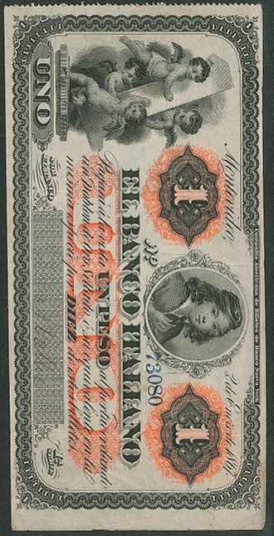
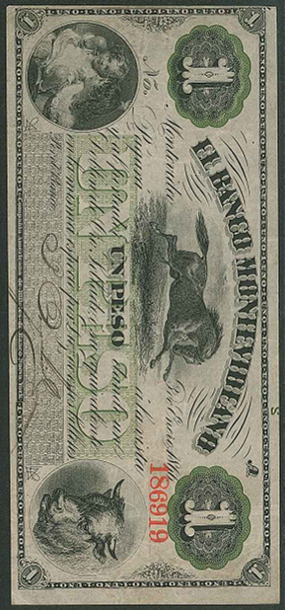

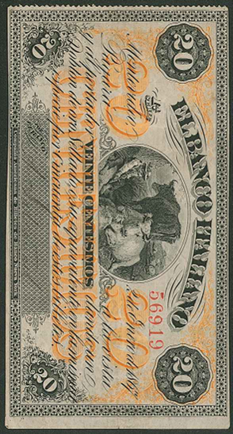

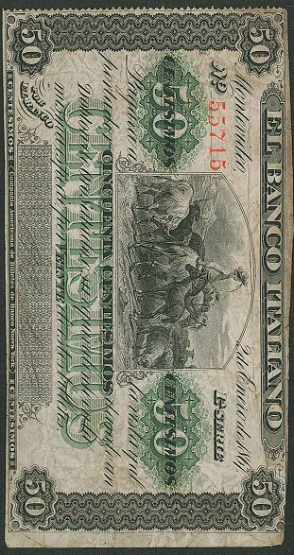

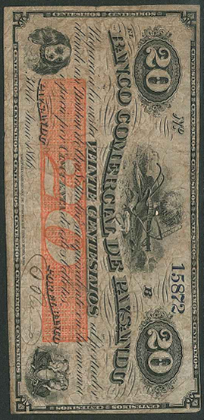

108
Group of
Uruguay
banknotes
Stamps and Collectables Auction, 26 March 2018 Page 24 .
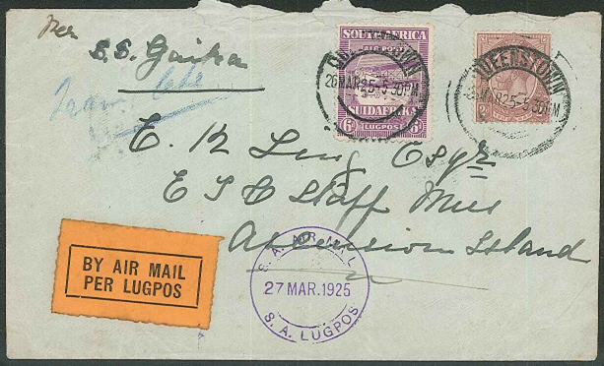

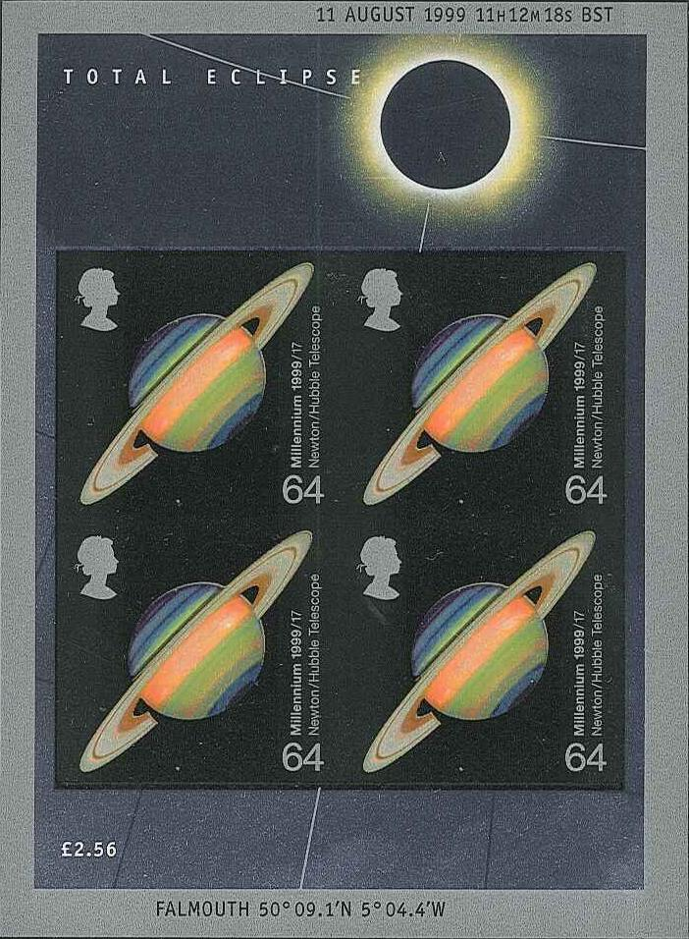
235
South Africa to Ascension

253
UK Eclipse miniature sheet
variety imperforate

