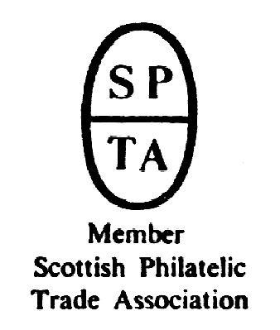

Robert Murray
5 & 6 Inverleith Gardens, Ferry Road,
Edinburgh, EH3 5PU
Tel. 0131 552 1220 :: 0131 478 7021
website www.stamp-shop.com email auction@stamp-shop.com
Stamps and Collectables Auction
AUCTION
CATALOGUE
ONE POUND
Monday 11 February 2019
at 7.00pm
Catalogue of Postage Stamps and Collectables to be sold by Public Auction, within the
STEWART’S-MELVILLE CLUB PAVILION, 523 FERRY ROAD, EDINBURGH, EH5 2DW.
On view at Pavilion on afternoon and evening of sale, and at Shop for one week prior to sale (see details later in catalogue).

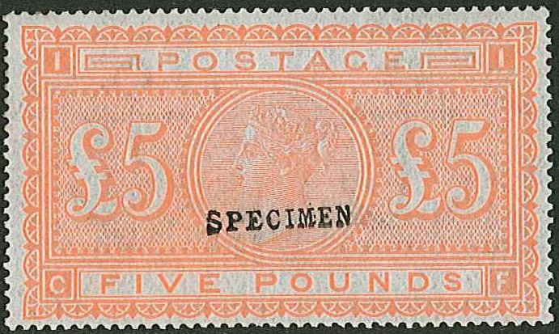

341

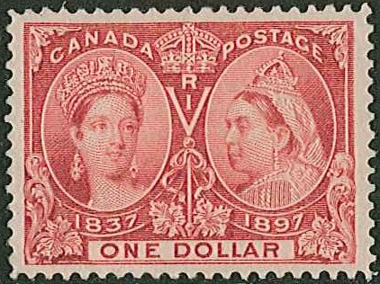
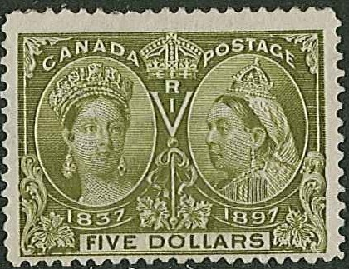

Ex 179 180
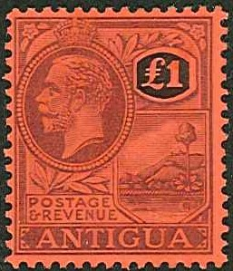
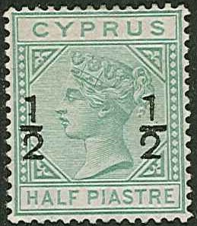
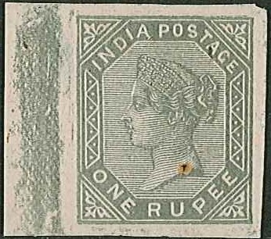
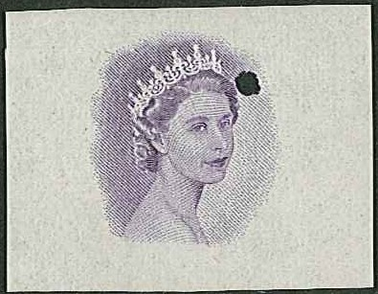
Stamps and Collectables Auction, 11 February 2019 Page 2 Estimate.
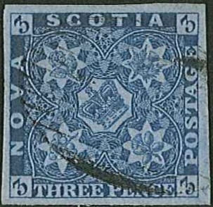
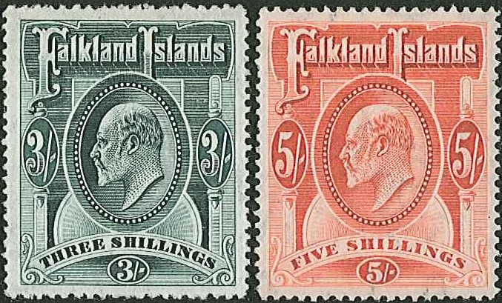
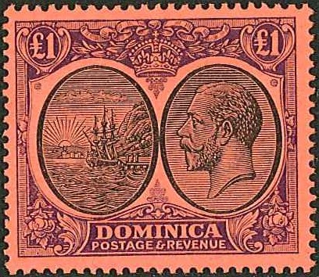
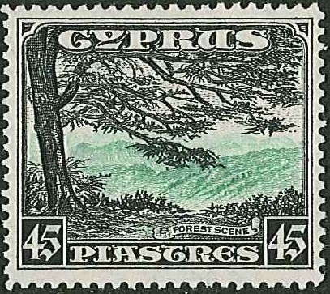
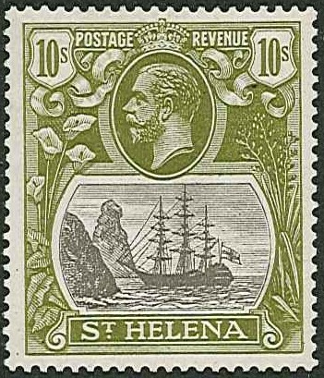
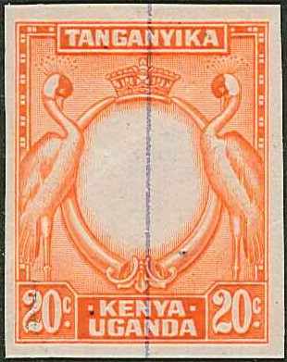
ex 164 195 241 ex 296
178
ex 196 200

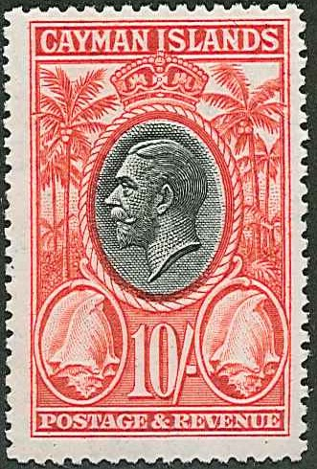
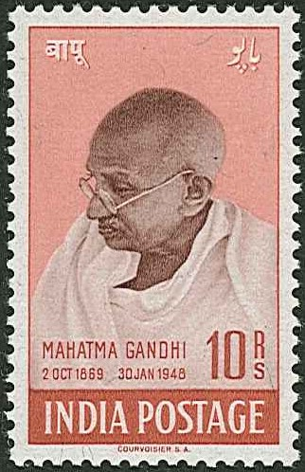
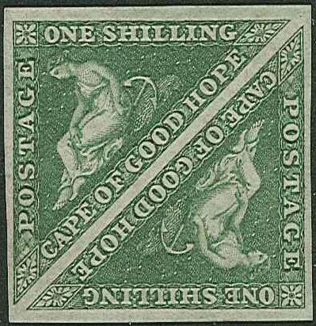
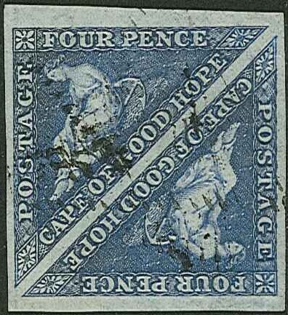
201 251 ex 299

ex 306 307
ex 181 ex 240
Stamps and Collectables Auction, 11 February 2019 Page 3 Estimate.
Viewing times are listed on page 25.
(Viewing starts on Tuesday 5th February)

Collections and Mixed Lots.
1 A traditional six-volume world collection from earlies to about 1960 with very little later,
mostly odd values or part sets. Includes many stamps cat. a few pounds each – noted China,
Germany (inc. 3rd Reich), UK with Penny Black (top-left corner missing), 1867 5/- u.
(faults), 1939-48 2/6 green, 5/- red, and 10/- ultramarine (each in fourblock with 2 u.m., 2
m.m.), 1955-58 Waterlow Castles set m.m., many Commonwealth, etc. Also a folder of
Germany 3rd Reich sheets and blocks with some damage, and a bundle of FDCs etc. (UK,
Rhodesia, Swaziland, etc. (1,000s, c.150 covers) ☑ .. .. £300.
2 Two heavy cartons, with an all-world collection in 18 volumes, much used, mainly odd
values or part sets. While extensive and with good range, tends to be cheaper stamps.
Partly picked. (Many 1,000s). ☑ .. .. .. .. £200.
3 Two large and heavy cartons with 22 assorted albums/binders/stockbooks of world
stamps. Wide range of countries and periods represented. Also some loose leaves. (Many
1,000s) [1a] .. .. .. .. .. .. £150.
4 Three cartons full of shoeboxes etc. filled with world stamps, mostly sorted by country. A
wide range of countries and periods covered, with many stamps catalogued in pounds.
Also contains some album pages and covers. (10,000s) [1a] .. .. £120.
5 Four large stockbooks of mainly used UK (often heavily duplicated, particularly in KG5/
KG6 – and best is a 1948 S.Wedding £1 u.m.), plus stockbook of foreign, small stockbook
of Norway railway postmarks, loose world in packets, book Scottish Post Offices (Mackay
1989), etc. (Many 1,000s) ☑ .. .. .. .. .. £100.
6 Three-volume world collection to mid-1960s with later UK to late-1970s. Includes better
UK (2-margin Penny Black cut into on other sides, some early phosphor commems m.m.),
useful early m.m. and used Commonwealth part sets and odd values (many cat. pounds,
e.g. Bermuda KG5 to 5/- u.). (1,000s) ☑ .. .. .. .. £100.
7 A big, fat, heavy (c.8kg) Citation album with pages to 1978 well filled with mostly used
stamps of the world. (c.23,800) ☑ .. .. .. .. £100.
8 A box with five assorted albums/stockbooks – stockbook well-filled with mint (much QE,
some earlier), album of countries A-D (much mint QE), album of m.m. (much royalty),
album of used odd values/sets, and stockbook of m. & u. (1,000s) ☑ .. 90.
9 Box with album containing Commonwealth KG5/KG6 short sets m.m. and some used.
Mix inc. some similar in filing drawer, also with a few foreign. Also nine junior albums
(some sparse or empty), a quantity of loose, etc. (Many 100s) ☑ .. .. 80.
10 Old file case with a Senf Illustrated Postage Stamp Album in two parts (part II is stamps
issued since 1890). Mostly odd values, inc. Penny Black. Also Imperial albums vol.II –
Africa and America. Some toning in UK pages of Senf. (Many 100s) ☑ .. 80.
11 Two large and heavy cartons with 15 assorted albums/stockbooks of world stamps, 8 tins/
shoeboxes of stockcards and loose, etc. Better France noted in album and stockcards.
Duplication, heavy in places. (10,000s) [1a] .. .. .. .. 80.
12 Large stockbook of France and UK. The France is mainly used defins and pictorials, the UK
includes 600+ mixed used Penny Reds, other duplicated low value QV/KE7, and others.
(1,000s) ☑ .. .. .. .. .. .. 70.
13 Large and heavy carton with 23 assorted albums etc. of world stamps, some sparse. Also a
Carton of loose, covers, postcards, etc. (1,000s) [1a] .. .. .. 70.
14 Small box with mixed contents inc. some German States in a club book, Tristan da Cunha
cover with UK KE8 ½d and 1½d, WW2 censor covers (7), Shetland's First Air Mail 1937
(6 reg covers, 1 illus cover, 2 others roughly opened), various other stamps and covers.
(100s) ☑ .. .. .. .. .. .. 60.
A Buyer’s Premium of 10% (vat-inclusive) will be added to all sale prices.
Stamps and Collectables Auction, 11 February 2019 Page 4 Estimate.
Collections and Mixed Lots, continued.
15 Carton with eight assorted albums/stockbooks of world stamps, with some UK decimal
mint, Commonwealth mint (some badly mounted), Irish “We will not have HOME RULE”
label (damaged), etc. Also a quantity of loose. (1,000s) ☑ .. .. 60.
16 World collection in 11 binders – mostly used odd values/part sets, with little after 2000 seen.
(1,000s) ☑ .. .. .. .. .. .. 60.
17 Heavy carton with ten assorted albums/s’books of world stamps, many used odd values/part
sets with little after 1990. Also an album of mainly mint Disney stamps. (1,000s) ☑ [1a] 60.
18 Varied lot in carton with several albums of world stamps, loose material, some ephemera,
etc. (1,000s) ☑ .. .. .. .. .. .. 50.
19 Storage box with world mostly off-paper partly sorted into small boxes, packets, etc. Also a
box of world kiloware (c.1.9kg). (1,000s) ☑ .. .. .. .. 50.
20 Box of new issues in packets as delivered, mostly 2000-09 miniature sheets, covers, etc.
(100s) ☑ .. .. .. .. .. .. 50.
21 Box with assorted albums/stockbooks inc. single country New Zealand, Canada, Indonesia,
Aircraft, and Crests. Also three world albums, a binder, and a thick wad of album leaves,
much Commonwealth. (1,000s) ☑ .. .. .. .. 50.
22 Carton with stamps and covers, much British Africa particularly Southern Africa, but a wide
range of other countries included. Also old folder of used Japan (some forgeries), three
books, etc. (1,000s, 100s covers) ☑ .. .. .. .. 50.
23 A heavy carton with ten assorted albums/stockbooks of world stamps and covers. Also loose
in two pocket files. (1,000s) [1a] .. .. .. .. 50.
24 Two boxes with 16 assorted albums/stockbooks of world stamps and covers, with Channel
Is., Isle of Man in printed hingeless albums, and royalty-related albums noted. (1,000s) [1a] 50.
25 Two albums and a stockbook, much modern UK and Commonwealth, two junior albums of
world, two cover albums (much in UK FDCs), loose world in packets. (1,000s) ☑ 40.
26 Box with two file boxes of world stamps and covers, and R.Mail album of UK FDCs
1957-76, file of UK pre-decimal mint large blocks, an empty stockbook, etc. (1,000s) ☑ 40.
27 A box with a Commonwealth album, album pages of Germany and Luxembourg, a file box
with stamps, covers, Italian postcards, supplies etc., a binder of world, some literature, 2
binders, and some unused leaves etc. (Many 100s) ☑ .. .. .. 40.
28 The shop's charity box – albums, stockbooks, loose stamps in packets, tins of mounts, etc.
(1,000s) ☑ .. .. .. .. .. .. 40.
29 Small box with 11 tobacco tins of Commonwealth and 1 tin of USA. Also 16 remainder
club books of world priced in £sd. (100s) ☑ .. .. .. .. 40.
30 Small box of world stamps on stockcards, in pockets, etc. Wide range of countries and
periods. (100s) ☑ .. .. .. .. .. .. 40.
31 Box with four junior albums, folders of world mint, used, and covers, New Zealand packs,
large bundle of covers (much UK FDCs). (Many 100s, 100s of covers) ☑ .. 40.
32 Small box with world stamps on stockcards etc. with a wide range of countries. (100s) ☑ 40.
33 Box of album pages, with a wide range of countries. Includes some covers and postcards.
(1,000s) ☑ .. .. .. .. .. .. 40.
34 Box with nine assorted albums/stockbooks with world stamps and covers, inc. two sparse
Lincolns etc. (100s) ☑ .. .. .. .. .. 40.
35 Box with m. & u. Australia 1913-84 in album pages and stockbook, m. & u. U.S.A. in stock-
book and stockleaves, a plastic biscuit box of world on/off-paper partly sorted. (1,000s) ☑ 40.
36 Small box of album leaves with stamps from a wide range of countries, nothing very
modern. Also some loose. (Many 100s) ☑ .. .. .. .. 40.
37 Box with ten assorted albums/stockbooks, some small – some sparse, UK 1987 yearbook.
Also a storage box with world off-paper, partly sorted inc. some UK QV used. (1,000s) ☑ 40.

“[1a]” at the end of a description indicates that the lot will not be taken to the auction venue
Stamps and Collectables Auction, 11 February 2019 Page 5 Estimate.
Collections and Mixed Lots, continued.
38 Stockbook of m. & u. from South Africa and S.W.Africa to 1954 (singles and pairs) (c.630).
Also Sweden 1948, 1951 inc. mint blocks, strips. (c.120) ☑ .. .. 40.
39 Box with mixed contents – envelopes of Canada & NZ, album page of Jordan, album of
Tuvalu 1976-82, album of foreign countries S-V, an album of Australia maxi-cards
1978-82, Commonwealth in album and envelope, etc. (Many 100s) ☑ .. 40.
40 Heavy carton with a world accumulation on/off-paper partly sorted in shoeboxes, packets,
stockbooks, albums, inc. some France Red Cross booklets, world airletters, etc. Also some
literature, covers, and three watermark detectors. (1,000s) [1a] .. .. 40.
41 Box of loose stamps on/off-paper partly sorted, world covers, etc. (1,000s) ☑ .. 30.
42 Two shoeboxes of off-paper – one marked “World”, other “Foreign”, but both appear to be
mainly non-Commonwealth. Includes some on-paper. Net weight c.1kg. (1,000s) ☑ 30.
43 Carton with world accumulation in ten stockbooks, file box, and album pages in envelopes.
(1,000s) ☑ .. .. .. .. .. .. 30.
44 Smaller carton with three stockbooks and loose album pages, with world stamps, noting UK
QE pre-decimal mint and USA used 1861 onwards. (Many 100s) ☑ .. .. 30.
45 A box with a stockbook of world, junior album, world covers, bag of world on-paper, much
Africa, etc. (100s) ☑ .. .. .. .. .. 30.
46 Flat box with world in packets, stockleaves, and a binder. Some packets have heavily dupl.
mint Commonwealth. (1,000s) ☑ .. .. .. .. 30.
47 Two cartons of mostly Sumner Collection productions with 4 binders of First Day Litho-
graphs 1979-90 (UK/Islands), 2 large binders of Great Historic Stamps FDCs, 3 heavy
binders of FDCs From Around the World (Postal Commemorative Society), album of 1978
Coronation FDCs, 1983 Commonwealth Collection, etc. [1a] .. .. 30.
48 Some duplicated Canadian booklets comprising SG SB52 (1), SB54 (2), SB55 (17) and
SB56 (17), a small album of Egypt to 1952, and a few mixed others. ☑ .. 20.
49 British Commonwealth; a heavy carton with a substantial collection in 13 assorted albums,
a stockbook, and a packet, of m. & u. stamps from earlies to c.2005. In QV-KG5 there are
mainly odd values or part sets but inc. thirty 1935 Jubilee sets mint (mainly m.m.). In KG6
there are 1 u.m. and 21 m.m. full definitive sets, many more part sets, various 1948-49
S.Wedding sets (9 u.m., 20 m.m.), and many 1949 UPU mint with Hong Kong noted. The
QE has 2 u.m. and 20 m.m. early definitive sets, with more part sets m. & u., then later
with Canada particularly strong. (1,000s) ☑ .. .. .. .. £750.
50 --; 1937-52 colln. in album of used sets and part sets inc. Bahamas 1948 set, Barbados
1950 set, Bermuda 1938 values to £1 (missing 10/-), Br.Guiana 1938 set, Cyprus 1938
set, Falklands 1938 set, Hong Kong 1938 values to $10, Nyasaland 1938 values to £1,
Sierra Leone 1938 set, etc. Excludes larger dominions (Australia, Canada, NZ, etc.).
(c.1,470) ☑ .. .. .. .. .. .. £300.
51 --; small box with c.70 stockcards of selected individual stamps or sets, with much British
Africa inc. five Cape Triangulars. Little after about 1960s. Total s.t.c.£6,170, PTSA
£1,735. (100s) ☑ .. .. .. .. .. .. £280.
52 --; two-volume collection of countries A-N up to about 1960s only. Includes better values
in Australia, Canada, Ceylon, UK (inc. good-looking 4-margin penny black, red MC, fair
1840 2d blue g.u., cut-to-shape Embossed set), Hong Kong, India, and New Zealand but
condition quite varied. (100s) ☑ .. .. .. .. £150.
53 --; album with m.m. colln. of QE period up to c.1970 of countries M to R with defins
(c.25 sets) and commems (mainly sets), and some used. Defin sets inc. N.Borneo 1954,
1961, Sabah 1964, N.Rhodesia 1953, 1963, Nyasaland 1953, Rhod. & Nyasaland 1954,
1959. (100s) ☑ .. .. .. .. .. .. £150.
PLEASE USE FIRST CLASS POST – DON’T MISS A BID FOR NINEPENCE !
A Buyer’s Premium of 10% (vat-inclusive) will be added to all sale prices.
Stamps and Collectables Auction, 11 February 2019 Page 6 Estimate.
Collections and Mixed Lots, continued.
54 British Commonwealth; 1953-75 (some later) collection in album of almost entirely used
sets and part sets. Complete defin sets inc. Cyprus 1955, 1960, Gibraltar 1953, Malta 1956,
North Borneo 1961, N.Rhodesia 1963, Rhod. & Nyasaland 1954, 1959. Excludes larger
dominions – Australia, Canada, NZ, etc. (c.2,500) ☑ .. .. .. £150.
55 --; two old file cases with m. & u. colln. in Imperial album and two-volume New Imperial
album, with mainly odds and some part sets, inc. UK Penny Black u., Cyprus 1934 set
(11) m.m. Toning on some pages but stamps seem unaffected. (Many 100s) ☑ .. £120.
56 --; six large stockbooks of all areas and periods, often with moderate duplication. Majority
used but some mint, and with decent numbers of medium values throughout. Just a few
foreign also. (Many 1,000s) ☑ .. .. .. .. .. £100.
57 --; four-volume collection on printed pages in polypockets, of m. & u. QV and KE7, mostly
odd values, with some areas quite sparse. Condition varies but many fine. (100s) ☑ £100.
58 --; 1936-51 m.m. & u. collection in three New Age albums, much as part sets and odds.
Toning on some pages but stamps seem unaffected. (100s) Also some empty pages. ☑ £100.
59 --; 1953-65 m.m. & u. colln. in three New Age albums, much as part sets and odds. Toning
on some pages but stamps seem unaffected. Also a stockbook of more recent inc. some
foreign. (Many 100s) ☑ .. .. .. .. .. £100.
60 --; carton of 8 stockbooks and stockcards with single volumes of Australia, Canada, Ireland,
New Zealand, the rest mixed countries. Much used, duplication in places. (1,000s) ☑ 80.
61 --; a long box with a dealer's stock of dupl. u.m. sets of Rhodesia, Malawi, NZ, and others,
much mid-1960s to early-1980s. S.t.c.£2,500. (c.1,500 sets) ☑ .. .. 70.
62 --; a long box with a dealer's stock of dupl. u.m. sets of Malta and New Zealand, much mid-
1960s to early-1980s. Also some used and some other countries inc. foreign. (Many 100s of
sets). ☑ .. .. .. .. .. .. .. 60.
63 --; a mixed lot with Indian States on old sales page, Swaziland mostly mint in a folder (s.t.c.
£200), S.W.A. 1953-80 m.m. on printed leaves (s.t.c.£320), St. Helena 1937-63 m. on
leaves and m. & u. on stockleaves. Also some duplicated Southern Africa airletters. 60.
64 --; stockcards with Sierra Leone KG5 values to 10d in u.m./l.m.m. fourblocks (10 blocks),
Gold Coast 1928 set (10) used, Bahrain 1950 set (9) m.m., Bechuanaland KG5 2/6 sea-
horse m.m., UK KE7 Army Official 6d m.m., Newfoundland 1910 values to 15c m.m.
(10), British Levant KE7 values to 5pi m.m. (6), etc. .. .. .. 60.
65 --; collns. of used, with dupl., some m.m. on stockleaves, of New Zealand in two binders,
and single binders for each of Canada and Malta, from earlies to fairly recent. (1,000s) ☑ 60.
66 --; two stockbooks with mostly used selection with some duplication, inc. used Cape
Triangular 1d (3) and 4d (2), condition mixed. (c.3,900) ☑ .. .. 60.
67 --; four volumes of mostly used odd values/part sets mainly KG6/QE up to c.1970 inc. some
1935 Jubilee and KG6 omnibus. Includes UK which has some earlier. (1,000s) ☑.. 50.
68 --; Australia, Canada, and New Zealand 1970-80 u.m. and/or used (often both) on pages,
reasonably complete. (100s) ☑ .. .. .. .. .. 50.
69 --; collection of used with dupl., and some mint, in four stockalbums, from earlies up to
c.2000. Mainly smaller countries, and even there only some represented. (1,000s) 50.
70 --; box with a New Age album, eight assorted albums. stockbooks, tin of u.m. new issues,
bundle of album leaves, and some loose. (1,000s) ☑ .. .. .. 50.
71 --; bulk sets u.m., mainly South Africa and Homelands from 1980s, in quantities up to 25,
with c.50 different sets. Also some UK 1950s/60s defins/country issues. S.t.c.£1,000+ ☑ 50.
72 --; Popular album well filled with stamps mostly up to KG6 – much in Australian States.
Light dupl. in places. (Many 100s) ☑ .. .. .. .. 50.
73 --; stockalbum with mint, used, and a few covers. Also inc. some foreign. (Many 100s) ☑ 40.
74 --; seln. of sets in album of m.m. inc. Aden 1939 (missing 14a), Burma 1937 opt. on India
(3p-5r), Ceylon 1935 (the 3c u.), India 1937 (3p-10r), etc. Some stuck at hinge. (c.100) ☑ 40.
75 --; three stockbooks of sets and odds, dupl. in places, much Southern Africa. (Many 100s) ☑ 40.
Stamps and Collectables Auction, 11 February 2019 Page 7 Estimate.
Collections and Mixed Lots, continued.
76 British Commonwealth; box with an album of 1937 Coronation and 1946 Victory m.m.,
also five assorted albums/stockbooks and loose pages with much Australia, Zimbabwe, and
a wide range of other countries. (1,000s) ☑ .. .. .. .. 40.
77 --; seln. of u.m. in stockcards, small stockbooks, etc. from various countries inc. Falkland
Islands, Christmas Is., Cocos Islands, etc. part prepared to enter in Buy or Bid Sale. Also
bundle of Canada FDCs and other covers. (100s) ☑ .. .. .. 40.
78 --; large shoebox filled with off-paper mixture inc. a few sets in glassines. Also includes
some covers etc. Net weight c.1.1kg. (1,000s) ☑ .. .. .. 30.
79 --; three SG One-Country albums – Australia, Canada, and New Zealand – with collections
of used with some m.m. from earlier up to 1987. (100s) ☑ .. .. 30.
80 --; Africa; collections of used, with dupl., and some mint in two stockalbums – of S.Africa
and Central Africa. Also two stockbooks of mostly used – one of S.Africa, other mixed
Africa. (1,000s) ☑ .. .. .. .. .. .. 40.
81 --; --; Gold Coast 1884-1952 (and some later Ghana) m.m. colln. on pages s.t.c.£345., and
Sierra Leone 1956 duplicated values to 10/- inc. blocks u.m. s.t.c.£172. (100s).. .. 40.
82 --; Antarctic; seln. on stockcards of u.m. from A.A.T., B.A.T., and Ross Dep. (c.150) 30.
83 --; Asia; collections of used, with duplication and some mint, on stockleaves in three
binders of India, Pakistan, Bangladesh, Ceylon/Sri Lanka, from earlies up to fairly recent.
(1,000s) .. .. .. .. .. .. 80.
84 --; Omnibus; stockbook with 1948 Silver Wedding u.m. sets from 11 Malayan States,
Dominica, Morocco Agencies (Tangier), and British PAs in E.Arabia, plus m. & u. sets
from 1972 Silver Wedding, 1973 R.Wedding, and 1974 UPU. Also two stockbooks of
later u.m. royalty related stamps and m.s. (c.1,100) ☑ .. .. .. £100.
85 --; --; an album with 1977 Silver Jubilee stamps etc, and a three-volume collection of 1981
Royal Wedding. ☑ .. .. .. .. .. .. 30.
86 --; --; 1981 Royal Wedding – two albums and loose pages of u.m. stamps and m.s. (100s) ☑ 30.
87 Europe; stockbook of m. & u mostly middle period Spain (c.450), Spanish Colonies (c.400),
Portugal (c.70), Portuguese Colonies (c.850), and a few others. ☑ .. .. 40.
88 --; Eastern Europe; single stockalbums for Czechoslovakia, Hungary, and Poland, mint
and used with some duplication in the used. (Many 100s) ☑ .. .. 30.
89 --; Western Europe; single stockalbums for France, Germany, Italy, Netherlands, and Switz-
erland, mainly used, some dupl., some mint. (1,000s) ☑ .. .. .. 50.
90 Foreign; collection in various stockalbums, mint and used, much is odd values and part sets
with duplication in places. (1,000s) ☑ .. .. .. .. 60.
91 --; four albums/binders of stamps (one affected by damp). Also single volume of China, and
three volumes of USA. Much used with some dupl. (1,000s) ☑ .. .. 50.
92 --; an album of mostly used of various countries with much Europe, an album of m. & u.
USA, early Europe on stockcards (mixed condition), etc. (Many 100s) ☑ .. 40.
93 --; three-volume used collection, mostly odd values, many identified in pencil. (1,000s) ☑ 30.
94 Middle East; used colln. on stockleaves of Aden and Gulf States inc. Qatar 1966 2r, 5r sur-
charges used (SG 149-150 cat.£340). (c.300) .. .. .. 30.
95 Scandinavia; a stockalbum each of Denmark and Sweden mint and used with some dupl.
in the used. Some better values. Also album with cheaper Denmark FDCs. (1,000s, c.35
covers) ☑ .. .. .. .. .. .. 70.
96 Booklets; collection in two albums of world booklets, much in Scandinavia, other Europe,
some Australia, etc. (c.155) ☑ .. .. .. .. .. 60.
97 Thematic; pages prepared for display on Rubber – the Weeping Wound, Clouds, Harnessing
the Power of Nature, Bridges of the World, and Water Engineering. Mostly stamps, and with
a few gaps. (100s) ☑ .. .. .. .. .. 40.
A Buyer’s Premium of 10% (vat-inclusive) will be added to all sale prices.
Stamps and Collectables Auction, 11 February 2019 Page 8 Estimate.
Collections and Mixed Lots, continued.
98 Thematic; Aviation; box with an album of aviation covers (mostly UK), album of covers of
Great Airplanes of Europe, album of test pilot covers, two albums of stamps and covers etc.
for RAF 80th and 90th annivs. (some signed). Also album of WW2 70th Anniv. (“War at
Sea – Submarines”). (c.290) ☑ .. .. .. .. .. 40.
➲ --; Football; see Liberia.
99 --; Railways; mint and used collection in stockalbum. (c.1,100) ☑ .. .. 30.
100 Covers; box with six single cover albums, much UK, one album of Japan. Also an album of
Guernsey presentation packs. (100+) ☑ .. .. .. .. 30.
101 --; box of world covers and postal stationery in three albums and loose, with a mix of comm-
ercial mail and commemorative covers. (100s) ☑ .. .. .. 30.
102 --; Antarctic; covers with Australian stamps from ANARE 1947, Mawson 1954 (2),
Mawson 1955 postcard, Wilkes 1959, then AAT stamps on covers many with cachets (17),
Ross Dependency covers and postcards (13). ☑ .. .. .. 30.
103 --; Commonwealth; box of covers, mainly non-FDC, of Southern Africa, PTSA £1,450.
(c.250). Some marked retail prices seem about right, others are high, often 2x to 10x
normal retail. ☑ .. .. .. .. .. .. £100.
104 --; --; box of covers and some postcards, mainly non-FDC of East and Southern Africa.
PTSA £1,400. (300) See note for last lot re. retail prices. ☑ .. .. 80.
105 --; --; box of dupl. first day and political souvenir covers, mainly Rhodesia, Zimbabwe, and
Ghana (c.375). Also another box of FDCs etc. (c.200) ☑ .. .. 50.
106 --; Royalty; heavy carton with 11 binders of covers for various royal events – much UK but
with a seln. of Commonwealth countries included. Also some stamps, min.sheets, PHQs,
etc. (c.540 covers) ☑ .. .. .. .. .. £100.
Cinderella; Commonwealth; seven stockcards of mint fourblocks and used singles, s.t.c.
107 £421, PTSA £135, and others on stockleaves etc., much S.Rhodesia/Rhodesia/Zimbabwe.
Also South African documents from 1920s-70s with share certificates, property sales with
revenues attached. (100s, 26 documents) .. .. .. .. 40.
➲ --; see also China, Poland, USA, UK.
108 Forgeries; mixed Commonwealth selection with 29 various early lithographed, 4 opts.,
14 BCOF JAPAN opts., 2 others. .. .. .. .. .. 50.
➲ --; see also French Colonies (Indo-Chinese POs, Réunion), India, St. Kitts-Nevis (Nevis),
South Africa (Cape of Good Hope).
109 Literature; flat box with 17 yellow SG Commonwealth country catalogues, 8 foreign sec-
tional cats., and other catalogues etc. Mixed ages. [1a] .. .. .. 40.
110 --; The Postal Agencies in Eastern Arabia and The Gulf by Neil Donaldson (1975), and SG
France & Colonies sectional catalogue (2010). ☑ .. .. .. 20.
111 --; SG Commonwealth and British Empire 1840-1970 catalogue, 2017 edition, used. ☑ 20.
112 --; International Encyclopedia of Stamps in six binders, C.B.S. 2018 as new, Michel
Valuable Stamps of the World, etc. [1a] .. .. .. .. 20.
113 --; two different Timbres de France catalogues, published by Yvert & Tellier and Spink/
Maury, both 2016 editions, as new. (Cost €21.90 and €24.90 new). ☑ .. 15.
114 --; SG Australia country catalogue, current 10th edition (retail £32.95), as new. .. 12.
115 Supplies (Second-Hand); approx. 30 packets of apparently unopened cover/booklet album
pages, stockleaves, etc. Also a binder of stockleaves, and SG Windsor Sovereign binders
vols. 1 and 2. [1a] .. .. .. .. .. .. 60.
116 --; two Royal Mail Stamps albums with slipcases, large R.Mail stockbook, and 7 packs of
loose R.Mail leaves for FDCs etc. All as new. ☑ .. .. .. 40.
117 --; two large cartons of albums, binders, cover albums, stockbooks, etc. Most quite service-
Able. [1a] .. .. .. .. .. .. 40.
Stamps and Collectables Auction, 11 February 2019 Page 9 Estimate.
Non-Philatelic Items (Collectables)
BANKNOTES
118 Album of world notes with many which are current or old but exchangeable inc. Euros
(€170), Hong Kong ($170), Malaya ($888), Netherlands (55g), Norway (NKr.4,500 inc.
old series), Singapore ($189), UK (£2), Scotland (£53), USA ($60). ☑ .. £500.
119 Small mix with a few foreign current or exchangeable inc. Germany (10dm), Ireland (£5),
Denmark (50k), Spain (1,000p), etc. Also two RBS £1 notes in clear blocks. ☑ 20.
CIGARETTE AND TRADE CARDS
120 Massive lot in six flat fruit boxes, with sets in albums, empty 1930s corner-slot albums,
many thousands of loose cards, sorted cards in packets, etc. Untidy and poorer quality in
some. [1a] .. .. .. .. .. .. £100.
121 A vaguely similar lot in three fruit boxes and plastic tub. [1a] .. .. £100.
122 Box with over 50 albums of cigarette cards (corner-slot and adhesive, mainly sets), plus
others loose inc. Kensitas silk Flowers (c.90), and a printed album with complete set of
Kensitas silk National Flags (mounted with stamp hinges). ☑ .. .. 80.
123 Three large corner-slot albums with mainly black & white portrait cards of footballers and
other sportsmen or teams. (c.350) .. .. .. .. 50.
124 Topical Times; three Topical Times Panel Portraits Album of Star Footballers corner-slot
albums with colln. on 96 large size portrait cards, plus 12 loose, probably all-different, and
generally very fine. .. .. .. .. .. .. 50.
COINS
➲ Estimates are based on a gold market price of £1,000/oz, and silver of £12.25/oz.
125 Four albums; two of world contain mainly quite modern (typical “holiday money”), and
two of UK decimal have £2 coins (46), 1983-2015 £1 coins (138), 50p (53), as well as
many lower denominations. .. .. .. .. .. £280.
126 1977-80 four-album collection of UN Food and Agriculture Organisation coins from
various countries and inc. Tonga 1979 20p and 1980 10p tiny gold coins (total AGW
c. 0.033oz) and several silver. (161) .. .. .. .. £140.
127 Two box-binders of mostly UK coins, the main value in the silver (£7-1s-6d face in pre-
1947), some foreign also. (100s) ☑ .. .. .. .. £130.
128 Mainly UK mix inc. two of UK 1992-93 EU 50p each sealed in R.Mint plastic block, four
silver chains each with silver proof coin (1984 £1, 1989 £1, 1989 £2 Claim, 1989 £2 Bill,
all with a bit of wear), three USA 1986 boxes (each with $½ and silver $1), etc. ☑ 80.
129 Big old biscuit tin well-filled with a very general world mix. Most of it just loose, and inc.
Some tokens etc. (Approx. 15kg+ net weight.) ☑ .. .. .. 60.
130 Box with general world mix in a number of smaller containers. All sorts, in no particular
Sense of order. (Approx. 13.3kg net weight.) ☑ .. .. .. 60.
131 Old shopping bag with a general mix of mainly standard pre-decimal UK, but inc. a USA
silver dollar, a few UK pre-47 silver coins, a silver charm bracelet, etc. (100s) ☑ 60.
132 Medium carton of very modern very commercial coins and other marketed medallions etc.
(much London Mint Office and similar). Some quite “chunky”. (c.70) ☑ .. 30.
133 Small box with a mix of UK and world coins inc. discoloured Canada 1973 set. ☑ 20.
134 United Kingdom; box of Royal Mint folders inc. individual folders, often two of each, for
£1, £2, and £5 coins, plus year sets, etc. Includes three of 1989 folder with £2 Bill and £2
Claim. (28 folders) ☑.. .. .. .. .. .. £100.
135 --; proof sets for 1980 (3), 1981 (2), 1987, 1988, and 1990, plus various other coins, and
a 1969 Investiture official medal (silver 45mm, in original box). ☑ .. .. 30.
A Buyer’s Premium of 10% (vat-inclusive) will be added to all sale prices.
Stamps and Collectables Auction, 11 February 2019 Page 10 Estimate.
Non-Philatelic Items, continued.
COINS
136 United Kingdom Proofs; collection of Royal Mint proof sets comprising 1971, plus
straight run 1982 to 2002. (22) ☑ .. .. .. .. £150.
137 --; --; another lot with the same content. ☑ .. .. .. .. £150.
138 --; --; selection of boxed individual silver proof coins comprising £1 (9), £2 (3), £5 (3),
2 x 5p (1), 2 x 10p (1), 2 x 50p (1), and 2 x £2 (1, inc. the Claim of Right version). ☑ £150.
139 --; --; a similar lot comprising £1 (6), £2 (2), £5 (3), 2 x 5p (1), 2 x 10p (1), 2 x 50p (1),
and 2 x £2 (1, inc. the Claim of Right version). ☑ .. .. .. £120.
140 --; --; 2003 Royal Mint Silver Proof Piedfort 3-Coin Collection comprising £1 Arms, £2
DNA and 50p Votes for Women. Cat. £150. ☑ .. .. .. 40.
141 --; --; 2009, 2010 and 2011 Countdown to London 2012 silver proof £5 coins, in Royal Mint
box with spaces for full set of four. ☑ .. .. .. .. 40.
142 --; --; a similar lot. ☑ .. .. .. .. .. 40.
143 --; --; a similar lot, but with only 2009 and 2010. ☑ .. .. .. 30.
144 --; --; 1984-87 boxed set of four different silver proof £1 coins. ☑ .. .. 20.
145 --; --; another of the same. ☑ .. .. .. .. .. 20.
146 --; --; another of the same. ☑ .. .. .. .. .. 20.
147 Gold Coins; two tiny gold items; Congo 2017 50f coin (0.5g .585 grade), and King James
medallion (0.5g .585 grade). .. .. .. .. .. 15.
148 Silver Coins; boxed set of three large but thin Fiji 2012 $10 Diamond Jubilee coins in box,
each 1oz .999 grade. Also three other items. ☑ .. .. .. 30.
149 Coin Supplies; 18 unopened packets (each of 3 leaves and inserts) of W.H.Smith Collecting
System coin pages – 9 small, 8 medium, 1 large, etc. ☑ .. .. .. 20.
MEDALLIONS
150 Set of 43 “The Kings and Queens of England” gold medallions produced by John Pinches
Ltd. (between 1971 and 1975). Each is a very small medallion (13mm diameter) in 22 carat
gold; the earlier ones generally in little pouches, later mostly in presentation cards. Total
gold weight for set is 3.86oz. Also box to house these. ☑ ▲ .. .. £3,200.
151 A single loose Lady Jane Grey medallion from the above set (duplicate). ☑ ▲ .. 70.
POSTCARDS
Three shoeboxes of cards (many in clear wallets) of Scotland, other UK, some foreign, and
152 a few subjects. A small percentage are modern, most are 1900s-20s. (Estimated c.1,000 in
wallets, c.400 loose) ☑ .. .. .. .. .. £150.
153 Two boxes of cards, largely foreign, early to c.1960s. (Estimated c.2,500) [1a] .. 30.
154 Mixed bundle inc. a some modern, mainly UK/Scotland (110+) ☑ .. .. 15.

OTHER CATEGORIES
155 Autographs; 1999 UK souvenir cover for Dartmouth Passing Out Parade, with two sig-
natures – one of these being “Philip” (Duke of Edinburgh). .. .. 80.
156 Cinema; selection of “Lobby Cards” for Bambi (7) and Snow White and the Seven Dwarves
(7), some wear. Thought to be original. .. .. .. .. 30.
157 Model Railways; Triang No.1 Passenger Train set “OO” guage in original box with steam
loco Princess Elizabeth 46201, tender, 2 coaches, track, and battery box. The staples in the
box have rusted and left marks on loco and coaches (which might clean), and the track is a
bit dirty. Untested. Also boxed Honby Dublo D1 Island Platform and other accessories.
Finally a junior stamp album (inc. UK 1971 Heinz pack). [1a] .. .,. 30.
158 Model Vehicles; three boxes each with set of three vehicles produced by Corgi for Royal
Mail. Also four other Post Office vehicles and a Lledo B.R. truck. (14 vehicles) ☑ 20.
Stamps and Collectables Auction, 11 February 2019 Page 11 Estimate.
Non-Philatelic Items, continued.
OTHER CATEGORIES
159 Olympic Games; selection of items kept as souvenirs of the 1936 Berlin Olympic Games
by a non-competing athlete. Includes stadium tickets for nine consecutive days, three Union
Flag lapel badges, three different Olympic Rings badges/brooches, souvenir purse, folding
comb, postcards (17, inc. a few with Reichssportfeld/Berlin rubber stamp), photo packets
for days 1-3, and a few other items. ☑ .. .. .. .. £100.
160 Photographs; four binders and one self-adhesive photo album of modern colour photos of
UK and modern trains, and railway-related topics. Includes a few shipping etc. (c.800) [1a] 30.
161 Precious Metal Stamp Replicas; 1977 sterling silver replica of UK 1977 Jubilee 10p
stamp (73g gross weight). Also sterling ingot for 1977 Jubilee Tour (92g gross), and 13
base metal coins. ☑ .. .. .. .. .. .. 50.
162 Telephone Cards; two small folders with collection of mainly Falkland Islands cards, used
and unused. Some duplication. (c.130) ☑ .. .. .. .. 50.
163 Collectables Mixed Lots; box of postcards, cigarette cards, other collectables. (100s) ☑ 30.
End of Non-Philatelic Section
Stamps Classified by Country
164 Antigua; 1921-29 wmk. MCA set (7) fine and fresh mounted mint (tiny bit of adhesion on
front of 5/-). SG 55-61 cat.£300. .. .. .. .. £100.
165 Ascension; 1934 Pictorial set (10) v.f.u. (the 2/6 centred right, 5/- centred low and with
blunt-looking corner due to perf. configuration). SG 21-30 cat.£120. .. 20.
166 --; 1938-53 ½d to 10/- perf. 13½ m.m. (s.t.c.£500+ for u.m.) (13) .. .. 60.
167 Australia; 1913-2009 collection of m.m. and used in two binders, with much of the value
in the mint from 1980-2009 (hundreds of dollars face) (100s). Also some PSBs. ☑ £150.
168 --; 5 binders of mint and dupl. used from States to c.2008, much from QE period. (100s) ☑ 50.
169 --; 1914-31 collection of mostly used varieties on the KG5 Heads ½d, 1d, 1½d, and 2d
values, with detailed description beside each stamp. Some varieties quite clear, others
very tiny. (c.700) ☑ .. .. .. .. .. .. £100.
170 --; 1913-88 mostly used in two binders, with dupl. in KG5 issues. (100s) ☑ .. 30.
171 --; 1984-2006 u.m. and used seln. on stockleaves, often in sets. Also a few from 1930-53
u.m. S.t.c.£300+ (c.530, 2 m.s.) .. .. .. .. .. 35.
172 --; 2007-08 u.m. and used seln. on stockleaves mainly in sets (c.270, 1 m.s.). Also A.A.T.
1966-2009 u.m. and used, etc. (c.200, 2 m.s.) S.t.c.£720. .. .. 75.
173 Bahamas; 1884-1954 m. & u. selection on one well-filled page inc. 1938-52 values to £1
m.m., 1954-63 values to £1 m.m., etc. S.t.c.£430. (c.90) .. .. .. 50.
174 Barbados; 1921-37 m. & u. seln. on stockleaf with 1921-25 m.m. values to 2/-, used values
to 3/-, 1935 Jubilee set (plus extra 1/-) m.m., etc. S.t.c.£300. (c.50) .. .. 50.
175 Brunei; 1908-22 short set to $1 (1 of each value), plus 1916 set (2), mixed m.m., a few
poorer. Cat.£146. (13) .. .. .. .. .. 20.
176 Canada; album pages with useful m. & u. range of pre-dominion colonies with British
Columbia and Vancouver Island 1860 2½d sound u., British Columbia 3d g.u. (sl.
trimmed), 50c on 3d unu. (“as is”), Canada (14 inc. 1851 3d Beaver g.u. (3 margin)),
New Brunswick (17), Newfoundland (13, inc. five early imperfs mixed unu.), Nova
Scotia (14, inc. 1851 3d u. with faults), and Prince Edward Island (11). Varied condition
but many good/fine. .. .. .. .. .. .. £300.
177 --; Newfoundland; 1860-1947 m. & u. colln. on pages, from 1860-64 issues (a couple
genuine, plus several forgeries), then stronger from 1897 with 1897 Anniv. set (14) heavy
m.m., 1897-1918 set (8) m.m., 1910 set (11) very heavy m.m., 1911-16 Coronation set (11)
m.m., 1919 Contingent set (12) m.m., etc. (c.190) Some other provinces also. £240.

A Buyer’s Premium of 10% (vat-inclusive) will be added to all sale prices.
Stamps and Collectables Auction, 11 February 2019 Page 12 Estimate.
178 Canada; Nova Scotia; 1851-60 3d bright blue fine used with good strong colour and four
good to wide margins. BPA certificate (1981) states genuine. SG 3 cat.£150. .. 50.
179 Canada; 1897 Jubilee short set to $1 mounted mint - mixed, with some heavily mtd., but
the 10c fine, 15c poorer, 20c heavy, 50c small thin, and $1 fine, SG 121-136 cat.£1,486 (12).
Also used values to 8c (9), 1897-98 defins to 8c u., and Newfoundland 1937 Coron. long
set m.m., etc. .. .. .. .. .. .. £200.
180 --; 1897 Jubilee $5 heavily mounted mint, disturbed gum (small area at left may be missing
gum or might be light thinning), centred low, and three or four short perfs at top. SG 140
cat.£1,400. .. .. .. .. .. .. £100.
181 Cayman Islands; 1935 Pictorial set (12) fine m.m./l.m.m. (the 10/- very lightly hinged,
and centred to upper-right). SG 96-107 cat.£200. .. .. .. 70.
182 China; 1913-50s shoebox of dupl. mostly used in glassines. Also some Taiwan. (Many
100s) ☑ .. .. .. .. .. .. .. 40.
183 --; People's Republic; 1949-52 colln. of commems on pages with each set both unused
and cancelled. All are reprints where these exist, and also including equivalent issues for
North East China (inc. the scarce reprints of 1949 Trade Unions set - the “used” set with
only touches of cancels). Cat.£772. (186) .. .. .. .. £100.
184 --; --; 1961 Table Tennis Championships se-tenant block of four taken from miniature sheet,
fine used. .. .. .. .. .. .. 20.
185 --; --; 1963 Giant Pandas imperforate set (3) fine used (SG 2116-8var) cat.£350. 50.
186 --; --; 1963 Monkeys imperforate set (3) f.u. (SG 2121-23var) cat.£150. .. 20.
187 --; --; 1967 Thoughts of Mao Tse-tung (1st issue) set (11, comprising two strips of five and
one single) unmounted mint (each strip lightly folded on perfs between second and third
stamps). SG 2343-2353, cat.£8,500. .. .. .. .. £2,000.
188 --; --; 1967-68 Poems of Mao Tse-tung set (14) used (mainly commercially used, some
c.t.o., three or four small creases/minor blemishes). SG 2372-2385, cat.£130. .. 40.
189 --; --; 1968 Directives of Mao Tse-tung se-tenant strip of five fine mounted mint, SG
2397-2401 cat.£8,000. .. .. .. .. .. £2,000.
190 --; --; 1978 National Science Conference miniature sheet unmounted mint (no gum), SG
MS2765a cat.£700. .. .. .. .. .. .. 70.
191 --; --; 1979 Study of Science from Childhood miniature sheet unmounted mint, with a few
minor bends in margin (from handling), SG MS2900 cat.£2,500. Also same set (6) u.m.,
cat.£14. .. .. .. .. .. .. .. £500.
192 --; Cinderellas; International Famine Relief Fund 1920s labels in blocks of 35 and 15.
Some perf. separation. (Possibly produced in USA for this fund.) .. 20.
193 Christmas Island; 1965-90 collection of stamps – u.m. inc. fourblocks, a few used – FDCs,
Airletters, year packs, etc. on album pages in five folders and loose. (100s, 100s covers) ☑ 50.
➲ Cuba; see UK (Used Abroad)
194 Cyprus; 1880-1935 m. & u. seln. on stockleaves inc. better e.g. ½d SG 1 plates 12 and 15
m.m., 1881 ½d on 1d SG 7 plate 201 u., plate 205 m.m., SG 9 plate 218 u., 1881 30pa on
1d SG 10 plate 217 u., 1882 2pi with top left triangle detached SG 19a u. (2 short perfs at
foot), 1904 values to 12pi m.m., 1921 values to 18pi m.m., 1934 set (11) u., etc. S.t.c.
£3,500. (c.159) .. .. .. .. .. .. £300.
195 --; 1882 ½ on ½pi, wmk. Crown CC, with the “spur on 1” variety fine mounted mint
(fairly heavy hinge). Centred just a little high, and one perf at foot a little short. SG 23c
cat.£1,500. .. .. .. .. .. .. £150.
196 --; 1934 Pictorial set (11) l.m.m. (small mark on 1½pi, blunt corner on 9pi), SG 133-143
cat.£200. .. .. .. .. .. .. 60.
197 --; 1955-2000 m. & u. colln. on stockleaves/stockcards etc. inc. 1955 defin set l.m.m.,
some fourblocks or larger multiples. Also inc. some Turkish Cypriot Posts etc. (c.600,
6 m.s., 1 p.pack, 2 FDCs). ☑ .. .. .. .. .. 60.

Stamps and Collectables Auction, 11 February 2019 Page 13 Estimate.
198 Denmark; 1854-59 4sk with dotted spandrels selection of 29 used examples, mainly good/
fine and generally shades around orange-brown. SG 10/11 cat.£17 each = £493. 30.
199 --; 1858 4sk with wavy line spandrels selection of 25 used examples, mainly good/fine,
mixed shades. SG 15-17 cat.£16 each = £400. .. .. .. 20.
200 Dominica; 1923-33 £1 very fine unmounted mint, with very light pencil certification mark
on gum. SG 91 (cat.£225 for m.m.) .. .. .. .. £100.
201 Falkland Islands; 1904-12 3/- deep green and 5/- red fine m.m. The 3/- with horiz. perfs
a bit rough (not damaged), 5/- fine l.m.m. SG 49b, 50, cat.£375. .. .. £120.
202 --; 1953-2018 collection of mint and used in three stockalbums, where the general pattern
is mint set followed by used set. The mint is mixed m.m./u.m. to 1968, then seems to be
u.m. Appears fairly complete. Also includes some earlier Falklands (inc. 1938 defin 10/-
m.m., 1960 Birds set both l.m.m. and f.u., 1968 defin set u.m.), some S.Georgia, F.I.D.,
B.A.T., etc. (100s) ☑ .. .. .. .. .. £350.
203 --; envelopes from Falklands Philatelic Bureau to UK 2005-18, many with newsletters etc.
inside (44, with good range of stamps used), a cover album with FDCs etc. or Falklands-
related UK covers, an album of booklets, m.s., etc, some maxi-cards, and other covers. ☑ 40.
204 Faroe Islands; 1975-92 stockbook of duplicated u.m. inc. fourblocks and some used, with
toning affecting some. (100s) ☑ .. .. .. .. .. 10.
205 France; 1849-1964 collection of m.m. and u. defins in album, with 26 imperfs and other
earlies. Light dupl., some mixed condition. (100s) ☑ .. .. .. 50.
206 --; 1960-90 mint collection in four Yvert et Tellier hingeless printed albums. Nearly all
u.m. (few l.m.m. in early 1960s) and mostly complete in standard issues to about 1987
with less later. Contains some precancels etc. S.t.,c.£2,700. (100s) ☑ .. £240.
207 --; 1990-2011 u.m. colln. of stamps (mainly in sets), m.s., and sheetlets in two stockbooks.
S.t.c.£2,950. (100s) ☑ .. .. .. .. .. £300.
208 --; 1961-90 Art stamps u.m. in small envelopes, each identified. S.t.c.£300. (32 sets) ☑ 30.
209 --; Booklets; 1965-99 collection of mint booklets comprising Red Cross 1965-97 (13),
definitive 1971-91 (13), and commemorative 1985-99 (18) with many better inc. 1971 SG
DSB49. Total s.t.c.£1,007. ☑ .. .. .. .. .. £120.
210 French Colonies and Post Offices Abroad; French Indo-China; 1888-1944 m. & u. seln.
on stockleaves inc. some mint fourblocks, and with some stamps cat. in pounds each (a few
£10 to £60). (c.220) .. .. .. .. .. .. 40.
211 --; French POs in China/Indo-Chinese POs in China; selection of m. & u. on stockleaves
inc. several cat. between £14 and £48. (c.70) .. .. .. 40.
212 --; Indo-Chinese POs in China; Forgeries; seln. of 34 different (one as pair). 40.
213 --; Réunion; Forgeries; early forgeries of the 1852 15c and 30c each cancelled by date-
stamp, 4 margins. (Originals are SG 1-2, cat.£45,000) .. .. .. 15.
214 --; Saint Pierre at Miquelon; 1892-1946 colln. of m.m. and a few used on old printed
pages, inc. several sets and some postage dues. S.t.c.€756 (Maury 2010/11 = c.£670) 50.
➲ --; see also Collectables (telephone cards).
215 Gambia; 1902-05 set (12) overprinted SPECIMEN, fine mounted. SG 45s-56s, cat.£250. £100.
216 German States; 1849-1920 album of m. & u., the Bavaria being the most complete with
many sets there. Also includes Germany 1872-1926 inc. 1926 Air mixed m./u. (100s) ☑ 50.
217 Germany; 1923 75,000m on 400m in complete coil roll of 500 stamps (face value
37,500,000m). SG 284. .. .. .. .. .. 20.
218 --; 1933-45 fine collection on stockleaves unmounted mint or used. Many better included
e.g. 1936 Winter Relief set (9) u.m., 1937 Culture Fund MS635 u.m. & u., MS637 (this one
mounted mint), 1938 Winter Relief set u.m., 1939 Motor Show set u.m., Brown Ribbon 42+
108pf u.m., Postal Employees set (12) u.m., 1940 Brown Ribbon 25+100pf u.m., 1945 12th
Anniv set (2) u.m., etc. S.t.c.£3,900. (c.570, 4 m.s.) Also includes four covers, 52 postmark
cut-outs, 9 postcards, etc. .. .. .. .. .. £500.
A Buyer’s Premium of 10% (vat-inclusive) will be added to all sale prices.
Stamps and Collectables Auction, 11 February 2019 Page 14 Estimate.
219 Germany; 1933-45 m. & u. collection in Lighthouse hingeless album inc. 1933 Welfare
Fund set apparently u.m. (but some probably regummed, and a couple poorer), 1935
OSTROPA miniature sheet f.u., 1937 Culture Fund m.s. used (MS637), etc. Fairly complete
either m. or u. (100s) ☑ .. .. .. .. .. £160.
220 --; 1933-45 album with m. & u. colln. of sets and odds. Also includes the period 1919-32
inc. 1928 Zeppelin 2m, 4m u., Officials 1920-27, Belgian Occupation 1919-20, various
Offices Abroad, Occupied Serbia 1941-43. (100s) ☑ .. .. .. 60.
221 --; two stockbooks with mostly used colln. of W.Germany 1954-2006, with a few earlier
Germany, and some m.s. Also some W.Berlin and E.Germany. (c.1,600, 24 m.s.) ☑ 30.
222 --; two heavy cartons with 24 assorted albums/stockbooks, stockcards, etc. All periods
represented, but much post-1945. Duplication, heavy in places. (10,000s) [1a] .. £150.
223 --; Allied Occupation; 1945-49 m. & u. colln. in Lighthouse hingeless album with a fairly
complete collection but without Soviet Zone, with better French Zone inc. Baden 1948 (no
“Pf”) mixed m./u. set (10), 1949 Freiburg m.s. perf u.m., imperf m.m., Red Cross m.s. m.m.,
Red Cross set u.m., Rhineland-Palatinate 1949 Red Cross set m.m., Red Cross m.s. u.m.,
Württemberg 1949 Red Cross set m.m., Red Cross m.s. u.m. Also Saar 1947-59 fairly
complete either m. or u. inc. 1948 Flood Relief both m.s. used. (100s) ☑ .. £120.
224 --; --; album of m. & u. with French Zone, Soviet Zone inc. 1949 Goethe u.m., West
Saxony 1946 Leipzig Fair m.s. u. (corner crease), Thuringia 1946 National Theatre
MSRF11-12 both u., and other better. (100s) ☑ .. .. .. £100.
225 --; --; ten values of the 1947-48 issue, each in u.m. lower marginal six-block (one damaged),
all with diagonal violet “20/Magdeburg” overprint. Status uncertain. .. 15.
226 --; West Germany; 1949-2005 in three Lighthouse hingeless albums, fairly complete either
m. or u., with better earlies e.g. 1949 Centenary u., 1949 Relief Fund l.m.m., 1950 Bach u.,
and so on. Also some others. (100s) .. .. .. .. £100.
227 --; --; 1954 etc. Heuss colln. of u.m. (some mounted on margins) and used booklet panes/
part panes, in album. S.t.c. approx. £1,500+ (c.60 items). .. .. 80.
228 --; --; a stockbook and shoebox of dupl. used and mint inc. some W.Berlin, a Lighthouse
album of used pairs/blocks, and a stockbook of used. Also a Schaubek album dated 1942
with m.m. & u. (1,000s) ☑ .. .. .. .. .. 40.
229 --; --; Booklets; seln. of 1990s booklets with Tourist Sights stamp series. S.t.c.£200+. (16) 30.
230 --; West Berlin; 1948-90 Lighthouse hingeless album with an almost complete collection,
Mainly used with just a few mint. Includes the early better commems and defins inc. 1949
Relief Fund m.s. used (discoloured). (100s) ☑ .. .. .. £100.
231 --; --; 1948-90 colln. in Lighthouse hingeless album with 1948-56 mixed m. & u., 1957-90
almost all u.m., and inc. 1948 (black opt.) set (20) mixed m./u., (red opt.) set (14) mixed
m./u., 1949 UPU m./u., Goethe mixed m./u., 1949 Relief Fund m.m., Relief Fund m.s. u.,
and the other better commems either m. or u. Fairly complete. Also a Lindner album of
1960-81 used. (100s) ☑ .. .. .. .. .. £100.
232 --; East Germany; 1949-90 in three Lighthouse hingeless albums, with mint (much u.m.)
and some used (inc. most of the earlies). Inc. 1950 Academy mixed m./u., 1951 China
Friendship m.m. (24pf no gum), 1953 Marx m.s. (vertical u.m. horiz. u. for perf; both m.m.
for imperf), 1955 Engels m.s. l.m.m., 1957 National Memorial Fund m.s. u.m. & u., etc.
Fairly complete either m. or u. (Many 100s) ☑ .. .. .. £120.
233 --; Occupations; album of 1916-44 issues, much mint with some used, with Belgium
1914-16, Bohemia & Moravia 1939-44, France 1940, Luxembourg 1940-41, Poland 1915-16
and 1939-44, Romania 1917-18, Russia 1941. Also other Plebiscite etc. areas – Allenstein
1920, Danzig 1920-38, Memel 1920, Slesvig 1920, Upper Silesia 1920-21, Marienwerder
1920. Includes many sets with better e.g. Danzig 1937 Productivity m.m. u.m., 1937
Daposta m.s. used MS252. (100s) ☑ .. .. .. .. £100.
Stamps and Collectables Auction, 11 February 2019 Page 15 Estimate.
234 Gibraltar; 1931-71 mint collection on large pages, with 1931-33 Rock set (4) m.m., 1935
Jubilee set (4) l.m.m., 1953-59 set (14) l.m.m., 1960-62 set (14) u.m., and other later sets
mainly u.m., etc. (c.170) .. .. .. .. .. 60.
235 Gilbert and Ellice Islands; 1939-45 2/-, 2/6, and six-block of 5/-, all commercially used.
Good without being 100%. Cat.£125. .. .. .. .. 15.
236 Gold Coast; Postal Stationery; selection of unused registered envelopes of QV (6 different)
and KE7 (1 with SPECIMEN opt., 1 with SPECIMEN overprint inverted). Also 4 used QV
registered envelopes. .. .. .. .. .. 60.
237 Hong Kong; 1880-2001 collection on m. & u. in stockalbum, with many sets but also part
sets and odds, and often with duplication. From about 1970s there are larger numbers of
u.m. sets. Includes some booklets, m.s., pres.packs, and FDCs. (Many 100s) Also a binder
of souvenir packs (9) .. .. .. .. .. £100.
238 --; three stockbooks of remaindered but duplicated used mainly QE, plus album pages from
KE7 onwards, and some m. & u airletters etc. (100s) ☑ .. .. .. 40.
239 Iceland; 1876-1967 collection of used on old printed pages. S.t.c. SKK.7,254 (Facit 2016,
= c.£620). (c.180) .. .. .. .. .. .. 50.
240 India; 1948 Gandhi set (4) unmounted mint. Some gum disturbance on lower values, the
10r very fine. SG 305-8 cat.£425. .. .. .. .. £120.
241 --; Forgeries; 1883 QV - Khundo Sakharam Postal Forgery die proof of the 1r slate. Small
tone spot and puncture hole, reduced at three sides, and small thin at upper-left. 70.
242 Indian States; Gwalior; 1938-48 1r (blunt corner), 2r, 15r, 25r, plus 1942-45 set (11), all
good/fine used. Cat.£513. Cancels not guaranteed. .. .. .. 70.
243 --; Hyderabad; 1934 Officials 4p and 1a, each in u.m. block of 25 (couple of small marks).
SG O46, O48, cat.£350. .. .. .. .. .. 30.
244 --; Jaipur; 1932-46 “POSTAGE” ¾a and 1a, each in u.m. fourblock, SG 59-60 cat.£128. 20.
245 Indonesia; 1948-99 mint (mainly u.m.) and used colln. on stockleaves inc. better. Also
1959 Conference booklet and some SG-unlisted 1949 stamps. (c.680, 9 m.s., 5 covers, 1
booklet) .. .. .. .. .. .. .. 50.
246 Ireland; 1975-90 u.m. seln. of sets with some dupl. inc. some pairs and blocks. S.t.c.£185.
(c.160) .. .. .. .. .. .. .. 20.
247 Israel; 1949-80 colln. of u.m. in an album, the earlier without tabs. Also includes a few
covers, booklets, postcards, etc. (c.1,370) ☑ .. .. .. .. 50.
248 Jamaica; 1921-29 mint and used range of defins on four pages, with values to10/- and
mixed duplication. S.t.c.£250. (c.70) .. .. .. .. 40.
249 Kenya, Uganda, and Tanganyika; 1912-21 mostly m.m. on pages, plus later KUT and
individual countries m. & u. on stockleaves to 1980s inc. blocks. Also Tanzania 1985-87
u.m. min.sheets (9, mostly imperf). (100s) .. .. .. .. 30.
250 --; 1938-54 10c black & green with “mountain retouch” variety (R.6/7) u.m., in pair with
l.m.m. normal. SG 135-135a cat.£95. .. .. .. .. 30.
251 --; 1938-54 20c imperforate single proof of orange frame. Creased and with central vertical
ink line. .. .. .. .. .. .. .. 20.
252 --; 1938-54 1/- with the “mountain retouch” variety (R.6/7) used, fair only with light
staining at left. SG 145ac cat.£500. .. .. .. .. 30.
253 --; Postal Stationery; 1893-1909 small collection of unused and used envelopes (6),
registered envelopes (3), postcards (2), reply card (1). Includes two overprinted SPECIMEN. 50.
254 Kuwait 1963-73 colln. of FDCs, mainly plain addressed covers. (c.74) ☑ .. 20.
255 Lesotho; 1983 Rock Paintings m.s. in imperf. progressive proof of 6 sheets. Also 1984 Mail
Coaches 30c value progressive proofs in 8 horiz. pairs. .. .. .. 20.
256 --; Postage Dues; 1966 1c and 5c each in u.m. upper-right corner block of 20 (5 x 4, hinged
in margin), each block with one stamp showing the LSEOTHO variety. Varieties are SG
D11a, D12a, cat,£82. .. .. .. .. .. 30.
A Buyer’s Premium of 10% (vat-inclusive) will be added to all sale prices.
Stamps and Collectables Auction, 11 February 2019 Page 16 Estimate.
257 Liberia; 2002 Football colln in two albums (c.64 covers, 1 m.s.) ☑ .. .. 20.
258 Malaya; substantial collection in large stockalbum comprising mint and used (the used with
dupl.) Straits Settlements 1867-1937, BMA 1945, Federated Malay States 1900-22, Malayan
Postal Union 1934-64, all the States from earlies to 1986. The general pattern is mint on
one page and used opposite, with many sets and part sets. Includes nine 1948-49 S.Wedding
sets (mainly u.m.), Kedah 1937 set u.m., Kelantan 1937 to $1 m.m., Malacca 1949 set u.m.,
Negri Sembilan 1949 set m.m., Penang 1949 set m.m. (20c short perfs), Selangor 1949 set
u.m./m.m., North Borneo 1945 BMA opt set m.m., Labuan, Sarawak 1950 set u.m./m.m.,
Japanese Occupation, etc. (1,000s) ☑ .. .. .. .. £300.
259 --; 1937-2010 large and heavy carton with six thick binders of FDCs and some other
covers from 1937 (unaddressed from 1997 onwards), and presentation packs from 1989
onwards. (c.500 covers, c.140 packs) [1a] .. .. .. .. £130.
260 --; Federated Malay States; 1900-34 m.m. seln. of Tiger issues up to 35c, with some
duplication. Mainly good/fine. S.t.c.£750. (c.50) .. .. .. 50.
261 --; Malayan Postal Union; 1951-63 postage due set (8, plus 7perfs/papers) l.m.m., plus
Malaysia 1966 p.due set (8) u.m. Cat.£135. (23) .. .. .. 20.
262 --; Malaysia; 1957-2010 collection of mint (mostly u.m.) and used on stockleaves in two
binders where general pattern is mint one page, used opposite, with dupl. in the used. Mint
seems fairly complete, used less so from 2005 onwards. (1,000s) ☑ .. .. 70.
263 --; --; 1982-2010 u.m. colln. of miniature sheets in broken binder (c.205). Also booklets
2000-2010 (22). ☑ .. .. .. .. .. .. 80.
264 --; Japanese Occupation; 1943 1c block of 30 (of which 26 u.m., 4 c.t.o.), and 4c block of
30 (of which 10 u.m., 20 c.t.o.). Toned gum. Cat.£81. .. .. .. 15.
265 Malta; 1922-26 £1 with sideways watermark, fine mounted mint (centred high). SG 139
cat.£150. .. .. .. .. .. .. 60.
266 --; 1926-27 set (17) fine m.m. (½d, 4½d poorer, short perf. on 5/-). SG 157-172 cat.£160. 50.
267 --; 1935-69 mint colln. on large pages inc. 1935 Jubilee set u.m. (the ½d no gum), 1956-58
set (17) l.m.m., other later sets often u.m. (c.170) .. .. .. 30.
268 Mauritius; 1859-2005 mint and used collection on stockleaves. Most value in the earlier
years, with 1859-61 6d f.u., 1860-63 9d g.u., 1863-72 10d f.u., 1879-80 2c g.u., 1898
Jubilee 36c g.u., 1900-05 1r f.u., 1910 2r50 f.u., and some others similar later. Total s.t.c.
£1,550+ (c.400, 3 m.s.) ☑ .. .. .. .. .. £120.
269 --; 1910 seln. of seven KE7 values to 5r m.m. (tone spots on 50c). Cat.£115. .. 20.
270 Montserrat; 1932 Tercentenary set (10) fine l.m.m./m.m., SG 84-93 cat.£160. 50.
271 --; a similar lot, the 5/- centred low and with one short perf. .. .. 40.
272 Morocco Agencies; Spanish Currency; 1914-26 12pt attractive m.m. with just a touch of
toning. SH 141 cat.£95. .. .. .. .. .. 15.
273 Netherlands; 1852-1986 useful mint and used collection in two stockbooks, from 1852-63
5c, 10c u., 1867-69 to 25c u., 1913 Centenary short set to 2½g u., numerous commem and
charity sets inc. many of moderate cat. price, and in later years most sets u.m. (some in
blocks) and u. (100s) ☑ .. .. .. .. .. £100.
274 Netherlands Colonies; Netherlands Indies 1870-1948 colln. of mint (mainly u.m.) and
used in stockbook and on stockleaves, with medium/heavy dupl. on the stockleaves. Also
some Curaçao. (c.920). Includes numerous cat. pounds each. (c.920) ☑ .. 40.
275 New Guinea; Officials; 1932-34 2/- fine u.m. lower marginal fourblock. SG O53 cat.£120. 20.
276 New Zealand; 1873-1960 two-volume collection m. & u. with 1953 defins in mint four-
blocks (mounted on one top corner stamp), 1976-82 u.m. but not complete. Also 1984 year-
book, and loose inc. stamp packs and later. (100s) ☑ .. .. .. 40.
277 --; 1874-2009 collection of m.m. and used in two binders, with much of the value in the mint
from 1980-2009 (hundreds of dollars face). (100s) Also some NZ PSBs, Cook Is., and Ross
Dependency. ☑ .. .. .. .. .. .. £150.
Stamps and Collectables Auction, 11 February 2019 Page 17 Estimate.
278 New Zealand; two stockbooks with mostly u. colln. of QE period to c.2009, with a few
earlier and some m.s. mint, etc. (c.2,200, 29 m.s.) ☑ .. .. .. 50.
279 --; 1937-79 stockbook of duplicated mint (mostly u.m. and inc. some blocks) and some used.
(100s) ☑ .. .. .. .. .. .. 30.
280 --; 1974-2003 FDC colln. In five binders, standard PO covers, inc. some Tokelau, Niue, and
Ross Dep. Toning on some earlier covers. (c.380) ☑ .. .. .. 40.
281 --; Officials; 1907-11 mint and used seln. on pages with 2/- m.m. (touch of toning at top), 5/-
m.m. (right marginal). S.t.c.£420. (16) .. .. .. .. 60.
282 --; --; 1908-33 mint & used selection on three pages with values to 1/- m.m. S.t.c.£560. (44) 80.
283 --; --; 1924-36 useful mint selection on three pages, generally fine m.m./l.m.m. (35, plus
1 used). S.t.c.£1,400. .. .. .. .. .. £180.
284 Norway; 1855-2016 substantial collection of mint and used on stockleaves in two binders,
starting with used in the early issues inc. 1855 4sk, 1856 2sk, 3sk, 8sk, 1867 values to 8sk,
1871 values to 7sk, 1877 values to 60ø – some faults in these but many good/fine.
Continues used, with mint starting 1893, odd values first then more complete from 1910.
Thereafter general pattern is mint one page (mostly u.m. from mid-1970s), used opposite
with dupl., with completeness increasing with time. Also includes officials, postage dues,
and some 2016 FDCs. (1,000s) .. .. .. .. .. £150.
285 --; album of miniature sheets 1972-2011 u.m. with a few used (48), booklets 1996-2004
(55). Also two binders of year packs and other souvenir folders/cards 1997-2010 (32). ☑ 60.
286 --; 1996-2007 presentation pack collection in a binder, and 2016-17 loose. ☑ .. £120.
287 Poland; Cinderella; 1970s-80s mostly m.m. Solidarity stamps/blocks, cards, etc. (c.300) ☑ 40.
288 Portugal; 1963-81 Europa stamps complete run inc. 1977 and 1978 miniature sheets.
S.t.c. £641. (50, 2 m.s.) .. .. .. .. .. 40.
289 Rhodesia; 1896-1985 mostly used on pages inc. 1896-97 values to 5/- u., 1897 values to 8d
u., 1898-1908 values to £2 u., Falls 1d, 5d, 1/-, 2/6 m.m., 2½d, 5/- u., 1909 values to 10/- u.,
Admirals range up to 1/- m.m., 2/- u. (3), Double Heads 4d, 6d, 1/- u. Also Rhodesia &
Nyasaland 1954 set u., Rhodesia/Zimbabwe mostly in sets. S.t.c.£2,180. (100s) .. £120.
290 --; 1898-1908 used seln. of values to £2, duplicated and often in strips or blocks. Also
1896-97 short set to 1/- m.m., and a few others. S.t.c.£570+ (c.85) .. .. 60.
291 --; 1909-12 1/- with “missing stop” variety mounted mint. SG 107a cat.£170. .. 60.
292 Rhodesias; 1940-60 mint (mostly u.m.) seln. of N.Rhod., S.Rhod., Rhod. & Nyasaland, and
Nyasaland, with sets and odds and some multiples. S.t.c.£500. (c.200) .. 50.
293 Rhodesia and Nyasaland; 1954-63 colln. on pages with 1954-56 set m.m. & u., 1959-62
set m.m. & u., m. & u. commems, some blocks, 1961 p.due set m.m., etc. Also Nyasaland
1950 p.due set (5) m.m. .. .. .. .. .. 60.
294 --; 1954-56 1d ultramarine imperforate proof block of four, upper marginal with gum
(unmounted), each stamp with small punch hole at upper corner. .. .. 60.
295 --; 1954-56 3d carmine-red imperforate proof right-marginal single with gum (unmounted),
punch hole at centre. .. .. .. .. .. 30.
296 --; 1954-56 proof of head vignette in violet (as in 5/- stamp) on gummed paper with gum
(unmounted), small punch hole at upper-right. Also normal 5/- stamp m.m. .. 30.
297 Russian Post Offices in the Turkish Empire; 1872-90 duplicated mainly used seln. on
stockleaf inc. largest number in 10k (50, mixed papers). S.t.c.£1,200. (86) .. 60.
298 Saint Helena; 1922-37 wmk. MCA short set to 5/- l.m.m. (5/- u.m.), SG 92-95 cat.£115. 50.
299 --; 1922-37 wmk. Script short set to 10/- (including 1½d deep carmine-red) l.m.m./m.m.
(couple of shortened perfs at top of 1/6), SG 97-112 cat.£515. .. .. £130.
300 Saint Kitts-Nevis; Nevis; Forgeries; stockpage with interesting mix of 59 forgeries of
various styles and productions, mainly early, with a little dupl. Also some notes on these. 80.
301 Saint Vincent; 1913-17 wmk. MCA £1 very lightly mounted mint. SG 120 cat.£120. 50.
A Buyer’s Premium of 10% (vat-inclusive) will be added to all sale prices.
Stamps and Collectables Auction, 11 February 2019 Page 18 Estimate.
302 Singapore; 1948-2012 mint (mostly u.m.) and used collection in two stockalbums where
the general pattern is mint on one page with used opposite (with duplication in the used).
Includes 1948 both perfs to $2 m.m., 1948 S.Wedding $5 u.m. and used (2 – one fine),
1955 set m.m., and so on. Mint seems fairly complete, used less so from 1995 onwards.
(1,000s) ☑ .. .. .. .. .. .. £240.
303 --; 1955-2013 large and heavy carton with seven thick binders of FDCs and some other
covers from 1955 – unaddressed from 1972 onwards, and presentation packs from 1979
onwards. (c.350 covers, 200 packs). [1a] .. .. .. .. £180.
304 --; 1969-2010 collection of u.m. miniature sheets in binder inc. 1969 150th Anniversary,
etc. (c.185) ☑ .. .. .. .. .. .. £150.
305 --; Booklets 1973-2004 colln. in binder with light dupl. (c.45). Also pres. folders (10) ☑ 30.
306 South Africa; Cape of Good Hope; 1855-63 triangular 4d blue very fine “square pair”
very fine used, with large margins on all sides. SG 6a cat.£180 as singles. Also a single 4d
deep blue fine used with three margins (narrow at one point) cat.£95. .. 60.
307 --; --; 1855-63 triangular 1/- deep dark green fine and attractive “square pair” fine mounted
mint, with good to wide margins on all sides. Good gum, not quite complete. Brandon
certificate (1982) states “unused pair with large part original gum is genuine”. SG 8a cat.
£900 (as singles). .. .. .. .. .. .. £240.
308 --; --; 1853 triangulars - 1d on strongly blued paper f.u. (3 margins, attractive, tiny pinhole),
1d on lightly blued paper f.u. (3 margin), and two 4d triangulars (both 3 margin) f.u. Cat.
minimum £815. .. .. .. .. .. .. 50.
309 --; --; Forgeries; quite early forgeries of triangular 1d, 4d (4), and 6d, all with “cancels”,
fair to fine. .. .. .. .. .. .. 15.
310 South Africa; accumulation of pre-Union Provinces in stockbook, on album pages, stock-
leaves, etc. inc. twelve Cape triangulars (some faults), and other better stamps. Some dupl.
(c.1,600). Also 10 postcards inc. interprovincials. ☑ .. .. .. £120.
311 --; duplicated defins 1961-82 m. & u. in stockbook (c.1,500), Homelands duplicated m. &
u. up to 1984 in a second stockbook (c.50 sets and 1,100 loose stamps). ☑ .. 40.
312 --; 1910-78 m. & u. colln. on pages, also inc. SWA, Cape of Good Hope (inc. triangular
4d used), various Rhodesias, etc. (100s) .. .. .. .. 30.
313 --; Postage Dues; 1950-58 6d in fine used block of 40 (4 x 10), neat cancels and with gum.
SG D43, cat.£7 x 40 = £280. .. .. .. .. .. 30.
314 South Arabia; Qu'aiti State in Hadhramaut; 1966 Churchill 10f and 15f, each in u.m.
sheet of fifty. SG 66-67, cat.£975. .. .. .. .. 40.
315 Southern Nigeria; 1907-11 (1909) 5/-, 10/- and £1 mounted mint. Fine and fresh appear-
ance, partial gum disturbance but not at all bad. SG 54-56 cat.£390. .. .. £100.
316 Southern Rhodesia; 1935-53 mint (mostly u.m.) seln. on stockleaves with sets and odd
values inc. some multiples. Also some N.Rhodesia. S.t.c.£370. (c.175) .. 35.
317 --; 1937 ½d and 1d, each in corner block of eighteen (6x3) of Waterlow plate proofs.
Gummed, imperforate, with punch holes. Each block with imprint at corner, controller's
signature, and with various creases, rubs, etc. as usual. .. .. .. £100.
318 --; 1937 definitives - five sets of 13, all appear good/fine used. Cat.£115. .. 20.
319 Sudan; 1936-54 m. & u. colln. on printed leaves inc. 1950 Air set m.m., 1951 set mixed
m./u., 1936-46 Officials set m.m. (15m is f.u.), 1948 Officials set m.m., 1950 Airs set u.,
1948 p.dues m.m., etc. S.t.c. c.£800. (c.145) .. .. .. .. 70.
320 Sweden; 1920-34 small specialised study of the Standing Lion issue, all but one used,
written-up on a few pages. Includes the scarce 5ø green perf 9½ with wmk. KPV f.u.
(centred high). S.t.c. SKK.8,784 (Facit 2016, = c.£750). .. .. .. 50.
321 --; 1900-90 collection of mint (mostly u.m.) and used on stockleaves inc. m.s., some four-
blocks and larger. Numerous better individual items. S.t.c.£1,750. (c.630, 11 m.s., 1 cover,
2 pieces) .. .. .. .. .. .. £120.
Stamps and Collectables Auction, 11 February 2019 Page 19 Estimate.
322 Switzerland; substantial accumulation, mainly used, in a KA-BE album and six stock-
books/stockalbums, inc. a colln. of used fourblocks 1960-87, a colln. of used 1955-81, etc.
Duplication medium to heavy in places. (1,000s) ☑ .. .. .. 80.
323 --; 1862-1968 mint and used colln. in album. Strongest in c.1915-50 (where there are many
stamps or sets with decent catalogue prices), and fairly complete after that. (c.500) ☑ £100.
324 --; album of covers inc. 1924 registered air cover with six 1923 values, 1970-88 FDCs, and
others. (c.219) ☑ .. .. .. .. .. .. 40.
325 --; Back-of-the-Book; collection on stockleaves of mint (mostly u.m.) and used Frank
Stamps, Officials, Postage Dues, and International Organisations, inc. some fourblocks,
with better included e.g. Official 1950 SG O522-32 set (11) u., and early postage dues
s.t.c.£140. Total s.t.c.£1,100. (c.580, 8 covers) .. .. .. £120.
326 Union of Soviet Socialist Republics; 1976-95 three stockleaves of u.m. and u. definitives,
duplicated up to x24 (approx.). S.t.c.£1,100+ (c.380) .. .. .. 40.
327 United Arab Emirates; 1973-94 u.m. and used collection on stockleaves inc. 1973 defin
set u.m. with some pairs. Also some Abu Dhabi inc. some 1972 UAE opts. S.t.c.£730.
(c.138, 2 airletters) .. .. .. .. .. .. 50.
328 United Nations; substantial collection in carton with FDCs for NY 1951-2000 (c.340),
Geneva 1970-79 (c.100) in a box inc. more covers loose, a printed album of mint (mainly
u.m.) 1951-62 and 1972-80, binder with printed pages 1970-78 with singles, blocks, etc,
three binders of used from NY, Geneva, and Vienna, duplicated first day cards 1975-91,
PSBs (21), etc. (1,000s) ☑ .. .. .. .. .. 50.
329 --; ten stockbooks of mint (mostly u.m.) N.Y., Geneva, Vienna singles and fourblocks (often
“emblem blocks”). Also a Schaubek printed album of mint Geneva and Vienna, and two
shoeboxes of NY, Geneva, and Vienna FDCs etc. (1,000s stamps, 100s covers) [1a] 40.
330 United States of America; 1908 etc. seln. of coil stamps m. & u. inc. better, identified by
Scott numbers; 349 m.m., 350 u.m. (ragged perfs at foot), 351 m.m. (2), 353 u.m., u. (2),
355 u.m. (small mark on gum), 388 u., 395 u.m., 444 u.m., etc. S.t.c. US$3,970 (14) £150.
331 --; mint accumulation in four stockbooks, year packs, folders, plate blocks in a metal filing
unit, booklets, etc. Face value expected to be in many $100s. ☑ .. .. 90.
332 --; 1893-1965 (and a few later) colln. of m. & u. in stockbook inc. 1893 Columbus values
Used to 30c, 1901 Buffalo set (6) u., some faults, and other better stamps. Also inc. book-
lets, fourblocks, revenues, a good range of Newspaper Stamp facsimiles, etc. (c.1,500) ☑ 50.
333 --; two plastic tubs containing 15 shoeboxes or similar, and an album of FDCs, commercial
covers and postcards, both used and unused. Also three storage boxes of similar loose and
in 5 albums. Nothing very modern, and with duplication. (1,000s) [1a] .. 50.
334 --; Cinderella; a binder of sheets of Christmas seals 1975-2001, not a complete run, some
with duplicates, and 1917-67 singles or blocks on album pages, etc. (1,000s) ☑ .. 15.
335 Vietnam; 1951-84 m. & u. selection on stockleaves and loose with Independent State,
South, North, and Combined State inc. better e.g. 1951 30p SG 73 u.m. Light dupl. (c.240) 30.

A Buyer’s Premium of 10% (vat-inclusive) will be added to all sale prices.
Stamps and Collectables Auction, 11 February 2019 Page 20 Estimate.
United Kingdom
336 1840 Penny Black LH plate 1A fine used (almost four margin – actually is clear all round,
but oh-so-close at upper-right), two red MC cancels. .. .. .. 50.
337 1840 Penny Black PI plate 2 (distinctive P square) fine used with three margins, red MC. 30.
338 1840 Penny Black EL fair used with 1844-type numeral cancel. Stamp is 3½ margin and
thinned at left. Cat.£1,800. .. .. .. .. .. £100.
339 1840 selection of Penny Blacks (10) and Twopence Blue (1) all used in various states of
repair – a couple fair, others very poor. .. .. .. .. £120
340 1854-57 Penny Red red brown (Small Crown, perf. 16) fine mounted mint with almost full
original gum, centred to lower-left. SG 17 cat.£375. .. .. .. 40.
341 1867-83 £5 orange CF on white paper with SPECIMEN overprint (type 9, the overprint
more heavily impressed at left) fine and attractive. Centred slightly low and to right, good
perfs, fine fresh appearance, quite a lot of crackling on gum. Upper-left corner has small
area of disturbed gum and a tiny thin on one perf tooth. SG 137s cat.£4,500. (A previous
sale description of this stamp had it as “blued paper”, but we see only the slightest hint
here – the blue paper version is SG 133a cat.£3,500). .. .. .. £800.
342 1867-83 wmk. Maltese Cross 5/- plate 1 good used. Centred well to left, moderate cancel,
good colour, a few short perfs and tiny corner crease, SG 126 cat.£675. Also 11 other QV
to KG5 10d to 10/- values. .. .. .. .. .. 50.
343 1883-84 white paper set (3) fresh mounted mint. The 2/6 fairly well centred, reasonably
well mounted, one shorter perf at left, 5/- heavily mounted with adhesion on gum along
top, well centred, and with creases, and the 10/- quite well centred, hinge remain, and
small corner crease. SG 178-183 cat.£3,825. .. .. .. £400.
344 1887-92 £1 green good mounted mint. Centred high and to left, a few ragged perfs at foot,
three hinge marks/remains on complete and fresh gum, and couple of other minor imper-
fections. SG 212 cat.£3,250. .. .. .. .. .. £600.
345 1902-13 (1902) KE7 £1 very fine used. Good colour, centred low, neat low-central
Guernsey c.d.s. (plus clip of another c.d.s. at top), a few tidied perforations, very fresh on
reverse. SG 266 cat.£825. .. .. .. .. .. £200.
346 1913-19 (1915) De La Rue Seahorse 5/- bright carmine fresh m.m. and fairly well centred,
but quite possibly reperforated at top and foot. SG 409 cat.£650. .. .. 30.
347 1913-19 (1918-19) Bradbury Seahorse 5/- rose-red fine and fresh mounted mint. Centred
high and slightly to left. Brandon certificate (1979) states genuine. SG 416 cat.£325. 50.
348 1929 PUC £1 used. Reasonable appearance, well centred, short perf at top, oval cancel,
very small tear and small thin at top. SG 438 cat.£550. .. .. .. £100.
349 1934 re-engraved Seahorse 2/6 unmounted mint upper-left marginal (mounted on margin),
centred to right. SG 450 cat.£150. .. .. .. .. 40.
350 1971-onwards extensive collection of Machin definitives in two albums. All used, and
written-up in specialised detail with different screens, papers, value positions, head types,
etc. Some duplication. (1,000s) Also a few Machin FDCs. ☑ .. .. 50.
351 2012 Olympic Winners complete set of 29 sheetlets of six, plus the 34 Paralympic Winners
sheetlets of two, all u.m., face value c.£162. Also standard FDCs for all 63 sheetlets. ☑ £120.
352 2012 Olympic Winners set of 29 sheetlets of six, and Paralympics set of 34 sheetlets of 2,
all u.m. in album (face value £162). Also R.Mail book Team GB Gold Medal Winners
Stamp Collection (no stamps), and a 2008 Beijing to London Handover book. ☑ £100.
353 2012 Olympic Winners set of 29 sheetlets of six, and 34 assorted singles, plus the 34
sheetlets of 2 Paralympics Winners, all u.m. in album. Face c.£184. ☑▲ .. £110.
354 Country Stamps; Scotland; large stockbook with big quantity of 2003 etc. 2nd and 1st
stamps u.m. (often in blocks), used, u. on piece, or on cover. Mint face value c.£590. ☑▲ £350.
355 Miniature Sheets; 1978-2007 u.m. colln. in two small R.Mail albums. Also inc. two PSBs.
Face value c.£160. ☑▲ .. .. .. .. .. 95.
Stamps and Collectables Auction, 11 February 2019 Page 21 Estimate.
United Kingdom, continued.
356 Booklets; 1970-2015 collection in four binders and loose. Total decimal face value
c.£2,500 (of which c.£2,170 is NVIs). (610) ☑▲ .. .. .. £1,500.
357 --; Prestige Stamp Booklets; 1969-2015 (Great War) in album, with some loose. Complete
run plus 2 duplicates. Face value c.£677. (68) ☑▲ .. .. .. £400.
358 Presentation Packs; 1964 Geographical pack very fine and complete, though with typical
curl through shrinkage, minor dent. .. .. .. .. 40.
359 --; presentation book for XVth Universal Postal Congress, Vienna 1964 containing 15
pages of stamps, another page has been roughly torn out, and a few odd items removed.
Generally clean, and scarce. .. .. .. .. .. 20.
360 --; 1997 Castles high values (pack no.40), cat.£150. .. .. .. 30.
361 --; Royal Mail Definitive Stamps Collection folder containing five packs (nos. 43A, 53-57),
face value c.£30. ☑ .. .. .. .. .. .. 18.
362 --; Year Books; 1998-2007 run of ten books. Face value c.£425. ☑▲ .. £250.
363 --; --; 2010-13 (4 books), face value c.£360. ☑▲ .. .. .. £220.
364 --; --; 2014-17 (2016 is missing four m.s.). Face value c.£410. ☑▲ .. .. £280.
365 Presentation Pack Collections; 1989-2018 (Oct.) colln. of commems in seven Royal
Mail albums (3 with slipcases), no Greetings in 1989-96 and no Great War 2014-18, some
cellophanes missing. All in large heavy carton. Face value c.£1,500. (c.370) ☑▲ £900.
366 --; 1968-2015 colln. of defin and high value packs in album, decimal face value c.£244.
(c.55) ☑▲ .. .. .. .. .. .. £140.
367 --; 1970-2015 album of country packs, plus a few others. Decimal face c.£145. (c.55) ☑▲ 85.
368 --; Year Packs; 1967, 1968 (2), 1969, and 1974-2010, in an album and loose. Decimal
face value c.£860. (44) ☑▲ .. .. .. .. .. £500.
369 --; 1996-2009 (missing 2004) run of packs, some cellophanes missing. Face value c.£540.
(13) ☑▲ .. .. .. .. .. .. £320.
370 --; 2010-13 (4 packs) face c.£360. ▲ .. .. .. .. £220.
371 --; 2014-17 (4 packs) face c.£435. ▲ .. .. .. .. £280.
372 --; Year Books; 1996-2009 run of fourteen books. Face value c.£590. ☑▲ .. £350.
373 UK Postage Material; mainly 1970s/80s presentation packs, year packs, albums, stock-
book, etc. Face value c.£560. Also some pre-decimal etc. ☑▲ .. .. £300.
374 --; selection of booklets, pres.packs, blocks, etc. Vendor’s stated face value c.£380 ☑▲ £220.
375 --; R.Mail p.pack album with packs, loose sheets, blocks, PSBs, etc. Face c.£180. ☑▲ £100.
376 --; Smiler sheets, PSBs, stockcards, etc. Face c.£154. ▲ .. .. .. 90.
377 --; binder of booklets, p.packs, blocks, etc. Vendor’s stated face value c.£157. ☑▲ 90.
378 First Day Covers; 2012 Olympic Winners complete set of 29 sheetlets of six, and Para-
lympic Winners complete set of 34 sheetlets of two, in two cover albums. (63). ☑ 40.
379 First Day Cover Collections; 1989-2018 colln. of standard Bureau covers in seven Royal
Mail albums (missing Great War 2014-18). (c.420) ☑ .. .. .. £300.
380 --; 1968-2007 in 5 Royal Mail cover albums and three other binders, mostly standard bureau
covers (c.470). Also 7 mint m.s. ☑ .. .. .. .. 30.
381 --; 1973-2000 colln. in Royal Mail album and loose – standard bureau covers. (c.245) ☑ 24.
382 --; 1980-84 Sumner 22ct Gold Replicas colln. in six albums. (c.150) ☑ .. 24.
383 Philatelic Numismatic Covers; 1995-2018 collection in nine Royal Mail albums (with
slipcases) (does not include Commonwealth Games or Kew), plus an empty album. ☑ £350.
384 --; 2002 Commonwealth Games Royal Mail cover with the four different £2 coins. 50.
385 --; 2009 Kew Gardens cover with Kew 50p coin. .. .. .. 50.
386 Scottish Covers and Postal History; album pages of Scottish postmarks, some on cover,
some on piece, mainly from Dunbartonshire (some Argyll and others), with much QE pre-
decimal, and some earlier. (100s) .. .. .. .. 40.
A Buyer’s Premium of 10% (vat-inclusive) will be added to all sale prices.
Stamps and Collectables Auction, 11 February 2019 Page 22 Estimate.
United Kingdom, continued.
387 UK Covers and Postal History; 1843-88 small box of covers (some with contents), mostly
Scottish (c.20), plus some receipts and later covers. Includes interesting 1843 penny red
imperf cover Crossgates to Inveresk, Musselburgh, with boxed “MISSENT/TO/INVER-
KEITHING” mark overstruck by Maltese Cross (missent mark probably applied in error). ☑ 30.
388 --; 1840 Southgate Mulready caricature envelope “No. 4” used but with stamp removed. This
is the “Blarney Stone” design with allusions to Ireland and China. Addressed to Blyth, North
Shields, this is in generally good though slightly worn condition, with the adhesive (probably
a penny black) removed. Couple of strikes of red MC on front, red 1840 datestamp on
reverse. Very scarce (standard work on these – published 1984 – lists 14 used examples). 50.
389 U.K. Stamps Used Abroad; Cuba; UK 1867-80 1/- plate 7 used on small piece with duplex
cancel – the numeral portion unclear, but the c.d.s. part shows HAVANA and date clearly. 20.
390 Philatelic Covers; 1965-2011 seln. of commemorative and first day covers in four binders
inc. Penny Red repro. pack (c.250). Also a binder of Guernsey FDCs 1984-97 (c.45). ☑ 50.
391 Islands; printed hingeless album 1969-84 for Jersey and Guernsey, a similar album 1973-85
for I.o.M. Also a quantity of later loose in packets to 1990 for Channel Is., 1986 for I.o.M.
(Many 100s) ☑ .. .. .. .. .. .. 60.
392 --; three printed hingeless Lindner albums with u.m. collections of Guernsey 1969-90
(missing many 1980-86), Alderney 1983-90, Jersey 1970-90 (not complete), and I.o.M.
1973-90 (not complete). Also some FDCs, used, a stockbook of country issues, etc. Total
face value expected to be in the region of £240. ☑ .. .. .. 50.
393 --; bootbox of mint, used, FDCs, packs, booklets, etc. of Guernsey, Isle of Man, and Jersey,
plus some country issues, and two “Air Service” labels. ☑ .. .. 40.
394 Isle of Man; 1973-2007 u.m. collection in two Lindner hingeless albums. Apparently
complete basic inc. m.s. and p.dues (inc. original 1973 set). A few faults in 2007, and some
loose 2008 issues and duplicates. Face value roughly £370. Also a few postcards (26) ☑ £100.
395 --; 2003-06 range of c.t.o. sets on stockleaves. S.t.c.£230. (c.240, 12 m.s.) .. 20.
396 --; 2006-09 range of c.t.o. sets on stockleaves. S.t.c.£300. (c.200, 10 m.s.) .. 30.
397 UK Cinderellas; Machin 1p (elliptical perf) mint sheet of 200 with vertical printed black
bars (stuck at one point causing serious damage to a few). Also 2001 DLR Christmas
training self-adhesive stamp in four sheets of 50, folded in centre gutters. .. 20.
398 United Kingdom Collections and Mixed Lots; a large and heavy carton with nine large
binders of commemoratives in presentation packs (345, largely complete 1999 onwards)
and on first day covers (475, mostly standard bureau covers). Decimal mint face value
c.£1,100. Also two other binders with country and defin FDCs (c.50). ☑▲ .. £720.
399 --; 1971-2015 collection of commems and m.s. in three stockalbums, comprising u.m. and
used, the earlier used having duplication. The mint is not complete; its face value is
expected to exceed £1,000. (1,000s) ☑▲ .. .. .. .. £600.
400 --; 1840-1970 decent (though not always tidy) collection in Windsor album with extra
pages tucked in. Starts with 1840 Penny Blacks (5, quite mixed used) and Twopence Blue
(quite good 3 margin u.), other line-engraved inc. Penny Red Plates (c.150 up to plate 224,
plus a few mint), 1847-54 Embossed set plus extra 10d (mixed quality used, mainly cut
square). Surface-printed issues reasonably represented in mainly fair/good/fine condition
inc. a few cancels of POs Abroad, 1867-83 5/- plates 1 and 2 used (both with faults), later
QV to 10/- sound u., 1883-84 Lilac & Green set average u. Then KE7 and KG5 are more
patchy, and stronger again in KG6 and QE though without any particular highlights.
(100s) ☑ .. .. .. .. .. .. £400.
401 --; two binders of definitives and country stamps 1971-c.2010 with some earlier, mint and
used (the used having dupl. and inc. some commems). Decimal mint face c.£500. Also
some other stamps. ☑▲ .. .. .. .. .. £300.

Stamps and Collectables Auction, 11 February 2019 Page 23 Estimate.
United Kingdom, continued.
402 United Kingdom Collections and Mixed Lots; 1971-2000 u.m. colln. in two SG/Davo
printed hingeless albums, of commems, m.s., defins, and country issues. Defins and
country not complete and inc. some used. Mint face c.£500. (100s) ☑▲ .. £300.
403 --; disorderly lot in suitcase, the main part of which is modern UK, and would appear to
be a standing order from 1980 to 2004 for presentation pack, FDC, and mint PHQs.
Looks like it might be complete (or close to it) but not checked. Face value if complete
probably about £500. A few others also. ☑▲ .. .. .. £280.
404 --; 1841-1997 m. & u. colln. in three-volume printed album. Also some later loose.
Decimal face c.£470. ☑▲ .. .. .. .. .. £280.
405 --; 1840-1970 useful collection in SG hingeless album. Starts with 1840 Penny Black ( 4
margin but g.u. only) and Twopence Blue (almost 4 margins, black MC, possible thins etc.),
1847-54 1/- embossed fair u. (cut square, creased), small but reasonable seln. of surface-
printed, 1883-84 Lilac & Green set mixed u. (9d poorest), 1887-1900 short set to 9d mixed
m.m. (some faults), KE7 set to 10/- mainly used, various KG6 to 10/- (2), both Wembley
sets (mainly u.m.), KG6 complete basic m. or u., and QE about 95% complete per spaces
(inc. phosphors). Also small range of Departmentals (21), and decent spread of Postage
Dues. (100s) ☑ .. .. .. .. .. .. £240.
406 --; 1953-97 colln. of u.m. commems in two Lighthouse hingeless albums, inc. early phos-
phors. Almost complete. Also an album of later miniature sheets. Face value c.£350.
(100s) ☑▲ .. .. .. .. .. .. £240.
407 --; 1971-99 collection of m.m. & u. in two binders, where main value is in the postage value
of the mint. Also a binder of pres.packs. Total mint f.v. c.£310. ☑▲  .. £170.
408 --; 1881-1970 mint collection in Windsor album inc. KE7 2/6 m.m. (vertical crease),
1924-25 Wembleys m.m., 1939-48 high value set (6) m.m., 1951 high values set (4) m.m.,
1955-58 Waterlow Castles set (4) m.m., early phos. commems m.m./u.m., some useful
other defins, etc. (100s) .. .. .. .. .. £160.
409 1840-1984 collection in SG One-Country album, from 1840 Penny Black (poor u.), sel-
ection of surface-printed, 1883-84 2/6 to 10/- average u., and reasonable range thereafter
inc. high values, QE phosphor commems complete mainly l.m.m., and a straight run of
decimal commems complete u.m. to 1984 (and partial defins). .. .. £120.
410 --; 1840-1984 collection on SG printed One-Country leaves, from 1840 Penny Black (poor
u.) and Twopence Blue (fair u. 2-margin), 1847-54 embossed set (poor u., cut-to-shape),
selection of surface-printed, reasonable range of KE7-KG6 mainly u. inc. some high values.
QE has phosphor commems complete mainly l.m.m., and a straight run of decimal
commems complete u.m. to 1984 (and partial defins). Also small s'book of duplicates. ☑ £120.
411 --; 1840-1979 m. & u. colln. in Sumner Collection Historic Stamps of Great Britain
album, with 1840 Penny Black (f.u., 3½ margin) 1840 Twopence Blue (g.u., 2 margin),
small but reasonable seln. of surface-printed, KE7 to 5/- u., KG5 to 10/- u., KG6 high
values, and the QE mainly u.m. (100s) ☑ .. .. .. .. £120.
412 --; 1840-1999 m. & u. colln. in two-volume printed Davo album, inc. poor Penny Black
(missing corner), other QV/KE7, 1924-25 Wembleys mixed m./u., 1948 S.Wedding £1
u.m., QE mixed m. & u. inc. some decimal mint. (100s) ☑ .. .. £120.
413 --; 1975-96 heavy carton with collection of FDCs (standard Bureau) and presentation
packs (many missing cellophane) in two binders and three R.Mail albums. No Greetings,
and toning on some earlier FDCs. Mint face value c.£200. (c.250 FDCs, c.180 p.p.) [1a]▲ £110.
414 --; 1840-2005 two heavy cartons with assorted used and some mint in five albums, six
stockalbums, a stockbook, etc. Includes Penny Black (2 close margins), 1840 2d Blue (2+
margins), penny red plates, and later issues with duplication (medium/heavy in places)
(1,000s) Also dupl. 1960-65 plain FDCs with Aberdeen cancels. .. .. £100.
A Buyer’s Premium of 10% (vat-inclusive) will be added to all sale prices.
Stamps and Collectables Auction, 11 February 2019 Page 24 Estimate.
United Kingdom, continued.
415 United Kingdom Collections and Mixed Lots; 1840-1974 m. & u. colln. in two stock-
books with 1840 2d Blue (g.u., 2 margins, other sides cut-into), various surface-printed u.
to 5/-, KE7 to 10/- faulty u., KG6 1939-48 high values set (6) m.m. (5/- short perfs, 10/-
dark blue with spot at lower-left), 1955-58 Waterlow Castles set (4) u.m., and later
m. & u. Also Guernsey, Jersey, I.o.M. m. & u. to 1978 in three stockbooks. (100s) ☑ £100.
416 --; large plastic tub with 14 binders mostly with duplicated used modern UK. Value is in
QV used in printed album inc. a Penny Black, in another binder are Penny Red Plates
(c.190), and some UK decimal mint throughout. Also 3 cover albums. Small amount of
non-UK stamps and covers included. (10,000+) [1a] .. .. .. £100.
417 --; 1952-2012 collection of used commems and miniature sheets (and some defins/country
issues) in three stockalbums, much of the recent with the same rather smudgy “NE/SR TYNE-
SIDE MAIL CENTRE” cancel. Commems seem fairly complete (not phosphors). (100s) ☑ 90.
418 --; 1902-55 m.m. & u. colln. on pages inc. KE7 odd values to 1/- m.m., 10/- faulty u., 1951
high values set (4) m.m. (10/- poorer), 1952-54 Tudor Crown set (17) in m.m. pairs,
1955-58 Waterlow Castles set (4) in m.m. pairs, etc. (c.200) .. .. 80.
419 --; two heavy cartons with 17 assorted albums/stockbooks with mostly used, much modern,
with duplication (heavy in places). (10,000s) [1a] .. .. .. 80.
420 --; 2014-18 Royal Mail The Great War collection in album comprising stamps (30), p.packs
(7), sheets (1), FDCs (5), PNCs (5), PSBs (2), etc. Face value c.£106 in mint stamps, £10 in
coins. ☑ .. .. .. .. .. .. .. 70.
--; album of decimal defins (a few country and high values), mainly u.m. and with many in
421 blocks – many with Enschedé imprints. Mint face c.£115. ☑▲ .. .. 70.
422 --; 1953-70 u.m. commem singles, pairs, fourblocks and larger (some with cylinder nos. etc.)
in four stockbooks. Also a stockbook of similar m.m., and ½ and ¼ sheets of various
Wildings and country issues. (1,000s) ☑ .. .. .. .. 60.
423 --; 1953-2015 in five binders with m. & u. 1953-70 and mostly used 1971 onwards. Also 2
Binders of Jersey, Guernsey, and I.o.M. mostly used to c.2010. (100s) ☑ .. 50.
424 --; massive lot in two cartons and four small boxes, almost entirely KG6 defins highly dupl-
icated off-paper, many sorted by value. We're told that only the perfins have been extracted
from this lot. (Many 1,000s) Also an SG UK Four Kings specialised cat. (13th Edn.). [1a] 50.
425 --; a tub and a box with 5 shoeboxes of unused PHQs (inc. some early e.g. 1974 Tree),
FDCs in five single cover albums, and a shoebox and packet of gutter pair FDCs 1978-83
etc. (1,000s PHQs, c.630 FDCs, 39 gutter pair FDCs) [1a] .. .. 50.
426 --; 1840-1970 m.m. & u. colln. On pages with two Penny Blacks (one 1½-2 margin but cut-
into at bottom-left, the other badly damaged); all others quite standard. (100s) .. 40.
427 --; binder of 2012 Diamond Jubilee PNCs, four with UK £5 coins, 6 with other countries
coins, a binder of UK 1911-34 used, 1952-70 mint, and a binder of Vario stockleaves. ☑ 30.
428 --; box with 7 assorted albums/stockbooks with a range of stamps, four small stockbooks, 6
club books, album pages, loose, etc. Also a stockbook of Jersey. Some non-UK. [1a] 30.
429 --; SG Celebration Collection – The Victorian Era album with small QV used colln (some
toning on pages), a few pages, and other odds inc. several 1841 2d blues used. ☑ 30.
430 --; accumulation of quite modern bits and pieces inc. mint airletters (c.30), FDCs, booklets,
presentation packs, etc. (Face of decimal adhesives c.£24.) ☑ .. .. 20.
THE END OF THE SALE
© Robert Murray 2019

Stamps and Collectables Auction, 11 February 2019 Page 25 Estimate.

We are delighted to announce that Charlie Munro will soon be joining the team here at Robert Murray Stamp Shop. He will be starting full-time in mid-March, and generally manage all aspects of the business. He will already be very familiar to those customers who attend our auctions.
He’s been a customer of the shop here since he was twelve years old, and has had an interesting career including a period as an opera singer, currently being the Master Hallmarker at Edinburgh Assay Office. He’ll bring a wealth of knowledge and experience to our business, as well as a good helping of his well-known enthusiasm.

AUCTION PROGRAMME

 25 March 2019 
 3 June 2019 
These dates, though fairly firm, are still provisional. The publication of the auction catalogue is confirmation of the date.

VIEWING ARRANGEMENTS
Viewing at our Shop; The shop will be open at the following times for viewing.
Tuesday 5th February 12 noon-4pm Wednesday 6th February 2pm-8pm
Thursday 7th February 10am-6pm Saturday 9th February 12 noon-6pm
Viewing by appointment available at some other times (e.g. the Friday)
Viewing at the Auction Venue; Monday 11th February;
Larger lots (marked “☑” in the description); on view at auction venue from 3pm: Smaller lots, on view by 4.00pm. Viewing will end at about 6.50pm.
Lots marked “[1a]” are not taken to the auction venue (see information box below).

IMPORTANT; Viewing Arrangements for “Not-To-Auction” Lots.
This relates to all lots in this auction which have the “[1a]” symbol in their description, signifying that they will not be taken to the auction venue. It will be arranged so that these lots can be viewed at our shop premises on auction day, and that purchases can be collected that same evening.
{a} In addition to the normal viewing arrangements noted above, any lots marked “[1a]” can be viewed at our smaller shop at 1A Inverleith Gardens, on Monday 11th February from 3pm to 6.45pm. Should there be pressure on available space, viewing will be at the discretion of our staff.
{b} After purchasing and paying for any “[1a]” lots at the auction venue, customers can take their receipted invoice to our shop and pick up these lots, from 8pm until ten minutes after the last customer has been cleared through accounts.
{c} Customers can still opt to collect their lots from us later in the week during shop opening hours.
{d} There is no parking directly outside 1A, so customers will have to park a little further along Inverleith Gardens. While we can lend you a trolley, there will be no available staff to carry boxes.

Stamps and Collectables Auction, 11 February 2019 Page 26 Estimate.

NORMAL BIDDING STEPS
We list here our normal bid steps for your information. This may be of help to bidders who are unable to
attend the sale, as any written bids received which do not fit our normal pattern would usually be taken
down to the next normal step. (We keep to these increments as much as possible, but do sometimes
change if circumstances make it desirable.)
Up to £20, bids are in £1 steps. From £20 to £30, bids are in £2 steps.
From £30 to £50, bids are in £2 or £3 steps (i.e. £30, £32, £35, £38, £40, £42, £45, £48, £50).
From £50 to £100 in £5 steps. From £100 to £200, bids are in £10 steps.
Then £220, £240, £260, £280, £300, £320, £350, £380, £400, £420, £450, £480, £500, £550, £600, £650, £700, £750, £800, £850, £900, £950, £1,000, £1,100, £1,200, etc., and above this in 5% to 10% steps.

Methods of payment accepted at auction;
Cash (Sterling, Euro notes) Cheque (from established customers)
Debit Card (no surcharge) Credit Card (no surcharge)
Methods of payment accepted after auction; all the above plus
Direct bank transfer to our account (Robert Murray Stamp Shop, sort code 82-45-05, account
80371787) but please quote invoice number, and email or phone to advise us of payment,
plus PayPal by arrangement (additional fee of 4% UK, 5% foreign).

Abbreviations; a list of abbreviations and symbols used is normally included in the auction catalogue. We suggest that you keep a copy for future reference.
m./u.m. mounted/unmounted mint accum. accumulation
l.m.m. lightly mounted mint colln. collection
g./f.u. good/fine used unu. unused seln. selection
v.f.u. very fine used inc. including pmk. postmark
FDC first day cover PSB prestige stamp booklet cat. catalogue price
lvs. album leaves bkt. booklet p.stat. postal stationery
s.t.c. stated to catalogue (by vendor) m.s. miniature sheet
S.o.W. “Stamps of the World” catalogue PNC philatelic numismatic cover
c. circa (usually approximate quantity) PTSA priced to sell at
c.d.s. circular datestamp [1a] lot not being taken to auction
▲ Smaller bid steps accepted ☑ earlier viewing of lot on auction day

THIS IS HOW YOU CAN BID;
In Person. This is a public auction, and bids are made in person at the auction in the traditional manners.
By post. Please use the Bid Form supplied, and send first class.
Telephone bids will be accepted at any time before the sale (but the earlier the better). These bids should be confirmed in writing (post or email), even if the written confirmation will not reach us until after the auction. Numbers are 0131 552 1220, or 0131 478 7021 up to about 2pm on sale day, after which use the mobile number.
A mobile number (07974 962649) can be called on the afternoon and evening of sale only. Please speak to someone – no texts, no recorded messages. If no answer, just try again (we can be busy !).
E-mail bids should be sent to us at auction@stamp-shop.com at any time from the moment you receive this catalogue until 2.45pm on Monday 11 February. Please do not e-mail bids to us after that time. Please use the format and wording used on the bid form that comes with your auction catalogue, and include your postal address. (We have a back-up email address of stamps@blueyonder.co.uk in case of problems.) We normally confirm receipt of email bids within
24 hours (not on the Sunday before the auction, and usually within one hour on the auction day). If you do not get an email confirmation from us within that time, please try again, or phone.
Stamps and Collectables Auction, 11 February 2019 Page 27 Estimate.
€uro Currency; We are happy to accept Euro cash payments in our shop. We normally allow the market rate rounded down to the next whole penny. For example, at the time of writing, the market rate is 0.8733, so we are allowing 87p per Euro (which is probably better than your bank will give you). You can also pay for lots in this auction by Euro banknotes (postal customers please confirm before sending). We also accept payments in our shop in Euros, and we buy some old “legacy” currencies, as well as other coins and notes.

CREDIT CARDS
We are happy to accept MasterCard and Visa credit card payments, as well as payments by Debit Card. This facility can be used by room purchasers (who pay their accounts at the auction), by other local customers (who pay their bill in our shop), and by postal buyers.
In order to deal with postal clients, our bid forms have been designed to make space for credit or debit card instructions.
If you want your purchases charged in this way, please complete the appropriate section.
Do not complete these details unless you want to pay by card, and to have the lots posted.

List of Prices Realised Stamp and Collectables Auction 26 November 2018
1 750. 2 380. 3 150. 4 400. 5 320. 6 85. 7 180. 8 110. 9 180. 10 65.
11 130. 12 55. 13 100. 14 65. 15 90. 16 220. 17 130. 18 75. 19 40. 20 40.
21 60. 22 140. 23 - 24 65. 25 42. 26 60. 27 35. 28 70. 29 48. 30 50.
31 28. 32 70. 33 65. 34 60. 35 28. 36 30. 37 45. 38 40. 39 22. 40 28.
41 20. 42 20. 43 28. 44 20. 45 20. 46 42. 47 24. 48 750. 49 420. 50 600.
51 480. 52 55. 53 95. 54 70. 55 120. 56 85. 57 90. 58 75. 59 38. 60 30.
61 30. 62 350. 63 38. 64 42. 65 - 66 95. 67 45. 68 400. 69 380. 70 120.
71 60. 72 20. 73 95. 74 120. 75 90. 76 240. 77 120. 78 120. 79 28. 80 16.
81 11. 82 28. 83 48. 84 150. 85 70. 86 70. 87 20. 88 26. 89 19. 90 30.
91 80. 92 35. 93 400. 94 38. 95 28. 96 20. 97 10. 98 19. 99 18. 100 17.
101 18. 102 18. 103 35. 104 48. 105 20. 106 35. 107 30. 108 13. 109 85. 110 400.
111 80. 112 42. 113 45. 114 19. 115 120. 116 220. 117 260. 118 110. 119 30. 120 11.
121 80. 122 280. 123 130. 124 170. 125 65. 126 240. 127 130. 128 280. 129 38. 130 30.
131 30. 132 200. 133 70. 134 60. 135 28. 136 55. 137 65. 138 18. 139 24. 140 12.
141 380. 142 22. 143 26. 144 30. 145 420. 146 42. 147 40. 148 15. 149 12. 150 75.
151 240. 152 100. 153 55. 154 50. 155 75. 156 65. 157 65. 158 - 159 500. 160 150.
161 180. 162 300. 163 26. 164 35. 165 1700. 166 - 167 130. 168 75. 169 42. 170 20.
171 20. 172 130. 173 55. 174 26. 175 20. 176 38. 177 35. 178 200. 179 120. 180 850.
181 100. 182 300. 183 - 184 75. 185 85. 186 60. 187 130. 188 190. 189 120. 190 85.
191 90. 192 50. 193 - 194 28. 195 - 196 550. 197 220. 198 200. 199 1100. 200 260.
201 160. 202 130. 203 160. 204 1600. 205 1200. 206 400. 207 200. 208 200. 209 95. 210 280.
211 1000. 212 130. 213 160. 214 100. 215 1000. 216 480. 217 950. 218 70. 219 450. 220 -
221 180. 222 180. 223 100. 224 90. 225 95. 226 28. 227 - 228 32. 229 85. 230 20.
231 110. 232 22. 233 48. 234 35. 235 42. 236 55. 237 130. 238 500. 239 10. 240 260.
241 80. 242 90. 243 95. 244 32. 245 35. 246 110. 247 90. 248 - 249 75. 250 70.
251 42. 252 70. 253 55. 254 45. 255 28. 256 48. 257 30. 258 - 259 35. 260 80.
261 150. 262 28. 263 28. 264 40. 265 13. 266 13. 267 65. 268 150. 269 24. 270 35.
271 170. 272 45. 273 350. 274 70. 275 32. 276 38. 277 70. 278 28. 279 42. 280 32.
281 70. 282 60. 283 12. 284 10. 285 35. 286 48. 287 26. 288 22. 289 140. 290 15.
291 20. 292 10. 293 12. 294 - 295 40. 296 260. 297 55. 298 32. 299 95. 300 30.
301 22. 302 130. 303 110. 304 42. 305 200. 306 120. 307 100. 308 240. 309 85. 310 150.
311 60. 312 70. 313 450. 314 160. 315 110. 316 70. 317 110. 318 180. 319 38. 320 190.
321 170. 322 80. 323 16. 324 28. 325 130. 326 120. 327 160. 328 60. 329 180. 330 70.
331 860. 332 670. 333 620. 334 390. 335 370. 336 - 337 60. 338 20. 339 - 340 100.
341 35. 342 460. 343 340. 344 820. 345 820. 346 560. 347 460. 348 300. 349 200. 350 170.
351 170. 352 150. 353 110. 354 200. 355 600. 356 130. 357 220. 358 70. 359 - 360 -
361 20. 362 240. 363 80. 364 75. 365 35. 366 - 367 10. 368 90. 369 17. 370 320.
371 55. 372 20. 373 13. 374 70. 375 20. 376 190. 377 240. 378 190. 379 35. 380 26.
381 70. 382 680. 383 400. 384 360. 385 550. 386 300. 387 240. 388 180. 389 180. 390 95.
391 75. 392 55. 393 80. 394 60. 395 22. e. & o.e.
Stamps and Collectables Auction, 11 February 2019 Page 28 Estimate.
GENERAL NOTES

The Auction Venue is 650 metres West of our Shop, on Ferry Road. It has its own car park.
The bar (upstairs) is open 6-10pm and also serves a variety of food, teas and coffees. Please note that we do not allow drinks at the viewing tables, but you are welcome to bring drinks down from the bar once the auction has started.

Phoning for results ? Note that our shop does not open until noon on a Tuesday, and
we do not normally answer the phone on the day after the auction until after that time.
A Buyer’s Premium of 10% (vat-inclusive) will be added to all sale prices.

Alternative bids, and overall spending limits, are acceptable. Advice available if required !

Our Facebook page often has a few illustrations and further descriptions and comments, extra to what is in the catalogue. Just search for “Robert Murray Stamp Shop” . . . feel free to “like” us !

Material accepted for future sales – please make an appointment if you would like to discuss your lots.

Email bids are acknowledged within 24 hours (1 hour on auction day). If no reply from us, please resend.

Remember the Buy or Bid Sale, which runs from 5pm until 5 minutes after the main auction finishes - you can buy items outright at the “buy” price, or place a bid at or above the “upset” price.

Follow us or connect online – as well as our main website at www.stamp-shop.com we can be found on the social media by searching for “Robert Murray Stamp Shop” on LinkedIn, Google+, and Facebook.
Our Website will still be the first port-of-call for most information, but the Facebook and Google+ pages will be useful places for news, updates, snippets, and comments.

BID FORM – Stamps and Collectables Auction 11 February 2019
to Robert Murray, Tel. 0131.552 1220 :: 0131.478 7021
5 & 6 Inverleith Gardens,
Edinburgh, EH3 5PU Email auction@stamp-shop.com
Please bid on my behalf for the undermentioned lots, up to the limits stated. I understand that lots will be purchased as cheaply as other bids, or reserves, if any, permit. I accept the rules printed on the reverse of this bid form.
Date; .............................. Signed; ..................................................
Lot No Description Maximum Bid Lot No. Description Maximum Bid

NB; a buyer’s premium of 10% will be added to the hammer price of any purchases.
BLOCK CAPITALS, PLEASE ! Please post my purchases and charge to my
credit/debit card;
Name;
❑ MasterCard  Visa  Debit Card
Address;
Card number;
Postcode;
Telephone number; Expiry date; ......... Start date; ......... Security Code; .........
Signed; …………....................Name as on card; .....................
bid form overleaf
FORTHCOMING AUCTIONS; Our next auction is planned for 25 March 2019.
This auction is conducted according to the “Philatelic Auctioneers Standard Terms and Conditions of Sale” (available if requested), with the exception of Clause 6, where “Scottish” should be substituted for “English”.
A Buyer’s Premium of 10% (inclusive of global v.a.t.) will be added to the sale price of all lots.
Telephone bids are accepted, but must later be confirmed in writing. Alternatives and limits are accepted.
Material can be accepted at any time for inclusion in future sales. Our commission is 12% of the sale price, plus administration fee of £1.50 per lot + £6.50 per vendor (all plus v.a.t.). Full details on request.
We DO NOT charge buyers a handling charge per lot, nor is there VAT added to any sale prices.
Please bid early. In the case of equal bids, the lot will be sold to the person whose bid was received first (unless free bidding in the room equals the top book-bid, although the Auctioneer will try to regulate the bidding in such a way as to avoid this).
Apart from viewing the lots in person, you can get a better description of any lot, by telephoning or writing. (Photocopies are available, at a minimal plus postage, or request scans by email.)
Remember the Buy or Bid Sale - bring items along on the night. We will try to sell them for you, at a charge of 10% + 25p (optional insurance 1% extra). Have a look at what’s on offer before and during the main auction. You can buy items outright or place a bid. (Larger lots delivered to our shop are charged £1 per lot entry fee.)
The annual subscription for our auction catalogues is currently £7 for inland addresses. If you are not already on our mailing list, please send us £9 with a note of your name and address. Regular bidders and buyers may qualify for free renewal. Rates abroad are European countries £12, Overseas £15.
Successful postal bidders should note that postage stamps are not an acceptable means of paying your account.
Prices realised for this sale will be published with our next catalogue. If you are not normally on our mailing list, the List of Prices Realised can be had by simply sending us a stamped addressed envelope. Alternatively, you can be put on our auction mailing list (see above).
The telephone number at the Stewart’s-Melville Pavilion is 0131.551 2331 (mobile 07974 962649).
Open Bids (“Buy Bids”) are not normally accepted. If such bids are made, they will be taken to mean a bid of ten times the printed estimate.
Any invoices remaining unpaid fourteen days from the auction date (or after delivery to a postal buyer) will attract interest at the rate of 2% per month or part thereof.
Robert Murray
Scotland’s Best-Stocked and
Most Popular Stamp Shop.

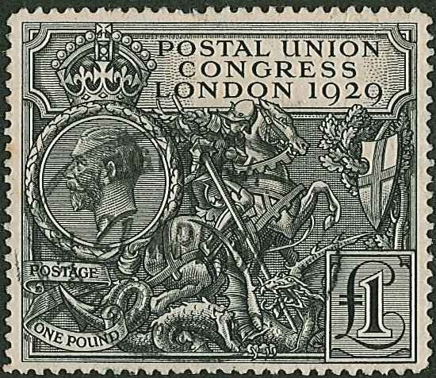
Stamps and Collectables Auction, 11 February 2019 Page 31 .

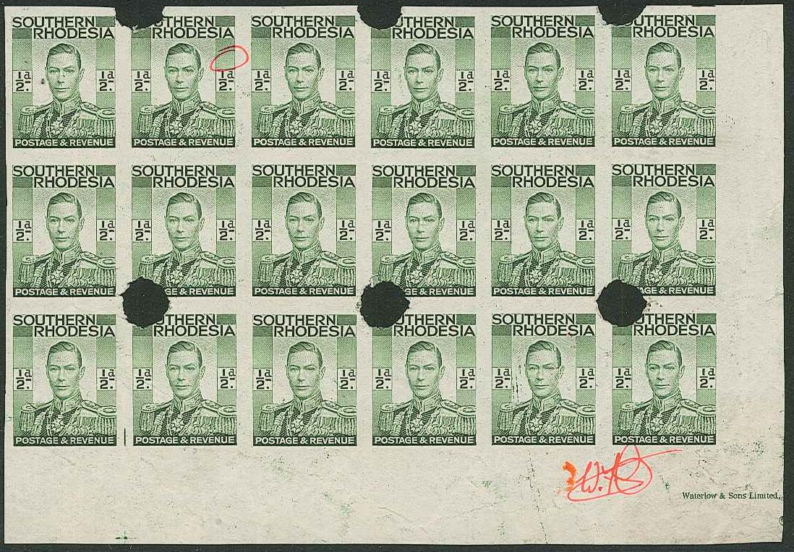

348

ex 317

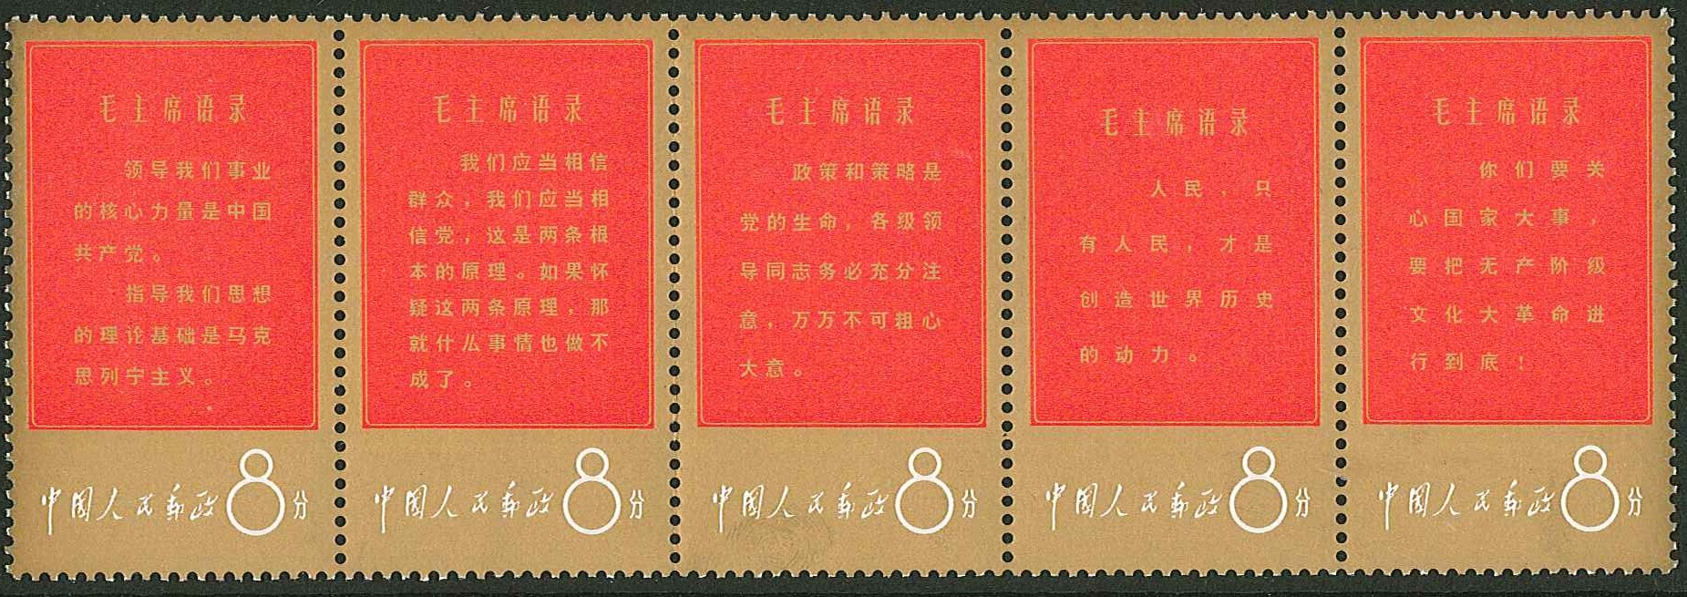

ex 187
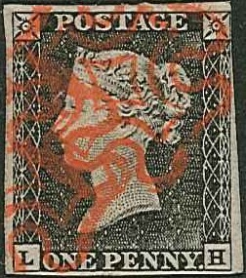
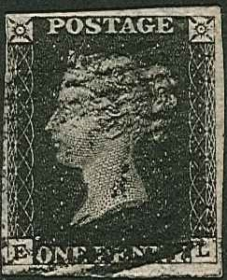
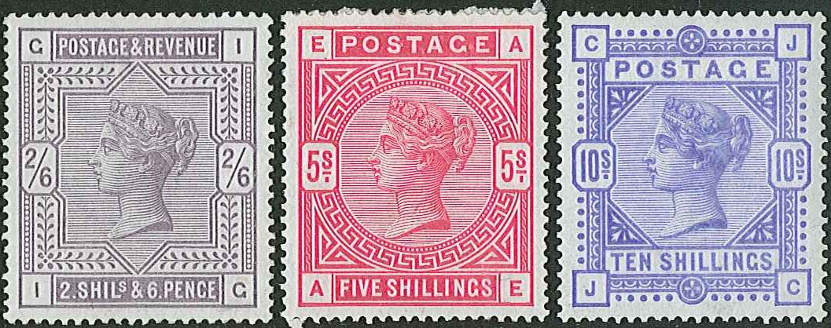

336 338

343
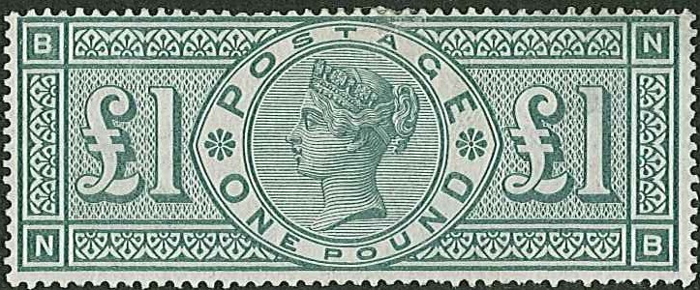
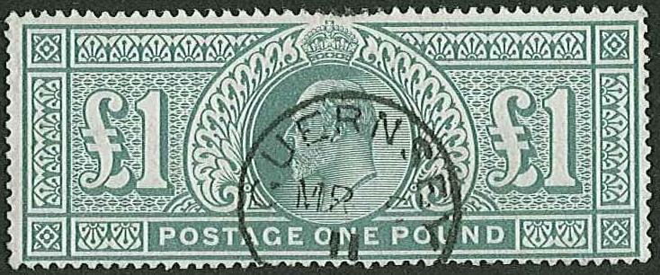

344 345


Stamps and Collectables Auction, 11 February 2019 Page 32 .

191

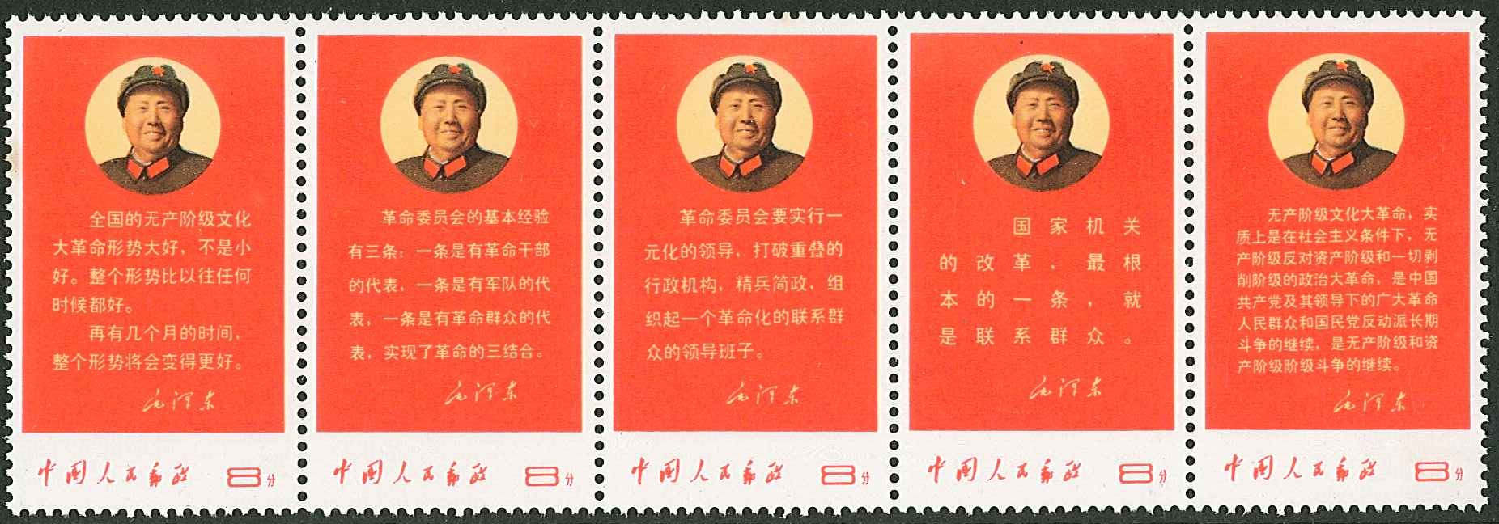

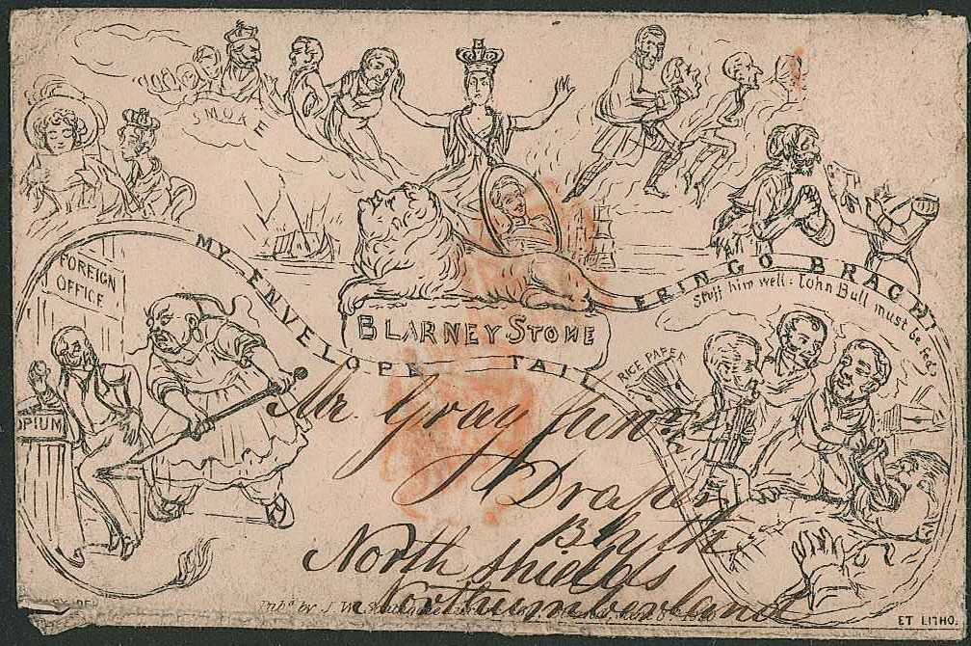
189

388

