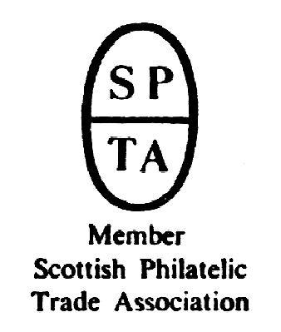

Robert Murray
5 & 6 Inverleith Gardens, Ferry Road,
Edinburgh, EH3 5PU
Tel. 0131 552 1220 :: 0131 478 7021 :: 0845 0500 886
Collectables Auction
AUCTION
CATALOGUE
50p
Collectables Monday 21 June 2010 Collectables
at 5.00pm
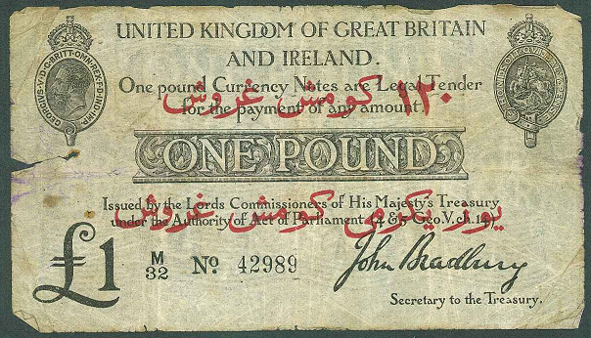
Catalogue of Collectables to be sold by Public Auction, within the
STEWART’S-MELVILLE CLUB PAVILION, 523 FERRY ROAD, EDINBURGH
On view at Pavilion on afternoon of sale (see details later in catalogue),
and at Shop during business hours (Tue, Thu, Fri 10am-6pm, Wed 2pm-9pm,
and Sat 10am-7pm) for one week prior to sale, or by appointment.

45

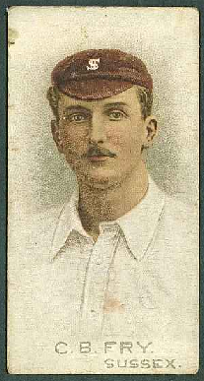
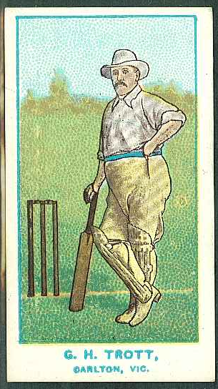
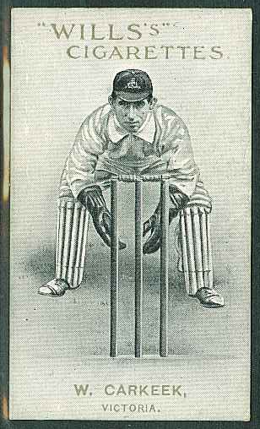
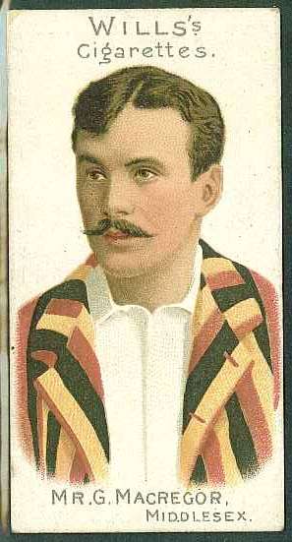
ex ex
81 86

ex ex
82 90

0845 0500 886 website www.stamp-shop.com email auction@stamp-shop.com
Stamps and Collectables, 21 June 2010 Page 2 Estimate.
All notes, terms, and instructions in the accompanying Stamp Auction
catalogue also apply to this catalogue. That catalogue’s bid form should be
used for both sales.
STARTING AT 5.00pm
AUTOGRAPHS
1 Old autograph book, probably round about 1937/39, with cricketers/cricket teams (inc.
Aberdeenshire, Fifeshire, “League of Coloured Peoples”, Gloucestershire, West Indies ?,
Forfarshire, and footballers (apparently 25 members of Aberdeen FC). .. 20.
2 Framed print of David Coulthard, signed by him. ☑ .. .. .. 10.
➲ --; see also in the Stamp Auction; Covers (Golf), UK (Autographed Covers).
BANKNOTES
3 An impressively wide-ranging world collection in five binders (using photocorners).
Excludes China, Germany, and Scotland, which are offered here separately. The strength
is undoubtedly in the variety, effort clearly having been made to obtain examples from as
many countries as possible, rather than in depth, some of the larger countries being
surprisingly thin. Much is cheap, but many included worth at least a pound or two, and
some better e.g. Sweden 1941 50kr (fine). (Approx.1,150) ☑ .. .. £200.
4 Box of “banknote kiloware”, apparently all duplicates to the previous lot. Just under 5kg,
some individual notes being present in bundles of 100+ (especially German inflation), so
quite possibly 2,500 to 3,500 altogether. ☑ .. .. .. .. £100.
5 Mixed seln. of £1 notes, mainly Scottish (inc. modern reprints from original plates, of
North British Bank £5. and Caledonian Banking Co 1890 £1), plus British Forces, English,
etc. (22) .. .. .. .. .. .. .. 35.
6 Small album with world selection (23) ☑ .. .. .. .. 24.
7 Folder of mixed world notes, generally cheaper unc., often with a little dupl. (c.250+) ☑ 24.
8 Small mix comprising England £1 (5), 10/- (2), other world (10). .. .. 15.
Scotland
9 1924-55 slightly duplicated selection of circulated £1 notes of Clydesdale & North of
Scotland Bank, Commercial Bank, and Union Bank - between 1 and 4 each of 12 different
notes/dates in varied condition. (28) .. .. .. .. £100.
10 A similar lot (28) .. .. .. .. .. .. £100.
11 A similar lot (28) .. .. .. .. .. .. £100.
12 Bank of Scotland; 1923 (28 May) “square” £1 note, fine (though with centre hole from
folding). SC101c cat.£200. .. .. .. .. .. 60.
13 --; 1921 (11 Oct.) “square” £1 note, VG (generally fine, but a couple of holes through
folding). SC101c (cat.£200. for F). .. .. .. .. 50.
14 --; 1930 (19 Oct.) £1 note, generally VF+ but with tear in lower margin extending just into
the design. SC102 (cat.£100. for VF). .. .. .. .. 40.
15 --; 1932-43 four £1 notes – 15.4.1932 VG, 15.9.1937 VF, 2.6.1943 F, and 16.10.1943 VF.
Cat. approx.£170. .. .. .. .. .. .. 50.
16 --; 1941 (7 May) £1 note, about EF. SC103b cat.£80. .. .. .. 30.
17 --; 1945-88 selection of twenty £1 notes, with a good variety of types, signatories, and other
wmk./imprint. Condition mainly EF/Unc.(a couple earlier maybe only VF). Cat. approx.
£540. .. .. .. .. .. .. .. £100.
18 --; 1959-88 selection comprising £1 (5) and £5 (10) with reasonable variety, mixed quality,
poor to unc. .. .. .. .. .. .. 80.
19 British Linen Bank; 1918 (5 November) “square” £1 note, VG. Fair amount of handling,
creases, marks, and general wear, but still in acceptable condition. SC202a (cat.£200. for F.) 50.
Stamps and Collectables, 21 June 2010 Page 3 Estimate.
BANKNOTES, continued (Scotland).
20 British Linen Bank; 1926-69 selection of twelve £1 notes, nearly all-different, and mainly
VF/EF/Unc. Cat. roughly £480. .. .. .. .. .. £100.
21 --; 1951-69 seln. comprising £1 (7) and £5 (4), fine to unc. .. .. 45.
22 Clydesdale Bank; 1925 (21 Jan.) “square” £1 note in about VG condition – looks worse on
reverse. SC302b (cat.£260. for Fine). .. .. .. .. 50.
23 --; 1927-88 useful seln. of seventeen £1 notes, nearly all-different, and mixed condition
though most are VF/EF/Unc. Includes 1.5.1946 (about VF). Cat. roughly £560. £120.
24 --; 1952-2006 (and one each 1939 and 1943) mixed seln. comprising £1 (6), £5 (9), and
£10 (5), reasonable variety, mixed condition, poor to EF. .. .. £170.
25 Commercial Bank of Scotland; 1867, 1872, 1873, and 1875 £1 notes (black, pale blue,
blues, and black), each with the lower panel cut off (i.e. “By order” downwards). Proofs ? 30.
26 --; 1926 (1 November) £5 in Fine condition – general good appearance, heavy central folds,
other marks and creases, and the hand-signature a bit faded. SC413a cat.£300. .. £100.
27 --; 1956 (3 January) £20 in almost EF condition (colour smudges at top and foot). SC424b
(cat.£180. for VF, £350. for EF). .. .. .. .. 60.
28 Commercial Bank and National Commercial Bank; 1927-68 selection of twelve £1
notes, nearly all-different, and in poor to uncirculated condition. Cat. roughly £400. 80.
29 National Bank of Scotland; 1915 (11 Nov.) “square” £1 note, about Fine condition.
SC501b cat. “from £220.) .. .. .. .. .. 75.
30 --; 1929-57 selection of eight £1 notes, nearly all-different. Mainly VF-Unc., a couple
poorer. Cat. roughly £400. .. .. .. .. .. 80.
31 --; 1953 (3 January) £5, EF but for a couple of tone spots. SC512f (cat.£180. for EF). 60.
32 National Commercial Bank of Scotland; 1928-68 selection (therefore including
Commercial Bank, National Bank, and National Commercial Bank) comprising £1 (12) and
£5 (4), poor to EF. .. .. .. .. .. .. 80.
33 North of Scotland Bank Ltd.; 1907 (1 May) £1 note, overprinted diagonally in red “The
North of Scotland and Town & County Bank Limited/in which is incorporated/The North
of Scotland Bank Limited”. A rare note. In James Douglas’s Scottish Banknotes (1975) he
reports Town & County Bank notes being overprinted in a similar way, but makes no
reference to North of Scotland Bank issues being treated thus. Would probably grade as Fine
– the note is intact and colours are strong, but much wear, numerous folds and creases,
grubby marks especially on the reverse, etc.  .. .. .. £500.
34 --; 1924 (1 March) £1 note, about F. SC710a cat.£180. .. .. .. 60.
35 --; 1926 (1 March) £1 note, handsigned p.Accountant, about F. SG710a cat.£180. 60.
36 Royal Bank of Scotland; c.1826/1831 forgery of One Guinea note. This is a good quality
production on watermarked paper, with handwritten numbers, and signed by hand, and is in
fair condition; some general wear and grubbiness, portions missing at left and at foot. It is
endorsed “Forged” six times on the reverse.
Accompanying this is an 1831 entire letter from the Custom House in Grangemouth to The
Cashier at the Royal Bank of Scotland in Edinburgh (GRANGE/MOUTH two-line mark, dated
PAID mark), in which the Collector (?) explains that the note was accepted by the First Clerk
(who has also signed on the reverse of the note) in good faith, and asks that the bank issue a
genuine note in its place. Accompanying write-up (from Robson Lowe’s collection ?)
suggests that the bank did not accede, but there is no evidence that this is the case.
It seems that the crime of banknote forgery could carry the punishment of execution,
transportation, or amputation, but that it was also common for banks to honour forgeries
innocently accepted, so as to maintain confidence in paper money. A fascinating item. £500.
37 --; 1917 (1 Sep.) “square” £1 note, grading about VG/F, with various folds and creases,
general wear and grubbiness from use. SC801b (cat.£180. for F.) .. .. 60.
38 --; 1921 (29 June) “square” £1 note, Fine. SC801c cat.£160. .. .. 75.
A Buyer’s Premium of 10% (vat-inclusive) will be added to all sale prices.
Stamps and Collectables, 21 June 2010 Page 4 Estimate.
BANKNOTES, continued (Scotland).
39 Royal Bank of Scotland; 1928-2001 fine collection of thirty-five £1 notes, the later ones
usually EF/Unc., the earlier issues in more varied condition but generally at least average.
Good variety inc. different types, signatures, etc. Includes 1.9.1941 VF/EF, 6.1.1944
almost EF, 1.8.1953 EF. Cat. roughly £500. .. .. .. .. £150.
40 --; 1949 (1 March) £5 note signed Thomson and Brown, VF. SC806 cat.£200. .. 50.
41 --; 1952 (1 December) £5 note, EF. SC807a cat.£90. .. .. 40.
42 --; 1964-96 mixed selection of £1 (18), £5 (16), and £10 (2) notes. Good variety although
includes duplicates, mixed condition. .. .. .. .. £150.
43 Union Bank of Scotland; 1920 (7 July) £1 note in poor condition (“fair” at best, with
creases, stains, tears, holes, etc.). SC901d (cat.£280. for F.) .. .. 20.
44 --; 1926-54 selection of ten £1 notes, in varied quality (Good to EF), showing good variety
though some duplicates. Cat. roughly £400. .. .. .. .. 80.
45 United Kingdom; Treasury Notes; 1915 £1 overprinted in red for use by British
Expeditionary Forces in Turkey, “The Dardanelles Overprint”. A rare note but in quite
poor condition, probably grading as “good” (heavy creases and folds, torn about 2cm into
at left, some stains, etc., and some violet colour rubbed on reverse). TR15 (cat.£2,000 for
VG). .. .. .. .. .. .. .. £500.
46 --; --; 1919 £1 Fisher, with “L” over “51” prefix, fine. TR17b (cat.£85. for VF). 20.
47 England; folder of £1 notes of Peppiatt (1), Beale (26), and O’Brien (3). Also three others.
Mixed circulated condition. ☑ .. .. .. .. .. 40.
48 --; selection comprising 10/- (2), £1 (8), £5 (2), and £10 (1), from Peppiatt to Page, mainly
VF/EF, but three are washed/faded. .. .. .. .. 40.
49 --; 1956 (28 April) white £5 note, VF, clean and fresh. BE96b cat.£75. .. 30.
50 China; extensive collection in binder (using photocorners), mainly 1920s-40s, some later,
and with attractive variety. (c.105) .. .. .. .. 40.
51 Germany; extensive collection in album (using photocorners), roughly 1900-80, with
Reichsbank, inflation issues, State Loan currency, Allied Occupation, Reichsbahn, local
issues, notgeld, etc. Hardly anything post-1949. (c.210) ☑ .. .. 80.
BOOKS
52 Mixed box, with several on exploration and travel, mixed others e.g. Practical Bee Keeping
(DT Macfie), How to Catch Trout (“Three Anglers”, 1890), Canada in Khaki (1917), others
with decorative covers. (41) ⊗ .. .. .. .. .. 40.
53 The Concise Encyclopedia of Antiques, compiled by “The Connoisseur”, edited by L.G.G.
Ramsayin four volumes, New York 1956-9. ☑ .. .. .. 15.
54 Golf; mixed box of books inc. Golf is my Game (Bobby Jones, 1961), Mr. Punch's Golf
Stories (estimated c.1910), Charles Whitcombe on Golf (1931), etc. (15) ☑ .. 30.
55 Polar; small mix of six titles inc. The Arctic Year (Freuchen & Salomonsen, 1958), Sir
Hubert Wilkins (J. Grierson, 1960). ☑ .. .. .. .. 15.
CIGARETTE AND TRADE CARDS
56 Massive lot in about two dozen albums, nearly all in sets. While most are commoner issues,
there are good sets to be found; some odds/part sets also. Condition on the whole is fine but
for two points; {1} some of the albums have been damp at their corners which will have
affected some cards, {2} many cards have been individually wrapped in cellophane which
has done no obvious damage but may have damaged some. (Many 1,000s) ☑ .. £400.
57 Medium carton with a nice collection/accumulation of sets. As far as we can see, these are
all complete sets, all different, and generally in good condition – many are fine/very fine,
and all are simply loose in bundles. In all about 260 sets, the largest numbers in Wills,
Player, and Gallaher, but also numbers of Phillips, Churchman, Mitchell, Millhoff, and
odd sets of smaller companies. Full list available. ☑ .. .. .. £400.
Stamps and Collectables, 21 June 2010 Page 5 Estimate.
CIGARETTE AND TRADE CARDS, continued.
58 Useful album of Cricketers with Hartley's (S.Africa) 1929 South African English Cricket
Tour (one odd card, cat.£70., good), R.& J. Hill 1923 Famous Cricketers set (cat.£200.),
1925 Famous Cricketers including the S.Africa Test Team set (£250.), 1926 Caricatures
of Famous Cricketers large size set (£100.), Millhoff 1928 Famous Test Cricketers set
(£142.), Morris 1925 Australian Cricketers set (£85.), Murray, Sons & Co. 1912 Cricketers
three odd in mixed condition (£70. each), a range of Ogden Guinea Gold (86) and Tab (100,
plus 1901 Our Leading Cricketers set, £168.), Ogden Cricket 1926 set (£130.), 1928
Australian Test Cricketers set (£130.), Prominent Cricketers of 1938 set (£110.), and a few
other odds. Mainly fine. ☑ .. .. .. .. .. £200.
59 Shoebox well-filled with thousands of cards sorted into bundles. A wide mix, probably
mainly part sets/odds, although believed to include some complete sets, and with good
variety, not just of the commonest issues. ☑ .. .. .. .. £100.
60 Useful album of cricket with Pattreioux 1926 Cricketers Series (9 odds), Phillips 1900
Guinea Gold (9 odds), Player 1926 Cricketers, Caricatures by RIP set, 1930 Cricketers
1930 set, 1934 Cricketers 1934 set, 1938 Cricketers 1938 set, Wills 1928 Cricketers 1928
set, 1929 Cricketers (2nd Series) set, etc. Mainly fine. ☑ .. .. .. £100.
61 Useful mixed album of sets with Gerard 1938 Modern Armaments (cat.£60.), Carreras
1929 Notable MPs (£65.), 1939 Film & Stage Beauties (£27.), Churchman 1939 Kings of
Speed (£30.), 1938 In Town Tonight (£25.), 1938 Boxing Personalities (£100.), Lambert &
Butler 1926 Pirates & Highwaymen (£45.), 1932 A History of Aviation (green, £50.),
Mitchell 1927 Clan Tartans (2nd) (£30.), 1923 Famous Crosses (£15.), C.W.S. 1928
Wayside Flowers (£48.), and a few others. Generally fine, individually covered in
cellophane. ☑ .. .. .. .. .. .. 90.
62 Mix in box, early to modern, with fair numbers of sports (football and cricket). Some
scarcer included. (Many 100s) ☑ .. .. .. .. 50.
63 Metal box with many hundreds of mainly loose cards, some less common seen, and inc. 23
odds of Player’s Golf. A few trade cards also included. ☑ .. .. 50.
64 Plastic tub with a few hundred cards inc. a few duplicated A&BC pop stars, 11 odds of D.C.
Thomson Cup-Tie Stars of All Nations, mixed tobacco issues. (100s) ☑ .. 30.
65 About 30 contemporary stick-in printed albums with mainly full sets, mixed condition. ☑ 20.
66 Attractive mix of silk cards in box. Includes Kensitas Flowers (10 small, 33 medium, 2
large, all in original folders), a bundle of Kensitas silk flags (c.70). ☑ .. 20.
67 Mixed lot in box, loose and in albums (mainly adhesive printed type). (100s) ☑ 15.
68 Ardath; 1936 Photocards series “D” of Scottish football teams (association and rugby) –
including everything from Hibernian and Glasgow Rangers to Kirkintilloch Rob Roy and
Perth Half-Holiday Junior Select. Complete set but for no.94 (164 of 165), mainly EF.
Cat.£198.80. ☑ .. .. .. .. .. .. 50.
69 Churchman; 1931 Prominent Golfers (large size) set (12) complete and fine, framed
(properly done, without any adhesive). Cat.£400. ☑ .. .. .. £100.
70 B. Morris & Sons Ltd.; 1923 Golf Strokes Series set (25) complete and fine, framed
(properly done, without any adhesive). Cat.£150. ☑ .. .. .. 40.
71 Ogden; big collection of Guinea Gold cards in two albums (540, sorted) and loose (100s,
largely unsorted). .. .. .. .. .. .. £100.
72 Pattreiouex; eight Senior Service corner-slot albums with sets of photographic-type cards,
apparently all sets. ☑ .. .. .. .. .. 12.
73 Godfrey Phillips; 1926 Famous Cricketers set (32), mainly good/fine though a few with
faults. Cat.£160. .. .. .. .. .. .. 35.
Some further illustrations will be available on our website at www.stamp-shop.com/images.html, but
possibly not until just the last few days before the auction.
A Buyer’s Premium of 10% (vat-inclusive) will be added to all sale prices.
Stamps and Collectables, 21 June 2010 Page 6 Estimate.
CIGARETTE AND TRADE CARDS, continued.
74 Players; useful album of sets comprising 1910 Army Life (cat.£45.), 1912 Ships' Figure-
heads (£62½), 1913 Cries of London (£50.), 1914 Victoria Cross (£65.), 1916 Polar
Exploration (2nd) (£55.), 1917 Gems of British Scenery (£25.), 1916 Cries of London (2nd)
(£20.), 1923 Struggle for Existence (£5.), 1916 Players Past & Present (£22½), and 1923
Miniatures (£10.). Generally fine, individually covered in cellophane. ☑ .. 50.
75 F. & J. Smith; 1902 Champions of Sport (blue backs) two odd cards (of cricketers Joseph
Darling and K.S. Ranjitsinhji), fine. Cat.£85. each. .. .. .. 40.
76 --; 1912 (May) Cricketers part set (38 cards between nos. 1 and 49), in poor to fine
condition – mainly fine. Cat.£15. each = £570. .. .. .. £100.
77 --; 1912 (August) Cricketers complete set of additional numbers (51 to 70) in quite mixed
condition (approx. 10 fine, 6 fair, 4 very poor). Cat.£550. .. .. 50.
78 Sniders & Abrahams; 1905 Australian Cricket Team part set (12 of 15) in mixed condition
(approx. 7 good/fine, 5 average/poor). Cat.£540. .. .. .. 75.
79 Taddy; 1907 South African Cricket Team, 1907 seln. of six odd cards, average/good
condition. Cat.£55. each = £330. .. .. .. .. 50.
80 --; 1907 County Cricketers seln. of eight odd cards in average/good/fine condition. Cat.£40.
each = £320. .. .. .. .. .. .. 50.
81 Wills; 1896 Cricketers complete set of fifty of this rare issue, the condition generally good
to fine. The worst are a bit grubby, and/or with small marks, rounded corners, scratches, etc.;
the best are fine and fresh. The one illustrated (of C.B. Fry) is probably typical of the
average quality. Catalogue price £4,000., and very seldom seen even as odd cards. £750.
82 --; 1901 Cricketer Series complete set of fifty of this scarce issue, plain backgrounds (no
vignettes), and with mixed brands on backs (Gold Flake, Traveler, etc.). Catalogue £600.
Although some have marks or other blemishes, the greater majority are fine and fresh, and
above the general quality one would expect from this period. .. .. £150.
83 --; 1902 Vanity Fair unnumbered (1), “1st Series” (3), and “2nd Series” (2), all of these
being of cricketers. Poor to very fine. Cat.£36½ .. .. .. 10.
84 --; 1908 Cricketers with “WILLS’^{S}” heading on front, and including two versions each of
nos.2, 5, and 25, mainly good/fine, cat.£371. .. .. .. 70.
85 --; Australian Issues; 1903 Australian & English Cricketers (numbered) complete set of 25,
mainly fair to fine. Cat.£400. .. .. .. .. .. 75.
86 --; --; 1905 Australian Club Cricketers selection of 40 different, all with club names, mixed
green and blue backs, mainly good to fine, a few with faults. Cat.£700. .. £150.
87 --; --; 1907 Prominent Australian and English Cricketers selection of 38 different between
nos. 1-50, plus no.66 with grey caption, mixed condition, mainly poorer. Cat.£492. 30.
88 --; --; 1909 Australian and English Cricketers (name at foot of picture) set of 25, mixed red
and blue borders, mixed Capstan and Vice-Regal backs. Mixed quality, mainly fair to fine.
Cat.£375. .. .. .. .. .. .. 50.
89 --; --; 1910 Australian & South African Cricketers seln. of 71 different including some of
same portraits with light and dark backgrounds. mainly blue borders but some red.
Condition varies from fair to fine though a few poorer. Cat.£1,065. .. .. £100.
90 --; --; 1911 Australian and English Cricketers complete first set of fifty (Capstan backs,
mixed with and without “50”), plus numbers 51-59 (8 Capstan, 1 Vice Regal backs). Mainly
good to fine though a few poorer. Cat.£700. .. .. .. .. £100.
91 --; --; 1926 Cricketers photographic, plain backs, part set, missing only nos. 16 and 26.
Majority good/fine, some poorer. (61 of 63) Cat.£455. .. .. .. 75.
92 --; --; 1929 Cricket Season 1928-29 pert set (missing two) good/fine. (46 of 48) Cat.£123. 20.
93 --; New Zealand Issues; 1926 English Cricketers set of 25, fine. Cat.£70. .. 20.
94 Germany; bundle of cards (“Cigaretten-Bilderdienst”) of 1936 Olympics (c.90 medium,
25 large) and Adolf Hitler (39 medium, 18 large), fair/fine. .. .. 24.
Stamps and Collectables, 21 June 2010 Page 7 Estimate.
CIGARETTE AND TRADE CARDS, continued.
➲ Cricket; note the strong section of Cricket cards throughout this section. Also see Postcards.
95 Golf; useful album of odd cards e.g. Churchman Prominent Golfers (7), Men of the
Moment in Sport (5), 3 Jovial Golfers (11), Player’s Golf (12), Championship Golf Courses
(set of 25), Wills Famous Golfers (9), Golfing (11). Mainly fine. (105) ☑ .. £100.
96 Cigarette and Trade Cards; Golf; album of modern cards, either modern issues or
reproductions. (9 sets) ☑ .. .. .. .. .. 20.
97 Trade Cards; useful album of cricketers with A.&B.C. Gum 1959 Cricketers set (48,
cat.£120.), 1961 Cricketers set (48, larger size, £144.), Amalgamated Press 1922 Sporting
Champions (7 odds), several useful Barratt odds, Barratt 1956 Test Cricketers set (35,
mixed quality, £210.), etc. ☑ .. .. .. .. .. £100.
98 --; useful album of cricketers with Bassett 1979 Cricket (2nd) set (50, cat.£175.), Boys'
Realm 1922 Famous Cricketers set (12, £50.), Carr's Biscuits 1967 Cricketers set (20,
£140.), Chums 1923 Cricketers set (23, cat.£115.), Clevedon Confectionery 1959 Famous
Cricketers (17 odds, £187.), Kane Products 1956 Cricketers (both sets, £75.), Morning
Foods 1953 Test Cricketers set (25, £55.), National Spastics Society 1958 Famous County
Cricketers set (24, £48.), etc. ☑ .. .. .. .. .. £200.
99 --; useful album of cricketers with Reeves' Chocolate 1912 Cricketers (1 odd, poor, cat.
£30.), Sunicrust 1974 Cricketers (39/40, mixed), D.C.Thomson 1926 The World's Best
Cricketers set (32, £88.), 1930 The World's Best Cricketers part set (29/36, £159½), 1955
(1957 ?) County Cricketers set (64, £160.), 1958 The World's Best Cricketers set (72,
£234.), Young Britain 1922 Favourite Cricketers part set (27/30, £92½), etc. ☑ .. £180.
100 --; Australian Licorice Pty. Ltd.; 1931 South African Cricketers set (12), good/fine, cat.
£162. .. .. .. .. .. .. .. 40.
101 --; Barratt; 1957 Test Cricketers set (48) fine, cat.£336. .. .. 80.
102 --; D.C. Thomson; 1955 County Cricketers dupl. seln. of odd cards (nothing higher than no.
16), mainly fine. (56, cat.£2½ each = £140.) .. .. .. .. 20.
103 --; Happy Home; 1914 Women on War Work silk set (12) in fine condition. Cat.£100. 20.
104 --; --; 1912 Child Studies (15, cat.£7½ each), 1914 Flags (8 diff. + 6 dupl., £7½ each), and
1912 Our Lucky Flowers (set of 9 + 1 dupl., cat.£13. each). Mainly fine and fresh though a
few small faults. .. .. .. .. .. .. 40.
105 --; My Weekly; 1916 Battle Series (set of 9, cat.£63.), 1914 Floral Beauties (set of 12 + 2
dupl., cat.£80.), 1912 Lucky Emblems (15 diff. + 2 dupl., cat.£144½), 1915 Our Soldier
Boys (set of 12 + 3 dupl., cat.£105.), 1914 Soldiers of the King (7 diff., cat.£45½), 1913
Sweet Kiss Series (set of 6 + 1 dupl., cat.£56.), and 1916 War Heroes (4, cat.£32.) ☑ 50.
COINS
106 Mixed box with various proof sets (6 UK, 4 foreign), various boxed UK (1989 2 x £2 silver,
1994 £2 piedfort, 1996 £5 silver proof, 1993 £1 piedfort, 1989 £1 silver proof, 1985 £1
piedfort, 1990 2 x 5p silver proof), four foreign silver proof coins, various loose, Maria
Theresa thaler, etc. ☑ .. .. .. .. .. £120.
107 A hat box with a mix of items inc. a presentation box of Queen Mother coins (11, mainly
silver proof), UK 1953 “plastic set”, and mixed loose UK and world. (100s) ☑ .. 80.
108 Mainly UK mix in shallow box, with several UK commem crowns (inc. 1935, 1937, and
six at £5), a few silver UK, USA silver dollars of 1899 and 1925, etc. ☑ .. 75.
109 General world mix in several tins, coffee jar, etc. (c.11kg gross weight) ☑ .. 60.
110 UK proof sets for 1970, 1971, 1982, 1986, 1987, and 1988, an album of mainly UK coins
inc. a few small silver, and some others loose. ☑ .. .. .. 50.
A Buyer’s Premium of 10% (vat-inclusive) will be added to all sale prices.
Stamps and Collectables, 21 June 2010 Page 8 Estimate.
COINS, continued.
111 Box with five UK 1970-86 proof sets, duplicated commem crowns, 2 silver proof crowns,
other medallions, silver stamp replica, etc., as well as various similar Isle of Man. ☑ 50.
112 Mix in box inc. USA 1926 silver dollar, UK 1890 and 1891 crowns, two 1953 “plastic sets”,
etc. ☑ .. .. .. .. .. .. .. 50.
113 Wooden box with world mix. Includes £3 face in UK pre-47 silver, some mixed old copper
coins, etc. ☑ .. .. .. .. .. .. 45.
114 Three sweetie tins filled with a world mix, much of the bulk being UK pennies and half-
pennies. (Approx.23kg gross weight) ⊗ .. .. .. .. 40.
115 Loose mix in box of UK and world inc. just a few silver, plus UK 1953 “plastic set”, etc.
Also some stamps. ☑ .. .. .. .. .. 30.
116 Mixed quantity of world, the best being Straits Settlements 1909 $1 VF+, then just a few UK
pre-1947 silver, etc. (100s) Also a few banknotes. ☑ .. .. .. 30.
117 Two large albums “Coins of All Nations” with a collection of single-stamp first day covers
(c.1978-80) of 96 different countries, each with a coin of the country encapsulated. ☑ 20.
118 Album with ten sets of various countries in presentation cards, mainly 1970s. ☑ 15.
119 Ice cream tub with loose world mix (c.2.25kg net). Much common, some not so. ☑ 15.
120 Album with a seln. of Germany and others. (32) ☑ .. .. .. 10.
121 United Kingdom; collection in album with some useful farthings 1790-1830s, 1886 ¼d unc.
various silver inc. some back to George III, etc. through to a few modern. (100s) ☑ £140.
122 --; “Fantasy” Maundy set for King Edward VIII, dated 1936, plus a gold-plated 1977 crown
mounted on chain, and a 1951 Festival crown. ☑ .. .. .. 15.
123 --; 1951 Festival crowns (2), 1990 Queen Mother £5 crowns (3), and several other cheaper
crowns. ☑ .. .. .. .. .. .. 20.
124 --; proof sets for 1984, 1985, 1986, 1987, plus a few other sets etc. ☑ .. 40.
125 --; 1984-87 “£1 Silver Proof Collection” in original box. ☑ .. .. 35.
126 China; seln. of 18 silver-dollar-type coins, but sold “as is”. ☑ .. .. 30.
127 --; small box with a mix of “cash” coins, mainly brass type, mixed sizes/ages. (69) ☑ 30.
128 United States of America; 1852 gold $1, generally VF but two lumps of solder on reverse
where it has been mounted. .. .. .. .. .. 30.
129 Vietnam; seln. of eight coins of Chinese style, dated between approx. 1420 and 1900. 30.
➲ Emergency Currency; see stamp auction (Denmark).
GOLD COINS
130 Barbados; 1995 Queen Mother $10 in .5833 gold (AGW 0.1458oz). ☑ ▲ .. 90.
131 Cook Islands; 1997 tiny Princess Diana $5 in .9999 gold (AGW 0.04oz). ▲ .. 24.
132 Isle of Man; 1973 half sovereign, unc. (AGW 0.1173oz) ▲ .. .. 80.
133 --; 1980 Queen Mother gold One Crown, the 0.375 purity version (AGW 0.0601oz). ▲ 40.
134 --; 1981 Royal Wedding half sovereign, unc. (AGW 0.1173oz) ▲ .. .. 80.
135 Seychelles; 1995 Queen Mother 100r in .583 gold (AGW 0.1458oz). ▲ .. 90.
136 South Africa; 1981 One Half Krugerrand, EF. ▲ .. .. .. £350.
137 --; 1981 One Quarter Krugerrand, EF. ▲ .. .. .. .. £175.
138 --; 1981 One Tenth Krugerrand, EF. ▲ .. .. .. .. 70.
139 United Kingdom; reproduction of 1820 George III £2 coin, to normal specifications of
weight and purity. Possibly produced by Pobjoy Mint and sold by them as a “restrike”
(which it is not, as it is not from the original dies). ☑ .. .. .. £200.
140 --; 1893 sovereign, F+. ▲ .. .. .. .. .. £160.
141 --; 1908 half sovereign, VF. ▲ .. .. .. .. .. 80.
142 --; 1911 sovereign, VF. ▲ .. .. .. .. .. £160.
143 --; 1911 half sovereign, VF. ▲ .. .. .. .. .. 80.
144 --; 1913 half sovereign, EF. ▲ .. .. .. .. .. 80.
145 --; 1923 proof half sovereign, a very scarce date. .. .. .. £150.
Stamps and Collectables, 21 June 2010 Page 9 Estimate.
GOLD COINS, continued.
146 United Kingdom; “Fantasy” piece, being in the style, size and weight of a sovereign,
dated 1936, and with the portrait of King Edward VIII. 9ct, fine gold plated. Some
fingering marks. ▲ .. .. .. .. .. .. 40.
147 --; 1937 proof half sovereign, very slight wear on obverse, but still a very scarce date. ▲ £150.
148 --; 1980 sovereign, unc. ▲ .. .. .. .. .. £160.
149 --; 1980 sovereign, unc. ▲ .. .. .. .. .. £160.
150 --; 1980 proof half sovereign, in box. ▲ .. .. .. .. 80.
151 --; 1980 proof half sovereign, in box. ▲ .. .. .. .. 80.
152 --; 1982 half sovereign, unc. ▲ .. .. .. .. .. 80.
153 --; 1982 half sovereign, unc. ▲ .. .. .. .. .. 80.
154 --; 1982 half sovereign, unc. ▲ .. .. .. .. .. 80.
155 --; Touch Pieces; 1974 reproductions in gold (one 18ct., other “solid gold”) of touch pieces
of Charles II and Queen Anne. ☑ .. .. .. .. 40.
MEDALLIONS
156 Selection of gold-plated sterling silver actual-size replicas of classic stamps (22 from set of
25). Approx. 7½oz net weight. .. .. .. .. .. 40.
157 United Kingdom; seln. of seven comprising 1935 Jubilee 32mm silver (one EF, one with
solder), 1937 Coronation 32mm (1 silver EF, 1 silver F, 1 bronze/brass ? VF), 1937
Coronation unofficial bronze, and one “Empire Day”. ☑ .. .. 24.
158 --; 1935 Silver Jubilee large (58mm) silver medallion, EF/unc in original box. ☑ 30.
159 --; 1935 Silver Jubilee standard (32mm) silver medallion, unc. in original box. .. 15.
➲ Medallions; see also Stamps; Thematic (WWF).
MEDALS
160 Queen’s South Africa Medal (3rd type reverse) with three clasps (Belfast, Orange Free State,
and Cape Colony), and King’s South Africa Medal with two clasps (South Africa 1901, and
South Africa 1902), both named to a private in Gordon Highlanders. About EF. £120.
161 First World War group of three (1914-15 Star, BWM, Victory) named to member of Royal
Navy (A.B. then L.S.), plus Royal Fleet Reserve Long Service and Good Conduct Medal,
and Imperial Service Medal (“BR:OMN:” version, same recipient). ☑ .. 50.
162 First World War standard pair named to Lieut. H. Bettison (no number or regiment), the
Victory Medal with oak leaf. Also matching miniatures, and framed certificate for mention
in despatch (E. Yorks. Reg., printed signature of Winston Churchill, stains). ☑ 30.
163 First World War standard pair named to private in Seaforth Highlanders, plus the matching
Memorial Plaque. .. .. .. .. .. .. 35.
164 First World War Memorial Plaque. .. .. .. .. 30.
165 WW1 standard pair named to a sapper in R.E.; also WW2 group of three (1939-45 Star,
Burma Star, War Medal) in original box (same surname). ☑ .. .. 30.
166 WW1 British War Medal named to British member of Mombasa Defence Force. Also a
WW2 Defence Medal. .. .. .. .. .. 15.
167 WW2 group of six comprising 1939-45 Star, Africa Star, France and Germany Star, Defence
Medal, War Medal, and Territorial Efficiency Medal with MILITIA clasp (named to Lt. in
R.E.), mounted for wear. Also matching set of miniatures, and ribbons. ☑ .. 60.
168 WW2 group of six comprising 1939-45 Star, Africa Star with 8th Army clasp, Italy Star,
France & Germany Star, Defence Medal, and War Medal. Also 1953 Coronation Medal. ☑ 40.
169 WW2 group of five comprising 1939-45 Star, Africa Star, Italy Star, Defence Medal, and
War Medal. ☑ .. .. .. .. .. .. 30.
170 WW2 group of four comprising 1939-45 Star, Burma Star, Defence Medal, and War Medal
with Oak Leaf (mention in despatches). Also a facsimile set of miniatures, and ribbons. ☑ 40.
A Buyer’s Premium of 10% (vat-inclusive) will be added to all sale prices.
Stamps and Collectables, 21 June 2010 Page 10 Estimate.
POSTCARDS
171 Album with about fifty WW1 silk cards (mixed types, mainly fair/good/fine), plus more
modern railway engines (55), a few modern motor cars, and another album with postcard-
size photographs of military aircraft (60). ☑ .. .. .. .. 70.
172 Mainly Scottish (much S.W. Scot.) in small album inc. some better e.g. 1907 royal shoot,
High House Colliery Auchinleck (creased), Hospital Saturday Creetown 1908. (c.95). Also
further mixed in small biscuit tin. ☑ .. .. .. .. 40.
173 Album of mainly cards showing Gladys Cooper (c.120), plus mixed greetings (c.50) ☑ 30.
174 Small mix of Paris (25), Versailles (17), and Cologne (23, inc. ten RP cards of the 1919
Rhine Army Peace Celebrations and two others with British Army connections), plus
Tuck’s Queen’s Dolls’ House (11). .. .. .. .. 24.
175 Scotland; Dundee; album with a general collection of all areas. Much is in town centre
views, but also several; Broughty Ferry etc. Includes 1915 “Torpedo Craft at Dundee”,
1905 first Sunday tram at Ninewells, Magdalen Green Station (creased), Boiling Whelks
at Broughty Ferry, etc. (c.175) ☑ .. .. .. .. £150.
176 --; Edinburgh; album of Central Edinburgh views, generally just the standard material,
but with some interest all the same. (c.200) ☑ .. .. .. 40.
177 --; --; single real photographic card showing a funeral procession, said to be at Newhaven,
and of one of the Royal Scots killed in the Gretna rail crash (although most casualties were
buried in a mass grave). Worn and grubby. .. .. .. .. 10.
178 Cricket; small colln. in album of 26 cards, the majority individual players, some teams,
about 1900s/30s. ☑ .. .. .. .. .. .. 50.
179 Golf; three small albums with about 55 modern cards, slight dupl., and a couple of older. ☑ 15.
180 Military; bundle of c.160 modern cards, mainly artist cards of military uniforms, some repro.
Harry Payne, etc. ☑ .. .. .. .. .. .. 6.
181 Motor Cars; seven RP cards with posed photographs of large cars with their drivers,
believed all to be in Edinburgh around 1907-8, usually with name of driver written on back.
Also two similar photographs, and a few other mixed postcards. .. .. 30.
182 Modern Cards; large lot in fifteen scrap albums (using photo-corners), plus two shoeboxes
and two tubs. Nearly all are UK views, probably about 1960s/70s. Includes some of railways
and other transport. (1,000s) ⊗ .. .. .. .. .. 30.
OTHER CATEGORIES
183 Bric-a-Brac; box with two oval picture frames, black wooden African head, carved tusk (?)
of crocodile chomping a man, wooden bowl, ceramic dishes, pair of bookends, etc. {Will not
be posted} ⊗.. .. .. .. .. .. .. 30.
184 --; box of odds-and-ends with binoculars, little alarm clocks, small brass box, watches, tub
of golfer's tees and markers, a putting machine, shoebox of golf balls, tee-square, etc. {Will
not be posted} ⊗ .. .. .. .. .. .. 30.
185 --; a Safeway Greenbox filled with mixed items inc. two pictures, boxed set of teaspoons,
binoculars, metal dishes etc., carving knife, etc. Also a shaped metal-framed mirror, and a
mirror tray. {Will not be posted} ⊗ .. .. .. .. 20.
186 --; three matching dining chairs, possibly approx. 1910s/30s, with design on backs of grapes
and leaves. {Will not be posted} ⊗ .. .. .. .. 15.
187 --; a china statuette of Mr. McAwber (44cm high, some faults), and a soapstone (?) figure
of Quasimodo (25cm). {Will not be posted} ⊗ .. .. .. 20.
188 China and Ceramics; Wedgwood “Livingstone” dinner service comprising large plates
(13), medium plates (8), smaller plates (12), soup/dessert plates (11 large, 12 medium),
dishes/ashettes of various sizes (7), and three tureens (two with covers). Decorative floral
border principally in red, orange, and dark blue. Probably earlyish 20th-century, generally
fine. {Will not be posted} ⊗. .. .. .. .. .. 50.
189 --; Royal Doulton “The Old Balloon Seller” (hand-painted title on base, with code HN1315).
Possibly about 1920s/1930s ? {Will not be posted} ⊗ .. .. .. 30.
Stamps and Collectables, 21 June 2010 Page 11 Estimate.
190 China and Ceramics; Noritaki circular dish with cover, c.185mm diameter, the base with
decorative border, cover with design of Japanese ladies in garden with mountain in back-
ground. Fine. {Will not be posted} ⊗ .. .. .. .. 20.
191 --; three-piece Japanese tea set, comprising teapot (c.155mm high) with lid (lid broken), tea-
caddy (sugar bowl ?) (c.100mm high) with lid, and jug (c.125mm high). All with same design
of two seated Japanese men on one side, floral design on other. {Will not be posted} ⊗ 20.
192 --; three boxes of mixed china and glassware. (Dozens) {Will not be posted} ⊗ .. 20.
193 --; box of cheap mixed china etc. (13 items) {Will not be posted} ⊗ .. .. 15.
194 --; box and plastic tub of mainly glassware (vases and others), plus ceramics (mainly hand-
painted), and some metalware. {Will not be posted} ⊗ .. .. .. 20.
195 Communion Tokens; small box with seventeen different inc. Broughton (brass), Carstairs,
Culsalmond, Glenorchy & Inishall, Stockbridge, Tiree. ☑ .. .. 40.
196 --; seln. of 11 different, seven of these being Edinburgh & Leith (inc. Lady Glenorchy’s
Free Church, North Kirk Leith, Barony, Cramond). .. .. .. 24.
197 Computers; a “vintage” Amstrad PCW8256 complete in very good second-hand condition,
packed in original box, with keyboard, printer, manual, etc. ⊗ .. .. 10.
198 Ephemera; hard-covered bound copy of Laws of the Incorporation of Goldsmiths of Edin-
burgh, 1886 (44 pages), plus an 1883 document, being the Indenture for an apprenticeship
with an Edinburgh goldsmith. .. .. .. .. .. 30.
199 --; paperbound copy of Laws of the Incorporation of Goldsmiths of Edinburgh, 1886 (faults). 10.
200 Golf; an all-wooden golf club (putter ?), the shaft possibly repaired and cut down. ☑ 5.
➲ --; see also (in Collectables section) Books, Cigarette Cards, Postcards, Telephone Cards,
(and in Stamps section) Autographed Covers.
201 Jewellery; four-drawer wooden cabinet with mixed selection, late 19th-Century to modern,
inc. 1894 Kruger 1/- in brooch, small RAUXAF badge, bracelets, brooches, and others. ☑ 40.
202 Model Vehicles; colln. of 17 different (Days Gone, Bypost, etc.) Royal Mail vans, railway
parcel vans, and similar, plus 2 stamp exhibition souvenir vans, all in boxes, all in boxes, 3
other PO without boxes, etc. ☑ .. .. .. .. .. 40.
203 Pictures; four calendars (1960-78, three of these Briggs) each with a good quality print of a
painting by Sir William Russell Flint (Conversation Piece, Naomi, Pepita Serafina and
Romira, and The Garden of Romance). ⊗ .. .. .. .. 20.
204 --; four calendars (Briggs, 1936-67) each with a good quality print – two by Sir Gerald Kelly
(Girl with Pitcher, Ma Aung Saw Myawng II), one each by Paul Jobert (Off Algiers), and J.
McIntosh Patrick (Autumn Kinnordy). ⊗ .. .. .. .. 20.
205 Postal; small collection of small models of postboxes, postmen, postal bicycles, motor-
cycles, a few non-postal (e.g. soldiers), and odd others. Quite modern, the majority of lead.
(c.70 items) ☑ .. .. .. .. .. .. 35.
206 Telephone Cards; small collection of cards, all with golf subjects (c.47), also set of four
Beano/Dandy phonecards. ☑ .. .. .. .. .. 24.
207 Watches; silver pocket watch with Chester hallmark of 1885 (large fancy face with gold
coloured roman numerals) in traveling case, plus two wrist watches. ☑ .. 30.
208 Collectables Mixed Lots; box of modern postcards (est.1,500), plus a small bundle of
Judge's, and a few small snapshots inc. several aircraft. .. .. .. 24.
209 --; UK 1935 Silver Jubilee official silver medallion, a WW1 Princess Mary Gift Box
(empty), and a Home Guard matchbox holder. ☑ .. .. .. 15.
210 --; shoebox of modern postcards (mainly UK), a framed group of reproduction Player's golf
cigarette cards, and a Shiskine Golf Club 1996 calendar. ⊗ .. .. 10.
211 --; two Princess Diana medallions, seven phone cards, some reproduction USA banknotes,
etc. ☑ .. .. .. .. .. .. .. 10.
THE END OF THE SALE
© Robert Murray 2010
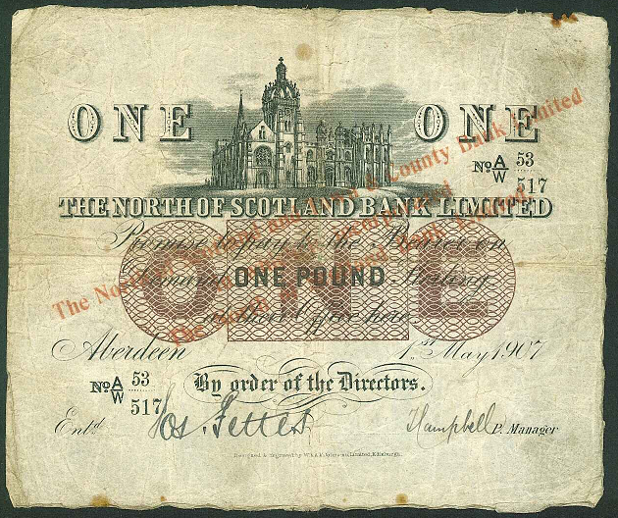
Stamps and Collectables, 21 June 2010 Page 12 Estimate.

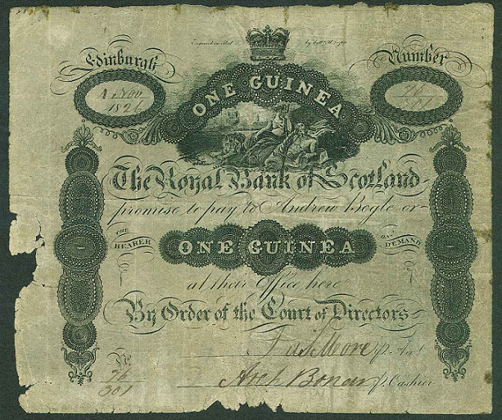
33
36

