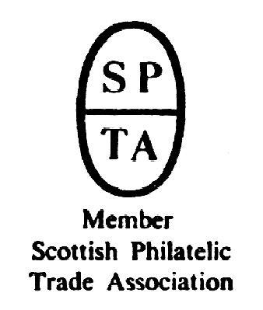

Robert Murray
5 & 6 Inverleith Gardens, Ferry Road,
Edinburgh, EH3 5PU
Tel. 0131 552 1220 :: 0131 478 7021
AUCTION
CATALOGUE
ONE POUND
website www.stamp-shop.com email auction@stamp-shop.com
Stamps and Collectables Auction
Monday 26 August 2019
at 7.00pm
Catalogue of Postage Stamps and Collectables to be sold by Public Auction, within the
STEWART’S-MELVILLE CLUB PAVILION, 523 FERRY ROAD,
EDINBURGH, EH5 2DW.
On view at Pavilion on afternoon and evening of sale, and at Shop for one week prior to sale (see details later in catalogue).
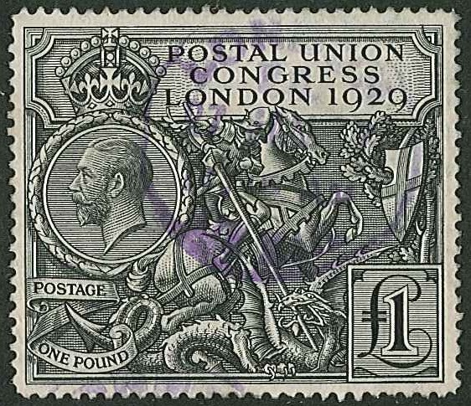
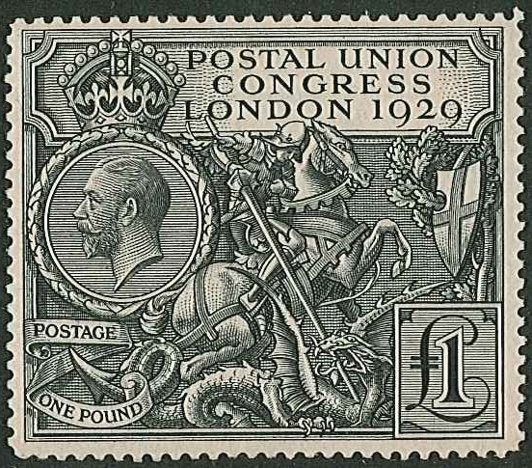

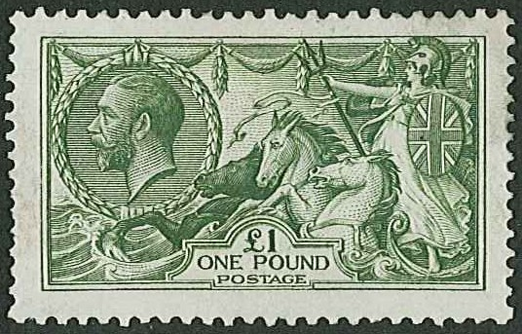

389 388 390

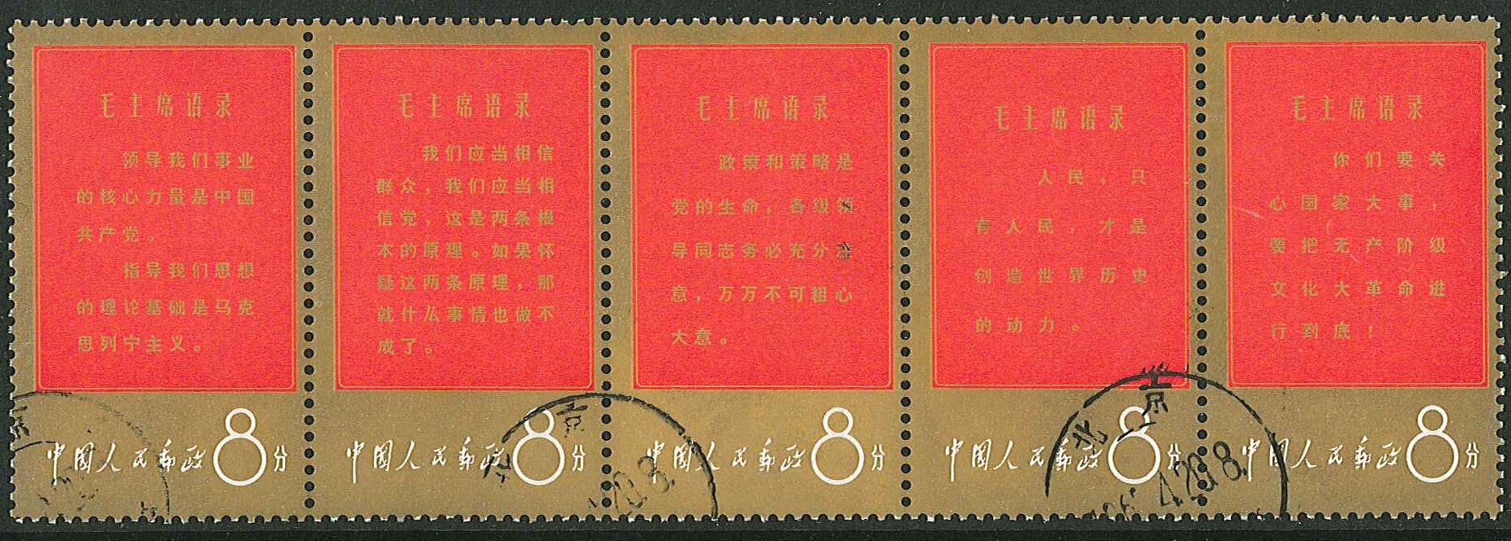

ex 261
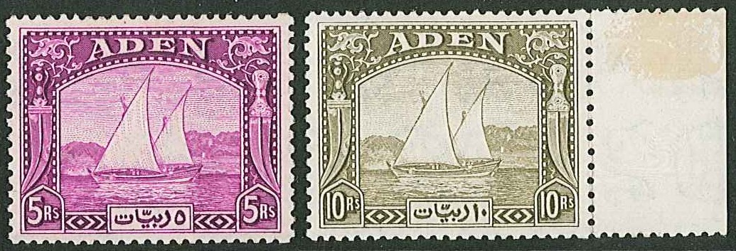
Stamps and Collectables Auction, 26 August 2019 Page 2 Estimate.
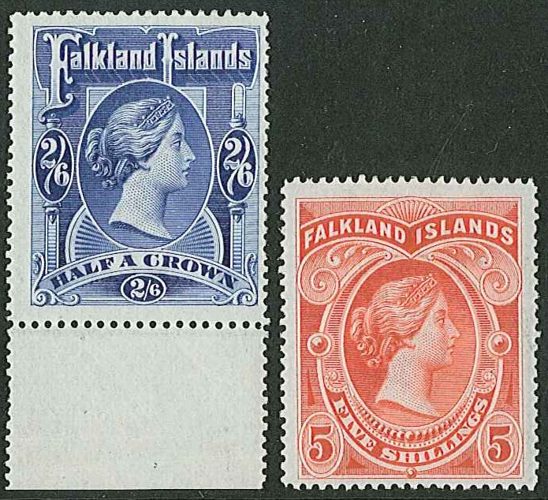
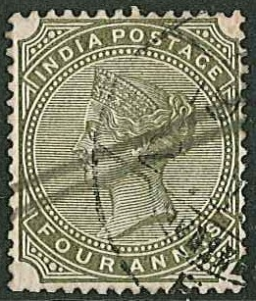
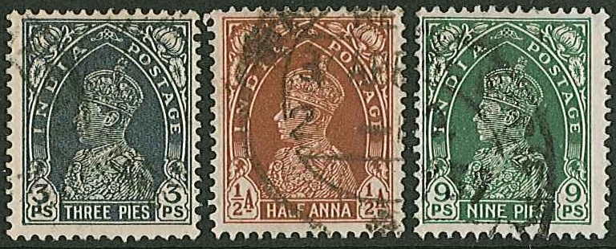
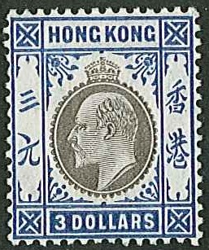
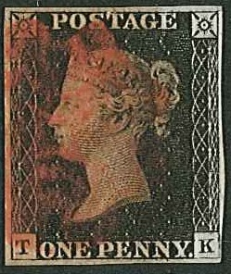
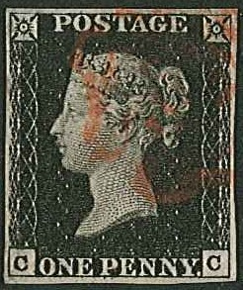
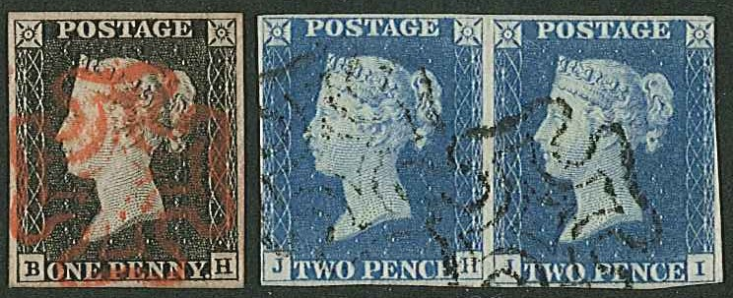
ex 236 313
318
(inverted watermark)
268

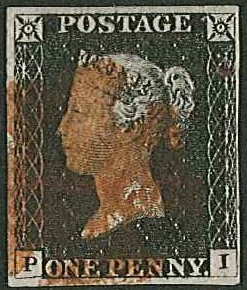
319 (inverted watermarks) 353 354

352 355
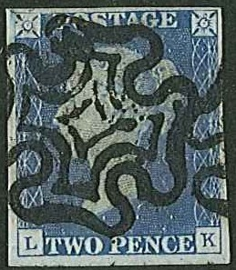
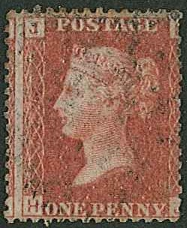
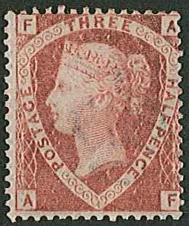
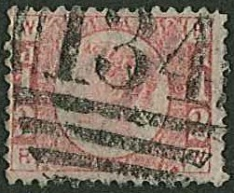
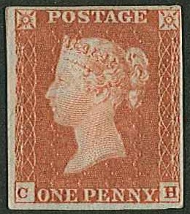
365 369 374 375 377
(plate 225) (plate 9)
Stamps and Collectables Auction, 26 August 2019 Page 3 Estimate.
Viewing times are listed on page 27.
(Viewing starts on Tuesday 20th August)

Customers should note that pressure of viewing space at our premises will be at more of a premium than usual due to the volume of larger lots. Please make full use of all our advertised viewing opportunities. Saturday can be particularly busy, don’t forget we are open till 8pm on Wednesday, and that viewing is available by appointment on Friday.

We are looking for a strong-backed willing worker to help at this and subsequent auctions from 1.30pm in the afternoon till circa 10.30pm. This might suit a student who is available on Mondays and we pay the national living wage to anyone who does the job, even if they are under 25. Remaining auction dates for this year are 7th October and 25th November. Please spread the word !

Collections and Mixed Lots.
1 The Illustrated Postage Stamp Album (Senf) with mint and used stamps, picked over in
places but inc. better with UK 1840 Mulready 2d envelope unused, Gibraltar KE7 ten
m.m. values inc. 2/-, 4/-, 8/- and £1. Some areas sparse. (Many 100s) ☑ .. £350.
2 Box with 50 remaindered club books, with about 80% Commonwealth. Vendor states
remainder is PTSA £2,420 (generally at quite low percentage of catalogue). (1,000s) ☑ £240.
3 Six large stockbooks of mint and used alphabetically from Afghanistan to Monaco, mostly
smaller countries, largely odds with some sets, up to c.2000, some later. (1,000s) ☑ £150.
4 A similar lot of seven large stockbooks from Mongolia to Zululand. (1,000s) ☑ £180.
5 Old large Lincoln album with a colln. that started in 1901, and contains stamps up to late
1940s with a few later, inc. a Penny Black (2+ margins, red MC), and other stamps cat. a
few pounds each. Picked over in places. (Many 100s) ☑ .. .. £120.
6 Box with a large unnamed album with stamps up to c.1910, Challenge album with stamps
up to c.1930, Movaleaf (inc. a few useful older China), a Strand, an old Improved, and
another old album, with many stamps catalogued in pounds each. (Many 100s) ☑ £120.
7 Carton with single albums of Europe, UK/Commonwealth, USA 1932-82 commems, ships
thematics, Taiwan covers and year packs; and three albums of UK FDCs 1969-81. Also
another box with stockcards inc. UK 1951 high values u.m., 1946 Victory sets used, file
box of Prinz mounts, Prinz guillotine, etc. (1,000s) [1a] .. .. .. £120.
8 Tub with 19 assorted albums/stockbooks (some small), and a bundle of album pages with
a wide range of world stamps. (1,000s) Also three small albums of cig./trade cards. ☑ £100.
9 Carton with six assorted albums/stockbooks of world stamps, much Europe and Common-
wealth, Canada mint inc. 1979-82 year packs, two binders of Royal Events etc. Also two
file boxes of loose off-paper, partly sorted, etc. (1,000s) ☑ .. .. £100.
10 Small album with Commonwealth (1937 Coronation 135 of std. design both m.m. and used,
a few others), and U.S.A. (fair range inc. some useful earlies e.g. 1851-57 12 c imperf
vertical pair with 3 margins f.u., 1869 1c unu., 1893 Columbian 30c m.m. but thinned, 50c
g.u., 1898 Omaha 50c and $2 used with creases etc.). (100s) ☑ .. .. £100.
11 Box with 63 remainder club books (some with loose pages), much Commonwealth and
Europe. (1,000s) ☑ .. .. .. .. .. .. £100.
12 Two cartons with world collections in 27 assorted albums/stockbooks. Also Deutsche Post
1948-2004 Olympic binder with stamps/covers. Some foxing from storage. (1,000s) [1a] £100.
13 Box with eight assorted albums (4 Commonwealth, 4 foreign), much used, from earlies up
to 1990s. Also a box of stockbooks, loose on/off-paper, album of crests, etc. (1,000s) [1a] £100.
14 Heavy lot in two cartons with world mostly u. colln. in 5 volumes (inc. 12 pages of China),
15 assorted albums/stockbooks, UK covers in 3 albums (inc. 18 penny red covers), Canada
yearpacks (1982, 1985-89), loose etc. in 2 file boxes, envelopes, etc. (many 1,000s) [1a] £100.
15 Tub of 13 assorted world albums, with a wide range of stamps mint and used. (1,000s) ☑ 90.

Alternative bids, and overall spending limits, are acceptable. Advice available if required !
A Buyer’s Premium of 12% (vat-inclusive) will be added to all sale prices.
Stamps and Collectables Auction, 26 August 2019 Page 4 Estimate.

Collections and Mixed Lots, continued.
16 Carton with nine assorted albums/stockbooks of world, noting Commonwealth especially
New Zealand, FDCs in two albums and loose (much UK, I.o.M. and Australia), loose/
album pages inc. Australian States, NZ advert stamps, UK 1d reds, etc. (1,000s) ☑ 80.
17 A box with mainly pre-1950 stamps, much Commonwealth in club books (19) inc. Indian
States and Newfoundland, two albums, loose in glassines inc. piece with three strikes of
“HAMPTON COURT CAMP/11 MAY 37/Kingston-on-Thames” pmk., a few covers inc. S.Africa
pre-union, etc. (Many 100s) ☑ .. .. .. .. .. 80.
18 Carton with 11 assorted albums/stockbooks, much foreign. Also stockleaves, loose in
packets, and three empty albums etc. (1,000s) ☑ .. .. .. 80.
19 A box with mixed contents – an album The Stamps and Postmarks of the United Kingdom
(1896, inc. Penny black with 3+ margins and red MC, c.60 1d red plates, other QV), also
later UK and world stamps/covers in album and loose. (100s) ☑ .. .. 70.
20 Flat box with world album pages inc. Brasil (s.t.c.£500+), France & Colonies (s.t.c.£450+),
Germany (s.t.c.£400+), and Czechoslovakia (s.t.c.£160). (1,000s) ☑ .. 70.
21 A well-filled carton with albums, stockbooks, covers, loose (partly sorted), stockcards,
etc. (1,000s) ☑ .. .. .. .. .. .. 70.
22 A well-filled wine box with two-volume thematic collection, more thematics on leaves, also
world albums/stockbooks, loose partly sorted, covers, etc. (1,000s) ☑ .. 70.
23 Box with 19 assorted albums and 8 various stockbooks, inc. a Lincoln (sparse), a Nister,
and another un-named 19th Century album. Wide range. (1,000s) [1a] .. 70.
24 A large and heavy carton with 17 assorted albums/stockbooks of world stamps, a shoebox
of stockcards, UK FDCs, loose, stockleaves, etc., inc. some UK mint (face c.£45) [1a] 70.
25 Collector’s mostly used stock from Germany (1 stockbook, all periods), UK (3 stockbooks),
Netherlands (1 s/b), Argentina (2 small s/b), etc. Duplication, heavy in places. (10,000s) ☑ 60.
26 Two flat plastic boxes with album pages, loose in envelopes, etc. inc. Palestine revenues,
Nigeria 1920s 4/- booklet (empty), Iceland 1931 10kr six-block with Tollur cancels, etc.
(Many 100s) ☑ .. .. .. .. .. .. 60.
27 Box with m. & u. Commonwealth collection (much KG6 inc. some UK m.m. high values).
Also some loose, covers, coins (much UK with some Jersey). (100s) ☑ .. 60.
28 Carton with albums, leaves, covers, loose stamps, etc. Much UK inc. some interest in post-
marks, minor varieties, etc., and with two of 1948 S.Wedding £1 u.m. (1,000s) ☑ 60.
29 Five stockbooks, a binder, and three student notebooks of used, much Commonwealth, a
stockbook of Malta 1978-85 u.m. Also a stockbook of UK pre-decimal commems mint, and
duplicated (heavy in places) used defins/country stamps, issues in four stockbooks, etc.
(1,000s) ☑ .. .. .. .. .. .. 60.
30 Box with three albums/binders with much Europe, one binder with San Marino, Switzerland
& Italy, an album of Belgium & Sweden, large album with USA & Switzerland. (Many
100s) ☑ .. .. .. .. .. .. .. 60.
31 Box with 6 assorted albums, 3 various stockbooks, 1 cover album, and 1984 Olympics
cover album. Includes Ideal first edition of 1906 (rather sparse). (1,000s) ☑ .. 60.
32 Box with 8 assorted albums and 7 various stockbooks, with a wide range of stamps inc. a
binder of Danish charity labels. (1,000s) ☑ .. .. .. .. 60.
33 Box with 12 assorted albums, 4 various stockbooks - a wide variety of stamps. (1,000s) [1a] 60.
34 Three boxes containing five file boxes of world mixture, UK FDCs 1964-94 in four albums,
and 1964-82 duplicated in a box, seven of 1966 Burns newspaper covers, two stockbooks
of world, etc. Heavy lot. (1,000s stamps, 100s covers) [1a] .. .. 60.
35 Box with world collection in album, I.o.M. 1958-92 u.m. in album (decimal face c.£100),
I.o.M. FDCs 1995-98 in album, UK p.packs (35, face c.£41), etc. ☑ .. 50.
36 A carton with four stockbooks of world, 3 albums of UK inc. m.m. commems in pairs
1971-80, with m.m. defins and country issues as well, plus loose world on/off-paper.
(1,000s) ☑ .. .. .. .. .. .. 50.
37 Box with 8 assorted albums and 7 various stockbooks, inc. an album of world miniature
sheets. (1,000s) ☑ .. .. .. .. .. .. 50.
Stamps and Collectables Auction, 26 August 2019 Page 5 Estimate.

Collections and Mixed Lots, continued.
38 Flat box with Commonwealth island territories m. & u. on dealers’ sale sheets – Fiji etc.
Also binder, album pages, packets of mostly used (much Europe – France etc.) (100s) ☑ 50.
39 Large lot in one large and one medium plastic storage tubs, with sparse three-volume world
collection in Scott International albums, some mint modern USA (some fine, some stuck), a
folder of China (unfortunately a “sticky” photo album which has caused damage, but inc.
1978 Galloping Horses m.s. mint but damaged, 1964 Peonies set of 15 c.t.o., etc.), numbers
of USA FDCs (some toning), and loose world. (1,000s) [1a] .. .. 50.
40 Large and heavy carton with 3 albums up to 1940s, 3 stockbooks of world, China 1993 year-
book and 1994 Three Gorges album, loose on/off-paper, UK PHQs in three albums, and UK
duplicated used (heavy in places) in 6 stockbooks etc. (1,000s) [1a] .. .. 50.
41 Two boxes, one with world on leaves etc. and dupl. UK, other with three shoeboxes of UK
commercial mail from KG6 to early 1970s, plus empty Royal Mail FDC album, p.pack
album, etc. (1,000s stamps, 100s covers) [1a] .. .. .. 50.
42 Box with world album, two cover albums and loose covers (much in UK FDCs but inc.
Hong Kong FDCs from 1980s), loose stamps on/off-paper, etc. (Many 100s) ☑ .. 40.
43 Box with Canada album used to 1975, two Commonwealth albums of KG6/early-QE, GB
Special album with m.m. & u. to 1970, UK FDCs 1953-93 in two albums and loose (hand-
written), etc. (100s) ☑ .. .. .. .. .. 40.
44 Two-volume Westminster collection The Royal Family which contain various other items
as well, and another album History of WW2 with covers, PNCs, etc. Also loose stamps,
covers, etc. from HK, China and others. Face value of UK coins £19. ☑ .. 40.
45 Filebox with world stamps on album pages, on stockleaves/stockcards and loose in packets.
(many 100s) ☑ .. .. .. .. .. .. 40.
46 Box with seven assorted stockbooks and loose stamps and covers, much of Middle East
especially Gulf States c.t.o. (Many 100s) ☑ .. .. .. .. 40.
47 Flat box of album leaves, loose stamps, small stockbooks, old approval sheets, new issues
from Netherlands, etc. (1,000s) ☑ .. .. .. .. 40.
48 Box with 3 albums of thematic covers (Apollo/Girl Guides/Football), five assorted albums/
stockbooks of world stamps, loose stamps, and covers, etc. (Many 100s) ☑ .. 40.
49 Small box with world stamps on stockcards, much variety. (100s) ☑ .. 30.
50 Box with five junior albums (100s). Also some supplies – various album pages, a shoebox
of mainly Showgard mounts, Showgard cutter, etc. ☑ .. .. .. 30.
51 Box with world in 3 albums and 1 stockbook, inc. some UK decimal mint. Also two albums
of UK FDCs 1964-94 (handwritten to 1987, then typed). (100s stamps, 100s covers) ☑ 30.
52 Box with 5 assorted albums/stockbooks, album pages, loose stamps and covers etc. (100s) ☑ 30.
53 Box of world stamps on album leaves and stockleaves. Also some loose. (1,000s) ☑ 30.
54 The shop’s “Charity Box” with six assorted albums, loose, on/off-paper, some covers, etc.
(Many 100s) ☑ .. .. .. .. .. .. 30.
55 A suitcase full of album pages, loose stamps, old catalogues, tourist photo booklets, etc.,
inc. some non-philatelic stuff. Much seems common. (1,000s) [1a] .. .. 30.
56 Tin of world off-paper, mostly used, little UK. (1,000s) ☑ .. .. 20.
57 Box with two stockalbums of world stamps, world in glassines, mount guillotine, etc. [1a] 20.
58 A really quite odd lot. Display panels which have been studiously and individually created
by mounting selections of stamps of various subjects, surrounded by supporting text and
other illustrations. Subjects include Scots in Canada, Queen Mother, Railway Pictorial,
The Tribes of Israel, etc. (c.20) [1a] .. .. .. .. 20.
59 Box with bag of foreign kiloware and covers (c.3.9kg), and a similar bag of UK and
Commonwealth (2.5kg). Includes some off-paper. (1,000s) [1a] .. .. 15.

Any lots marked “[1a]” will not be taken to the auction venue, and have to be collected from our shop (see notes on page 26).

A Buyer’s Premium of 12% (vat-inclusive) will be added to all sale prices.
Stamps and Collectables Auction, 26 August 2019 Page 6 Estimate.

Collections and Mixed Lots, continued.
60 British Commonwealth; a valuable collection in 22 various stockbooks (some broken)
and stockalbums, from Queen Victoria (inc. classics) up to late-1960s. Much is useful,
with large numbers of stamps catalogued in pounds, some in tens of pounds. A few countries
not represented. Better countries include Aden & States, Bahrain, Barbuda, Bechuanaland,
Bermuda, Br.Guiana, Br.Honduras, B.I.O.T., Br.Levant, Br. Occ. of Italian Colonies,
Br.Virgin Is., Brunei, Canada and Provinces, Cape of Good Hope, Cayman Is., Ceylon,
Cook Is., Dominica, Fiji, Gambia, Gibraltar, Gilbert & Ellice, Gold Coast, Hong Kong,
Ireland, Jamaica, K.U.T., Leeward Is., Malta, Mauritius (inc. very poor used 1859 POST
PAID 2d), Montserrat, Morocco Agencies, New Hebrides, New Zealand, Nigerias,
N.Rhodesia, Nyasaland, P.N.G. and constituent parts, Pitcairn, Rhodesia, St.Helena,
St.Lucia, St.Vincent, Sierra Leone, Solomon Is., S.W.A., Swaziland, Trinidad, Tristan
da Cunha, Turks & Caicos, Zanzibar, Zululand.
Interesting lot, though it presents some hard work, as some are in excellent condition,
most are fine, some a bit lower grade, but also includes damaged items. Some varieties
scattered through. ☑ .. .. .. .. .. £2,000.
61 --; fine old collection in Imperial album (2nd Edition, with spaces for stamps up to 1928
– some later included). Comprises mint and used stamps of all areas, with largest numbers
of cheaper stamps but also fair numbers of medium value, and a decent scattering of better,
with just a little picking in places. Some better inc. UK 1840 1d poor u. and 2d g.u., KE7
2/6 m.m. (tone spots), some 1911-12 Downey m. blocks, Gibraltar KE7 m. odds, Morocco
Agencies QV m. odds, Malta 1903-04 set (7) m.m., Hong Kong 1903 odds to 50c m.m.,
1912-21 $10 f.u., K.U.T. 1897 2r m.m., seven Cape Triangulars u., Gambia 1898-1902
set (8) m.m., St.Helena 1903 set (6) m.m., Canada 1868-90 Large Queen 1c unu. (no
gum), 1903-12 short set to 20c m.m., useful Newfoundland, Barbados 1912-16 set (12)
m.m., South Australia 1902-4/1904-11, and others in a similar vein. (Several 100s) ☑ £700.
62 --; album labelled “Islands/Caribbean” which contains that and mixed others m. & u. from
KG5 to c.1960s. Better countries inc. Antigua, Ascension (1924-33 odds to 2/- u., 1934 1d
to 5/- u. plus 5/- m.m., 1935 Jubilee sets m.m. & u., 1938-53 to 10/- m.m., 1956 set f.u.),
Bahamas, Bermuda, Br.Honduras, Falklands (1960 Birds set v.f.u.), Falkland Depend-
encies (1954 set m.m.), Gibraltar (1953-59 set l.m.m.), Hong Kong (1938-52 25c blue
l.m.m./u.m. plate fourblock), 1923-56 p.dues five each u. of 2c to 10c), St. Helena, and
Tristan (1960 set l.m.m.). Many useful sets, and mainly fine. (100s) ☑ .. £400.
63 --; three albums of mainly used from QV to c.1987, with a useful seln. of odds/part sets/
sets of pre-1960 stamps inc. many catalogued at a few pounds. (100s) ☑ .. £120.
64 --; album of KG6 mostly m.m. (a few used) with sets and odds. Some toning on leaves but
most stamps seem ok. (100s) ☑ .. .. .. .. .. £100.
65 --; carton with 11 assorted albums/stockbooks, and stockleaves. Includes some modern
booklets and FDCs, etc. (1,000s) ☑ .. .. .. .. £100.
66 --; stockbook of QV-KG6 m. & u. (mainly KG6), album of m. & u. up to mid-1970s inc.
UK, and a Davo album of Malta 1885-1988 m. & u. (mostly u.m. from 1967 onwards).
(Mainly 100s) ☑ .. .. .. .. .. .. 90.
67 --; carton with 13 assorted albums and 8 various stockbooks, with a wide range of countries.
(1,000s) [1a] .. .. .. .. .. .. 90.
68 --; an album labelled “Islands – Indian/Pacific/Mediterranean” which contains that and
others m. & u. inc. some better early QE defins (e.g. Gibraltar 1953, 1960, HK 1954,
N.Borneo 1961, Tristan 1954 etc. m.m.). (100s) ☑ .. .. .. 80.
69 --; box with five albums, much in used odd values inc. some UK. Also a stockbook, a few
covers, and a binder of mint, mostly KG6/early QE. (100s) ☑ .. .. 70.
70 --; three albums of m. & u. inc. mint blocks and sheets, much in KG6 period, with some
earlier. Includes Egypt. (100s) ☑ .. .. .. .. 60.
71 --; box with 6 assorted albums, 11 various stockbooks, and 1 cover album, with a wide
range of stamps inc. UK. (1,000s) ☑ .. .. .. .. 60.
Please post bids First Class – don’t miss a bid to save a few pennies !
Stamps and Collectables Auction, 26 August 2019 Page 7 Estimate.

Collections and Mixed Lots, continued.
72 British Commonwealth; box with 8 assorted albums, 2 stockbooks, and a cover album,
with a wide variety of stamps inc. UK. Also Australia 1988 year book. (1,000s) ☑ 60.
73 --; a King George VI printed album (good condition) with m.m. and used mainly odd values.
Also an album of mostly u. 1950s/early-60s from some countries but some poorer. (100s) ☑ 50.
74 --; thick bundle of album pages m. & u., many countries, many medium values. (1,000s) ☑ 50.
75 --; box with 6 assorted albums inc. King George VI album, and 3 various stockbooks, with a
wide range of stamps. Little UK noted. (1,000s) ☑ .. .. .. 50.
76 --; shoebox of m. & u. on stockcards and in packets. Wide range. (1,000s) ☑ .. 40.
77 --; stockbook of m. & u. from countries A to B (mainly smaller countries), much QE period
with some earlier. (100s) ☑ .. .. .. .. .. 40.
78 --; box of collector’s duplicates m. & u. sorted in packets. (1,000s) ☑ .. 30.
79 --; flat box with m. & u. on album leaves and stockleaves. Also some loose in packets and
in a small stockbook. (1,000s) ☑ .. .. .. .. 30.
80 --; small packet of Queen Victoria stamps, mixed countries (inc. UK), mainly used. (c.250). 20.
81 --; Africa; five stockbooks of m. & u. from Gold Coast/Ghana, Malawi, Nigeria, South
Africa, and Zimbabwe, with sets, part sets, and odds, up to c.2000. (Many 100s) ☑ 70.
82 --; --; box of South Africa/Homelands/Namibia/Zimbabwe mint stamps (often fourblocks)
and FDCs, much from 1980s. (Many 100s) ☑ .. .. .. 40.
83 --; Americas; ten stockbooks and stockleaves of m. & u. from West Indies (Anguilla to St.
Vincent) with sets, part sets, and odds, up to c.2000. Also stockbook of Canada. (1,000s) ☑ 90.
84 --; Asia; four stockbooks and one binder of m. & u. from Aden, Ceylon/Sri Lanka, Malaya
and States, and Singapore. Sets and odds up to c.2000. Light dupl. (Many 100s) ☑ 80.
85 --; --; two stockalbums – one of India, Bangladesh, Ceylon/Sri Lanka, other of Pakistan,
much used with duplication. Also some Nepal. (Many 100s) ☑ .. .. 40.
86 --; Europe; three stockbooks of m. & u. of Cyprus, Gibraltar, and Malta with sets, part sets,
and odds, inc. Malta commem sets in 1950-2006). (Many 100s) ☑ .. .. 70.
87 --; Pacific Area; five stockbooks, and stockleaves, of m. & u. from Pacific Islands inc. PNG
with sets, part sets, and odds up to c.2000. Also a stockbook of New Zealand. (1,000s) ☑ 90.
88 --; West Indies; packet of m. & u. (c.550), or u. on piece (c.140), many modern pictorials. 20.
89 --; Omnibus; seven Royal Events albums with u.m. stamps from 1953 Coronation (106) to
1981 Duke of Edinburgh, but excluding 1981 Royal Wedding. (100s) ☑ .. 50.
90 --; --; heavy carton with nine various Royal Events albums with u.m. stamps, booklets, etc.
from 1981 Royal Wedding to 2011 Royal Wedding. Also includes a few covers. (100s) [1a] 50.
91 --; --; Covers; two heavy cartons with 18 various Royal Events albums with covers from
1972-2012. Also inc. a few stamps etc. [1a] .. .. .. .. 70.
92 Europe; five stockbooks of m. & u. from Spain and Portugal (both inc. Colonies) up to
c.2000 with sets, part sets, odds. (Many 100s) ☑ .. .. .. 90.
93 --; four stockbooks of m. & u. from Belgium (with Belgian Congo), Netherlands (inc. Col-
onies), Liechtenstein, and Luxembourg, up to c.2000 with sets, part sets, and odds. (Many
100s) ☑ .. .. .. .. .. .. .. 80.
94 --; three stockbooks of m. & u. from Austria, Greece, and Switzerland, with sets and odds
up to c.2000, with light dupl. (Many 100s) ☑ .. .. .. 80.
95 --; an album of mostly 1950s/60s m.m./u.m. from Belgium (also some used), Netherlands,
Italy, and Turkey, an album of Austria 1908-65 m.m. & u., and an album of 1940s Bohemia
& Moravia, Poland, etc. which also has some u. USA. Toning on all three albums. (Many
100s) ☑ .. .. .. .. .. .. .. 70.
96 --; thick bundle of album pages of m. & u., many countries inc. some less usual. (1,000s) ☑ 60.
97 --; two stockbooks of m. & u. from Italy and Vatican up to c.2000 with dupl. (Many 100s) ☑ 50.
98 --; album of m.m. & u. from earlies to 1960s of Austria, Netherlands, and Germany, with
many stamps/sets cat. in pounds. (Many 100s) ☑ .. .. .. 50.
99 --; shoebox of m. & u. on stockcards and in packets. Also a few Overseas. (1,000s) ☑ 40.
100 --; box of collector’s duplicates m. & u., sorted into countries in packets. (1,000s) ☑ 20.
A Buyer’s Premium of 12% (vat-inclusive) will be added to all sale prices.
Stamps and Collectables Auction, 26 August 2019 Page 8 Estimate.

Collections and Mixed Lots, continued.
101 Europe; Western Europe; carton with nine albums of m.m./u.m. and used, from earlies
to c.2000, from Belgium, Germany, Italy, Netherlands, Spain (3 albums), and Switzerland,
with better middle period included. (1,000s) ☑ .. .. .. £100.
102 --; Eastern Europe; large and heavy carton with 12 stockbooks and a binder with m. & u.
from Bulgaria, Czechoslovakia, Hungary, Poland, Romania, Yugoslavia, etc. up to c.2000,
with sets, part sets, odds. Light dupl. (1,000s) [1a] .. .. .. £100.
103 Foreign; box with eight albums – much in used odd values or part sets, with many from
Europe. Also a stockbook and a few covers. (100s) ☑ .. .. .. 70.
104 --; album with collection of mostly used from early imperfs (inc. France) to 1960s, much
Europe. (Many 100s) ☑ .. .. .. .. .. 60.
105 --; Africa; ten various stockbooks of m. & u. from former French Colonies, Algeria,
Burundi, Ethiopia, Eritrea, Mozambique Co., etc., with sets, part sets, and odds, up to
c.2000, few later. (1,000s) ☑ .. .. .. .. .. £100.
106 --; Asia; ten various stockbooks of m. & u. from Cambodia, China, Indonesia, Japan, Laos,
Philippines, Thailand, Turkey, Vietnam (2 books), with sets, part sets, and odds, up to
c.2000, few later. (1,000s) ☑ .. .. .. .. .. £120.
107 Latin America; nine stockbooks of m. & u. from Argentina (c.820), Bolivia (c.330),
Brasil (c.670), Chile (c.430, plus 4 sheets of 50), Colombia (c.270), Costa Rica (c.130),
Cuba (c.50), Dominican Republic (c.460), Ecuador (c.390), El Salvador (c.200), Guate-
mala (c.150), Haiti (c.140), Honduras (c.170), Mexico (c.540), Nicaragua (c.450), Panama
(c.250), Paraguay (c.450), and Peru (c.220). ☑ .. .. .. 80.
108 --; eight various stockbooks of m. & u. from Argentina, Brasil, Chile, Colombia, Costa
Rica, Cuba, Mexico, and Nicaragua, with sets, part sets, and odds up to c.2000, few later.
(Many 100s) ☑ .. .. .. .. .. .. 80.
109 --; collection of mint (mostly u.m.) multiples, much in fourblocks, some larger, from
1930s-90s on stockleaves. Most cat. price and quantity in Argentina and Brasil but many
other countries represented. S.t.c.£1,170+. (c.1,090) .. .. .. 80.
110 Middle East; five stockbooks and stockleaves of m. & u. from Egypt, Israel, Kuwait,
UAE, Yemen, etc., with sets/part sets/odds up to c.2000, with light dupl. (100s) ☑ 50.
111 --; binder of m. & u. from Turkey 1898-1979, Qatar 1957-92, UAE 1976-2009 (100s). Also
Iran covers and postcards 1917-55. (30) ☑ .. .. .. .. 40.
112 --; stockleaves of m. & u. Gulf States (c.300) inc. Oman u.m. Also on paper much 1970s
U.A.E. inc. high values. ☑ .. .. .. .. .. 24.
113 Scandinavia; five stockbooks of m. & u. from Denmark, Finland, Iceland, Norway, and
Sweden up to c.2000 with sets, part sets, and odd values. (Many 100s) ☑ .. 70.
114 --; two old worn Davo albums with remainder collection of Norway, Finland, Denmark,
Iceland, Greenland, and Faroes. Much in used sets/part sets. (c.2,650) ☑ .. 50.
115 Thematic; Aviation; six albums (two of Commonwealth, two of Europe, and one each
of Africa and Asia) with mint (much u.m.) and used stamps either “Air Mail” and/or
showing aircraft. Much is fairly modern but with some better older stamps. Many sets.
(1,000s) ☑ .. .. .. .. .. .. £200.
➲ --; Birds; see Japan.
116 --; Football; 2002 World Cup Westminster colln. in two binders with sheets, covers, etc. ☑ 20.
117 Cinderella; five stockbooks/binders of UK and Commonwealth revenues, some of the
books quite sparse. Also Barefoot GB Revenues 2002 catalogue, and a dismembered
Commonwealth Revenues catalogue 2000 (pencil marks). (Few 100s) [1a] .. 50.
118 --; flat box with stockalbum of mint Lundy 1929-61 with duplication, Lundy catalogue,
other locals, labels, revenues, receipts, etc. (100s) ☑ .. .. .. 30.
➲ --; see also Switzerland, UK (Cinderella).
➲ Forgeries; see Germany (WW2), Japan, UK (Forgeries, Propaganda Forgeries).
119 Perfins; general world (non-UK) mix. (c.350) .. .. .. 15.
➲ --; see also UK (Perfins).
Bids can be in person, handed in at our shop, or made by post, phone, or email.
Stamps and Collectables Auction, 26 August 2019 Page 9 Estimate.

Collections and Mixed Lots, continued.
120 Covers; carton with FDCs, special event covers, etc. with world covers in four single cover
albums and binder, and UK covers in four single cover albums and three larger albums often
with alternative pmks. (inc. one of 1974 Warriors 4½p with many Bruce-connected pmks.).
Also a shoebox of small Benham silks. (100s) [1a] .. .. .. 70.
121 --; box of unsorted world covers – philatelic and commercial. (100s) ☑ .. 50.
122 --; album leaves with covers/postcards with Paquebot and similar markings. UK and other
countries, mixed periods. (c.64) .. .. .. .. .. 40.
123 --; box with 5 Thames and two other cover albums, much UK FDCs. Also a box of covers
and loose stamps on/off-paper. (100s covers, 100s stamps) ☑ .. .. 30.
124 --; album with Germany 1930s-60s (c.35), other Europe (6), Australia used in Norfolk
Island (3), UK QV (8), etc. Some toning. ☑ .. .. .. .. 30.
125 --; 1954 crash cover – New Zealand to UK with red boxed SALVAGED MAIL/AIRCRAFT
CRASH/SINGAPORE 13.3.1954 cachet. Burned corners and other marks. .. 20.
126 --; South Atlantic; 1938-61 interesting bundle of covers, being mainly mail to and from a
chemist on board whalers in the South Atlantic. Perhaps of most interest are ten censored
covers 1940-41 (mainly addressed to him on board F.F. Southern Empress (FF = Floating
Factory) c/o Unilever or Salvesen, with mixed censor marks/tapes, inc. three with
“RELEASED BY P.C./(crown)/T.C.13.”, and one of 1939 to Canary Islands with German
airmail cachet and Spanish censor mark. Lot comprises mail to recipient on various ships
(36), commercial mail from him and others to UK addresses with Falklands Dependencies
stamps (38), and other (5). Some general wear, and some with worse faults. .. £200.
127 --; Philatelic Numismatic Covers; small mixed seln. inc. UK 1995 VE-Day cover with
£2 Peace silver proof coin. (14) ☑ .. .. .. .. 40.
128 --; --; three albums of The Royal Family PNCs by Mercury, much from 1997. UK coins face
value £20. (32) ☑ .. .. .. .. .. .. 40.
➲ --; see also New Zealand (1954 Comet crash cover).
129 Literature; SG Commonwealth and British Empire 1840-1970 catalogue, 2019 edition, very
good second-hand. (Retail £89.95) ☑ .. .. .. .. 40.
130 --; Scott Specialized Catalogue of United States Stamps & Covers, 2018 edition, very good
second-hand. (Retail $134.99) ☑ .. .. .. .. 40.
131 --; SG Great Britain Specialised – King Edward VII to King George VI catalogue, current
14th edition. (Retail £47.95 but out of print). Very good second-hand. ☑ .. 20.
132 --; Michel Deutchland-Spezial 2014 catalogue in two volumes, quite good second-hand.
(Retail €79.80 each) ☑ .. .. .. .. .. 30.
133 --; box with SG GB Concise 2010-2016 editions, C.B.S. 2014, and 10 other assorted SG
catalogues. [1a] .. .. .. .. .. .. 24.
134 --; Postmarks of England and Wales (Mackay 1988), Barred Numerical Cancellations vols.
2-6 (Parmenter & Goodman, 1985-88), Medal Year Book 2014, and five others. [1a] 20.
135 --; tray box of various old Michel Germany catalogues, assorted UK publications, etc. Also
an empty stockbook. [1a] .. .. .. .. .. 15.
136 --; Arabian Gulf States: Postal History Quarterly Autumn 2006 (no.19) to Winter 2012 (no.
43), with a few duplicates. [1a] .. .. .. .. .. 20.
137 --; The Overprinter Journal of the GB Overprints Society, 1970-2018 – not in order but may
be complete. (c.150) [1a] .. .. .. .. .. 30.
138 --; The Thai Times journal of the Thailand Philatelic Society 1977-2017 (c.114). Also Thai
Philately journal of the Society of Thai Philately 1978-2014 (c.65). Not in order but may be
fairly complete. [1a] .. .. .. .. .. .. 30.
139 --; heavy bag of mainly German interest inc. newsletters of Germany and Colonies Stamp
Club, run of Sammler-Express, individual books e.g. Bohemia & Moravia; A Collector’s
Notebook (Hammonds, 2009), Michel-Atlas zur Deutschland-Philatelie, etc. [1a] 30.
Any lots marked “[1a]” will not be taken to the auction venue, and have to be collected from our shop (see notes on page 31).
A Buyer’s Premium of 12% (vat-inclusive) will be added to all sale prices.
Stamps and Collectables Auction, 26 August 2019 Page 10 Estimate.

Collections and Mixed Lots, continued.
140 Supplies (Second-Hand); a large quantity (c.7kg+ gross) of mounts, much Hawid, mostly
strips, in various sizes, and mainly part packets. ☑ .. .. .. 90.
141 --; Safe Signoscope T1 watermark detector, and Safe Perfotronic electronic perforation
gauge, both with mains adaptors, Priz UV lamp, 2 magnifiers, etc. Untested. ☑ 60.
142 --; two red Senator Standard and one green Simplex Standard albums (worn but with new
leaves). Also packs of pages for Senator Medium (2), Simplex Standard, Senator Standard
(2), Devon (3), Devon interleaves (2). Some packets open (may not be complete), and a
bundle of FDC pages, and an old untested Philatector watermark detector. [1a] .. 40.
143 --; box with five stockbooks (three of which are still in film wrappers), bundles of Cosmic,
Malvern, and other leaves, Malvern cover album, etc. [1a] .. .. 24.
144 --; flat box with 16 assorted albums/binders. Also a box of 7 small stockbooks (one broken)
and 3 full-size stockbooks. [1a] .. .. .. .. .. 30.
145 --; a Safe Signoscope T1 watermark detector (price new £225). Also a Uvitec Micro UV
lamp and other accessories. All untested. ☑ .. .. .. .. 40.
146 --; a Safe Perfotronic 2 electronic perforation gauge, with mains adaptor. Untested. (Price
new £275). ☑ .. .. .. .. .. .. 30.

Non-Philatelic Items (Collectables)
BANKNOTES
147 Mainly Scottish mix comprising Clydesdale & N. of Scotland (1 x £5), Commercial (4 x
£5), National (4 x £1), National Commercial (5 x £1, 8 x £5), RBS (2 x £1), and Union
Bank (2 x £1, 3 x £5). Also Bank of England (1 x 10/-, 4 x £1), and foreign (6) .. £180.
148 Binder with selection of Scottish notes (c.47) plus a Bank of England 1950 £5 (very poor),
and another folder of Bank of England (29), and mixed foreign (51) ☑ .. £110.
149 Small mix with several Canada (face $20, mixed QE issues), USA $10, etc. (18) 20.
150 Scotland; Bank of Scotland; 1927 (10 March) “square” £1 note in VF+ condition (fine,
fresh and crisp with a few folds but a lower degree of general wear, a little toning at some
places, corners show little wear, one light and minimal ink mark on reverse). PMS BA89e
(cat.£500 for VF). .. .. .. .. .. .. £350.
151 --; --; 1929-88 (mainly 1950s/60s) bundle of £1 (44) and £5 (4) notes, in mixed F/VF (and
some EF) condition. .. .. .. .. .. £200.
152 --; British Linen Bank; 1955-68 bundle of £1 (54) and £5 (4) notes, in mixed F/VF (and
some EF) condition. .. .. .. .. .. £200.
153 United Kingdom; Treasury; Third Bradbury Issue £1 with prefix H over 10, VF+ con-
dition (generally fine, clean and crisp but with some wear more evident on the reverse, and
some knocks along top edge. TR16b (cat.£150 for VF). .. .. .. 60.
153A --; Bank of England; 1944 (12 Sep.) white £5 note, prefix E (generally VF but with glue
and graffiti on reverse) BE92a. Also 1950 (7 Sep.) white £5 note in only good condition,
BE94b. .. .. .. .. .. .. .. 40.

CIGARETTE AND TRADE CARDS
154 Massive stock/accumulation in 30 albums. Seems to be a stock priced up for sale as single
cards, though some may make up into full sets. Also loose in shoebox and in polystyrene
tub. (Estimated very roughly 15,000 cards ?) [1a] .. .. .. £400.
155 Big tub with large mix of cards – loose in small tub, a whole box of stick-in albums,
etc. (1,000s) [1a] .. .. .. .. .. .. £100.
156 Big tub with four smaller boxes of bundled cards, albums, etc. (1,000s) [1a] .. 70.
157 Album of Churchman (inc. 1929 Famous Railway Trains set, 1927 Famous Golfers (11
odds), 1928 Lawn Tennis (23 odds), etc., and Gallaher. In total 12 sets, 2 part sets. Total
cat. (by 2001 Murray cat.) = £483. ☑ .. .. .. .. 50.
Email bids are acknowledged within 24 hours (1 hour on auction day). If no reply from us, please resend.
Stamps and Collectables Auction, 26 August 2019 Page 11 Estimate.

Non-Philatelic Items, continued.
CIGARETTE AND TRADE CARDS
158 Three albums with nineteen sets of Mitchell (inc. 1928 Angling, 1916 Army Ribbons &
Buttons, 1929 Scotland’s Story), Carreras, Lambert & Butler (inc. 1915 Aviation, 1922
Motor Cars “A”.), Phillips (inc. 1927 Red Indians), and other brands, mainly good to very
fine. Total cat. (by 2001 Murray cat.) = £1,180. ☑ .. .. .. £150.
159 Four albums – two of odd cards, one of silk cards (cat.£287), and one of modern cards.
Also a small box of bundled sets (11, cat.£300), and some other odds. ☑ .. 40.
160 Ogden; selection of five sets comprising 1915 Boxers, 1915 Club Badges, 1935 How to
Swim, 1927 Jockeys & Owners’ Colours, and 1927 Picturesque People of the Empire.
Mainly good/fine. Cat.£817. .. .. .. .. .. £100.
161 Players; four albums containing approx. 43 complete sets (inc. a few duplicate sets) inc.
1930 Association Cup Winners, Cricketers of 1930, 1927 Game Birds and Wild Fowl,
1907 Highland Clans; 1936 Motor Cars, 1912 Regimental Uniforms (2 sets), 1914
Victoria Cross. Also a part set. Total cat. (by 2001 Murray cat.) = c.£1,550. Condition
mainly good/fine/v.f. ☑ .. .. .. .. .. £150.
162 Wills; five albums containing approx. 55 complete sets (inc. a few duplicate sets) and 3
part sets. Includes 1917 Allied Army Leaders, 1939 Association Footballers (2), 1928
Cricketers, 1913 First Aid, 1916 Military Motors (one set each type), 1912 Musical
Celebrities, 1914 Musical Celebrities 2nd Series, 1939 Old Inns 2nd Series, 1929 Rugby
Internationals, 1930 Speed, etc. Total cat. (by 2001 Murray cat.) = c.£2,500. Condition
mainly good/f./v.f. ☑ .. .. .. .. .. £220.

COINS
➲ Estimates are based on a gold market price of £1,140/oz, and silver of £12.80/oz.
163 Mostly older European silver and bronze coins but with a scattering of 20th Century U.S.A.
and others. Mixed condition. (120, plus 1 tiny gold coin) .. .. £150.
164 Mixed accumulation of coins in box. Fair percentage modern, some commercial, but older
odds also, and just a few silver, 3 Canadian sets, several UK £5 crowns, bag of pennies,
etc. [1a] .. .. .. .. .. .. .. £150.
165 Small box of UK and foreign coins, the main value in the silver. UK has silver face value
of £2-8s-7d in QV, 1817 6d, and a couple later. Foreign inc. Baden 1906 commem 2m
(VF), many others worth a pound or two. ☑ .. .. .. .. £120.
166 Small colln. in album of mainly UK (inc. 1935 and 1937 crowns, 1843 1½d EF, 1836 4d
EF, 1902 third farthing EF, etc.), with a few foreign (inc. USA 1898 silver dollar). (97) ☑ £100.
167 Coin Sets of All Nations commercial collection on boards in three boxes, put together about
1983-92. Each country has board with set of coins plus stamp on piece. (c.109) ☑ £100.
168 Mixed box with a few USA silver (two each of 2 different dollars and 4 different halves),
and mixed other world (mainly commoner). ☑ .. .. .. 80.
169 World mix in tin inc. some UK and other silver. (100s) ☑ .. .. 70.
170 Mixed box with UK and other sets, 5 x UK £5 crowns, 5 UK PNCs, and various others
inc. cheap bulk. ☑ .. .. .. .. .. .. 60.
171 Two cartons with a mix of very commercial modern items inc. a cabinet with a few
“painted” USA state quarters, two WW1 commemorative statuettes with embedded UK
pennies and silver threepences, box with 29 modern USA $1 coins, ten History of Scotland
medallions, other medallions, folders, etc. [1a] .. .. .. 60.
172 Little old suitcase with various containers of mixed world coins. All sorts, in no particular
sense of order. (Approx. 15kg gross weight) ☑ .. .. .. 60.
173 A generally similar lot. (Approx. 14.5kg gross) ☑ .. .. .. 60.
174 Silver Coins; three UK silver proof crowns, UK 1999 1oz Britannia (in box with base
metal Millennium £5), UK 1983 silver £1, Canada 1973 and 1975 commem dollars, and
Canada 1967 set. ☑ .. .. .. .. .. .. 70.

A Buyer’s Premium of 12% (vat-inclusive) will be added to all sale prices.
Stamps and Collectables Auction, 26 August 2019 Page 12 Estimate.

Non-Philatelic Items, continued.
COINS
175 Gold Coins; Gibraltar; 2015 Churchill gold £10 (3.112g, .999 grade), in folder along
with five 2015 Churchill £2 coins. ▲ .. .. .. .. £100.
176 Scotland; selection of sixty coins, mostly Bodles, Turners, and Bawbees, and in the
condition as commonly found, and inc. a Quarter Thistle Merk. One foreign also. £120.
177 United Kingdom; collection on pages of mainly English hammered coins. Shows a good
variety but condition varies. (160) .. .. .. .. £500.
178 --; mixed lot with silver proof crowns of 1972 (2), 1977 (2), 1981, three 1970 proof sets,
several mixed pre-1947 silver coins, and others. ☑ .. .. .. £120.
179 --; box of Royal Mint items inc. proof sets (7, between 1970 and 2004), uncirculated year
sets etc. (7, between 1994-2013), and folders/cards etc. of individual coins (17). ☑ £140.
180 --; 1939-45 boxed set of the seven years, each year with set of eight to ten coins, half-
crown to farthing. Average quality. ☑ .. .. .. 50.
181 --; 1953 proof set (10 coins) in original box of issue, excellent condition. Cat.£125. 50.
182 --; 2002 Commonwealth Games set of four £2 coins unc. in Royal Mint Official Souvenir
Coin Set. Couple of dents etc. on outer sleeve. .. .. .. 80.
183 --; Proof Sets; proof sets for 1970-85, 1988-89, and 1992-99. ☑ .. .. £150.
184 --; Maundy Coins; 1923 set (4) VF/EF. .. .. .. .. 60.
185 --; Silver Coins; collection in large folder of approx. 360 coins, with a high proportion of
Sterling silver (£11-17s-9d face in pre-1920), plus later (£1-2s-3d in pre-1947). Condition
mostly fair but with the odd better coin here and there. ☑ .. .. £500.
186 --; --; seven QV crowns (six different dates 1887-1900), and three double florins (2 x 1889,
1 x 1890), average condition. .. .. .. .. .. £120.
187 --; --; mix of pre-1947 silver coins, 2/6 to 3d, with total face value of £12-9s-0d ☑ £240.
188 --; --; bag of silver threepences (119 pre-1947, 21 pre-1920). ☑ .. .. 45
189 --; --; 2003 set of four silver proof pattern £1 coins in four Bridges designs. ☑ .. 30.
190 --; --; 2006 The Queen’s 80th Birthday Collection – A Celebration in Silver Royal Mint set
of 13 coins (£5 to 1p, plus set of four Maundy), in original box. Cat.£325. ☑ .. £100.
191 --; --; a similar lot. ☑ .. .. .. .. .. £100.
192 --; Gold Coins; 2003 Britannia Gold Proof Collection comprising one ounce £100, half
ounce £50, quarter ounce £25, and tenth ounce £10, in original box of issue. ☑ ▲ £2,000.
193 --; 1912 sovereign, VF. ☑ ▲ .. .. .. .. .. £250.
194 --; 1914 half sovereign, VF+ ☑ ▲ .. .. .. .. £125.
195 --; 1896 half sovereign in poorer condition (wear and buckles). ☑ ▲ .. £115.
196 Asia; collection on pages of mainly earlier coins of India, Middle Eastern, and other Asian
coins. (112) .. .. .. .. .. .. £200.
197 Spanish Area; mix in two small boxes of 23 coins (inc. 1 fake), all silver late 16th to early
19th Centuries, includes wreck coins and six Cob coins. ☑ .. .. £120.
198 --; a similar lot but in a folder, this one mostly 16th to 17th Centuries, and quite average
condition. (c.220) ☑ .. .. .. .. £260.
199 --; another similar folder, mostly 16th-17th Centuries. (c.159) ☑ .. .. £240.
200 United States of America; 1879-1928 selection of 18 different dates of Morgan and Peace
silver dollars, in mainly poor to fine grades. In presentation box. ☑ .. .. £170.
201 --; three Indian Head cents – 1870 (VG/F), 1875 (VF), and another 1875 with “75” in date
set lower (VG/F). .. .. .. .. .. .. £150.
202 --; 1916-47 seln. of 25 different dates of Walking Liberty half dollars. Generally grades
below fine, in presentation case. Also two worn 1899 quarter dollars. ☑ .. 80.
203 --; selection of mainly silver coins inc. twelve modern commem silver dollars, two earlier
silver dollars, ten mixed silver halves, six others. ☑ .. .. .. £150.
204 --; 1999-2008 colln. of 50 different State Quarters in two folders (each coin shown both
sides = 100). Also large map folder for same, with 48 coins (and a big hole poked by
someone’s finger right through Idaho). ☑ .. .. .. .. 30.
Material accepted for future sales – please make an appointment if you would like to discuss your lots.
Stamps and Collectables Auction, 26 August 2019 Page 13 Estimate.

Non-Philatelic Items, continued.
COINS
205 Ancient; selection on pages of 60 mostly Greek or other ancient coins, varying in condition
but still interesting. .. .. .. .. .. .. £180.
206 --; Byzantine; selection on pages of Byzantine coins in very varied quality, through to
some of early Mediaeval era. (95). .. .. .. .. £200.
207 --; Greek; Phaselis in Lycia 17mm diameter bronze coin; obverse Athena standing right
with thunderbolt and aegis; reverse prow of war galley right. Approx. 2nd to 1st Century BC.
Fine – all main elements visible, some pitting. Also Byzantine copper coin approx. 7th
Century AD. .. .. .. .. .. .. 40.
208 --; Roman; album with a good range of mixed Roman coins, 1st to 4th Centuries AD.
Varied condition. (387) ☑ .. .. .. .. .. £500.
209 --; --; album of 255 Roman coins, mostly late 2nd to 4th Centuries AD. Decent mix though
varied condition. ☑ .. .. .. .. .. .. £300.
210 --; --; album of 176 Roman coins, mostly late 2nd to 4th Centuries AD. Decent mix though
varied condition. ☑ .. .. .. .. .. .. £200.

MEDALS
211 WW1 1914-15 Star (reverse dirty) and BWM both named to 9314 Pte. J. Fraser, Cam’n
Highrs., and a single BWM named to S-4059 Pte. H. McKenzie A. & S. Highrs. Also a
few military badges etc. ☑ .. .. .. .. .. 40.
212 WW1 standard pair (upper pin of BWM hanger missing, small edge dents on Victory)
named to 2055 Dvr. S.Gregory. R.A. ☑ .. .. .. .. 20.
213 WW1 Memorial Plaque named to James Cook, fine. ☑ .. .. .. 30.
214 WW1 Memorial Plaque named to Robert Howieson (Pioneer, with Railway Transportation
Establishment, RE, died of pneumonia), fine, a bit toned. ☑ .. .. 30.

POSTCARDS
215 Postcard album (large, old, tatty, probably original, started in 1903) with very varied coll-
ection of Scottish, other UK, a number of foreign, and a few subjects. No one particular
strength. Some damp damage. (c.450) ☑ .. .. .. .. £150.
216 Odd mix in a box, apparently mainly purchased quite recently (mainly online) and with no
pattern evident. Mainly older cards (though some up to c.1950s) and inc. a number of inter-
esting, e.g. 4 mechanical, 2 Edinburgh undivided backs, 5 Dudley Hardy, 2 cards by Hesse
for 1910 Comet, etc. (c.260) ☑ .. .. .. .. .. £150.
217 Twelve shoeboxes of postcards, UK/foreign, used/unused. Mainly modern, but one box is of
older size. (Estimated c.8,500) [1a] .. .. .. .. 40.
218 Old album (perhaps c.1930s) with English and Welsh views. (c.170) ☑ .. 30.

OTHER CATEGORIES
219 Autographs; 1991 letter on notepaper headed “Sandringham House” and signed “Charles”,
thanking the recipient for the wild flowers along the Edinburgh By-pass. Envelope has
Buckingham Palace registered oval datestamp and E_{II}R monogram. .. .. 50.
220 Ephemera; three small boxes of theatre programmes etc. (c.210), ration books, Prudential
receipt books, prints, old bus tickets, etc. (100s) ☑ .. .. .. 30.
221 Games Consoles; consoles and games for Sega Master System, Super Nintendo, and Sony
Playstation. Untested. [1a] .. .. .. .. .. 30.
222 Literature; a box of The Dandy, and a box of Dandy Cartoon Books, approx. early 1990s.
Also The Ashley Book of Knots by C.W. Ashley (1953). [1a] .. .. 15.
223 Model Railways; substantial quantity of “OO” gauge Hornby, Lima, and other makes, with
7 locos, 10 carriages, 21 wagons, 2 controllers, much track, buildings/accessories, etc.
Untested. Circa 1970s/80s. [1a] .. .. .. .. .. 60.

A Buyer’s Premium of 12% (vat-inclusive) will be added to all sale prices.
Stamps and Collectables Auction, 26 August 2019 Page 14 Estimate.

Non-Philatelic Items, continued.
OTHER CATEGORIES
224 Model Vehicles; carton of Lledo/Days Gone range – all boxed – much late-1980s/1990s.
c.92) [1a] .. .. .. .. .. .. 90.
225 --; carton of Lledo/Days Gone range – all boxed – much 1990s. (c.87) [1a] .. 80.
226 --; carton of Lledo/Days Gone range – all boxed – much 1990s (c.81) [1a] .. 80.
227 --; box of Oxford Die Cast (8), large Corgis (2), small Corgis (13), Vanguard (1), and a set
of six small unnamed vintage cars. [1a] .. .. .. .. 26.
228 Telephone Cards; four albums of mixed world cards, UK (BT only), cards by theme, and
Channel Islands. (c.600 different, plus duplicates) ☑ .. .. .. 50.
229 --; Asia; two albums of cards – one of only Singapore (c.120 different, plus duplicates), one
of other countries (c.130 different, plus many duplicates). ☑ .. .. 30.
230 --; Europe; two albums (c.300 different, plus duplicates). ☑ .. .. 30.
231 --; Middle East; three albums with cards of about ten different countries. (c.480 different,
plus many duplicates). ☑ .. .. .. .. .. 50.
232 Collectables Mixed Lots; box with coins, the main value in the UK silver (£7-2s-0d face
in pre-1947, 13/- in pre-1920), plus other UK and a few foreign. Also a few stamps, post-
cards, cigarette cards, etc. ☑ .. .. .. .. .. £150.
233 --; small box of mixed photos (much Scottish) often with a transport theme inc. trams and
railways. Some have pencil notes on reverse (c.165). Also postcards on similar themes.
(c.60) ☑ .. .. .. .. .. .. 50.
234 --; box shaped like a treasure chest, with small mix of coins (inc. 12/- in UK pre-47 silver),
two WW1 medals (poor), etc. ☑ .. .. .. .. 20.
235 --; small box of world coins, and a few banknotes. ☑ .. .. .. 20.
End of Non-Philatelic Section

Stamps Classified by Country
236 Aden; 1937 Dhow set (12) l.m.m. Generally fine, but the 3½a has a diagonal crease, and
the 5r (which is the probably the bright aniline purple shade) is poorer (colour more
diffused at one side, diagonal crease). SG 1-12, cat.£1,200 minimum. .. £220.
237 --; 1939-64 m. & u. on pages inc. 1939-48 values to 5r m.m., 1951 surcharge set (11)
l.m.m., same set u., 1953-63 issue l.m.m. & u. inc. many shades, etc. (153) .. 40.
238 Andorra; colln. on stockleaves of both authorities, though mainly French (1931-2004 m. &
u. inc. 1931 values to 1f mint, 1931 postage dues 60c FD34, 1f (2) FD35 u., 1932 pictorial
values to 2f u. (16), a run of Europa 1966-85 u.m., and many others cat. in pounds (c.390,
1 m.s.); the Spanish 1929-92 m. & u. inc. 1948 1p35, 4p, 10p u.m. (c.65, 2 m.s.). £120
239 Ascension; 1922-2006 m. & u. colln. in stockbook inc. 1922 to 8d m.m. (short corner on
1d), 1924 set m.m., 1934 set m.m. (2/6 with short perf), 1938-53 set (16) m.m., 1948
S.Wedding set m.m., 1956 defin set f.u., 1963 defin set f.u., then f.u. sets to 1975, with
u.m. sets plus some used from 1976-2006. (100s) ☑ .. .. .. £150.
240 Australian States; extensive lot in stockbook and stockalbum comprising NSW (c.300),
Queensland (c.170), S.Aust. (c.230), Tasmania (c.140), Victoria (c.250), and W.Aust.
(c.100). Majority used, and with mixed duplication, condition decent on the whole but
numerous poorer stamps seen. Inc. many early issues and numerous other useful odds. ☑ £200.
241 --; Queensland; 1900 Boer War set (2) mounted mint. The 1d quite obviously creased
diagonally, the 2d with lesser creases. SG 263-4 cat.£490. .. .. 60.
242 Australia; 1913-48 m. & u. collection in album with medium range of 'Roos inc. OS
perfins, few KG5 Heads, 1913-14 Kookaburra 6d v.f.u. (2, c.t.o.), 1937-49 perf. 13½ x 14
set (11, plus two extra 3d types), Robes set (3, thick paper) u.m., plus 5/- thick paper imprint
block (hinged on margin), perf. 15 x 14 3d blue in two l.m.m. imprint fourblocks, 1932
Sydney Bridge 5/- commercially u. (some rough perfs), 1937 NSW set (3) in l.m.m. imprint
blocks, and various other 1930s/40s imprint blocks, etc. (c.400). Also a small colln. in a
second album. ☑ .. .. .. .. .. .. £120.
Stamps and Collectables Auction, 26 August 2019 Page 15 Estimate.
243 Australia; 1913-68 mint and used colln. on stockleaves, having a good basic spread plus
occasional better e.g. 1913-14 5/- g.u., 1915-27 5/- f.u., 10/-u. (faults), 1928 Stamp
Exhibition m.s. m.m. (perf. faults), 1931-36 10/- poor u., some better 1930s commems,
1937-49 Robes £1 (both papers) u., 1963-65 Navigators set (6) m.m./l.m.m., 1968-73
Navigators Specimen set (4) m.m., and reasonable ranges of postage dues, and OS perfins.
Also B.C.O.F. Japan with 2/- u., A.A.T., Christmas Is., Cocos, Norfolk Is. (100s) £120.
244 --; 1913-2005 colln. in two stockbooks with m. & u. sets, part sets, odds, inc. some better
1930s commems, 1963-65 Navigators set (6) m.m./u.m. Also some covers, States, and
AAT. (100s) ☑ .. .. .. .. .. .. 80.
245 --; 1913-36 m. & u. colln. in an album inc. m. & u. ‘Roos to 5/-, KG5 Heads to 1/4 many
m.m., both of these issues identified by wmk. etc. Also commems m. & u., p.dues and
officials used. (100s) ☑ .. .. .. .. .. 70.
246 --; 1928 Stamp Exhibition “miniature sheet” of four 3d stamps, fine l.m.m., centred low.
SG MS106a cat.£120. .. .. .. .. .. 30.
247 --; 1932 Sydney Bridge set (3) v.f.u. (c.t.o.), typically slightly roughly produced perfs. SG
141-143 cat.£200. .. .. .. .. .. .. 60.
248 --; carton with duplicated stock of used definitives 1937-2014 in four stockbooks, commem-
oratives 1927-2014 in seven stockbooks (which also includes some States, ‘Roos, and KG5
Heads). Also a stockbook of AAT. The duplication is very heavy in places with a page or
more of the same stamp. (10,000s) [1a] .. .. .. .. 60.
249 Bahamas; 1859-60 1d dull lake on thin paper, fine m.mint horizontal pair with four margins
(narrower at left, others good). SG 2, cat.£130. .. .. .. 40.
250 --; 1861-1968 m. & u. colln. on stockleaves, with 24 of the Chalon issues, other QV,
1902-07 5/- unused, 1911-19 3/- f.u., 1921-29 Seal set (5) m.m., 1938-52 mixed values to
£1 (1 u.m., 1 m.m.), 1948 S.Wedding set l.m.m., and various QE sets. (c.300+) .. £150.
251 Barbados; 1852-1968 useful mint and used collection on stockleaves. Starts with a good
selection of Britannias inc. 1852-55 ½d g.u., 1d (3) and 4d mixed u., 1858 1/- apparently
f.u. with very large margins (but paper on back), and mixed others inc. 1d bisect on piece
(“as is”), 1905 2/5 f.u., 1897-98 Jubilee set (9) mixed m.m., 1920-21 Victory 3/- l.m.m.,
1946 Victory 1½d with “two flags” variety u.m., various QE sets, etc. (c.350) .. £200.
252 Belgium; 1861-1962 colln. of mint (mostly u.m.) and used in stockbook, inc. 10 imperfs,
1883 25c, 50c u. (SG 65-66), 1915 Red Cross set m.m. SG 157-9, 1922 5f, 10f (slight gum
crease) m.m. (SG 372-3), and others cat. in £tens. S.t.c. £3,200. (c.1,100, 5 m.s.) ☑ £200.
253 British Solomon Islands; 1922-97 mint colln. on stockleaves, from 1961 mainly u.m.
S.t.c.£314. (c.490, 10 m.s.) ☑ .. .. .. .. .. 40.
254 Brunei; 1907-2000 mint colln. on stockleaves, mainly u.m. from 1949 onwards. S.t.c.£325.
(c.250, 4 m.s.) ☑ .. .. .. .. .. .. 40.
255 Canada; mainly QV to KG6 seln. of single stamps with Railway Post Office postmarks
or similar (147) .. .. .. .. .. .. 30.
256 China; 1900-65 used and unused collection on pages, mainly 1940s-60s with largest
numbers of Sun Yat-Sen and P.R.C., and inc. some better e.g. 1962 Stage Art part set f.u.
(4f creased, 30f missing). (c.850) .. .. .. .. 80.
257 --; stockbook of mostly mint, much 1940s, inc. fourblocks, and 1948 Merchant Steam Nav.
Co. set (4) in sheets. Light duplication. Also some other countries. (100s) ☑ .. 50.
258 --; People’s Republic; 1950 $8,000, $10,000 (SG 1419-20), $3,000, $5,000 (SG 1486a-87)
each in u.m. (no gum as issued) sheets of 200, folded in half vertically. Cat.£400. 40.
259 --; --; c.1964-75 selection on stockleaves, nearly all fine mounted mint, with 1970-71 Tiger
Mountain set (cat.£300), 1971 Paris Commune 10f, 22f (£305), Albania set (£180), 1972
Physical Culture set (£180), Shipping set (£325), Wang Chin-his (£60), Red Flag Canal set
(£225), 1973 Working Women set (£160), White-haired Girl set (£160), 1974 Gymnastics
set (£80), Acrobatics set (£65), and 1975 Wushu set (£35). (121) .. .. £300.
260 --; --; 1965 Tsunyi set (3) l.m.m. (cat.£225 for u.m.), 1965 Army set (8) f.u. (c.t.o., cat.£55),
and a few other (cat. c.£90). .. .. .. .. .. 40.
A Buyer’s Premium of 12% (vat-inclusive) will be added to all sale prices.
Stamps and Collectables Auction, 26 August 2019 Page 16 Estimate.
261 China; People’s Republic; 1967 Thoughts of Mao Tse-tung (1st issue) set (11, com-
prising two strips of five and one single) fine used (c.t.o.). SG 2343-2353, cat.£1,850. £300.
➲ --; see also German Colonies and POs (Kiautschou).
262 Cyprus; 1880-1968 mint and used collection on stockleaves, from 1880-81 opts on UK
(20, inc. 4d unu.), other medium/better values in QV/KE7/KG5, 1934 set (11 - all m.m.
but 45pi u.), 1938-51 set (19) m.m., 1948 S.Wedding 1½pi with “extra decoration”
variety l.m.m., and £1 l.m.m., 1955 500m and £1 u.m., 1960 opt. set (15) u., 1963 Scouts
miniature sheet u.m., etc. Mainly fine, but some faults in places. (325, 3 m.s.) .. £170.
263 --; small tin of duplicated used QV and KE7, mostly singles, some pairs/blocks. (Many
100s) ☑ .. .. .. .. .. .. .. 50.
264 Dominica; 1877-1958 mint and used on four pages with good range inc. 1907-8 5/- m.m.
(slightly toned), 1935 Jubilee set m.m., 1938-47 defin set (14) mixed m.m./u., 1948
S.Wedding set m.m., 1951 defin set (missing $1.20) mixed m.m./u., etc. S.t.c.£480. (104) 40.
265 Egypt; 1926-82 with a couple earlier m.m./u.m. range on stockleaves inc. 1953 100m to £E1
(SG 429-432) m.m., 1976 200m to 110m (SG 1280-83) m.m., etc. (c.90) .. 40.
266 Falkland Islands; 1885-1969 m. & u. colln. on stockleaves with 1885-91 1d l.m.m., 1d u.,
two of 1891 ½d on bisected 1d used (different halves), various 1891-1902 values to 1/-,
1904-12 short set to 1/- m.m., 1938-50 short set to 2/6 m.m., 1948 S.Wedding set m.m.,
1960-66 Birds set (missing 1d) f.u., 1968 Flowers set (14) u.m., etc. Mainly good/fine.
(202) .. .. .. .. .. .. .. £220.
267 --; 1885-1955 used selection on stockleaf with a little duplication. Includes 1885-91 1d,
4d (2), 1912-20/1921-28 2½d (4), 1921-28 6d (2), etc. Mainly fair/good/fine. S.t.c.£750.
(65) .. .. .. .. .. .. .. 50.
268 --; 1898 2/6 fine mounted mint lower marginal, centred to right, and 5/- fine m.m., centred
low. SG 41-42, cat.£525. .. .. .. .. .. £120.
269 Falkland Islands Dependencies; 1944-69 m.m./u.m. small colln. on stockleaves inc. 1944
opts. set (32) m.m., 1946 Thick Map two sets of eight m.m. pairs (each pair with one “gap
in parallel”), and 1/- single m.m. with “POKE” variety, 1948-49 Thin Map set (9) heavy
m.m., 1954-62 Ships set (15) m.m., 1963-69 South Georgia set (16) l.m.m., etc. Mainly
good/fine. (c.130) .. .. .. .. .. .. £100.
270 France and Colonies; 1849-2003 m. & u. in three stockbooks inc. 1920s/30s commems,
1936 Air 50f “Banknote” g./f.u., numerous National Relief Fund sets m.m./u.m. Also inc.
Council of Europe, UNESCO, and French Colonies. (Many 100s) ☑ .. £130.
271 French Colonies; mint (many u.m.) and used colln. on stockleaves from many Colonies,
inc. better Oceania and others cat. many pounds. (c.340, 1 booklet) .. .. 60.
272 Germany; c.1809-70 seln. of covers etc., with pre-stamp, N. German Confederation, one
1814 during French Occupation, etc. (26) .. .. .. .. 60.
273 --; 1872-1938 m. & u. collection (sometimes both) in two Lindner hingeless albums.
Includes various better stamps inc. several early issues, Zeppelins with 1928 set both m. &
u., 1930 S.America 2m g.u., 4m unu., 1931 Polar 1m fair m.m., 2m damaged u., 1933
Chicago set mixed u. with some faults, various Third Reich inc. miniature sheets, etc.
Enormous total catalogue but quite a variety of condition. (Many 100s) ☑ .. £200.
274 --; 1872-2008 extensive collection in stockbook and on stockleaves m. & u. with Empire,
Weimar Republic (inc. five poor used 1928-31 Zeppelins), Third Reich (with better u.m.,
m.m., and used), Allied Occupation with many better (French Zone with Baden 1949
Rebuilding and Red Cross m.m., etc.), W.Germany with many better inc. 1949 Centenary
set u.m., 20pf, 30pf u., 1949 UPU m.m. & u., Refugee set u., 1950 Bach set u., 1951
Charity u.m. (crease on 20pf) and u., Humanitarian m.m. & u., 1952 Humanitarian m.m.
& u., and so on with many later sets both u.m. & u. Also stockbook of all periods of
Germany, and a small stockbook of Danzig. (1,000s) ☑ .. .. .. £150.
275 --; 1872-1919 two folders of mixed covers. Good variety with some interesting. (c.90) ☑ 70.
276 --; 1918-32 two albums of commercial covers arranged in roughly date order, generally
with written-up tags, and a good overall range. (c.200) ☑ .. .. £100.
Alternative bids, and overall spending limits, are acceptable. Advice available if required !
Stamps and Collectables Auction, 26 August 2019 Page 17 Estimate.
277 Germany; 1923 Inflation period in mint upper corner fourblocks, mounted in margin
(stamps u.m.), light duplication. S.t.c.£900. (44 blocks) .. .. .. 50.
278 --; 1922-23 collection of inflation period covers with a wide range of different frankings
and destinations (several to Belgrade). (c.54) .. .. .. 60.
279 --; 1924-31 selection of airmail covers inc. 1924 card by Airship Z.R.-3 to USA, 1928
card by Zeppelin USA to Germany, 1929 cover (faults) by Bremen catapult mail, 1931
by Imperial Airways to Kenya. (12) .. .. .. .. 40.
280 --; 1934-45 four albums of very mixed covers, inc. censors, 1942 Pleskau local, incoming
mail, occupied areas, etc. Interesting lot. (c.400) ☑ .. .. .. £300.
281 --; 1945-46 album of Allied Occupation period covers, inc. a couple with obliterated Hitler
stamps, several “Gebűhr bezahlt”, etc. (99) ☑ .. .. .. 80.
282 --; First World War; a decent range of Prisoner-of-War material from or to Germany inc.
a number to Red Cross in Copenhagen. (c.65) .. .. .. £100.
283 --; Second World War; British forgery of Hitler Head 3pf attached to printed postcard
dropped over Germany in 1943. Reverse side has picture of and text about Dr. Robert Ley.
Michel Karte 1, cat. €200. Also two leaflets RAF-dropped over Germany. .. 50.
284 --; --; selection of 14 Prisoner-of-War mail items inc. six from German camps to Serbia,
one each to Croatia, Swiss Red Cross, Netherlands, UK, and USA, 1 Yugoslavia to
Germany, and an unused UK POW letter sheet. .. .. .. 40.
285 --; --; propaganda “forgery” of unused postal stationery card, the stamp design being
Churchill’s head with a naval ship cracked over it, and text “WERT Keinen PFENNIG”.
Thought to be genuine. .. .. .. .. .. 30.
➲ --; Second World War; the following ten lots represent an extensive collection of wartime
Field Post covers which are arranged in binders simply in date order, most covers having
slips of paper/labels giving further information about postmarks etc. We understand the
collector may have had a preference for material from eastern areas (East Germany,
Poland, Ukraine ?). Typically covers/cards will have “Feldpost” or similar printed or
written at top, will often have Feldpost postmarks, and some have other markings. A few
other items included. Condition is generally good/fine.
286 --; --; 1939 (March-December) (51). Also philatelic card with cachet “Die Heimat ist frei/
Arnsdorf b.T. am 3. X. 1938” ☑ .. .. . . 50.
287 --; --; 1940 (January-December) (c.180) ☑ .. .. .. .. £150.
288 --; --; 1941 (January to June) (c.100) ☑ .. .. .. .. £100.
289 --; --; 1941 (July to December) (c.120) ☑ .. .. .. .. £100.
290 --; --; 1942 (January to June) (c.125) ☑ .. .. .. .. £120.
291 --; --; 1942 (July to December) (c.170) ☑ .. .. .. .. £150.
292 --; --; 1943 (July to December) (c.130) ☑ .. .. .. .. £120.
293 --; --; 1944 (January to June) inc. cover with both German and Jersey stamps. (c.105) ☑ £120.
294 --; --; 1944 (July to December) (c.125) ☑ .. .. .. .. £100.
295 --; --; 1945 (January to May) (c.60) Also a few unused lettercards/sheets, etc. ☑ 50.
296 --; West Germany; 1949-90 m. & u. collection in two albums, with the bias of value to the
earlier period. Includes the early years substantially complete (often both m. & u.) inc.
1951-52 Posthorn set (16) l.m.m. (the 70pf u.m.), 1954-60 Heuss set (20) m.m., and so on.
In the last few years there are fewer used. Enormous catalogue. (100s) ☑ .. £200.
297 --; --; 1949-69 collection of mint (mostly u.m.) and used on stockleaves inc. many better
in 1949-55 period, and from 1957 fairly complete u.m. and used. Also includes tête-bêche,
gutter pairs, coil stamps, etc. S.t.c.£2,750. (c.900, 31 u.m. fourblocks). Also FDCs 1959-68
(c.85). ☑ .. .. .. .. .. .. £160.
298 --; 1962-2000 collection of mint (u.m. from 1975) and used in five various albums. Also
albums of Germany 1876-1945 m. & u., W.Berlin 1949-79 used, and East Germany
1950-78 used. (1,000s) ☑ .. .. .. .. .. 60.
Remember the Buy or Bid Sale, which runs from 5pm until 5 minutes after the main auction finishes - you can buy items outright at the “buy” price, or place a bid at or above the “upset” price.
A Buyer’s Premium of 12% (vat-inclusive) will be added to all sale prices.
Stamps and Collectables Auction, 26 August 2019 Page 18 Estimate.
299 Germany; West Berlin; 1948-90 collection of mint (much u.m.) and used in Borek
hingeless album with u.m. 1956-76 fairly complete, stockleaves with 1977-90 u.m.
(fairly complete from 1982), stockleaves with 1948-90 used, FDCs, postcards etc. inc.
many better stamps cat. £tens. (c.630, 6 m.s. for mint, c.560, 1 m.s. in used). ☑ .. £150.
300 --; 1949-90 m. & u. on stockleaves with many sets and inc. 1949 Goethe 20pf, 30pf used,
Berlin Relief Fund set m.m., 1950 Philharmonic set m.m., Lortzing u., various Freedom
Bells u., and various other better from this period. From 1965 onwards mostly one mint
and one used set. (100s) .. .. .. .. .. £100.
301 --; --; 1949-90 m. & u. collection in a printed, hingeless Lighthouse album, some with mint
and used of same stamps, inc. 1949 Goethe set fair/fine used. (100s) ☑ .. 30.
302 --; East Germany; 1949-90 m. & u. in seven stockbooks and on stockleaves, with many
sets, formed as two separate collections, with duplication, inc. many better earlies with
1950 Academy m.m. and others cat. in tens of pounds. (1,000s) [1a] .. 50.
303 German Area; useful collection in two albums with Allied Occupation, Saar, and Danzig.
A fine range of material inc. many of the higher-priced items, e.g. Allied Occ. (Russian)
1949 Goethe m.s. both m.m. and c.t.o. A few spots of toning. (100s) ☑ .. £200.
304 --; stockbook of Upper Silesia, Slesvig, Memel, a few German Colonies, Occupation areas,
etc. Also some Italy, Austria, etc. (100s) ☑ .. .. .. .. 40.
305 --; mixed lot in two stockbooks etc., with Bavaria, Locals, Allied Occupation, Third Reich,
W.Germany/Berlin, etc. and some Austria. (100s) ☑ .. .. .. 40.
306 --; seln. of covers with overprinted Germania stamps, mainly Belgium (18), also Romania
(2), Latvia (1), Ob.Ost. (1). .. .. .. .. .. 30.
307 German Colonies and POs.; small seln. of covers etc. from China (1), Kamerun (1 certif-
icate of delivery), S.W.A. (2 covers, 1 front), and Turkey (1). .. .. 15.
308 --; China; 1901 postcard (printed heading “Königreich Württemberg/Feldpostkarte” addr-
essed to Germany with “TSINTAU/KIAUTSCHOU/a” c.d.s. (15 June), Erfurt receipt mark.
Also 1900 cover (folded and worn) with “K.D.FELD-POSTSTATION/No.2” c.d.s. (9 Sep.),
with Peking as return address, and Wilhelmshaven 23.4.01 backstamp. .. 40.
309 Grenada; 1861-1966 m. & u. collection in album, from 14 Chalons, 5 1875-81 surcharges,
1902 KE7 set (10) m.m., 1904-06 2/- m.m., 1908-11 Badge set (5) m.m., 1921-31 set (22)
m.m., 1934-36 set (10) l.m.m./m.m., etc. (213) ☑ .. .. .. £170.
310 --; 1861-1968 mint and used collection on stockleaves. Fair range of QV inc. 1861-62 1d
bluish green used (1977 certificate states treated and filled thin, SG 1 cat.£300), 26 further
Chalons, 1887 1d tête-bêche pair g.u., various later QV surcharges, 1902 10/- m.m.
(faults), 1921-31 5/- f.u., KG6 to 10/- m.m., and various QE sets. (c.345) .. £130.
311 Heligoland; selection on stockleaf, mainly fair to fine and with some duplication. Sold
“as is”. (36) .. .. .. .. .. .. 40.
312 Hong Kong; 1863-2004 stockbook of mostly used with light dupl., and inc. QV surcharges
and 1938-52 KG6 used odds to $10. (100s) ☑ .. .. .. 30.
313 --; 1904-06 $3 mounted mint, small pencil marks on gum. SG 88 cat.£375. .. 80.
314 --; 1948 Silver Wedding set (2) v.f.u., cat.£131.50 .. .. .. 40.
315 --; 1999-2010 box of stamp packs, with an original selling price stated as HK$1,622
(= c.£170). (26 packs) ☑ .. .. .. .. .. 90.
316 India; 1854-1968 mixed collection in stockbook plus a few stockleaves. Strongest in the
early issues with (all these in poor to fine condition) 1854 ½a (6), 1a (8), 2a (4), and 4a (8,
all cut-to-shape). Later issues also contain better e.g. 1966 optd. fiscal 6a sound u., 1902-11
KE7 3r (2), 5r (2), 10r, 15r g.u., 1911-23 25r fair u., 1926-33 15r wmk. invtd., 25r upright
& invtd. g.u., 1937-40 15r fair u., 1948 Gandhi 10r heavy m.m. (small gum thin), etc.
(c.750) ☑ .. .. .. .. .. .. £200.
317 --; 1860-2000 stockbook of mostly used with light dupl. inc. 1948 Gandhi 10r f.u. (slightest
thinning). Also a stockbook of Officials and States. (100s) ☑ .. .. 50.
318 --; 1882-90 4a olive-green with inverted watermark, good used (sound, with c.d.s. and two
diagonal manuscript ink lines), perfs at lower left just trimmed. SG 96w cat.£375. 40.
You can phone for results from Noon on the day after the auction.
Stamps and Collectables Auction, 26 August 2019 Page 19 Estimate.
319 India; 1937-40 3p, ½a, and 9p, all good/fine used with inverted watermarks. SG 247w
(cat.£120), 248w (£250), 249a (£120). .. .. .. .. £100.
320 Indian States; large collection/accumulation in stockalbum, stockbook, and a few loose
stockleaves. Convention and Feudatory States of all periods, mint and used. It would
appear that the collector has included everything that came their way, so condition ranges
from poor to very fine, and mixed levels of duplication in some. (Estimated c.1,700) ☑ £200.
321 Ionian Islands; 1859 set (3) mint/unused. ½d is unused (no gum, 4 close margins), 1d m.m.
(part gum, 4 margins), 2d m.m. (almost 4 margins, lower corner clipped, some toning). SG
1-3 cat.£203. .. .. .. .. .. .. 40.
322 Ireland; 1922-2004 stockbook of m. & u. with sets and odds inc. mint (mostly u.m.)
commem sets 1929-93. (100s) ☑ .. .. .. .. 60.
323 --; 1985-2000 seln. of u.m. sheetlets, s.t.c.£320. (26) .. .. .. 35.
324 Japan; 1875-1995 m. & u. colln. of stamps showing birds, on stockleaves with better 1940s
inc. 1949 Postal Week 8y l.m.m. (SG 556). (100s) ☑ .. .. .. 50.
325 --; Forgeries; seln. of used forgeries of early issues on stockleaves, inc. 17 square Dragons.
(c.90) .. .. .. .. .. .. .. 30.
326 Korea (South); 1970-87 mint collection on pages, nearly all as u.m. sets (c.750+, 3 m.s.).
Also a few earlier, and some l.m.m. miniature sheets. .. .. .. 60.
327 Lebanon; 1925-61 mint (much u.m.) and used colln. on stockleaves inc. many cat. in
pounds (or £10/£20+). (c.220) .. .. .. .. .. 40.
328 Liechtenstein; 1920-2004 u.m. collection on stockleaves inc. many cat. in tens of pounds,
s.t.c.£1,140 (c.475, 8 m.s.). Also maximum cards 1978-2003, s.t.c.£570. (c.90) ☑ 90.
329 Malaya; extensive collection in large stockalbum, from Straits Settlements (inc. 6 of crown
opts.), FMS, BMA, Malaysia, the range of individual States, plus Japanese Occupation,
Labuan, North Borneo, and Sarawak. Good range of material including better values, sets,
and high values, as well as numbers of commoner items. Condition varies, but many are
good to very fine. Some light duplication. (c.2,000) ☑ .. .. .. £300.
330 --; Pahang and Penang; 1895-1962 mint seln. on stockleaf inc. Pahang 1950-56 $1 to $5
l.m.m., other better values. S.t.c.£480. (66) .. .. .. .. 50.
331 --; Penang; 1948-60 m.m./l.m.m./u.m. range on stockleaf with 1948 S.Wedding set (2)
l.m.m., 1954-57 set (missing 20c) l.m.m., etc. S.t.c.£210. (57) .. .. 20.
332 Mauritius; 1937 Coronation 20c in f.u. fourblock, the upper-right stamp with “line by
sceptre” variety (SG 251b cat.£50). Also 20c single g.u. (tiny spot of toning, centred to
upper-left) with “line through sword” variety (251a cat.£50). .. .. 30.
333 Monaco; 1885-1999 colln. of mint (mostly u.m.) and used in a stockbook and on stock-
leaves inc. 1885 1c, 2c, 40c m.m., 1940 Red Cross values to 10f+5f used (5), 1937 “Postes”
opt. set m.m. (50c short corner) SG 149-62, Europa 1963-81 complete u.m. and some u.,
and many others cat in £tens. S.t.c.£2,990. (c.960, 8 m.s.). Also 16 covers. ☑ .. £200.
334 New Zealand; Chalon 1d (lighter print), 2d, 3d, 4d, 6d, and 1/-, each printed in black on
thin white card, imperf and ungummed. .. .. .. .. 40.
335 Nyasaland; 1913-21 £1 with “serif on G” variety, fiscally used with oval rubber cancel,
couple of short perfs at upper-right. SG 98i (cat.£850 for postally used). .. 40.
336 Rhodesia Area; album of m. & u. with many m.m. sets, of N.Rhodesia, S.Rhodesia,
Rhodesia and Nyasaland, from KG5 to 1960s. Useful range but some spots of toning here
and there. Includes N.Rhodesia 1925-29 10/- g.u. (probably postal) and 20/- f.u. (looks
nice but quite possibly fiscal). (100s) ☑ .. .. .. .. £170.
337 Russia/U.S.S.R.; 1864-2000 m. & u. in three stockbooks with sets, part sets, and odds, with
light dupl. (Many 100s) ☑ .. .. .. .. .. 30.
338 Saar; 1920-59 colln. of mint (u.m. from 1947) and used (a couple fiscal ?) on stockleaves
inc. 1953 Air 5f brown, SG 158, and other better. (c.280, 2 FDCs). .. .. 50.
339 Saint Lucia; KG5-KG6 seln. comprising 1936 defin set (12), 1938-48 odd values to £1
m.m., 1948 S.Wedding set m.m. (small spot on £1), and a few others. S.t.c.£180. (41) 30.

A Buyer’s Premium of 12% (vat-inclusive) will be added to all sale prices.
Stamps and Collectables Auction, 26 August 2019 Page 20 Estimate.
340 San Marino; 1894-1990 mint (mostly u.m.) and some used colln. on stockleaves inc. 1952
Air: Stamp Day 200l u.m. SG 451, and other better. (c.470, 8 m.s.) .. .. 50.
341 Slesvig; 1920 seln. of 13 covers (and 1 part cover), mainly commercial, often with two or
more adhesives. .. .. .. .. .. .. 50.
342 South West Africa; 1914-23 pages and stockcards with S.Africa stamps used in SWA (20),
then m. & u. 1923 opts. identified on album pages by opt. settings, much in singles, some
horiz./vert. pairs. (c.200) .. .. .. .. .. 30.
343 Spain; 1851-1983 m. & u. colln. in stockalbum, much of it after 1950. (Many 100s) ☑ 50.
344 --; 1975-99 collection of u.m. in two Lighthouse hingeless albums. Seems complete inc.
m.s. (Many 100s) ☑ .. .. .. .. .. .. £100.
345 Spanish Colonies; m. (much u.m.) and used collection on stockleaves, from many Colonies
inc. better cat. pounds each. (c.520) .. .. .. .. 50.
346 Switzerland; Military Stamps; selection of mostly mint (a few used), much WW2 with
some WW1. (c.118 stamps, 11 m.s.) .. .. .. .. 50.
347 Union of Soviet Socialist Republics; 1958-75 colln. in two Schaubek albums, fairly
complete either mint (much m.m.) or used. S.t.c.£1,400+ (1,000s) ☑ .. 70.
348 United States of America; 1851-2000 with a few later m. & u. in two stockbooks with sets,
part sets, odds, and blocks. Also U.N. (NY, Geneva, Vienna) m. & u. with much in sets.
(Many 100s) ☑ .. .. .. .. .. .. 50.
349 --; 1972-89 year packs, duplicated up to four of each (35), also six other assorted packs/
books. Mint stamps face value c.$190. [1a] .. .. .. .. 35.
350 --; 1990s-2006 86 different u.m. sheetlets. Face value c.$570. S.t.c.£2,136. ☑ .. £120.
351 Upper Silesia; 1921-22 seln. of covers and postcards (some with stamps on picture side)
(11, plus 1 unu. p.stat.). Also 1 Saar, 1 Danzig, 2 East Silesia. .. .. 40.

United Kingdom

352 1840 Penny Black BH plate 1A fine used with red MC, 4 margins, plus 1840 Twopence
Blue fine used pair JH-JI with about 3½ margins, black MC cancels, light crease at one
corner. .. .. .. .. .. .. .. £150.
353 1840 Penny Black plate 4 CC f.u. with four medium to narrow margins, red MC. 60.
354 1840 Penny Black plate 3 TK f.u. with four medium to small margins (very close at lower-
right), smudged red MC. .. .. .. .. .. 50.
355 1840 Penny Black plate 2 PI f.u. with four medium to small margins, fairly heavy red MC,
possible flattened crease. .. .. .. .. .. 40.
356 1840 Penny Blacks - a selection of eleven used, generally fair to good with zero to three
margins. Includes one attractive with just 4-margins but big bad thin, and another decent
3-margin. .. .. .. .. .. .. £200.
357 1840 Penny Blacks - selection of six used, all with three to four margins. Two are phys-
ically fine, two are slightly poorer (one with corner chip, other with adhesion), and two
have thins. .. .. .. .. .. .. £150.
358 1840 Penny Blacks - card with nine used examples, the best of which is fair/good, and the
worst brutally damaged. .. .. .. .. .. £140.
359 1840 Penny Blacks - a selection of eight examples all in poor used condition. .. £120.
360 1840 Penny Blacks - four used examples with two to four margins, each with creases to
some extent. .. .. .. .. .. .. 90.
361 1840 Penny Blacks (3, in mixed used condition), and 1840 Twopence Blue (1, very poor
used). .. .. .. .. .. .. .. 70.
362 1840 Penny Blacks (2). One is quite attractive sound 3-margin with red MC, the other faulty
3½ margin with smudged black MC. .. .. .. .. 40.
363 1840 Twopence Blues - two used examples; KA (almost 4 margins, heavyish black MC),
and JL (3 margins, red MC at top. .. .. .. .. 80.
364 1840 Twopence Blues - three used examples, one being poor, the others worse. .. 50.
365 1840 Twopence Blue LK fine used with four margins, bold MC cancel (and part of another). 70.
Stamps and Collectables Auction, 26 August 2019 Page 21 Estimate.
United Kingdom, continued.
366 1840 Twopence Blue EI attractive used with four margins, distinct black MC, tiny tear at top. 50.
367 1840 Twopence Blue MB f.u. with three good margins, black MC. .. .. 40.
368 1840 Twopence Blue - two used examples, each with 3 margins and black MCs, and each
with small thins. .. .. .. .. .. .. 60.
369 1841 Penny Red imperforate fine mint. Four margins (good at left and foot, narrow at top,
tight at right), full original gum with heavy hinge remains, bend at right (not as strong as a
crease). SG 8, cat.£600. .. .. .. .. .. 80.
370 1841-79 collection of line-engraved on stockleaves inc. Penny Red imperfs (64 inc. set of
12 numbers in Maltese Cross cancels, some identified varieties, three blue numeral cancels),
1841 2d blues (15), 1d red plates (c.150), and others. Poor to fine. .. .. £150.
371 1847-54 Embossed 6d – two used examples, both cut “square”. One is quite fresh and is just
cut-into at two sides, the other a bit poorer (grubby, small thin, etc.). Cat.£1,000 each. 40.
372 1847-1900 QV collection on stockleaves with Embossed 6d (5), 10d (2), 1/- (4) all poor
used cut-to-shape, wide range of surface-printed in mixed used condition (some fine), later
values to 5/- and 10/-. Enormous catalogue but quality often lower. (200+) .. £260.
373 1864-79 Penny Red plate 84 complete sheet reconstruction of 240 used stamps. Mainly
sound/good/fine. .. .. .. .. .. .. 50.
374 1864-79 penny red plate 225 fine used with faint cancel mainly at upper-right. Centred
to right, one short perf at upper-right, and a touch of toning at edges, but still a very
presentable example. Cat.£700. .. .. .. .. .. £100.
375 1870-79 ½d plate 9 good used (sound, with some uneven perfs, moderate numeral cancel).
Cat.£700. .. .. .. .. .. .. 70.
376 1870-79 ½d plate 6 with COPESTAKE, MOORE, CRAMPTON & CO., LONDON. dorsiprint
(“underprint”) which would appear to be the smaller version of SG’s type 13. Good used
with blunt corner. Either SG (Spec.) PP27 (cat.£75) or PP35 (not listed on plate 6, unpriced). 15.
377 1870 1½d plate 1 fine mounted mint (crackled gum). Cat.£725. .. .. 60.
378 1883-84 high values set (3) on white paper, mounted mint. 2/6 is fresh m.m. with just two
or three shortened perfs, 5/- fresh m.m. with good perfs and well-centred, and 10/- fresh
m.m. and quite well centred. SG 178-183 cat.£3,825. .. .. .. £600.
379 1883-84 Lilac & Green set (10) average used, and five average used sets (of 14) of 1887-
1900 “Jubilee” issue. .. .. .. .. .. 70.
380 1887-1900 “Jubilee” set (14) mint – most are heavily mounted, and some are poorer in some
way, but the 1/- green is decent m.m. .. .. .. .. 50.
381 1887-92 QV £1 green good used with Guernsey cancel, some slight creases. SG 212 cat.
£800. .. .. .. .. .. .. .. £100.
382 1887-92 QV £1 green good used spacefiller with c.d.s. and rectangular cancel, reasonable
appearance but repaired tear, flattened crease, etc. SG 212 cat.£800. .. .. 40.
383 1902-13 KE7 basic set to 1/- mint – up to 7d are in fourblocks, then the top three values as
pairs. Most blocks are fine, heavily mounted on top pair, often fine u.m. on lower pair. 9d
pair is fine m.m., 10d is m.m. with bend, and 1/- is m.m. with some toning. A few other odd
faults. .. .. .. .. .. .. .. £150.
384 1902-13 KE7 £1 green decent used with Guernsey parcel cancel, a few short perfs and other
small blemishes. Cat.£750. .. .. .. .. .. 80.
385 1913-19 Seahorses 2/6, 5/-, and 10/- mounted mint. The 2/6 is heavy m.m., quite attractive
but small stain near centre; 5/- fine quite heavily mounted, centred a little to upper-right;
and 10/- is fine m.m. (hinge remains) attractive, centred partly to upper-right, perfs just a
little irregular here and there. Minimum cat.£960. .. .. .. £200.
386 1913-19 Seahorses 2/6, 5/- and 10/- m.mint. The 2/6 is fine l.m.m.; 5/- is m.m. with tone
spot at top, blemishes at upper-left, and some slightly short perfs; and the 10/- looks nice
l.m.m. but the gum not guaranteed and some perforations possibly “corrected”. Minimum
cat.£960. .. .. .. .. .. .. £120.

A Buyer’s Premium of 12% (vat-inclusive) will be added to all sale prices.
Stamps and Collectables Auction, 26 August 2019 Page 22 Estimate.
United Kingdom, continued.
387 1913-19 Seahorses 5/- l.m.m. (toned gum and couple of bends) and 10/- l.m.m. (fine,
centred to left). .. .. .. .. .. .. £120.
388 1913-19 (1913) Seahorses £1 fine unused (traces of gum only). Good appearance and quite
well centred (just a little high), perforations generally good but with three or four short at
left. .. .. .. .. .. .. .. £300.
389 1929 PUC £1 fine unmounted mint. Fairly well centred (high, and a little to left), good
perforations. A tiny bit of shine on some lower perforation teeth may indicate regumming.
SG 438 cat.£1,100. .. .. .. .. .. .. £350.
390 1929 PUC £1 fine used. A quite decent example, fairly well centred, good perfs though
a few irregular/partly short, violet rubber London c.d.s., very light toning visible from
reverse. SG 438 cat.£550. .. .. .. .. .. £150.
391 1939-48 high values set (6) u.m. (speck and wrinkle on £1). SG 476-8c, cat.£425. 70.
392 1955-58 Waterlow Castles set (4) u.m. A few shorter perfs at top of 5/- (also off-centre),
and one a little short at top of £1. SG 536-9 cat.£250. .. .. .. 60.
393 1959 Phosphor-Graphite set (8) u.m. (the ½d l.m.m., small spot on gum of 2d). SG 599-609
cat.£100. .. .. .. .. .. .. 20.
394 1962-70 small collection of listed varieties, mainly u.m. commems, mainly SG-listed as
“minor varieties” but inc. 1966 Christmas 3d ord. “missing T” u.m. (cat.£25), 1967 EFTA
1/6 phos. with “broken undercarriage leg” l.m.m. (£40). Some in pairs/blocks with normal.
(26 items) .. .. .. .. .. .. 40.
395 1964 Botanical 1/3 non-phos upper-left u.m. corner fourblock with dramatic paper-fold
variety on corner stamp. A fine variety, but which has not been cared for – general rubbing
on front, lower-left stamp has rounded corner, etc. .. .. .. 30.
396 1964-67 seln. of u.m. phosphor commems in stockbook, with Geographical (4 set), Botan-
ical (3 sets), etc. Also some u.m. Wildings, pre-decimal Machins, etc. (100s) ☑ .. 50.
397 Miniature Sheets;.1979-2012 collection of u.m. m.s. in two albums – 1979 to April 2007
has 9 of each, May 2007 to 20011 is one of each, and 2012 has two of each. Face value
c.£1,335. (420) ☑ ▲ .. .. .. .. .. £750.
398 Country Stamps; Scotland; 1971 3p mint blocks of 4, 6, and 10 (originally two complete
rows), with horizontal paper join. A little worn. .. .. .. 30.
399 --; --; 1971-93 22p yellow-green type II left-marginal u.m. six-block, with perforations
shifted 6.5mm high. Quite dramatic appearance. .. .. .. 80.
400 --; Wales; 1971-93 17p grey-blue commercially used sixblock each in types I and II. SG
W44, W44a, cat.80p and £50 each = £304.80. .. .. .. 30.
401 Departmentals; reasonable spread on stockleaves, mainly used, of I.R. (16), O.W. (6),
Army (8), Govt. Parcels (21), Education (2), and Admiralty (8). Majority probably
genuine, some uncertain, and some clear fakes seen. .. .. .. £100.
402 --; Admiralty; 1903 3d fine l.m.m. (first type opt.) with RPSL certificate (1960) states “is
genuine”. SG O106 cat.£425. .. .. .. .. .. £100.
403 Postage Dues; mixed ages packet of unsorted used inc. some blocks. (c.500) .. 20.
404 Smilers Sheets; 2000 Christmas pair of sheets u.m., SG LS2-3, cat.£250. .. 30.
405 --; 2007 Scotland sheet, and 2 each of 2 different private 2003 England Rugby sheets. Face
£56. .. .. .. .. .. .. .. 40.
406 Booklets; 1929 PUC 3/- booklet (serial 171) with three full panes remaining (2 of 1½d, 1
of ½d) plus part panes of 3 x 1½d and 4 x 1d stamps. Reasonable overall condition but
some marks on gum. Also 1935 Jubilee part 2/- and 3/- (poor) booklets. .. 50.
407 --; 1976-2014 colln. of booklets in two albums, with duplication. Face value c.£2,600, of
which c.£2,200 is in NVIs. (c.670 booklets) ☑ ▲ .. .. .. £1,500.
408 --; 1969-2000 in binder and loose, with decimal face value c.£1,400 (of which c.£1,160)
is in NVI stamps). (c.50 pre-decimal, c.400 decimal) ☑ ▲ .. .. £780.
409 --; Prestige Stamp Booklets; 1980-2012 collection in album, a complete run plus three
duplicates. Face c.£599. (59) ☑ ▲ .. .. .. .. £330.
Bids can be in person, handed in at our shop, or made by post, phone, or email.
Stamps and Collectables Auction, 26 August 2019 Page 23 Estimate.
United Kingdom, continued.
410 Booklets; Prestige Stamp Booklets; 1972-2005 (Brontë) album with either one or two
(in one case three) of each. Face value c.£520. (c.50) ☑ ▲ .. .. £280.
411 Presentation Packs;.1977 Machin high value set (3) in “long pack” no.13, cat.£170. Also
1997 Castles high values pack no.40 (cat.£150). .. .. .. 40.
412 Presentation Pack Collections;.1979-88 (with a few earlier), and 1995-2012 collection of
commem packs in five double and two single albums. Face value c.£1,005. (c.320) ☑ ▲ £550.
413 --; 1989-2005 with commems, defins, and country issues in 5 Royal Mail albums, Mill-
enium Collection, and loose. Face value c.£960. (c.340) ☑ ▲ .. .. £520.
414 --; 1992-2010 in eight Royal Mail albums, face value c.£820. (c.230) [1a] ▲ .. £450.
415 --; 1994-2009 (and a few later), face value c.£460. (c.145) Also a small m./u./covers seln.,
world, inc. UK 2005 Royal Mint Christmas coin set to £2. ▲ .. .. £260.
416 --; Year Packs; 1967-2010 complete run in three yearpack albums, plus duplicate 2007.
Decimal face c.£950. (46) ☑ ▲ .. .. .. .. .. £500.
417 --; Year Books; 1984-2010 complete run, face value c.£820. (27) [1a] ▲ .. £450.
418 --; --; 1990, 1992-2010 (20 books), face value c.£755. [1a] ▲ .. .. £420.
419 Forgeries; Stock Exchange forgery of the surface-printed 1/- green, plate 5, lettered EA,
fine on small piece of document with part Stock Exchange c.d.s. dated 1872. .. £100.
420 Propaganda Forgeries; WW2 German propaganda forgery of UK KG6 definitive ½d
“used”, and of 1d unused, each with margins on three sides. .. .. 40.
421 --; WW2 German propaganda forgery of Coronation 1½d showing KG6 with Stalin, unused
with upper margin. .. .. .. .. .. .. 30.
➲ --; see also Germany (WW2).
422 UK Perfins; mixed packets of pre-QE (c.500) and QE (c.500), some fiscally used. 30.
423 UK Cinderella; eight stockbooks of Island Locals and some 1971 Strike Post, some books
quite sparse. (Few 100s) ☑ .. .. .. .. .. 40.
424 UK Postage Material; large box with UK new issues as delivered, still in envelopes,
which on inspection seems to be 1981-2018 as two sets each of commemoratives, mini-
ature sheets, definitives, Post & Go, country issues, and some booklets. Not checked for
completeness, but has been on standing order, and face value expected to be in the region
of £4,000. [1a] ▲ .. .. .. .. .. .. £2,200.
425 --; 2003-19 (early) colln. of presentation packs in four albums with commems, defins, and
country issues. Face value c.£1,550. Defins/country are mostly on stockcards, and many
packs are missing cellophane. (c.300 packs/cards) ☑ ▲ .. .. .. £850.
426 --; 1971-2005 in yearbooks, presentation packs, album leaves, stockbook (which also
includes various world), etc. Face value c.£890. ☑ ▲ .. .. £480.
427 --; in sheets, part sheets, presentation packs, and PSBs. Face value c.£795. ☑ ▲ £440.
428 --; quantity of commems, defins, country issues, often in blocks or sheets, with little after
1985. Face value c.£830. ☑ .. .. .. .. .. £400.
429 --; two Royal Mail pres. pack albums with packs 1996-2005 and loose into 2006, year
packs 1988-89, and two albums of m.m. commems 1971-87. Face c.£500. Also some other
UK and foreign stamps. ☑ ▲ .. .. .. .. .. £280.
430 --; two stockbooks with 1971-83 commems in blocks (often 5+ of each), 1983-92 com-
mems mostly single sets. Also some defins and country issues. Face c.£420. ☑ ▲ £220
431 --; heavily duplicated 1979 u.m. traffic light gutter pairs, 50 blocks of twenty 10p stamps,
booklets, etc. Face value c.£485. Also a few covers. ☑ .. .. .. £220.
432 --; 1971-94 u.m. commems, defins, and country issues in stockalbum. Face c.£200. ☑ ▲ £110.
433 --; album with mint sets in blocks (some gutter pairs/blocks), much in 1976-80, often 9 of
each, sometimes more. Also some later blocks. Face c.£155. ☑ ▲ .. .. 75.
434 --; commems on leaves m.m. 1971-80, then later u.m. in bank bags etc. – of commems,
defins, and country issues to 1993. Face c.£150. ☑ ▲ .. .. .. 75.
435 --; selection of PSBs, m.s., etc. with face value c.£108. Also a few world stamps, and 1996
PNCs from Australia and Canada each with 1oz silver coin, etc. ☑ .. .. 75.
A Buyer’s Premium of 12% (vat-inclusive) will be added to all sale prices.
Stamps and Collectables Auction, 26 August 2019 Page 24 Estimate.
United Kingdom, continued.
436 First Day Cover Collections; 1964-2011 (March) colln. in seven single and four double
cover albums, various covers/cancels to 1978 then mostly standard bureau covers, with
commems, defins, PSB panes, etc. (c.570) [1a] .. .. .. £150.
437 --; a heavy carton with 7 single cover albums (one broken) and 5 double cover albums,
containing 1977-2012 commems and min. sheets (c.475), 1977-2012 defins and country
stamps (c.145), and 1980-2011 PSB single panes (c.55), mostly std. Bureau covers. ☑ £120.
438 --; 1940-2005 (July) heavy carton with colln. of commems, m.s., definitive, and country
issues in 11 Royal Mail albums plus some loose, mostly standard Bureau covers from 1974,
and often both cancellations from 2001 onwards. (c.780) [1a] .. .. 80.
439 --; 1940-2002 in 7 Royal Mail albums, much standard Royal Mail covers, some typed,
others handwritten. (c.450) [1a] .. .. .. .. .. 70.
➲ --; see also world mixed lots (Covers).
440 Philatelic Numismatic Covers; 1995-2007 collection of Royal Mail/Royal Mint covers
in two albums. Coin face value c.£102. (54) ☑ .. .. .. £120.
441 --; 1996-2007 Royal Mail/Royal Mint covers with coin face value £64 (20 covers). Also
two R.Mint £2 folders, and two sets of Guernsey 1985 coins. ☑ .. .. 75.
442 Scottish Covers and Postal History; 1795-1899 seln. of 15 items all with Edinburgh marks.
Includes 1840 cover from Bannockburn with Penny Black (3 margins, filing crease, untidy
MC cancels). .. .. .. .. .. .. 50.
443 --; 1840 (14 Aug. ?) entire to Ballindalloch (from Fochabers ?) with Penny Black QI (2½
margins) hardly tied by red MC. .. .. .. .. 40.
444 U.K. Covers and Postal History; (probably 11 Jan. 1841) entire Bury to Diss with Penny
Black EJ (plate 1B ?) tied by weak red MC. Stamp has two full and two partial margins.
Some faults to cover. .. .. .. .. .. 50.
445 --; 1965 (22 & 26 May) cover and card posted during shortage of ½d and 1d stamps during
work-to-rule. Each with manuscript note of part postage paid in cash, with c.d.s. Philatelic
cachet also applied. .. .. .. .. .. .. 10.
446 Islands; three stockbooks of u.m. and used from Guernsey 1941-2006, Alderney 1983-
2006 (decimal mint face value c.£400), Jersey 1943-2006 (face c.£450), and Isle of Man
1958-2006 (face c.£400). Also stockbook of UK island locals. (100s) ☑ .. £300.
447 --; used colln. of Guernsey 1969-2004 and Alderney 1983-2004 in two SG printed albums.
Also a used colln. of Jersey 1943-2004 in two similar albums which also contains WW2
issues m., and some 2004 loose used. (Many 100s) ☑ .. .. .. 50.
448 --; Jersey and Guernsey 1969-89, Isle of Man 1973-89, u.m. defins and commems in two
stockbooks and an album. Seems fairly complete. (100s) ☑ .. .. 50.
449 --; an album of Jersey 1977-83 mint/blocks/FDCs, plus 3 albums and a stockbook of
Guernsey 1975-82mint (inc. blocks), p.packs, FDCs, etc. (100s) ☑ .. .. 26.
450 Guernsey; 1969-2004 colln. of u.m. inc. m.s. in two Lindner printed hingeless albums,
fairly complete 1988 on (patchy before). Also includes Alderney 1983-2004 fairly complete.
Decimal face value c.£380. (100s) ☑ .. .. .. .. 90.
451 Jersey; colln. of pres. packs in two albums 1988-96, and later as received which go up to
2012. Those with despatch notes still enclose have cost of £615+. Also three empty binders
etc. (100s) ☑ .. .. .. .. .. .. £160.
452 --; 1969-2004 collection of u.m. inc. m.s. in two Lindner printed hingeless albums.
Decimal face value c.£380. (100s) ☑ .. .. .. .. 90.
453 --; 1992-2004 presentation packs and FDCs as received, also some p.packs only 2005-10.
Mint face value c.£252. (c.125 packs, c.115 FDCs). ☑ .. .. .. 65.
454 United Kingdom Collections and Mixed Lots; 1935-2018 (Aug.) (with a few earlier) m.
& u. collection of commems, miniature sheets, defins, and country stamps in four binders,
where main value lies in decimal mint (mainly u.m.). Face value c.£2,200. ☑ ▲ £1,200.
Our Facebook page often has a few illustrations and further descriptions and comments, extra to what is in the catalogue. Just search for “Robert Murray Stamp Shop” . . . feel free to “like” us !
Stamps and Collectables Auction, 26 August 2019 Page 25 Estimate.
United Kingdom, continued.
455 United Kingdom Collections and Mixed Lots; 1953-2012 three Lighthouse hingeless
printed albums, with pre-decimal mint and used, the decimal commems and m.s. fairly
complete to 2011 and some of 2012, plus some defins and country stamps. Face value
c.£1,400. (Many 100s) ☑ ▲ .. .. .. .. .. £780.
456 --; 1979-2012 colln. of u.m. singles, strips of four, six-blocks, etc. of Machins and country
issues, in stockbook and album. Face value c.£1,320. (1,000s) ☑ ▲ .. .. £700.
457 --; 1840-1900 almost entirely used range in Stanley Gibbons Celebration Collection
album. Includes 1840 1d and 2d, various line-engraved inc. ½d plate 9 g.u., 1847-54
Embossed set (3) cut “square”, decent range of surface-printed, 1867-83 5/- wmk. Maltese
Cross g.u., wmk. Anchor heavy u., 1884 £1 wmk. Three Crowns fair used, 1887-92 £1
sound used, , and numerous other useful. (154) ☑ .. .. .. £600.
458 --; 1841-2010 (June) collection of mint and used in five albums and loose, where main
value lies in u.m. commems 1971-2010, which has many pairs 1972-91. Face value
c.£1,000. (100s) ☑ ▲ .. .. .. .. .. £550.
459 --; 1971-2010 (June), with a few earlier, collection of FDCs and presentation packs in 12
Royal Mail albums and 4 other binders, all in three boxes. FDCs are mostly standard
bureau covers for commems, defins and country stamps. Pres. packs are commems and a
few others. Also includes 1948 S.Wedding £1 on folded plain cover with 29.4.48 cancel.
Mint decimal face value c.£860. ☑ ▲ .. .. .. .. £500.
460 --; large heavy box with mostly unopened envelopes as received from Royal Mail Tallents
House, which seem to contain 2000-2010 (possibly later) stamps, m.s., FDCs, booklets,
PSBs, etc. Face value unknown but could well exceed £1,000. Some damage due to storage.
[1a] ▲ .. .. .. .. .. .. .. £500.
461 --; 1840-1970 m. & u. collection in SG/Davo hingeless album. Starts with 1840 Penny
Black (just 4-margins, black MC), then decent range throughout with better such as 1870-74
1½d plate 1 m.m., 1867-83 5/- wmk. Cross (1 sound u., 1 poor u.), 1873-80 6d plate 16 fine
mint, 1883-84 Lilac & Green set average u., KE7 m.m. odd values to 1/-, 1912-24 m.m.
odd values inc. 9d olive (part gum), 1924-26 set (12) m.m./u.m., 1934-36 set (11) u.m.,
1951 high values set u.m./l.m.m., etc. QE is virtually complete u.m. with Wildings,
phosphor commems, etc. Also a few Departmental, p.due, and country issues. (100s) ☑ £450.
462 --; 1971-2004 u.m. colln. in three SG hingeless albums with defins, country issues, com-
mems, min.sheets, etc. Face value c.£800. ☑ ▲ .. .. .. £440.
463 --; 1935 (few earlier) to 2008 collection in five albums where main value is the mint
decimals – 1973-88 m.m., 1990-2008 (Cathedrals) u.m. which seem to have been removed
from p.packs. Face value c.£800. Also a bag of assorted world. (Many 100s). ☑ ▲ £440.
464 --; 1971-2010 m. & u. colln. on stockleaves in three binders with either m. or u. up to 2000,
then more mint from 2001 onwards. Includes commems, m.s., defins, country issues,
postage dues (these from 1914 on), etc. Decimal mint face c.£700. (100s) ☑ ▲ .. £400.
465 --; 1935-2004 u.m. collection in two SG/Davo printed albums (pages from 1840), with a
fairly complete run of decimal commems inc. m.s., and some defins and country issues.
Decimal face value c.£670. Also includes KG6 and pre-decimal commems. ☑ ▲ £370.
466 --; 1953-2004 u.m. colln. of commems, defins, and country issues in two printed hingeless
albums. Decimal commems fairly complete inc. m.s., but missing some Greetings. Also
some loose mint. Decimal face c.£650. ☑ ▲ .. .. .. £350.
467 --; 1840-1946 useful mainly used collection in album. Starts with 1840 Penny Blacks (2),
Twopence Blue, 1d red imperfs (31, with some varieties), 1841 2d blues (18), numerous
other line-engraved, decent seln. of surface-printed, then KE7 to 5/-, KG5 to 10/-, some
Departmentals, etc. (100s) ☑ .. .. .. .. .. £240.
468 --; 1841-1964 mainly QV selection on stockleaves, from 1841 1d reds (8) and 2d blues (8),
other 1d reds (160) and 2d blues (14), various surface-printed, 1880-81 1d mint fourblock,
1883-84 high values set (3) u., etc., and little later. ☑ .. .. .. £200.

A Buyer’s Premium of 12% (vat-inclusive) will be added to all sale prices.
Stamps and Collectables Auction, 26 August 2019 Page 26 Estimate.
United Kingdom, continued.
469 United Kingdom Collections and Mixed Lots; stockalbum of KE7 to c.1969, mint and
used, with some high values, reasonable range of KE7 to 10/- (2), KG5 Seahorses (17),
many QE sets, postage dues, country stamps, Channel Is. Occupation issues. (100s) ☑ £170.
470 --; 1840-1970 m. & u. collection in stockalbum inc. two u. Penny Blacks (1 almost 3
margins, other poorer), 1841 1d imperfs (56), 1854 etc. 1d Stars (c.75), 1858 etc. Penny
Plates (c.150), some surface-printed. KE7/KG5 onwards is more lower/medium values,
often duplicated, but inc. a few KG5 Seahorses, 1924-25 Wembleys, all KG6 high values
u., etc. (100s) ☑ .. .. .. .. .. .. £150.
471 --; two R.Mail FDC albums with pres.packs/booklets/PSBs (face value c.£190), and
standard FDCs 1994-99 (c.60), 2007-09 (c.50). Also 1971-80 commems m.m. (much in
blocks) and used (face c.£50). ☑ .. .. .. .. £140.
472 --; 1840-1976 colln. in album, the best of which is the Penny Black (used with four large
margins, quite heavy black MC, possible tiny thin), then 1840 2d Blue (4 margin though
very close on two sides, red MC), a few other QV, then nothing to 1924-25 Wembleys
m.m., 1934 defins m.m., KG6/QE m.m./u.m. Also a few Channel Is. u.m. (100s) ☑ £130.
473 --; 1967-2009 collection of definitive and country issues u.m. and used in album, and some
loose inc. some u.m. pairs. Decimal mint face c.£250. ☑ ▲ .. .. £130.
474 --; box with 12 assorted albums and 2 stockbooks, inc. a Windsor with torn Penny Black, a
small album with Penny Black (no margins), duplicated Penny Red plates (c.360), medium
album with KG6 defins and commems u.m. inc. 1948 S.Wedding £1, etc. (1,000s) ☑ £100.
475 --; 1858-1987 m. & u. collection in two binders with decimal commems almost complete
inc. pairs 1982-86. Also 1988 year pack, ten later p.packs. Decimal face c.£165. (100s) ☑ 90.
476 --; heavy carton with various collections 1841-2000, all in 14 assorted albums/stockbooks,
with m. & u. up to 1970, thereafter mostly used, just a few mint. Duplication in places.
Also binder of mint airletters, cover album of I.o.M. FDCs, binder of Channel Is./I.o.M.,
etc. Some toning from storage. (1,000s) ☑ .. .. .. .. 80.
477 --; 1880-1991 colln. of m. & u. in two albums, with decimal mint face c.£130 (appear u.m.).
Also two albums of FDCs 1965-80 (c.100, mostly handwritten), etc. ☑ .. 70.
478 --; 1841-1971 stockbook of m. & u. inc. 1841 2d Blues u., (3 pairs, 7 singles), assorted
Penny Reds (c.120), various surface-printed, and many later, mostly defins/country, etc.
(100s) ☑ .. .. .. .. .. .. 70.
479 --; small bundle of pages with a mix of stamps, covers, etc. inc. 1935 Jubilee 2/- booklet
(cover rubbed), 1939 cover repaired by PO and marked manuscript “Eaten by snails”, a few
varieties, 1947 card with 4d bisect, 1955 Waterlow Castles set (4) m.m., etc. (Dozens) 70.
480 --; 1887-1989 m. & u. colln. in printed Davo album (leaves from 1840, screw missing),
where main value may lie in u.m. commems. Decimal mint face c.£105. ☑ .. 60.
481 --; 1935-70 stockbook and stockleaves of u.m. singles and blocks of various sizes of u.m.
commems. Also some defins, and Morocco Agencies 1948 Olympics blocks. (1,000s) ☑ 60.
482 --; two albums of used 1840-2004 inc. a penny black (missing top-left corner, otherwise
good with 4 margins, red MC), other QV, etc. Also a binder of 1881-1970 mint inc. KG5/
KG6 seln. mostly m.m., and later, 3 binders and loose of UK FDCs 1940-96 inc. KG6/early
QE (c.260) etc. (100s) ☑ .. .. .. .. .. 60.
483 --; box with nine assorted albums and five various stockbooks etc., with stamps from Penny
Reds to QE. (1,000s) ☑ .. .. .. .. .. 60.
484 --; box with 4 assorted albums, 11 various stockbooks, loose in packets, etc. (1,000s) ☑ 60.
485 --; 2001-13 (and some 2014) plain covers in binder and loose, which have commem sets
cancelled with Dornoch c.d.s., then Bonar Bridge c.d.s. from 2003. Produced by favour,
and a good source of f.u. sets. (c.150 covers) ☑ .. .. .. 50.
486 --; 1840-1970 in two One-Country albums – one m.m., other u. Used album has a Penny
Black (4 margins, very heavy cancel), 1847 Embossed set (3, cut-to-shape), etc., the mint
is mainly QE commems. Also an empty GB Commem album to 1969. (100s) ☑ 40.
Please post bids First Class – don’t miss a bid to save a few pennies !

Stamps and Collectables Auction, 26 August 2019 Page 27 Estimate.
United Kingdom, continued.
487 United Kingdom Collections and Mixed Lots; 1841-2004 used colln. of commems,
defins etc. in two SG printed albums, and some loose. Main value probably in more recent
years. (100s) ☑ .. .. .. .. .. .. 40.
488 --; two Westminster binders, one Postal History Collection, other UK commems (various
pre-decimal, then 1977, 1985, and 2004 etc. Decimal face c.£60. ☑ .. .. 40.
489 --; box with 3 assorted albums, 6 various stockbooks, and a binder of covers etc. (100s) ☑ 30.

THE END OF THE SALE
© Robert Murray 2019

A Buyer’s Premium of 12% (vat-inclusive) will be added to all sale prices.

VIEWING ARRANGEMENTS
Viewing at our Shop; The shop will be open at the following times for viewing.
Tuesday 20th August 12 noon-4pm Wednesday 21st August 2pm-8pm
Thursday 22nd August 10am-6pm Saturday 24th August 12 noon-6pm
Viewing by appointment available at some other times (e.g. the Friday)
Viewing at the Auction Venue; Monday 26th August;
Larger lots (marked “☑” in the description); on view at auction venue from 3pm: Smaller lots, on view by 4.00pm. Viewing will end at about 6.50pm.
Lots marked “[1a]” are not taken to the auction venue (see information box on next page).

AUCTION PROGRAMME

 7 October 2019 
 25 November 2019 
These dates, though fairly firm, are still provisional. The publication of the auction catalogue is confirmation of the date.

NORMAL BIDDING STEPS
We list here our normal bid steps for your information. This may be of help to bidders who are unable to
attend the sale, as any written bids received which do not fit our normal pattern would usually be taken
down to the next normal step. (We keep to these increments as much as possible, but do sometimes
change if circumstances make it desirable.)
Up to £20, bids are in £1 steps. From £20 to £30, bids are in £2 steps.
From £30 to £50, bids are in £2 or £3 steps (i.e. £30, £32, £35, £38, £40, £42, £45, £48, £50).
From £50 to £100 in £5 steps. From £100 to £200, bids are in £10 steps.
Then £220, £240, £260, £280, £300, £320, £350, £380, £400, £420, £450, £480, £500, £550, £600, £650, £700, £750, £800, £850, £900, £950, £1,000, £1,100, £1,200, etc., and above this in 5% to 10% steps.

Methods of payment accepted at auction;
Cash (Sterling, Euro notes) Cheque (from established customers)
Debit Card (no surcharge) Credit Card (no surcharge)
Methods of payment accepted after auction; all the above plus
Direct bank transfer to our account (Robert Murray Stamp Shop, sort code 82-45-05, account
80371787) but please quote invoice number, and email or phone to advise us of payment,
plus PayPal by arrangement (additional fee of 4% UK, 5% foreign).

Follow us or connect online – as well as our main website at www.stamp-shop.com we can be found on social media by searching for “Robert Murray Stamp Shop” on LinkedIn and Facebook.
Our Website will still be the first port-of-call for most information, but the Facebook page is often used to pop up interesting bits of news or information, as well as having extra auction illustrations.

Stamps and Collectables Auction, 26 August 2019 Page 28 Estimate.
Abbreviations; a list of abbreviations and symbols used is normally included in the auction catalogue. We suggest that you keep a copy for future reference.
m./u.m. mounted/unmounted mint accum. accumulation
l.m.m. lightly mounted mint colln. collection
g./f.u. good/fine used unu. unused seln. selection
v.f.u. very fine used inc. including pmk. postmark
FDC first day cover PSB prestige stamp booklet cat. catalogue price
lvs. album leaves bkt. booklet p.stat. postal stationery
s.t.c. stated to catalogue (by vendor) m.s. miniature sheet
S.o.W. “Stamps of the World” catalogue PNC philatelic numismatic cover
c. circa (usually approximate quantity) PTSA priced to sell at
c.d.s. circular datestamp [1a] lot not being taken to auction
▲ Smaller bid steps accepted ☑ earlier viewing of lot on auction day

THIS IS HOW YOU CAN BID;
In Person. This is a public auction, and bids are made in person at the auction in the traditional manners.
By post. Please use the Bid Form supplied, and send first class.
Telephone bids will be accepted at any time before the sale (but the earlier the better). These bids should be confirmed in writing (post or email), even if the written confirmation will not reach us until after the auction. Numbers are 0131 552 1220, or 0131 478 7021 up to about 2pm on sale day, after which use the mobile number.
A mobile number (07974 962649) can be called on the afternoon and evening of sale only. Please speak to someone – no texts, no recorded messages. If no answer, just try again (we can be busy !).
E-mail bids should be sent to us at auction@stamp-shop.com at any time from the moment you receive this catalogue until 2.45pm on Monday 26 August. Please do not e-mail bids to us after that time. Please use the format and wording used on the bid form that comes with your auction catalogue, and include your postal address. (We have a back-up email address of stamps@blueyonder.co.uk in case of problems.) We normally confirm receipt of email bids within 24 hours (not on the Sunday before the auction, and usually within one hour on the auction day). If you do not get an email confirmation from us within that time, please try again, or phone.

€uro Currency; We are happy to accept Euro cash payments in our shop. We normally allow the market rate rounded down to the next whole penny. For example, at the time of writing, the market rate is 0.9116, so we are allowing 91p per Euro (which is probably better than your bank will give you). You can also pay for lots in this auction by Euro banknotes (postal customers please confirm before sending). We also accept payments in our shop in Euros, and we buy some old “legacy” currencies, as well as other coins and notes.

CREDIT CARDS
We are happy to accept MasterCard and Visa credit card payments, as well as payments by Debit Card. This facility can be used by room purchasers (who pay their accounts at the auction), by other local customers (who pay their bill in our shop), and by postal buyers.
In order to deal with postal clients, our bid forms have been designed to make space for credit or debit card instructions.
If you want your purchases charged in this way, please complete the appropriate section.
Do not complete these details unless you want to pay by card, and to have the lots posted.

The Auction Venue is 650 metres West of our Shop, on Ferry Road. It has its own car park.
The bar (upstairs) is open 6-10pm and also serves a variety of food, teas and coffees. Please note that we do not allow drinks at the viewing tables, but you are welcome to bring drinks down from the bar once the auction has started.

Note that the Buy or Bid Sale entry fee is now 50p per lot (having been the same price for many years !)
BID FORM – Stamps and Collectables Auction 26 August 2019
to Robert Murray, Tel. 0131.552 1220 :: 0131.478 7021
5 & 6 Inverleith Gardens,
Edinburgh, EH3 5PU Email auction@stamp-shop.com
Please bid on my behalf for the undermentioned lots, up to the limits stated. I understand that lots will be purchased as cheaply as other bids, or reserves, if any, permit. I accept the rules printed on the reverse of this bid form.
Date; .............................. Signed; ..................................................
Lot No Description Maximum Bid Lot No. Description Maximum Bid

NB; a buyer’s premium of 12% will be added to the hammer price of any purchases.
BLOCK CAPITALS, PLEASE ! Please post my purchases and charge to my
credit/debit card;
Name;
❑ MasterCard  Visa  Debit Card
Address;
Card number;
Postcode;
Telephone number; Expiry date; ......... Start date; ......... Security Code; .........
Signed; …………....................Name as on card; .....................
bid form overleaf
FORTHCOMING AUCTIONS; Our next auction is planned for 7 October 2019.
This auction is conducted according to the “Philatelic Auctioneers Standard Terms and Conditions of Sale” (available if requested), with the exception of Clause 6, where “Scottish” should be substituted for “English”.
A Buyer’s Premium of 12% (inclusive of global v.a.t.) will be added to the sale price of all lots.
Telephone bids are accepted, but must later be confirmed in writing. Alternatives and limits are accepted.
Material can be accepted at any time for inclusion in future sales. Our commission is 12% of the sale price, plus administration fee of £1.70 per lot + £7 per vendor (all plus v.a.t.). Full details on request.
We DO NOT charge buyers a handling charge per lot, nor is there VAT added to any sale prices.
Please bid early. In the case of equal bids, the lot will be sold to the person whose bid was received first (unless free bidding in the room equals the top book-bid, although the Auctioneer will try to regulate the bidding in such a way as to avoid this).
Apart from viewing the lots in person, you can get a better description of any lot, by telephoning or writing. (Photocopies are available, at a minimal plus postage, or request scans by email.)
Remember the Buy or Bid Sale - bring items along on the night. We will try to sell them for you, at a charge of 10% + 50p (optional insurance 1% extra). Have a look at what’s on offer before and during the main auction. You can buy items outright or place a bid. (Larger lots delivered to our shop are charged £1 per lot entry fee.)
The annual subscription for our auction catalogues is currently £10 for inland addresses. If you are not already on our mailing list, please send us £10 with a note of your name and address. Regular bidders and buyers may qualify for free renewal. Rates abroad are European countries £15, Overseas £20.
Successful postal bidders should note that postage stamps are not an acceptable means of paying your account.
Prices realised for this sale will be published with our next catalogue. If you are not normally on our mailing list, the List of Prices Realised can be had by simply sending us a stamped addressed envelope. Alternatively, you can be put on our auction mailing list (see above).
The telephone number at the Stewart’s-Melville Pavilion is 0131.551 2331 (mobile 07974 962649).
Open Bids (“Buy Bids”) are not normally accepted. If such bids are made, they will be taken to mean a bid of ten times the printed estimate.
Any invoices remaining unpaid fourteen days from the auction date (or after delivery to a postal buyer) will attract interest at the rate of 2% per month or part thereof.
Robert Murray
Scotland’s Best-Stocked and
Most Popular Stamp Shop.

Stamps and Collectables Auction, 26 August 2019 Page 31 .
List of Prices Realised Stamp and Collectables Auction 3 June 2019
1 180. 2 750. 3 300. 4 220. 5 70. 6 160. 7 100. 8 240. 9 70. 10 60.
11 80. 12 75. 13 140. 14 55. 15 55. 16 65. 17 40. 18 160. 19 100. 20 55.
21 55. 22 100. 23 170. 24 35. 25 130. 26 130. 27 35. 28 35. 29 35. 30 75.
31 50. 32 40. 33 42. 34 28. 35 48. 36 110. 37 45. 38 35. 39 28. 40 32.
41 240. 42 240. 43 140. 44 160. 45 70. 46 40. 47 150. 48 90. 49 70. 50 22.
51 95. 52 20. 53 14. 54 95. 55 55. 56 40. 57 28. 58 40. 59 22. 60 40.
61 60. 62 200. 63 35. 64 50. 65 24. 66 20. 67 35. 68 45. 69 35. 70 40.
71 38. 72 180. 73 20. 74 150. 75 55. 76 35. 77 130. 78 24. 79 30. 80 24.
81 40. 82 30. 83 30. 84 50. 85 40. 86 30. 87 24. 88 18. 89 26. 90 180.
91 80. 92 140. 93 18. 94 40. 95 40. 96 50. 97 45. 98 95. 99 35. 100 180.
101 24. 102 300. 103 380. 104 170. 105 60. 106 130. 107 95. 108 80. 109 50. 110 130.
111 55. 112 60. 113 60. 114 60. 115 28. 116 60. 117 24. 118 65. 119 120. 120 24.
121 75. 122 160. 123 90. 124 55. 125 260. 126 65. 127 65. 128 48. 129 42. 130 38.
131 40. 132 45. 133 65. 134 55. 135 120. 136 20. 137 95. 138 350. 139 42. 140 55.
141 60. 142 55. 143 55. 144 70. 145 180. 146 160. 147 55. 148 190. 149 180. 150 280.
151 90. 152 32. 153 2000. 154 320. 155 130. 156 50. 157 55. 158 200. 159 55. 160 450.
161 28. 162 50. 163 24. 164 140. 165 14. 166 13. 167 110. 168 70. 169 80. 170 65.
171 30. 172 35. 173 50. 174 - 175 60. 176 150. 177 55. 178 90. 179 70. 180 22.
181 35. 182 30. 183 30. 184 160. 185 24. 186 130. 187 170. 188 200. 189 38. 190 160.
191 160. 192 75. 193 100. 194 75. 195 20. 196 15. 197 17. 198 60. 199 24. 200 80.
201 55. 202 70. 203 55. 204 55. 205 380. 206 150. 207 170. 208 50. 209 24. 210 26.
211 20. 212 - 213 24. 214 35. 215 30. 216 16. 217 45. 218 48. 219 28. 220 180.
221 75. 222 42. 223 48. 224 24. 225 13. 226 20. 227 16. 228 20. 229 28. 230 110.
231 22 232 100. 233 28. 234 30. 235 20. 236 240. 237 40. 238 30. 239 70. 240 22.
241 60. 242 14. 243 32. 244 35. 245 55. 246 16. 247 95. 248 100. 249 11. 250 55.
251 35. 252 14. 253 14. 254 28. 255 28. 256 30. 257 15. 258 20. 259 15. 260 35.
261 65. 262 65. 263 80. 264 320. 265 80. 266 200. 267 200. 268 38. 269 48. 270 22.
271 28. 272 60. 273 15. 274 35. 275 35. 276 38. 277 55. 278 120. 279 90. 280 48.
281 65. 282 95. 283 40. 284 18. 285 85. 286 35. 287 180. 288 320. 289 280. 290 1250.
291 140. 292 70. 293 190. 294 90. 295 160. 296 40. 297 80. 298 7. 299 45. 300 18.
301 22. 302 22. 303 15. 304 14. 305 32. 306 19. 307 20. 308 80. 309 42. 310 32.
311 - 312 - 313 - 314 - 315 26. 316 30. 317 32. 318 38. 319 30. 320 150.
321 60. 322 90 323 650. 324 - 325 300. 326 70. 327 550. 328 150. 329 70. 330 14.
331 170. 332 - 333 80. 334 85. 335 55. 336 55. 337 30. 338 50. 339 250. 340 100.
341 20. 342 8. 343 300. 344 20. 345 28. 346 16. 347 160. 348 80. 349 18. 350 1100.
351 160. 352 75. 353 120. 354 120. 355 1000. 356 180. 357 - 358 32. 359 40. 360 680.
361 300. 362 180. 363 110. 364 100. 365 85. 366 75. 367 22. 368 22. 369 60. 370 -
371 55. 372 55. 373 110. 374 1150. 375 970. 376 900. 377 370. 378 150. 379 85. 380 320.
381 240. 382 1200. 383 2300. 384 5200. 385 1050. 386 1700. 387 190. 388 440. 389 35. 390 60.
391 200. 392 24. 393 1050. 394 960. 395 680. 396 640. 397 220. 398 90. 399 50. 400 32.
401 18. 402 20. 403 600. 404 70. 405 55. 406 70. 407 110. 408 60. 409 - 410 -
411 30. 412 450. 413 28. 414 380. 415 18. 416 45. 417 480. 418 22. 419 35. 420 17.
421 40. 422 140. 423 100. 424 55. 425 60. 426 100. 427 75. 428 170 429 130. 430 55.
431 60. 432 55. 433 380. 434 350. 435 110. 436 50. 437 80. 438 22. 439 14. 440 45.
441 19. 442 80. 443 70. 444 110. 445 110. 446 16. 447 430. 448 350. 449 320. 450 220.
451 240. 452 240. 453 150. 454 130. 455 100. 456 82. 457 70. 458 60. 459 42. 460 30.
e. & o. e.

IMPORTANT; Viewing Arrangements for “Not-To-Auction” Lots.
This relates to all lots in this auction which have the “[1a]” symbol in their description, signifying that they will not be taken to the auction venue. It will be arranged so that these lots can be viewed at our shop premises on auction day, and that purchases can be collected that same evening.
{a} In addition to the normal viewing arrangements noted above, any lots marked “[1a]” can be viewed at our smaller shop at 1A Inverleith Gardens, on Monday 26th August from 3pm to 6.45pm. Should there be pressure on available space, viewing will be at the discretion of our staff.
{b} After purchasing and paying for any “[1a]” lots at the auction venue, customers can take their receipted invoice to our shop and pick up these lots, from 8pm until ten minutes after the last customer has been cleared through accounts.
{c} Customers can still opt to collect their lots from us later in the week during shop opening hours.
{d} There is no parking directly outside 1A, so customers will have to park a little further along Inverleith Gardens. While we can lend you a trolley, there will be no available staff to carry boxes.

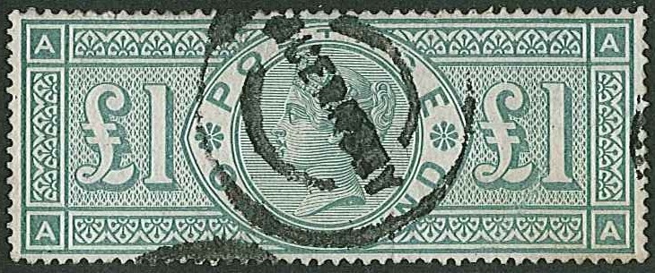
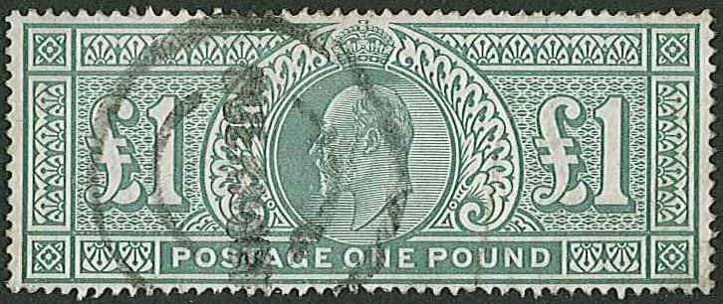
Stamps and Collectables Auction, 26 August 2019 Page 32 .

381 384
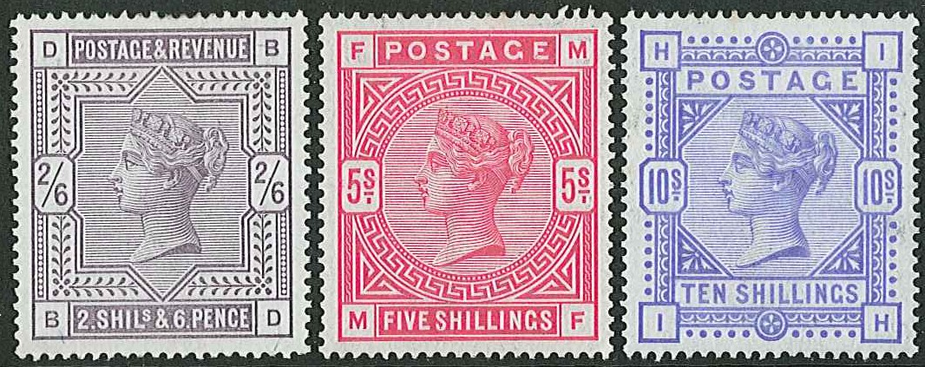

378
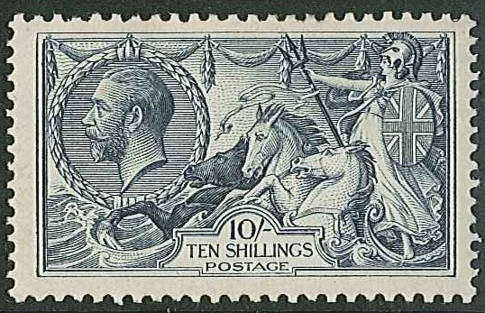
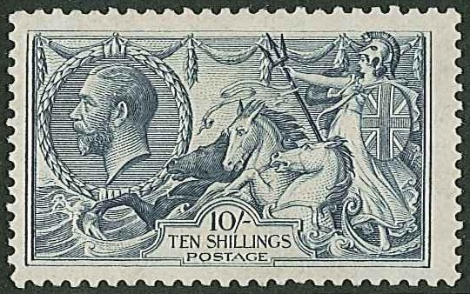

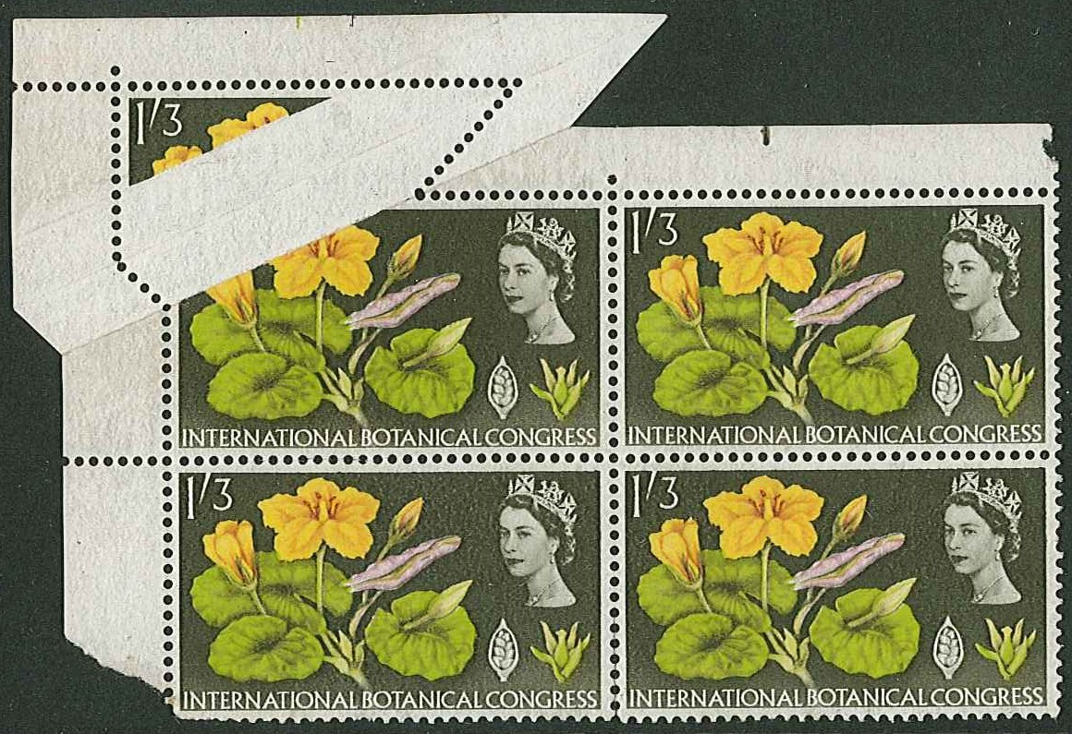
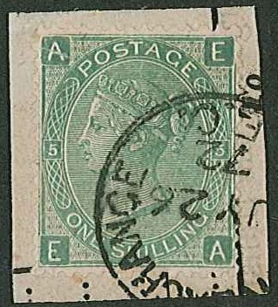
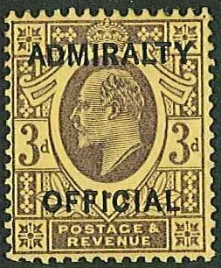
ex 385 ex 387

402 419
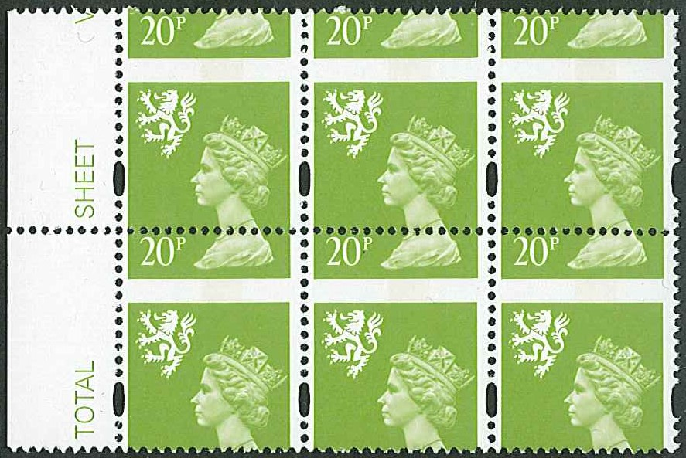

395

399

