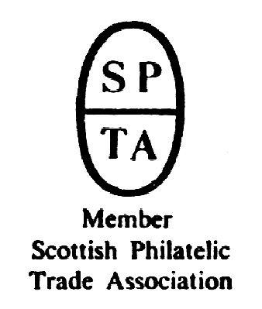

Robert Murray
5 & 6 Inverleith Gardens, Ferry Road,
Edinburgh, EH3 5PU
Tel. 0131 552 1220 :: 0131 478 7021 :: 0845 0500 886
Collectables Auction
AUCTION
CATALOGUE
50p
Monday 10 October 2011
at 5.00pm
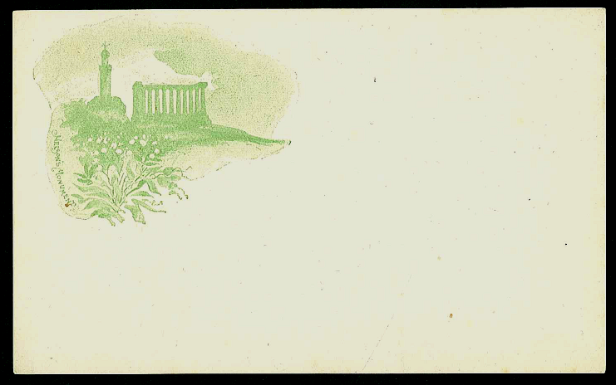
Catalogue of Stamps and Collectables to be sold by Public Auction, within the
STEWART’S-MELVILLE CLUB PAVILION, 523 FERRY ROAD, EDINBURGH
On view at Pavilion on afternoon and evening of sale (see details later in catalogue),
and at Shop during business hours (Tue, Thu, Fri 10am-6pm, Wed 2pm-9pm,
and Sat 10am-6pm) for one week prior to sale, or by appointment.

ex 80
1894 Edinburgh postcards

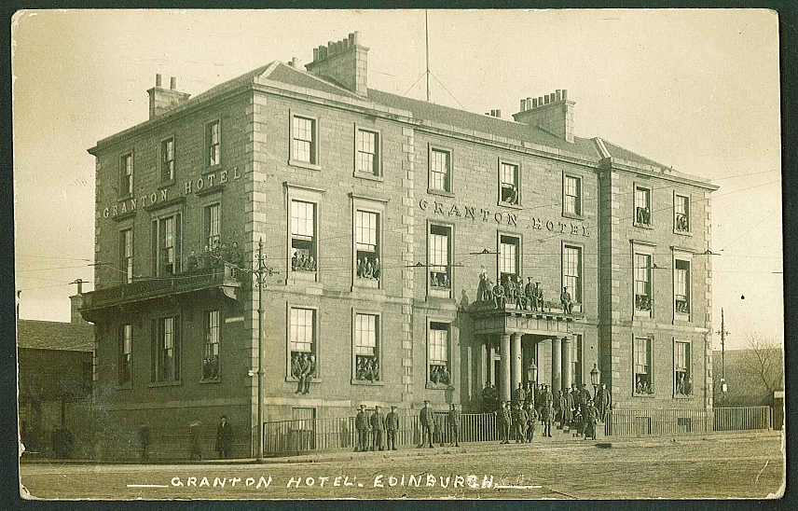

Granton
91

0845 0500 886 website www.stamp-shop.com email auction@stamp-shop.com
Stamps and Collectables, 10 October 2011 Page 2 Estimate.
All notes, terms, and instructions in the accompanying Stamp Auction
catalogue also apply to this catalogue. That catalogue’s bid form should be
used for both sales.
STARTING AT 5.00pm (in Upstairs Bar Area)
BANKNOTES
1 United Kingdom; small mix comprising Bank of Scotland £1 (5, 1953-55), £5 (1, 1955),
Bank of England 10/- (2). .. .. .. .. .. 35.
2 --; 1922 Treasury 10/- in only about “very good” condition. TR8 (cat.£140 for VF). 20.
3 Scotland; selection of £1 notes, all with different dates, of Commercial Bank 1927-55 (15),
Royal Bank 1927-40 (7), and Union Bank 1924-54 (16). Generally fair to fine. .. £200.
4 --; R.B.S. 2005 Nicklaus £5 (3) each in presentation wallet, unc. Also British Linen Bank
1968 £1 VF. .. .. .. .. .. .. 20.
5 --; Bank of Scotland; 1959 and 1966 £1, and 1965 £5, all fairly worn. .. 15.
6 England; 1951 (3 November) white £5, prefix W, VF (clean and fresh but with some
strong folds), BE94b cat.£80. .. .. .. .. .. 50.
7 --; --; 1951 (16 November) white £5, prefix W, VF (clean and fresh but with some strong
folds), BE94b cat.£80. .. .. .. .. .. 50.
8 Australia; 1961-65 10/- Flinders with reverse design of Old Parliament House, signatory
title “GOVERNOR, RESERVE BANK OF AUSTRALIA”, prefix AH/21, uncirculated. Krause 33,
cat. $350. .. .. .. .. .. 80.
9 --; another of the same, prefix AH/57, uncirculated. .. .. .. 80.
10 --; 1961-65 £1 with signatory title “GOVERNOR, RESERVE BANK OF AUSTRALIA”, prefix
HJ/95, uncirculated. Krause 34, cat. $300. .. .. .. 70.
11 --; 1974-85 (1988) $2 MacArthur – ten unc. examples, each from the final printing and in
individual presentation folders (Krause 43e cat.$9 each); also several other cheaper notes. 30.
CIGARETTE AND TRADE CARDS
12 Small box containing 22 different sets, and 1 duplicate set – Churchman, Gallaher, Players,
Wills, Mitchell, Phillips, generally fine. ☑ .. .. .. .. 60.
13 Large shoebox with many hundreds of loose cards. ☑ .. .. .. 30.
14 Tub with 1,784 (counted !) mixed loose cigarette cards. ☑ .. .. 35.
COINS
➲ With the volatility of the precious metal markets, some of the estimates in this section may be
superseded by events. Estimates here have been based on gold and silver prices of £1,050 and
£20 per troy ounce respectively.
15 Mix in box, much UK inc. a number of modern UK commem crowns (some £5) and six
folders, tins of mixed foreign, a few odd useful singles, etc. (100s) ☑ .. £120.
16 Mixed box (c.6.5kg gross) with much cheap material (UK commem crowns, pennies and
halfpennies, foreign odds, etc.) but including roughly £3/10/0 face in UK pre-47 and pre-20
silver. ☑ .. .. .. .. .. .. 80.
17 Mix in box (c.6.9kg gross) with much Australian and UK, a few banknotes. (100s) ☑ 75.
18 Heavy box of “smush” - UK and foreign low values, modern out-of-date, UK pennies and
halfpennies, etc. (c.16kg net) ☑ .. .. .. .. .. 70.
19 Large world mix in various tins, boxes, and bags, all in an old broken briefcase. All-world
inc. some UK. Unfortunately includes a bagful of USA 1c worth next to nothing, but others
make up. (c.19kg gross) ☑ .. .. .. .. .. 70.
20 Small box with a fistful of slightly better coins – some current or exchangeable foreign, a
few foreign silver, etc. (c.60) ☑ .. .. .. .. .. 55.
21 Medium box with world mix in tin and smaller box – the bulk in UK pennies, halfpennies,
etc. (c.10kg gross) ☑ .. .. .. .. .. 40.
Stamps and Collectables, 10 October 2011 Page 3 Estimate.
COINS, continued.
22 Small mixed box of mainly UK inc. a few silver. ☑ .. .. .. 30.
23 Mexican 8r coin of 1783 (from wreck of El Cazador), fair condition in presentation box.
Also eight modern philatelic numismatic covers, and a few stamps. ☑ .. 30.
24 Small mix inc. Lusitania medallion. ☑ .. .. .. .. 12.
25 United Kingdom; ten “Whitman” type folders with mix of farthings to florins inc. pre-47
silver of face value £5/5/-. ☑ .. .. .. .. .. £110.
26 --; album of pre-decimal coins from farthings to shillings, with most value in pre-1947
silver (face c.£5.) ☑ .. .. .. .. .. .. £120.
27 --; collection of decimal coins in album arranged by denomination and date, from ½p up
to 50p (28), £1 (21), £2 (14), and £5 (15). ☑ .. .. .. £130.
28 --; proof sets for 1996 to 2003 inclusive, and Executive Proof set for 2004. All in original
boxes. (9) ☑ .. .. .. .. .. .. £100.
29 --; box of mainly standard fairly modern items but in some quantity, with numbers of
commem crowns (mainly 25p, some £5), a few coins in presentation cards, 1993 proof set,
etc. ☑ .. .. .. .. .. .. .. £100.
30 --; mix of pre-decimal coins (none silver) with 2/6 (15), 2/- (50), 1/- (c.250), 3d (c.300),
1d (c.270, 1902 onwards), and ship ½d (c.260). ☑ .. .. .. 30.
31 --; small box of Victorian pennies, average condition (c.260). ☑ .. .. 26.
32 --; bulk lot of commemorative crowns (each in individual plastic case) comprising 1965
Churchill (7), 1972 S.Wedding (9), 1977 Jubilee (25), 1980 Q.Mother (4), and 1981
Wedding (18).☑ .. .. .. .. .. .. 20.
33 --; album of pre-decimal ¼d, ½d, 1d, brass 3d arranged by date. (100s) ☑ .. 15.
34 --; 2001 £2 coin with error of production – blank for centre has bee mis-cut, leaving a
roughly crescent-shaped space between the two parts, EF. .. .. 10.
35 --; Silver Coins; 1677 Charles II crown fair/fine, also 1844 crown (star stops on edge) F. 60.
36 --; --; four crowns around 1820, 1935 crown, halfcrowns of 1817, 1820, 1887, and 1923.
Mixed condition, some very worn. ☑ .. .. .. .. £100.
37 --; --; album arranged by date, with half-crowns (4 pre-1920, 11 pre-1947, 16 later), florins
(1, 19, 20), shillings (8, 25, 38), 6d (3, 20, 20), and silver 3d (17, 20). Mixed quality. ☑ £140.
38 --; --; 1996 “Anniversary Collection” in original box (7 coins, £1 to 1p, all in silver proof).
Cat.£150. ☑ .. .. .. .. .. .. 30.
39 --; --; two of 1998 silver proof Britannia £2. ☑ .. .. .. 30.
40 --; --; tin with £16/12/3 face value in pre-1947 coins. ☑ .. .. .. £320.
41 --; --; loose mix of pre-1920 (face £2/17/-) and pre-1947 (face £2/19/6) silver coins. Also
France 10f (2), Australia 2/- (1). .. .. .. .. £160.
42 --; silver proofs, each in original box, of 1995 £1, £2 (both), 1996 £1, £2, £5, 1997 £2, £5,
1998 50p. ☑ .. .. .. .. .. .. 60.
43 --; silver proofs, each in original box, of 1986 £2 Games, 1990 Q.Mother £5, 1999 Rugby
£2. Also 1999 1oz Britannia, and Jersey 2006 Churchill £5. ☑ .. .. 60.
44 --; Gold Coins; 1804 George III half guinea, F/VF. .. .. .. £120.
45 --; --; 1874 Half Sovereign, VF. ▲ .. .. .. .. £110.
46 --; --; 1894 Half Sovereign, VF. ▲ .. .. .. .. £110.
47 --; --; 1895 Half Sovereign, F. ▲ .. .. .. .. £110.
48 --; --; 1900 Sovereign, VF/EF. ▲ .. .. .. .. £220.
49 --; --; 1911 Sovereign, EF. ▲ .. .. .. .. .. £220.
50 --; --; 1911 Half Sovereign, VF+ but some glue on reverse. ▲ .. .. £110.
51 --; --; 1913 Half Sovereign, VF. ▲ .. .. .. .. £110.
52 --; --; 1913 Half Sovereign, VF. ▲ .. .. .. .. £110.
➲ --; --; see also Jewellery.
53 --; Sets; 85 of the 1968 specimen decimal sets in blue plastic folders, cat.£2.50 each.
(There are two types of cover print on these, and two colours of insert). ☑ .. 22.
A Buyer’s Premium of 10% (vat-inclusive) will be added to all sale prices.
Stamps and Collectables, 10 October 2011 Page 4 Estimate.
COINS, continued.
54 Ancient; one each of Pontus (?), Illyricum, India, Macedonia, Persia, Greece (?), and three
Roman. Mixed quality. ☑ .. .. .. .. .. 40.
55 Australia; 1915-61 range of silver threepences on home-made page. (72). .. 24.
56 --; 1912-63 range of silver sixpences on home-made pages. (c.188) .. .. £120.
57 --; 1911-63 range of silver shillings on home-made pages. (60) .. .. 24.
58 --; 1917-63 range of silver florins on home-made pages. (90) .. .. £240.
59 --; mix of silver coins comprising 3d (52), 6d (7), 1/- (3), 2/- (15), 1966 50c (8). ☑ 80.
60 --; “Type Set” folder with fairly complete range of KE7 to QE type coins (42) inc. several
silver. .. .. .. .. .. .. .. 40.
61 Canada; 1996 tiny gold $1 Maple Leaf, unc. (1/20th oz. 0.999) .. .. 45.
62 Europe; album with small colln. of Germany (63 inc. a few silver) and Poland (45). Also a
few Canada. ☑ .. .. .. .. .. .. 50.
63 Germany; c.1993-2001 collection of silver 10dm coins (54), each 15.5g of 0.625 silver
(ASW of each coin 0.3114oz). Also 2002 similar €10 coins, (6), each 18g of 0.925 (ASW
0.5353oz). Total ASW c.20oz. ☑ .. .. .. .. £280.
64 Guernsey; 1997 Golden Wedding silver proof £1 (2), and 1999 Royal Wedding silver proof
£1. Each 9.5g 0,925. ☑ .. .. .. .. .. 15.
65 Russia; 1898 gold 5 rouble, VF. ▲ .. .. .. .. 90.
MEDALS
66 Queen’s South Africa Medal (3rd type reverse) with five clasps (Cape Colony, Orange Free
State, Transvaal, South Africa 1901, South Africa 1902), EF. Named to 25718 TPR. T.
MACILWAIN 6TH IMP. YEO. .. .. .. .. .. 80.
67 WW1 Memorial Plaque (has been polished), plus matching WW1 Victory Medal (named to
28241 Pte. J. Sellar High. L.I.) ☑ .. .. .. .. 35.
68 WW1 pair (BWM, Victory) (named to 51610 Pte. J. Maguire E. Yorks. R.) Also small silver
badge (not military). ☑ .. .. .. .. .. 24.
69 WW1 standard pair (named to 640179 Pte F. Jackson 2-Can. Inf.). Also a silver cigarette-
holder-case, and other oddments. ☑ .. .. .. .. 30.
70 Group of six comprising 1939-1945 Star, Burma Star, Defence Medal, 1939-45 BWM,
Efficiency Decoration (GVIR, with Territorial suspender bar, and GVIR bar), and Special
Constabulary Long Service Medal. Also matching set of miniatures. ☑ .. £100.
71 Group of four comprising 1939-1945 Star, Burma Star, Defence Medal, 1939-45 BWM,
plus matching set of miniatures. ☑ .. .. .. .. 30.
POSTCARDS
72 Large old original album with collection of largely Scottish views, plus other UK, a few
foreign, artistic, and subjects. Mainly “golden age”, some up to about 1950s/60s. Some
better cards. (398) ☑ .. .. .. .. .. £150.
73 Accumulation in two boxes (large shoebox size) of just mixed cards of all periods and
types, but a good proportion from 1900-30 and inc. more unusual, some better views,
much European, artists, a few real photographic, etc. (Estimate c.1,500) ☑ .. £150.
74 Three shoeboxes of postcards – two boxes are of mainly modern but with a scattering of
older cards here and there inc. odd useful Scottish, the third box is mainly 1910s-1920s
Scottish inc. many Orkney, though quality is mixed (some worn or grubby, some with
stamps removed). (100s) ☑ .. .. .. .. .. £150.
75 Collection/accumulation with mix in album (200+, mixed types and periods inc. Scottish
and English views, some subjects, etc.), plus loose in small suitcase (100s, many
interesting Moderns). ☑ .. .. .. .. .. 40.
76 Floral Clocks; mainly modern seln. (70) .. .. .. .. 15.
77 Silks; woven silk card of the ship R.M.S. Celtic, with no manufacturer's name. Good but
with small faults. .. .. .. .. .. .. 20.
Stamps and Collectables, 10 October 2011 Page 5 Estimate.
POSTCARDS, continued.
78 Ascension; five unused cards (4 with undivided backs) with four different views. 15.
79 U.S.S.R.; 1911-39 postally used cards of Russia (8), Estonia (2), and Latvia (2). 15.
EDINBURGH POSTCARDS
80 Set of cards published by George Stewart & Co. of Edinburgh, certainly some of the earliest,
and possibly the very first, picture postcards to be published in the UK. In Picture Postcards
and their Publishers (Anthony Byatt, 1978) it says “... when the postal regulations were
relaxed in September 1894, a set of views of Edinburgh, printed by process blocks, was
quickly released. The views were very small and placed in the top left hand corner of the
card.”
Each is a 120 x 74mm white card with monochrome illustration on front, text on back (“POST
CARD/THE ADDRESS ONLY TO BE WRITTEN ON THIS SIDE” and “HALFPENNY/STAMP” within
interrupted box.
The series of cards is as follows; {i} Edinburgh from the Forth (light brown), {ii} a duplicate
of the same (mounted so as to show reverse), {iii} Nelson's Monument (light brown), {iv}
same (light green), {v} Edinburgh from the Forth (dull purple), {vi} St. Giles' Spire (light
green), {vii} Scott Monument and Castle (purple-brown), and {viii} same (grey-violet).
Cards are in fine and fresh condition, particularly fresh for their age, all are unused, and are
mounted with photo-corners on written-up pages. A rare group, significant to Edinburgh
collectors and to collectors of postcard history; we can remember seeing them displayed by
the collector who acquired them – probably 20 or 30 years ago, and have not seen any others
since. (8) .. .. .. .. .. .. £200.+
81 Two cards from George Stewart & Co.'s court size Edinburgh series (published 1898),
both unused (one with bend), plus two coloured vignette cards (c.1899-1900), and a
reasonable range of 45 cards of various parts of the city inc. some scarcer. (49) .. 80.
➲ Following is a section of 51 lots. This represents the greatest part of a large and important
collection of Edinburgh cards which has been assembled over the last twenty years with
much searching, and admirable levels of determination and spending. There are of course
standard cards included, but very many are unusual, and there are scarcer cards throughout.
Having taken an interest in such material for many years, I can say that there are many views
here I have never seen before. Almost all cards are of the “classic” period (c.1900-1920).
Duplication is minimal.
As a matter of interest, the collector kept a record of the cost of the cards. Some may have
been overpriced, and some may have been bargains, while others were bought when prices
were quite different from today's. The total cost is quoted at the end of each description, but
will not always be relevant.
82 Central Edinburgh; useful bundle of mixed mainly views inc. court size, royal events,
scarcer scenes, a few theatrical, etc. (53, £244) .. .. .. £150.
83 --; mixed bundle from West End to Calton Hill via Princes Street, Scott Monument,
Gardens, Ross Bandstand, plus Calton Hill, The Bridges, Castle, and Holyrood Palace, etc.
(250+, £183) .. .. .. .. .. .. £100.
84 --; another bundle, similar in range, but mainly different cards. (250+, £174) .. £100.
85 --; another bundle, similar in range, but mainly different cards. (250+, £186) .. £100.
86 --; another bundle, similar in range, but mainly different cards. (250+, £169) .. £100.
87 Old Town; bundle of mainly the upper half of the Royal Mile inc. Lawnmarket, Grass-
market, St. Giles, Tron Kirk, John Knox's House, plus Canongate Kirk, Grey friars, etc.
(c.100, £88) .. .. .. .. .. .. 50.
88 --; another bundle, similar in range, but mainly different cards. (99, £103) .. 50.
89 --; smaller bundle of mainly lower half of Royal Mile, with Tolbooth, Canongate, Huntly
House, some closes, etc. (61, £73) .. .. .. .. 50.
A Buyer’s Premium of 10% (vat-inclusive) will be added to all sale prices.
Stamps and Collectables, 10 October 2011 Page 6 Estimate.
EDINBURGH POSTCARDS, continued.
90 Granton; includes harbour, a procession (RP, possibly Granton Road), Wardie Hotel,
Wardie Steps. (19, £80) .. .. .. .. .. 60.
91 --; fine RP card of Granton Hotel (later HMS Claverhouse) with many uniformed soldiers at
windows and balconies. Postmarked Edinburgh 1915. (1, £18) .. .. 20.
92 Newhaven; includes trams, harbour, lanes/streets. (34, plus 1 comic, 1 modern, £160) £120.
93 Trinity and Starbank; small group (9, £40) .. .. .. 30.
94 Portobello; selection of mainly street scenes inc. various views of the High St., plus King's
Rd., Bath St., Brighton Pl., etc. (44, 1 modern, 1 photo, £185.) .. .. £120.
95 --; seln. of mainly the beach, pier, and Promenade. (39 inc. couple more modern, £103) 70.
96 --; seln. of mainly beach and Promenade, similar to, but different from previous lot. (47,
£105) .. .. .. .. .. .. .. 70.
97 --; a further generally similar seln., again different cards. (40, 2 modern, £90) .. 60.
98 --; Marine Gardens, Fun City, donkeys, entertainers, gold course, military horses, Figgate
Burn Park, etc. (37, inc. couple modern, 1 photo, £111) .. .. .. 75.
99 Joppa; mainly beach scenes and Esplanade, plus Brunstane, salt pans, etc. (30, plus 1
comic, 2 modern, £101) .. .. .. .. .. 75.
100 Dean; range of Dean Bridge, St. Bernard's Well, Dean Village, Glenogle, Dean Cemetery,
some streets and buildings in area. (55, plus 8 modern, £112) .. .. 75.
101 Stockbridge; various streets, and into that edge of New Town. (19, plus 2 modern, £109) 75.
102 Comely Bank/Inverleith; street scenes/tenements, plus Craigleith Hospital, Fettes College,
Botanic Garden, Inverleith Park, etc. (52 inc. 1 modern, £215) .. .. £150.
103 Canonmills/Goldenacre; from Dundas Street to the focal point of the city . . . Inverleith
Gardens, plus one Fettes. (16, £81) .. .. .. .. 60.
104 Blackhall; nearly all street scenes. (24, £142) .. .. .. £110.
105 Davidson's Mains; small seln. inc. motor bus in Barnton Gdns., school, Bruntsfield Golf
Club House. (15, £120) .. .. .. .. .. 80.
106 Cramond; covering Cramond Brig, Barnton Station, Fair-a-Far, etc. (35, modern, £139) £110.
107 --; Cramond Village, the shore, Promenade, etc. (38 inc. some a bit more modern, £110.) 75.
108 --; scenes on the River Almond, from Cramond Village to Craigiehall, plus two Cramond
House. (33, plus 1 modern, £84) .. .. .. .. .. 60.
109 Gorgie/Slateford; nice range of street scenes plus schools, churches, etc. (30, £252) £170.
110 Bristo/Lauriston; includes Students' Union, Royal Infirmary, Chambers St., George IV
Bridge, University (inc. two court size), George Watson's College, Meadows. (60, £154) £110.
111 Lauriston Fire Station; three cards c.1905 of firemen and tenders at Edinburgh Fire
Brigade Headquarters, Lauriston Place. (3, £33) .. .. .. 24.
112 Tollcross/Bruntsfield; small seln. from the general area inc. street scenes, Boroughmuir
School, Barclay Church. (14, £81) .. .. .. .. 60.
113 Morningside; many street scenes between Merchiston Place and Faimilehead. Also
Hermitage, Braid Hills Golf Course, various buildings. (44, £216) .. .. £150.
114 Colinton; mix inc. church, village, Colinton Dell, mills, some good street scenes. (51 inc.
two modern, £177) .. .. .. .. .. .. £130.
115 Juniper Green, Currie, and Balerno; mix inc. rural scenes, mills, street scenes, RP of
highland dance contest, etc. (25, £145) .. .. .. .. £110.
116 Swanston/Pentland Hills; various of Swanston cottages, otherwise rural views, some of
which surprising scarce, also two of Habbie's Howe at Carlops. (44, £96) .. 70.
117 Duddingston; loch, village, bridge in golf course, etc. (26, £48) .. .. 35.
118 Arthur's Seat/Salisbury Crags and The Pleasance; mainly the hills but also various
buildings in the area (as far as Nicolson Street). (35, £68) .. .. 50.
119 Innocent Railway; tinted photographic view of the station at St. Leonards. Rare card. (1,
£30) .. .. .. .. .. .. .. 30.
120 Newington; mainly street scenes such as Clerk St., South Clerk St., Minto St., Blacket Ave.,
Salisbury, etc. Fine selection inc. couple modern. (38, £294) .. .. £200.
Stamps and Collectables, 10 October 2011 Page 7 Estimate.
EDINBURGH POSTCARDS, continued.
121 Blackford; views of and from Blackford Hill, plus some local housing etc. (38 inc. 1
modern, £78) .. .. .. .. .. .. 50.
122 The Grange; mainly street scenes plus some individual buildings etc. (39, £264) £180.
123 Liberton; good range with some scarcer RP views. Includes Liberton Dams, mill, church,
Blackford Glen, etc. (27, 2 photos, 1 repro., £184) .. .. .. £130.
124 Gilmerton/Craigmillar; ten of Gilmerton, ten of Craigmillar Castle, and two other odds.
(22, £76) .. .. .. .. .. .. 50.
125 Haymarket/Roseburn/Murrayfield; good range inc. some scarce RP street scenes (as far
as Balgreen/Saughton). (40, 1 photo, £253) .. .. .. .. £180.
126 Corstorphine; some standard scenes, and many much less often seen. (53, plus several
modern/repros/photos, £281) .. .. .. .. .. £200.
127 South Queensferry; some of or including Forth Bridge, but other scarcer street scenes,
etc. (38, £132) .. .. .. .. .. .. 80.
128 Forth Bridge; wide variety of views, from construction to about 1930s. (126, plus a few
modern/others, £146) .. .. .. .. .. 70.
129 Leith Walk/Pilrig/London Road; quite a wide area inc. Easter Rd., Broughton St.,
Meadowbank, Ferry Rd., etc., some scarce. (35, £184) .. .. £130.
130 Port of Leith; mainly ships in harbour/docks, but also some surrounding buildings. (48,
£166) .. .. .. .. .. .. .. £120.
131 Leith; good range of mainly streets and buildings, plus Leith Links and Victoria Park. (52,
plus 2 modern, £203) .. .. .. .. .. £140.
132 Edinburgh; selection of comic, multi-view (inc. three court size), pull-out views, etc.
(54, £96) .. .. .. .. .. .. 50.
OTHER CATEGORIES
133 Badges; 1933-38 seln. of Red Cross badges and medals, with bars for First Aid, Nursing,
Chemical Warfare, 3 Years Service. (8 items) Also photo of the nurse. ☑ .. 20.
134 Books; Soldiering on St Kilda by James Mackay, 2002 (£29.95) .. .. 10.
135 Collectables Literature; box of books and catalogues on coins, banknotes, etc, mainly
about 1970s/80s. (10) ⊗ .. .. .. .. .. 10.
136 --; big heavy box of mixed books (mainly 1970s/80s) on all manner of collectables – post-
cards, brewerania, transport tickets, playing cards, matchbox labels, etc. (c.38) ⊗ 24.
137 Ephemera; small metal Bryant & May’s Wax-Vestas matchbox with picture of Glasgow &
S.Western Railway Co. Paddle Steamer “Juno” on lid. .. .. .. 5.
138 Jewellery; UK QV Jubilee Head Half Sovereign mounted in 9ct gold ring. ☑ ▲ £110.
139 --; UK 1900 Half Sovereign (well worn from having been in ring) and separately the ring
in which it has been mounted. ☑ ▲ .. .. .. .. £100.
140 --; UK 1982 Half Sovereign mounted in 9ct gold ring. ☑ ▲ .. .. £110.
141 Medallions; British propaganda repro. of German medallion for Lusitania sinking, 1915. 10.
142 --; bronze medallion (44mm) for Apollo 13, and another (64mm) for Apollo 15. ☑ 10.
143 --; 1973 four UK FDCs (inc. one dupl.) each with sterling silver medallion. .. 30.
144 --; 1975-76 six world PNCs each with sterling silver medallion of an explorer. ☑ 50.
145 Musical; a violin, quite old and worn, with case, bow, spare strings. ☑ .. 30.
146 Precious Metal Replicas; metal replica of USA $1,000,000 banknote by Washington Mint,
weighing c.128g, and with “.999 FINE SILVER” in the design. ☑ .. .. 70.
147 Prints; two matching prints (by Lizars, c.1830) of Greenock and Broomielaw, and another
(Bartlett, Wallis) of Leith Harbour, all tinted. .. .. .. 15.
148 Watches; four fob watches, two of these rolled gold, and two chains (base metal). ☑ 20.
End of Collectables Section – Stamps follow at 7pm
© Robert Murray 2011
A Buyer’s Premium of 10% (vat-inclusive) will be added to all sale prices.
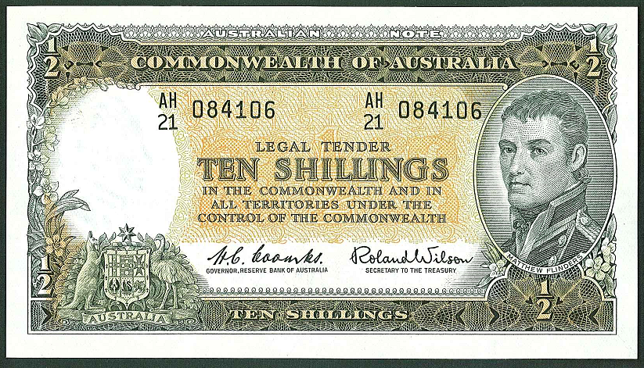
Stamps and Collectables, 10 October 2011 Page 8 Estimate.

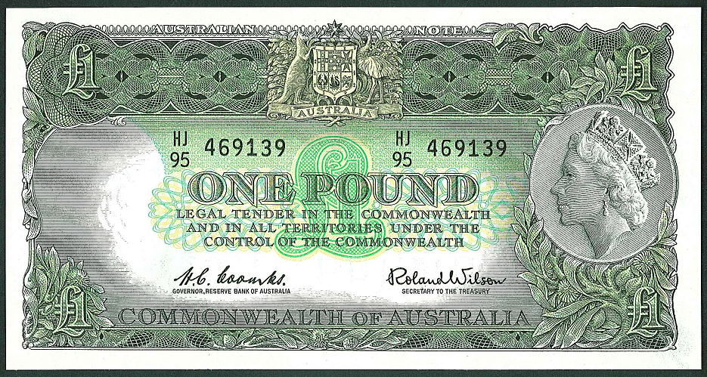
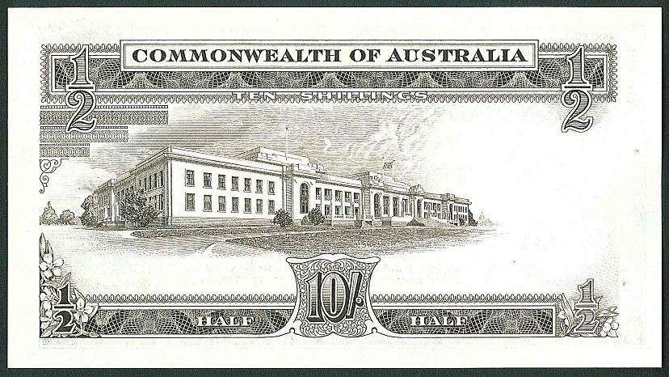
Lot 8
Lot 9
(reverse)
Lot 10

